Computer Science

Project

[Leane Matejko]

**Contents**

1.1 Description of the problem and stakeholders 3

1.2 features that make the problem solvable by computational methods 3

1.3 Research 6

1.4 Essential features 3

1.5 Limitations 3

1.6 Requirements 3

1.6.1 System requirements 3

1.6.2 Hardware requirements 3

1.6.3 Software requirements 3

1.7 Success Criteria 3

2.1 Top down design 4

2.2 Structure of my programs 4

2.3 Algorithms 4

2.4 Usability features 4

2.5 Key variables and data structures and classes 4

2.6 Test data to be used during iterative development 4

2.7 Further data to be used in post development 4

3.1 Iterative Development of the coded solution 5

3.1.1 Prototyping 5

3.1.2 Development and testing 5

4.1 Testing to inform evaluation 6

4.1.1 Post development testing 6

4.1.2 Usability testing 6

4.2 Evaluation of the Solution 7

4.2.1 Evaluating against the Success Criteria 7

4.2.2 Evaluating usability features 7

4.2.3 Maintenance issues and Limitations of Solution 7

4.2.4 Potential Improvements and changes 7

**Section One: Analysis**

**Max marks 10**

# 1.1 Description of the problem and stakeholders

For my project, I aim to create a platformer shooting/adventure game. Some features I would like for it to be a single player game that follows the main character around a map with different levels of difficultly. There will be smaller enemies (around three different varieties) all over the map, players slowly working up to a main boss at the end of each level. Players will be able to explore the map, however check points will force them to continue with the level (there might be a feature to remove this once the game is completed to all for more free-roaming.)

However, I want to have the game in a middle ground where the levels are challenging enough that experienced players can enjoy it but don’t deter new player with little experience from having fun. The interface also needs to be easy to use and function properly as this can lessen the experience, deterring more players.

**Stakeholders**

I am aiming for this game to be directed towards anyone above the age of 12, and has played some kind of platformer before. A large amount of experience will not be needed, however more experienced players should be able to find some enjoyment out of the gaming experience. Once levels are completed once, I would like to allow for these levels to be replay able, as later level will progressively become more and more difficult, this will allow for less experienced player to get used to the game mechanics or play the game at more comfortable pace/level. Achievements will be scattered throughout the game, providing a sense of accomplishment and want to continue playing.

# 1.2 features that make the problem solvable by computational methods

**Abstraction**

Abstraction will allow for the most important features to be focus on and anything extra will be secondary. This can prevent time from being wasted on pointless and insignificant details, and instead be used to create an enjoyable user experience (possibly through controls or interactions between characters).

**Decomposition**

Breaking down the problem into smaller parts rather than working on it as a whole can make finding the solution more digestible and can lead to easier documentation and planning.

Decomposition can used in two ways to create this game; either working on the project through the different levels (aiming for at least one, possibly three and potentially 5) or through the different characters (player, enemies and bosses). This can allow for basic playthroughs to be made and slowly add different features and details.

With planning, depending on which method of decomposing the problem, steps and objective can be made and later completed. This list can also then be put into order of priority, so if time constrains lead to certain aspects not being completed, the most important sections are finished so the game is still playable and feel somewhat complete.

**Inheritance**

As each level will have the opportunity for players to be able to add advantages to their characters (such a speed boost, jump increase or adding attack power) as well as enemies having overall the same features (except for the bosses at the end of each level) but increasing features such as their attack damage or health bar. As these similarities will result in repeat sections of code that will ultimately be redundant, inheritance can be used for characters/ enemies so all bases that will be the same can be there and extra features and add-ons can be added when necessary. This can reduce time and increase efficiency, while reducing the amount of code the computer needs to process.

**Iteration**

As each level will be fundamentally the same and just generally increase in difficulty, iteration is important as it allows for code to be reused for difference purposes depending on the situation. Throughout the game there will be checkpoint and monitors added to player values (e.g., Health bar, attack power, in-game benefits). Iteration can then be used to interact with these aspects and progress through the game.

**Encapsulation**

Encapsulation is useful as it prevents the game’s constants from being changed and prevent issues further down the line. As I want the game to be replay able and potentially to have checkpoints where a player can go back to (such as restarting a level from the beginning or the start of the current wave they are on). If the code is permanently changed then the player will have to continue regardless whether or not they would like to restart or continue. Encapsulation prevent this from happening through only accessing variable through methods, preventing accidental changes.

**Use of variable and constants**

Using variable throughout the game could allow for players to start at different difficulties or help use inheritance and iteration to give players a different experience depending on if they would like to play as a different style of character or play at a different difficulty. Constants would be used for calculations and situations that would not be affected by these changes; encapsulation will then be used to make sure they are not changed. Variables could then be used to store user input and then be used later on for calculations.

**File reading**

To avoid having constants and user data being lost, file storing and reading can be used to save user progress if they shut down the game and wish to continue later, or restoring data at a checkpoint.

**Basic AI**

To avoid enemies and other characters from the game feeling stagnant and to make the characters more difficult to defeat, most of the enemies within each level will have a basic AI that will interact will the player. This will be achieved through colliders that will interact and be on both the player and the enemies, as well as a monitor on the stats of the enemies or player.

This could lead to features such as enemies walking towards the player when they are within a certain radius and retreating once they are below a certain level. Players would then be forced to chase enemies or avoid certain pathways. Easier enemies will stay around in one place, will not try to seek out the player and not run away once its health is low enough. More difficult enemies will walk around more, actively attack the player and then run away once dealt enough damage (potential toward the nearest healing checkpoint).

**Ability to use arithmetic-based calculation and selections**

Most character will be controlled and reacted based on colliders that will be placed around the map as well as on and around the players and enemies. Most actions will be carried out based on some kind of calculation alongside a selection through a selection.

Examples could be the character controller its self or the enemies AI. For the character controller to work, input would need to be provided by the keys w, s, a or d. Depending on the key, the location of the character would then need to be used to decide if whether or not the character would be able to move. Calculations would done to change the x, y position of the character and selection would need to be made if the character can even move at all (as the colliders might have interacted with the end of the map or an object). As with the basic AI, calculations would be needed to calculate new health scores and then a selection could be used if the enemies would travel toward the player or run away.

**Use of selections to determine player’s outcome**

While most of the game not involve much decision making and instead focus on more a combat-based game, users will have the option to choose different styles of combat depending on the different pathways that they choose. This could increase the difficulty a player wishes to play and make the game more tailored towards the users and allow for the game to be more repayable as there are more options to explore.

**Colliders**

This will be the most important tool within creating a dynamic atmosphere and gameplay. Most calculations will rely on information from different colliders interacting and lead to different outcomes. Not only will these be ones that are directly connected to the player, but also ones that are related to the background and enemies/bosses. Rather than having certain events, such as cutscenes, happen at predetermined time, instead they can take once the player is beyond a certain point, allowing for more player freedom and providing more options to the player that would lead to a better experience.

# 1.3 Research

In deciding to create a game, there are different aspects from different games that I wish to incorporate into my own. Throughout this research this not only allows for more concrete ideas to be made but also prepare for issues that may occur in the future and show a solution to those issues. Each of the games choose have at least one aspect that will be taken and used in some way.

**Night in the woods**

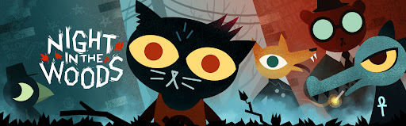Night in the woods is regarded to have a very immersive world, that many players engaged and allowing for choice and consequences. Personally, it is a game that I have been following for a long time, and although I have never played the game, I have always admired the commitment to detail and all the interactions between characters. The overall design and mechanics of the game and the open world show so much imaginations and creativity.

The game is created more so like an interactive story/world rather a game, as throughout you are exploring the world and talking to the different characters, learning about their lives/ motivations and completing tasks, along with a bunch of minigames and side quests. Depending on the actions of the players, there are several endings related to different characters.

Night in the Woods is a single-player adventure platformer released in 2017, created by Alec Holowka, Scott Benson and Bethany Hockenberry and developed by Infinite Fall. It has been nominated and won several different awards such as the BAFTA Games Award for Narrative. Throughout the game, you follow Mae and slowly uncover the reason for her return to Possum springs, reconnecting with different characters and slowly uncovering more information, revealing Mae’s past and making sense of the neighbourhood’s strange behaviour.

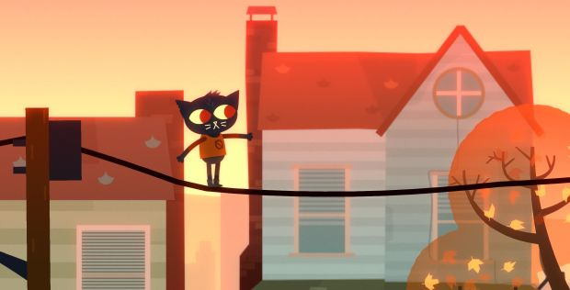 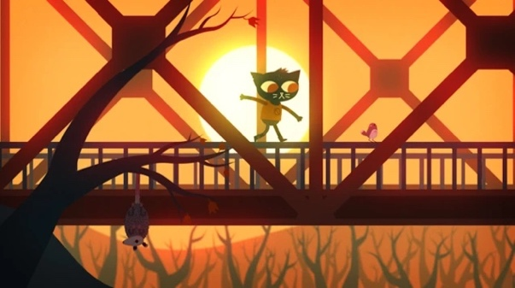

[Display of the creative use of platforming elements to the world and storytelling]

**Key Features**

* 2D adventure, platformer
* Story/dialogue focused
* Minigames
* Pathway based

**Aspects of the game**

* Inspirations
  + Different levels of platform
  + Interactions with the player
  + Progression of the story along with game mechanics
  + Use of puzzle and minigames to break up gameplay and increase engagement
  + Character controller and camera use
  + Rewards
* Restrictions and points to avoid
  + Largely story-based elements
  + Duologue based actions
  + Design of the map
  + No combat features
  + No rewards to the players

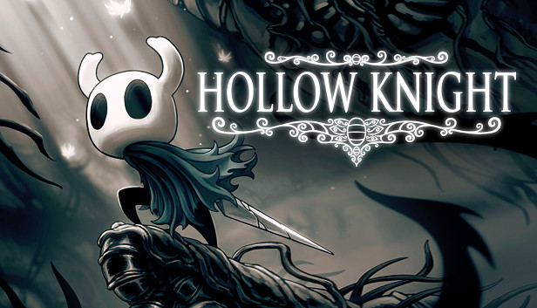**Hollow Knight**

Hollow knight is another game that I look to for inspiration, when planning my game. It is highly regarded and praised platformer game. Unlike Night in the Woods, it is many focused on fighting your way through each level rather than focusing on the story. Progressively, your character will gain new abilities and attacks that will aid in defeating future enemies/bosses. The progression throughout the game is changeling while still being enjoyable and engaging.

Hollow knight is a closer representation of what I wish to replicate, as the basic gameplay is enjoyable and the further player make their way though, the more skills they learn, different enemies they’ll encounter and more of the story is revealed. I also like the use items to change movement or provide boosts to the playable character’s attributes. This can allow for different forms of playability and increase the chance of replay to explore the different options provided. Personally, this is encouraging to equip the players with different options through items throughout the map or maybe a store menu that is available at different checkpoints.

Hollow Knight is an indie platformer released in 2017, created by William Pellen and Ari Gibson and developed by Team Cherry.

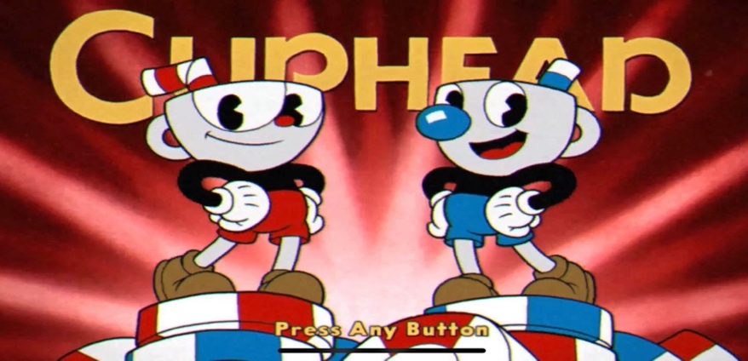**Cuphead**

Cuphead is the game I will probably take the most inspiration from, as it was what initially came to mind when wanting to make/ play a game. In terms of mechanics and functions, this is what I would like to take and replicate. This is a renowned game that really took over the gaming sphere once it was released. The attention to detail and world that has been created is beloved by many and created a repayable and enjoyable game. There is an overarching storyline that users learn through cut scenes, however the focus is on the game play and the achievement of the player. Throughout the game, you are tasked with completing several different platforming levels, and defeat the boss at the end. Once reaching the boss, you do not need to restart the whole level once you die, instead just the boss section. Each level has a different mechanic that the players can use, such as flying or using different types of power ups. There are also different stages the boss will go through, and variations in attacking styles that you need to adapt to. These changes in platforming, variation between characters and the ability to upgrade your characters, allow for increased engagement and more entertaining gameplay.

Cuphead is a ‘run and gun’ game developed by Studio MDHR and released in 2017, distributed over many gaming platforms such as PlayStation, Nintendo Switch and Xbox One. It has won many awards, one of which being ‘The Game Award for Best Art Direction’ and the ‘The Game Award For Best Independent Game’. The game takes inspiration from the golden age of American animation (heavily taking inspiration from Fleischer Studios) and takes you on a one-of-a-kind-journey. You follow the protagonists Cuphead and Mugman, who have accidentally sold their souls to the Devil. You must then travel through each area and level, defeating the bosses, attempting to repay your debt, until you are put up against the Devil and challenged to win in order to receive his casino. Throughout the game, you go head to head against mini bosses and main bosses alike, utilising the different power-ups and gameplay methods.

Aspects I wish to replicate from the game, are the difference between the main boss challenge and the overall level, providing this separation would allow for players to make mistakes and move on to later level without too much frustration. I would also like to look more into the different game mechanics to create variety between levels. I also like how the whole game is integrated and nothing feels out of place, however I understand that due to time castrates, this might not be possible and should be left to be one of the last tasks to be completed. The use of cutscenes in-between levels might also be helpful in bring levels together and create a more cohesive game and storyline.

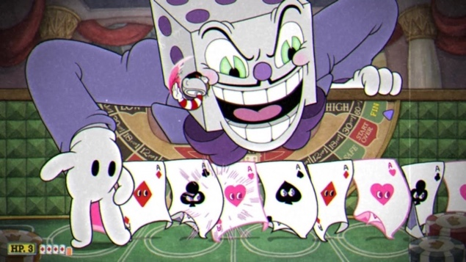 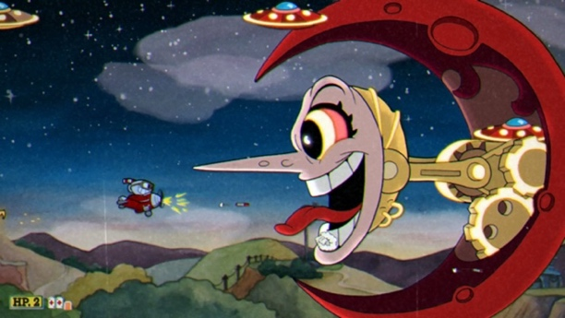

[Screenshots from boss fights King Dice (left) and Hilda Berg (right)]

**Aspects of the game**

* Inspirations
  + Different level
  + Various gameplay methods
  + Differences in enemies and bosses
  + Have checkpoints and ability to replay levels
  + Short cutscenes to explain new mechanics or small story elements
  + Multiple levels (Will limit this to 3, and continue to 5 if there is time available.)
  + Rewards and menus to use rewards
* Restrictions and points to avoid
  + Multiplayer elements
  + Making the whole game cohesive (only add certain elements if extra time is available)
  + Ability to choose levels (instead players have the ability to restart sections or the whole level and will return to the most recent checkpoint they left off from – include if there is extra time.)
  + Large story elements or art designs

**Rayman Legends**

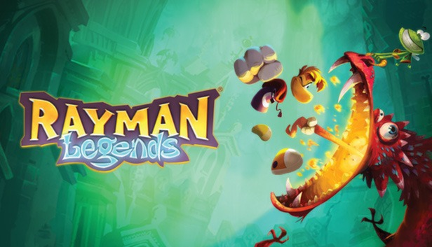This is another platforming game that I wish to take inspiration from. The contrast between levels and creativity used to achieve that creates a great gameplay experience. The levels are all connected in some way that leaves on level feeling out of place. The creative use of different outputs to further bonus levels is a genius idea (syncing up the obstacles of the level to the music in the background, making the sound effects go off as well and using a programmed scrolling screen to avoid the player from being too far ahead), making sure that everything does get too serious and keeps the level of fun of the players at a constant level, keeping them engaged for the more challenging levels. This is another game that not only uses platforming to travel through the map, but puzzles that force players to look at their surroundings and figure out how to continue. These puzzles tend to enhance the multiplayer aspect, however does not force players into needing extra people (as this can be restrictive and lead to annoyance or frustration due to levels being too ambitious and needing more people). AI is used across the game, giving the illusion that there is more than one player and making a more immersive world.

Rayman Legends is a platform video game released in August 2013, created by Michel Ancel and developed by Ubisoft, Ubisoft Montpellier and Pastagames. This the fifth game of the Rayman series and the sequel to Rayman Origins, it available across many platforms such as PlayStation 4, Xbox One and Nintendo Switch, as well as many others. At first, you play as Rayman (and Globox if you are playing multiplayer) making your way through the levels and saving the teenies, attempting to collect all of them to get a perfect score. The closer to a perfect score you get, the more Lums you receive (which can later be used to collect different costumes). You can avoid finding all of the teenies and not collect the trophies but you will not get as good of a reward towards the end. There are also bonus levels that once you complete, you receive 1 of the 10 princesses that you can use as playable characters (there is no difference between the playable characters as they do not have special moves or separate stats, they purely there for aesthetics and feed into the collector’s mind set, as you can skip the bonus levels and continue the main storyline levels.) There are also the music levels that I referenced earlier, that sync the player moving over the objects with the music, achieving this with a set scrolling screen and the inability to move beyond these means.

Similar to Mario, this is a game that I will only use the platforming mechanics to influence my game as there isn’t that much combat and the features that are there do not really interest me and are not in what I plan for my game. If I am unable to get the full effect of combat within the final version of the game, then I might take a similar approach, but for now the plan is to have a more ‘run and gun’ features than simply platforming features. However, the puzzles and the actual platform in done in a very interesting way, and is definitely something I wish to incorporate. I will do more research to see if there is any source code or explanations as to how this is coded, or I can do some tester sections to see if the player can passively interact with the surroundings.

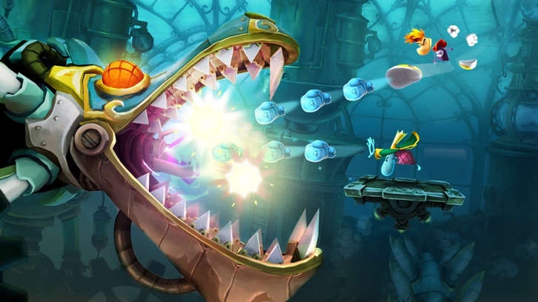

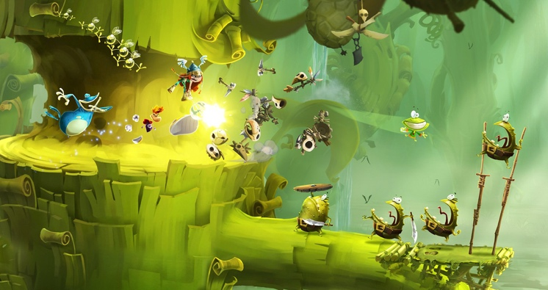

[Gameplay screenshots from Rayman Legends – (Left) Push square level with combat against enemies with playable characters Barbra, Rayman and Globox, (Right) Boss Level with playable characters Rayman and King Teenies]

**Aspects of the game**

* Inspirations
  + Platforming style
  + Different smaller enemies on each level
  + The different use of output to interact with the players
  + Different characters/ costumes
  + Core mechanics of characters
  + Small puzzles along levels with AI characters or features
  + Boss level mechanics
* Restrictions and points to avoid
  + Simple combat features from the playable characters
  + Very well integrated platforms
  + Special levels dedicated to a particular mechanic

**Super Mario Bros**

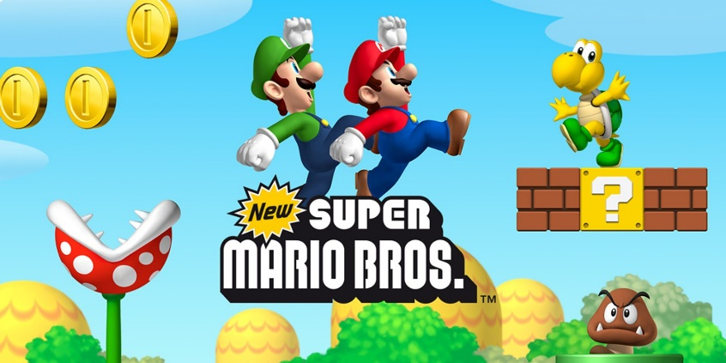Super Mario Bros has been a household game for many and gone through various iterations, continuing to be revamped and released on later consoles. This is a starting point for inspirations to different platforming games over the years. As many know, you go through each map as Mario (unless you are playing multiplayer, where you have the options to play as Luigi), completing platforming levels and defeating enemies along the way. There will be bonus levels and bosses sprinkled throughout the game play, and these will add game mechanics that normal levels would not have, changing the experience and reducing the chance that players will not complete the game/level.

Super Mario Bros is platforming game released in 1985 created by Shigeru Miyamoto and Gunpei Yokoi and developed by Nintendo, made for the Nintendo VS. System, later released to other consoles such as the Nintendo Switch, Wii, Game Boy Advance and the Nintendo DS. You play as either Mario or Luigi, running over different levels, collecting coins and power-ups that you use to defeat the smaller enemies within the game such as the turtles or the goombahs. The goal is to get through each level as quickly as possible and defeat the larger bosses, Bowser, eventually reaching the end and saving Princess Peach. Most level are relatively similar with different enemy placement and varieties, however new mechanics will be introduced, breaking up the gameplay and increasing engagement. Sometime this will increase or decrease the difficulty as extra information needs to be remembered and play (such as within the water level, you must keep an eye on your air meter and reach certain checkpoints otherwise you fail the level.)

I will use Super Mario as a template, as seen with many other games. Although, there are some combat methods (use of the fire flower up and being able to shot fire balls or jumping on top of enemies to kill them), I would prefer to use a different game as inspiration (Cuphead or Rayman Legends) as I would prefer more long distance attack options and the ability for upgrades to those attack options. Instead, I would just take the main platforming elements and interactions between the environment that the player has with other objects, such as the floating islands that you can run along or the ability to move to unseen areas of the map to complete bonus levels.

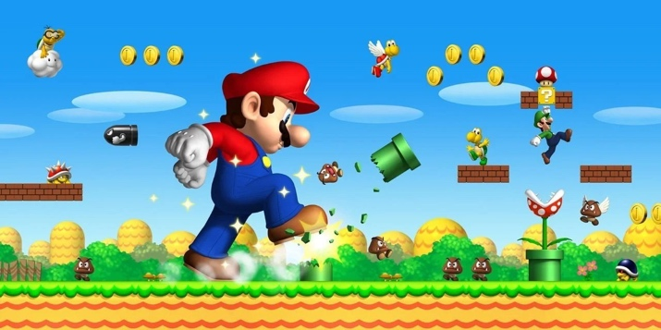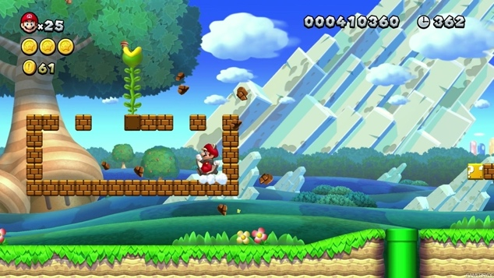

[Gameplay screenshots from Super Mario Bros (Left – Displaying the different uses of levels and platforming) (Right – Shows the use of Power-ups -Mega Mushroom – Making the player nearly invincible for 30 seconds unless they fall into a pit.)]

**Aspects of the game**

* Inspirations
  + Use of platformers
  + Moving enemies
  + Alternative ways to move around the map (such as through pipes of or secret entrances)
  + Possibility that entrances could lead to small minigames or rewards that can be used later on
* Restrictions and points to avoid
  + Multiplayer
  + Style of combat
  + More cutscene
  + Different style of level map

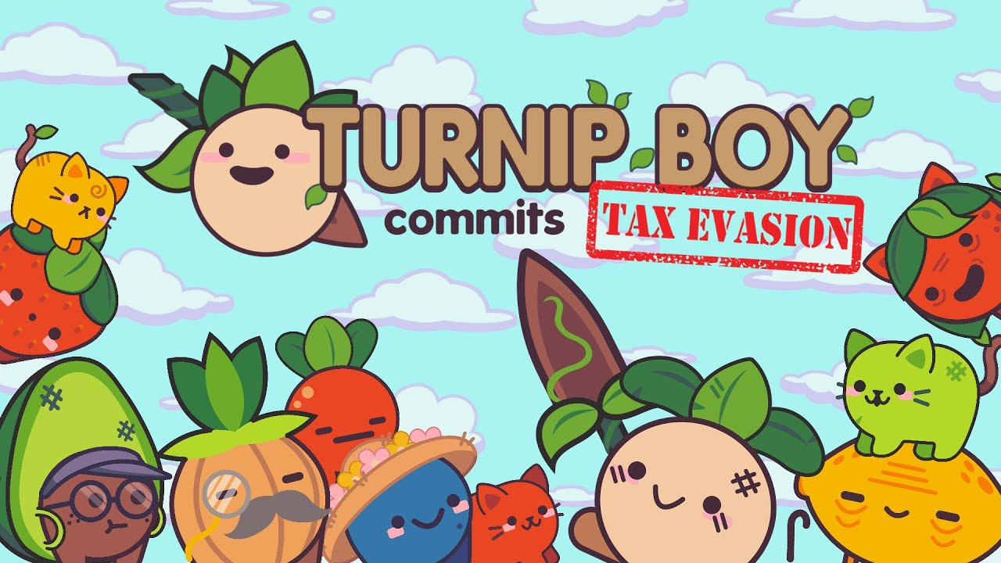**Turnip Boy commits Tax evasion**

Turnip Boy commits tax evasion is a charming 2D action/ adventure indie game that surprised players with amazing gameplay and storyline despite the crazy title. Initially, the game seems to be a simple exploration game where you go and retrieve items for various characters, maybe needing to interact with more of the world in order to achieve this. Progressively, the items become more difficult to gain and require combat and puzzle system to defeat bosses, never leaving the players too overwhelmed and unsure of their next move. Throughout, the developers have added small marker to guide the players towards the desired areas without removing too much of the open-world aspect of the game. This can decrease frustration to players since too much choice can lead to confusion and unenjoyment. There are also different styles of gameplay for the sections of the game, which I would like to replicate. The art style also has a shift between consciences and speaking parts, with I would like to use as a pixelated or more simplistic style would be much easier to do rather than needing to create everything in one style, this could also make everything seem less busy and make the focus clearer. One of the things I don’t wish to take from the game is the top-down view, instead I prefer the side view as this will probably be easier to implement and would also be easier to follow the character.

Turnip Boy is an adventure/fighting indie game that was released in October 2020 by Graffiti Games. The game was developed and created by Snoozy Kazoo and is available on Steam (so most PC/ computers) and the Nintendo switch. The game takes place in Veggieville starts out with Turnip Boy who has had his greenhouse repossessed by Mayor Onion and in order to receive it back, you must work off your debt. This is completed through a series of tasks that Mayor Onion has you complete, which forces you to explore the map, interact with other characters (such as Cran Cran or Old Man Lemon) and fight enemies. You are also able to complete side quests that unlock achievements and costumes (these parts of the game server little purpose to the overall story, but cater to the completionism gaming style that some users have, it all creates a more immersive experience). Once you have completed each level, in order to receive the item that you have been working for, you must complete a boss fight, completing a series of puzzle-like combat features. The same mechanics will e rerepeated throughout levels, however new ones are sometimes added or the same puzzle is changed to be more complex. The game is short and digestible enough that it can be played in one sitting, but contains enough content to keep you coming back.

Turnip boy has many puzzles that I believe could add many fun minigames within levels. If possible I would like to add some dialogue elements in-between sections that help guide the player to the next section or better explain the story, making the experience more immersive and real. I want to avoid the game feeling like a checklist to tasks that need to be completed and rather a world that players are open to explore, and especially one that rewards the player for going out of the structured gameplay. However, I understand that this takes large amounts of time and effort that I might not be able to dedicate to the project, this is something that is not needed and instead would be put on the same level as any cosmetic or story based points that will be added once all key components and mechanics have been added. I want to avoid the game feeling like a sandbox and have a fun world to explore, so I understand that if I want to implement a more story-based game then I need to do proper research and planning. I prefer games that have story-telling elements or allow for freedom from the player, so I believe that this will be a more enjoyable game overall. If I am unable to add larger cosmetic elements then I might take the hats system from Turnip boy and use that for extra rewards.

I also like that aesthetic of the game and will probably aim for a more complex style for cut-scenes and duologue sections and the rest of the game will have a more simplistic style (potentially pixelated as well.)

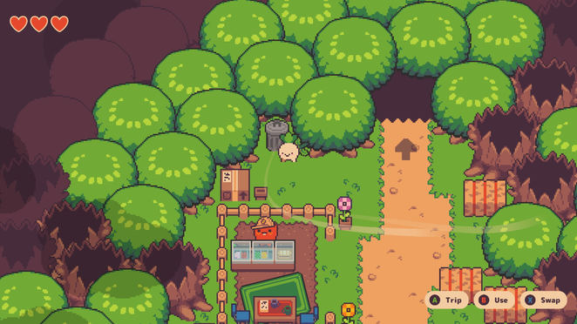 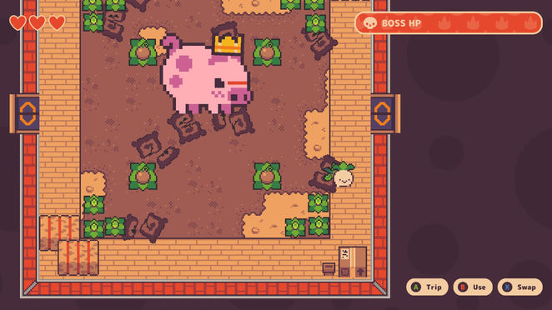

[Gameplay screenshots from Turnip Boy Commits Tax Evasion: (Left – Layer Lane, main land area that has secret pathways and NPCs to speak with) (Right – King Pig Boss Level, the first boss level that you encounter)]

**Aspects of the game**

* Inspirations
  + Art style
  + Cut scenes
  + Open world sections
  + Interactions with NPCs and bosses
  + Ability to customise playable character
* Restrictions and points to avoid
  + Top down view point
  + No platforming elements
  + Mainly focused on storyline and puzzles
  + All unique puzzles and sections

**Legend of Zelda: Breath of the Wild**

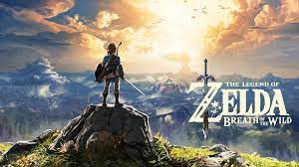Legend of Zelda is a series of action-adventure roleplaying games, with Breath of the Wild being the most recent release to date. Most of the LoZ games have a similar aim and storyline that change slightly. Breath of the Wild seems to have broken this mould and is a whole different entity to previous generations. The mechanics and options to the player have really changed and brought new life to the game. Previous versions were heavily story based and the mechanics reflected that as once specific items were gained they would stay with the player and would only be changed if a more specialised item was needed or an upgraded item is used. Breath of Wild mechanics are built for the game, as the developers want players to explore and interact with the environment. Items are made more temporary, and can be made from items scattered all over or collected from defeating enemies. Breath of the Wild is less so a game I want to replicate but instead one I will to take inspiration from how I was created to fit a particular style of gameplay. An open world adventure game would be near impossible for me to make but I want to create the same experience but for platforming/ run-and-gun game.

Breath of the Wild is an adventure-action game released in March 2017 designed by Eiji Aonuma and developed by Nintendo. BotW is only available on the Nintendo Switch and Wii U. The premise of the game is that the Kingdom of Hyrule is in danger from Calamity Ganon and Link (the player) must defeat him to restore peace. Throughout the gameplay, you meet past protectors of Hyrule and learn new techniques and mechanics that will later aid you in defeating Ganon, and you defeat smaller villains that you can gain loot and special items that can be combine and used for food (which can restore hearts), armour/ clothing (can be used for extra protection) or weapon (some of which that will have special abilities or moves. All weapons and armour can be mixed and matched to tailor the stats needed to defeat enemies. The game is open world, so while there are objectives that need to be completed, you are given all the time that you want (apart from some time sensitive sections) and could completely ignore the main storyline, which gives the player freedom to do what they want.

As said before, this game is very far outside what I wish to create and instead want take the feeling that the game has created and use that to better plan the mechanics and minigames so then the proper experience is provided. An open-world, story driven game is unachievable at this time, however the development is something to take inspiration from.

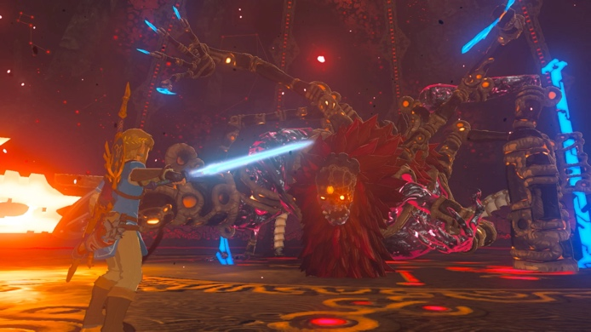 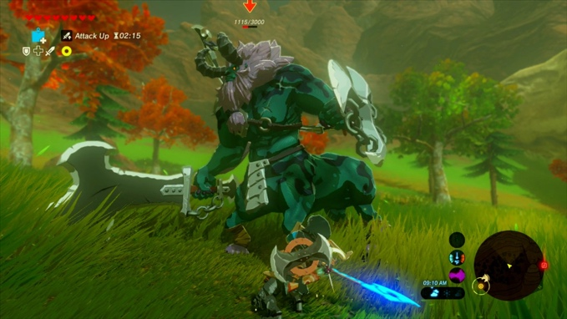

[Gameplay screenshots from Legend of Zelda: Breath of the Wild (Left – Link (the player) fighting the final Boss Calamity Ganon with the Master Sword) (Right – Link fighting lower level enemy) ]

**Aspects of the game**

* Inspirations
  + Integration with the mechanics and gameplay
  + Use of NPCs and enemies
  + Looting system
  + Ability to combine items and create weapons/ armour
* Restrictions and points to avoid
  + Large story-based elements
  + Open world adventure
  + 3D world

**League of Legends**

**Sources**

**COMPLETE**

**Sprites and Backgrounds**

**COMPLETE**

**Feedback**

**COMPLETE**

**Controls**

**COMPLETE**

# 1.4 Essential features

**Platforming features**

The game will at its core be a platforming game and will be the main focus despite any combat or ‘run and gun’ features. The player must be able to used different commands and combinations to complete levels. If I am able to use this to my advantage then I could provide bonus points/ prizes to plays that explore the map further and use the different platforming features to achieve this.

Players will have the option to use the arrow keys or the w, a, s, d keys to control the character. A mouse would not be needed as the third-person perspective would follow the player, however it might be need to selected options on the pause, main or shops menus, but this might be changed with using the numbers on keyboard since I plan for this to only be available for computers. This is will reduce the complexity of receiving inputs and make the process simpler.

Using inspiration from ‘Cuphead’ and ‘Rayman Legends’, I would like to vary the style and placement of the platforms, unlike ‘Super Mario Bros’ which has fairly similar mechanics from each level. If possible I would like to have the platforms integrated into the background much like ‘Night in the Woods’, to make the world seem more seamless, however this is not a necessity.

Key features:

* Various platforming areas
* Reward the player for exploring
* Combinations for player movement

Extra

* Integrate the platforms into the background

**Pause menu/ shop menu**

Pause menu - To break up game play, and allow for player to restart sections or levels. Hopefully this can also be used to provide a breather to player to reduce stress and stop high intensity moments from causing irritation. From personal experience, being able to pause the game in the middle of difficult sections made my experience more enjoyable and allowed for me to play for long periods more consistently. Without these features, I was more likely to not want to continue a game or forget about it altogether.

Shop menu – Can be used to give the players upgrades to more easily complete levels and might be needed later on as the level should increase in difficulty the further along you go. Coins/ rewards can be received through defeating the small enemies and specific upgrades could be dropped by larger/ more difficult enemies. Items of the same type (such as speed related or helmet related) cannot be used in the same instance, which will reduce the chance to over-powered buffs. The shop menu will double as the character customisation menu, where players can decide which boosters/ special items that they would like to use at any time.

**Enemy Ai based on difficulty level**

As mentioned before I would like to use some Ai to control the enemies to make them more complex and add difficulty. This will also make the NPCs feel more alive as they would react to the player and their attacks.

The AI would be basic and would rely on the collides features of unity, as will most of the features of the game. The enemies of each level will be divided into three different types that are all similar in terms of attack style, however will increase in difficulty depending on the type. Here is an outline for each enemy(Every level will have the same type of feature however the stats will change, such as increased health):

* Easy
  + Little to no AI, and will give the smallest amount reward. The only damage the player will receive if they directly come in contact with said enemy. The enemy will only bounce back slightly when hit. These enemies will be similar to the ‘Goombas’ in ‘Super Mario Bros’, as they do not outright attack the player however, it can still deal damage.
* Medium
  + If the player is close by, the enemy will come attack the player without any regard to their health level. It will deliver a smaller amount of damage compared to the hard enemies. The enemy will stop following the player once the player is a reached a certain distance (outside the collider) as the player will be slightly faster than the enemies (especially so if they add a speed boost to their character). Players will receive a moderate reward for defeating this enemy.
* Hard
  + This will have the most complex AI of all the standard enemies as this enemy will attack the player when come into a specific radius, however it will constantly be checking it’s health status, and once it goes below its threshold, then the enemy will go to the nearest healing point and return to full health. In a later level, I may add a speed boost to when the enemy is escaping as this will make it more difficult to defeat them.
  + There will be multiple health checkpoints for the enemies to recharge. In order to go to the closest one, there will be square colliders that will go the midpoint between two health checkpoints, signalling as to what one to go to.
    - The higher the level the more health checkpoints there are.
  + Possibly could follow the player to different platforms.
  + Possibly could add a feature where the enemy will not retreat if the player is low on health (such as two more hits and the player will be dead)
  + Will provide the biggest reward, possibly some special items.

Some diagrams as to how the enemies interact with its surroundings:

**ADD DIAGRAM**

The enemies in general will be scattered all over the map, on different platforms or the main ground. Most enemies will stay on the area that they spawn on however, the hard enemies might chase you to different level (this is an extra point I would the implement however if time constrains effect this, then it will be cut out.)

The number of each type of enemy will depend on the difficulty of the level. More explained in the next section.

**More than one level**

I believe this will be much easier than expected as all the level will be a variation of one another, just increasing difficulty and layout. The only specific level that might be different is the first level, which might act as the tutorial and help players get used to the mechanics. If levels are uncompleted/ barely started, they will be scrapped in favour of polishing up a near-finished level. The goal is as follows:

* Must complete

There must at least be the first the level that is fully functional and have all three types of enemies. There must be multiple platforms and all character attacks and feature must be completed. The enemies ratio would be 60%;30%:10%. (Easy: Medium: Hard)

* Would like to complete

There will be three levels:

* + - Level 1 – Will now act as the tutorial level (small cut-scenes or messages will be displayed that guide the player through the game. Potentially, could demonstrate the actions of all enemies, how to defeat them and the different platforming techniques through an NPC. This will be in a section before and then the actual level will start. Enemy ratio (80%: 15%: 5%)
    - Level 2 – Standard level. Enemy ratio (50%: 30%: 20%)
    - Level 3– Add a new platforming or combat mechanic (such as wall climbing, double jump or attack style). Enemy ratio: (20%, 30%, 50%)
* Ambitious choice

There will be five levels:

* + - Level 1 – same as previous level 1 in ‘would like to complete’
      * Enemy ratio – 80%: 15%: 5%
    - Level 2 – A water level will be added with a different style of gameplay (such as being able to float around in the water), other mechanics will likely stay the same way.
      * Enemy ratio – 60% : 20%: 20%
    - Level 3 – same as previous level 2 in ‘would like to complete’
      * Enemy ratio – 50%:30%:20%
    - Level 4 – An extra level will be added with a bonus section that is above the normal platforms, can only be found through exploring.
      * Enemy ratio – 30% : 30%: 40%
    - Level 5 – same as previous level 3 in ‘would like to complete’
      * Enemy ration – 10%: 30%: 60%

**Ability to upgrade characters**

Throughout the game, players can add upgrades that can be bought using rewards from defeating enemies or from completing quests. I would like for this to either have a physical checkpoint at the beginning of the first level (however I believe this could be annoying and frustrate the players into not wanting to use this feature.) or have a menu window that players can bring up and the game will be paused until they have completed their action.

I hope I can create the game so the upgrade items are not absolutely needed and instead just provide a boost, helping the player in difficult sections or making the levels faster to complete. Although I cannot create a fully open-world game, I want to give more options to the players and have them make the decision for themselves if they want an easier or more difficult game.

**Interactions with the platforms and NPCs**

Scattered throughout the level, I want to add some NPCs to flesh out the world and interact with the player. All NPCs with fall into one of three characters:

* Enemies – These are the characters that you play against and can receive items form. Descriptions of their AI and movement have been previously explained.
* Simple NPCs – Interactions will be simple and only involve small talking points that will show up once the player runs pass the character. Might provide small hints and useful tips or tell the player about hidden benefits (extra rewards or power-ups). They will be stagnant and have one place on the map where they stay, they will not be an obstacle but instead a part of the background.
* Helping hands – Larger NPCs that have a more predominant role within the story and helping the player. These characters will provide key information about game objectives, mechanics and power-ups. They can be called using a specific key or button on the screen. They will be one of these characters:
  + Narrator – guides the character through the first level, teaching the controls and combat features. Will likely have some AI that will play once the player reaches a checkpoint or presses continue. Will have some comments and speech options.
  + Merchant – Encountered at either at a checkpoint or menu that can be opened during levels. This will be the sections where players can buy upgrades/boosts for their character and double as the section where the character can be customised (boost/upgrades can be removed or added).
  + Checkpoint – Points throughout the map where characters can respawn after dying or loading a save file. Might have some speech actions and small interactions, such as asking the player if they would like to save and creating a save file.

**Ability to save progress**

Trying to complete the game in one sitting would difficult and can become exhausting, therefore reducing the chance for the game to be replayed, so a save system must be implemented and accessible at different points. This will be at:

* Beginning of the game – Players will have the option to open a save file and continue from their previous progress from an older session. Like most games there will be three save files and will all start blank. If all save files have been used, they will have the option to delete one save file(they will be asked multiple times to confirm as to prevent mistakes).
* Checkpoints – These will be throughout the levels and will ask the player if they wish to save their progress. Their current stats (health, inventory, etc. ) will be saved and if they have a death or suddenly exit the game, the player will be spawned back to the last checkpoint they saved at.
* Deaths – Players will be sent back to their last save point. If the player has never saved, then they will have to start the level all over again.
* Saving the game/ end of session – A menu will be available to exit the game and options to save will be there. If the player exits without saving, they will continue from their most recent save point.
* Automatic saves – The player’s progress will be saved every time they finish a level, and this will become their most recent saves, regardless if they actively save or not. This will be represented through an icon that will show up in the corner of the screen. There should be brief cutscenes in-between each level, so this should not happen while playing as this could change what is saved. Health will not be saved at the end of levels, as it is restored to full capacity.

**Replay levels/ Continue from checkpoints**

This is related to the save feature within the game. Since it could be frustrating to repeat whole levels because of one section, players will respawn at different checkpoints that they save at. This will reduce any repetitive sections, increasing engagement.

Also, once players have completed levels, they can have the option to replay levels. Either to:

* Improve previous attempts – Time and character stats will be shown to the player after every level completed, so I if they wish to improve these, the option is there.
* To change rewards/ game currency – All previous inventory and in game currency will be saved from any levels or playthroughs. Some items will be randomised so this gives players another chance to collect these rewards. However, any loses will also be saved, so this is at the players own risk (Players will be reminded beforehand).
* For enjoyment – If player preferred a particular level, rather than needing to play the whole game again, they will be able to replay any level that has been completed. Potentially, if the whole game is completed, then a free play version will be available and players can choose any of the levels, regards of completion, however they will be no save features.

**One boss level**

At the end of level 3 or level 5 (depending on the number of levels completed), there would be one bonus level added onto the end of the regular platforming section. These levels will focus on different style of platforming and combat. There would be different waves of the combat and platforms, normally changing after reducing the health of the boss to a particular threshold. The same controls will be used however the overall play style will be slightly different.

1. 5 Limitations

**Related to time constraints**

As stated before, time constrains will affect the number of features added into the game. There are essential features that will be around for all initiations of the game, regards of the time, as this need to still be a fun, playable experience. Most of these extra features come in the form of more levels and combat systems, so if they are not completed to a high enough standard, they can be removed and still not affect the overall gameplay to a certain degree.

**Multiplayer**

Attempting to coordinate the game through multiple players or devices seem to be a daunting task to complete, and very much outside of my knowledge on how to implement that. Not only do I think that this will be difficult and time-consuming, but I personally do not enjoy most multiplayer games, unless they are online. With the exception of a few games, it can lead to the screen being overcrowded and difficult to navigate (especially within 2D games), decreasing the overall user experience and making the game less desirable to play.

There is a solution to fix this such as, playing through spilt screen or isolating character to make them more readable. And there are many benefits to having multiplayer (creating more of a community, more interaction with other players or creating a more immersive experience), however these solutions tend to create further issues down the line, making the best decision to avoid multiplayer all together.

**Open world exploration**

I believe that an open world exploration feature would be great for story-telling or creating more interest and choices for the player. However, in order to create a world that is enjoyable and doesn’t take you out of the experience, more time would need to dedicated to designing the overall world and character, fleshing them out until everything fits. Games that have had team of specialised people have had to complete this task and have previously failed, so this is definitely outside of my skill set and amount of time I have to dedicate to the game. Smaller story-telling elements seem achievable and would be closer to what I want to implement.

**Storyline and creative elements**

This point ties into my previous point about open world exploration, creating a complex story or completely new assets for this game would be an extremely large project within itself and I do not believe I have the proper knowledge to pull that off or complete it to a standard that would be good enough.

Until all the features have been properly implemented and everything is playable and has been tested, all assets will be placeholders and the storyline will be basic. Anytime that is leftover will be dedicated to replacing the placeholders and adding cut scenes to better explain the story. Cut scenes will be skippable for the players who want to focus on game play as that should be the focus.

**Complex combat (such as combinations)**

Being able to focus on several different combat styles and method is something that I believe is key of making a game more diverse and enjoyable across large groups of people. However, that does mean that certain features need to be removed in order to make that happen. While combinations that happen accidently will be allowed and up to the player to use, deliberately connecting combat moves together will not be implemented. Trying to attempt this might lead to difficult/ redundant combat or coding conflicts that lead to larger bugs or issues. Processing all of that might lead to the game crashing and losing data, which will lead to progress lost and frustrated players. I am currently unsure how to implement these features in an efficient way that reduce the chance of this happening.

I will most likely add a cool down period to each move, reducing the chance of players brute forcing their way through the levels, but still making the moves not a one-time use or limited feature.

**Availability on multiple platforms**

This particular limitation is many due to me not being able to properly test my game through its many versions on multiple devices. In order to provide a similar experience on different devices, several sections many need to be changed (such as screen specs/ratios or button inputs). I understand that these things can be coded in the game with a few lines of code, however creating a similar experience over multiple takes subtle changes and tweaks that might be too time consuming and might not perform as well as expected. Therefore, focusing on the experience for the computer/PC users is more ideal as I can properly test everything and makes sure everything works.

Another feature that would be difficult to take into account is the specs and features that other computers/consoles have. If the game became impossible to run on a specific device due to a limitation of the system, this will cause for further testing and changes to be made, which might not be possible. Limiting the range of devices decreases the chance for bugs or errors that are due to incompatibility.

# 1.6 Requirements

## 1.6.1 System requirements

**Features of my game:**

Here the key features of my game. Any extra features that will be labelled as ‘**ambitious**’.

**Related to the playable character**

* Character controller – most likely will be a basic controller that works with either the w, a, s and d keys or the arrow keys. This will allow for a range of movement thought out the levels and the ability to use other keys for power up or menu options. There would also be a window corresponding the keys with the different actions possible.
* Option to choose between 3 characters (different playing styles)– There will be a cutscene or option that will be at the very beginning of the game to choose between three different characters. The options will be fairly vague and decide the playing style for the character. Each character will have a set of special moves and the base stats will be different (e.g., the defence hero has an increased amount of health or the attack hero does more damage etc. )
* Dynamic health system – Players will have a health bar that can be clearly seen in the corner of the screen that can be refilled through entering certain checkpoint or using particular power up. Other some characters will have dynamic health bar however, it will not be made visible to reduce overcrowding and make the game more readable.
* Interactive with platforms and enemies **–** There would be different affects depending on the enemy/ platform. I want to make the player able to interact with the world through the character , so varying the interactions depending on the object would achieve this.
* Interactive with supporting characters and objects– This feature ties in the previous point, however these interactions are mainly to provide hints or hide user menus in a more organic way, rather than adding them randomly and making them seem out of place.
* Healing **–** This will be available through checkpoints or power ups.
* Customisation through boosters **-** This will be available through the shop window and items will not be stackable. Instead, there will be an option to equip or not equip ( this will hopefully reduce coding conflicts), as well as, items of the same type cannot be equipped together, making sure the limits of the game are maintained. To implement this, there will be a method that hold the base stats and any add-ons will be added and removed from that.
* Ability to cause damage – This will towards all types and enemies and potentially some platforming sections that are temporary and breakdown as the player uses them.

**Related to combat**

* Standard weapon for player (available at all times) – this be in the form of some kind of gun or simple low level attack that can be used at all times. There will be no cooldown period for this weapon and player could potentially use them all of the time (this will take longer and be more difficult).
* Three special moves for every character – As each character is meant to have a slightly different play style, the special move should reflect that and differ for each hero. Each set will be similar and follow the idea of high risk= high reward or the greater amount of damage = longer cool down. These special moves will be the same throughout the whole game and will not be changed depending on the level.
* Enemies able to attack player – Each enemy will give a particular amount of damage, changing depending on the difficultly and level.
* Defensive moves are able to decrease damage taken – This will only be useable within a certain time range and radius of the attack, and the further and sooner a defensive move is used, the better. Very few would be able to block away 100% of damage received, especially within short period of time or distance.
* Varying levels of damage, dependent on the attack – this could vary based to the enemy faced or the platform on. This could deter player from performing risky acts and instead follow a safer route.
* Disadvantages to special moves (risk vs rewards) – Special moves will have a cooldown period (visible through icons on screen, created through UI elements) and some might have charging sections so they cannot be used immediately (this is to reduce accidents and make players think about their decisions.

**Related to the levels/ platforms**

* Multiple levels of height and various options – as the map will be the same every time, each level will be built within one section and the camera just follows the character around. Enemies will not be triggered until within a certain radius of the player, preventing the chance of them being within the same area. This can also allow for smaller areas for bonus rewards and secret levels.
* Different objects can act as platforms – Enemies will act a solid road block and can be used as extra platforms, however a small amount of damage will be taken in return. Most platforms will just act as environment and have no effect on the player. The height of the object does not matter as well, as any fall will receive no damage.
* **Ambitious :** Stagnant and dynamic platforms – I would like to implement some platforms that move within a certain range that the player can use to reach particular bonus sections. This will be unlike the enemies as the players will not receive any damage when using these platforms. This will be done to a few objects as not to create a disorienting mess.

**Related to the enemies**

* Three varieties of enemies – Each set of enemies will be a part of one of three groups: easy, medium or hard. Each variety can cause damage to the player, however their movement and AI is what is going to set them apart from each other. Visually, all enemies of the same type will look the same, to make them easier to differentiate and avoid within the game. Easy enemies will stay in one place and only damage you if you run into them. Medium enemies will walk around aimlessly and push you around, however there will be no projectiles that can hit you. Hard enemies will follow the character around once they have detected and run away once their health is low enough, unless the player’s health is low as well. Hard enemies will also be able to shoot a small amount of projectiles to cause damage.
* Variety of rewards available (Greater value = more difficult enemy defeated) – when enemies have been defeated, a small selection of items has the possibility of being dropped. These will be items such as temporary healings potions or speed boost or more currency to purchase more items from the merchant window.
* Different number of each enemy depending on the level – as the levels progress , there will be a larger number of enemies as the players get used to the controls and game mechanics. Not only will there a larger number, but a higher percentage of the more difficult enemies. (More detail about enemies within 1.4 Essential features.)
* Attacks can be made by the enemy – Most enemies will not try and actively try to damage the player and instead act as obstacles that cause damage. However difficult enemies will shoot a small number of projectiles fairly infrequently to change up the enemies actions.
* Enemies are able to retreat – this only applies the hard enemies, as there will be a script that allows them or run away if they are below a certain threshold. However, if the player’s health is also low the enemy will stay to try and finish you off. There will be healing checkpoints for the enemies on two sides of the map, the so play could still kill the enemies when they are retreating.

**Related to supporting characters**

* Merchant
  + Window with upgrades/ customise playable character – with the window used to purchase item, there would be a small section that allows of the player to customise their character with any items they’ve purchased or received. Items of the same type can only be used one at a time to avoid maxing out any variables by accident.
  + Assessable outside of the level – there will be a dedicate key for the merchant, as too many buttons or information on screen might leave little room for the player to see what they are doing.
  + Available within the level
    - Physical check point -Objects at the beginning of every level, prompting the player to check it out.
    - Button – dedicated key on the keyboard
* Narrator
  + Shown in cut scene – this be used as the tutorial level and just guide the players through the basics of the games (small NPCs will be added throughout to provide extra tips). The narrator will not be able to the interact with the surroundings and instead the player will be temporarily frozen in place and a pre-determined action will carry out. The player will be able to perform these actions too, however not at the same time as the narrator.
  + Does not interact with surroundings/ characters – as meant before, the narrator will become a static character and only interact with the player through cutscenes or a short number of lines.

**Related to supporting features**

* Health bar checkpoints – To make the levels more manageable, several healing checkpoints will be scattered around the map. Players will just need to run into them to activate (colliders will be used to achieve this.), however they will not be an obstacle to use as a platform. They will have an unlimited access (expect for some of the later harder levels, then a couple will only be temporary or take time to charge up.)
* Starting and ending checkpoints – this could be used for player feedback, as a timer can be added to when the starting and ending checkpoints are interacted with. These checkpoints will just be a part of the background and the players should not be able to detect it being there. These stats can then be used for achievements or player feedback.
* Auto-save – Beyond particular sections of the level, the players current data will be stored and used to re-enter the game at a later point either from prematurely exiting the game or a death. This could be indicted through a small sound effect or small icon in the corner of the screen. This will happen through checkpoints and will run the background, so when players are unable or forgot to save, there is not too game data lost.
* Save files – There would be an option of three save files, where player’s game data will be stored and loaded when selected. Once each game file has been used, the player must delete one of the files to restart. Game data files cannot be achieved and reloaded at a different time and every device will have its own save files.
* Respawning within the game – Once a character dies or reloads the game, there will be an option to restart the level (meaning all previous stats and items will be loaded as well and any progress made will be rewritten over) or restart from their last saved checkpoint (same rules apply here, just different game data will be loaded.). Reloading from a checkpoint reduces the chance of players needing to replay a level several times, only reach the same point every time, therefore not making that much progress. This can be changed or given a limit if shown to make the game too easy.

**Related to user experience**

* Personalisation – Players will be able to name their character and it will be used in speech options. Limits with character lengths and symbols will made to avoid names that ruin the UI elements of the game.
* Change volume – Although player’s can change the volume on their device, I would like to give the option to adjust the volume of objects and potentially turn off sound. There would be an option to turn off sound effect and/or music.
* Game feedback and statistics – This will be shown to the player at the end of each level and as the game data will be stored somewhere, they will be able to look into any achievements or past stats from any of the levels. This will most likely come in some form of window or button available on the title screen.

## 1.6.2 Hardware requirements

**Hardware required to play the game:**

* **Keyboard –** Most player controls and buttons will be used thorough the keyboard and will be focused on the most universal keys (arrow keys, space bar, escape etc.) as to make the experience the most similar for all players.
* **PC/Laptop –** Will be used to run the game. A standard laptop or general computer should be able to run the program. Any specialised features on a computer will be mostly ignored, however may improve performance. The processing requirements of the game will be minimised as much as possible.
* **Monitor –** Used to display the game. A standard screen should work.
* **Audio output –** Used to hear background noise or sound effects. Speakers or headphones should work. These are not absolutely required, as sound effects and music can be turned off.
* **(Potentially) Mouse –** Although most gameplay will be centred around keyboard controls, some aspects will require a mouse (such as menu or help buttons.

## 1.6.3 Software requirements

**Software used for programming/development:**

* **Unity (version 2020.3.7f1) –** IDE support used to bring together all the game element
* **Visual Studio Code –** IDE used to develop coded sections.

**Software used for running the game:**

The game does not need additional software to run. I am able to create an executable game file that can be shared and the game can then be played. This only works for Mac or apple devices, as my version of unity does not allow for a window version to be created, however I do know that this is possible.

# 7 Success Criteria

**Key features and requirements needed for the game to be complete:**

* **Character controller –** There will be a standard character controller that allows the player to move around the map and interact with the surroundings. The standard w, a, s, d or arrow keys will used to control movement. Other keys will be used for the special moves.
* **Options to choose between heroes –** When starting the game, there will be an option to choose between three varieties of heroes. This cannot be changed later on in the game, unless a new game file is started.
* **Dynamic heath system –** Instead of using a hearts system, I want my enemies to attack in different amounts so the health system must reflect that. A hearts system might not work, so creating a health bar would be my best approach.
* **Interactions with the environment and enemies –** Using markers, I would like for the player to interact with their surrounding and the different enemies. For specific areas or checkpoints, there will be dedicated button on the keyboard to activate any text or actions.
* **Interactions between supporting characters and objects –** This will be done similarly to the enemies and environment, with dedicated buttons and checkpoints.
* **Healing system –** There will stations and special moves to provide healing to the player, however there will be a refresh time period that needs to take place before these actions can be used again. Potentially, this refresh time will increase as the levels increase.
* **Customisation to the heroes through add-ons –** Through a separated window (the game will be paused when on this window), the player will be able to add power boosts that they have either purchased or received. This will be things such as an attack speed boost, however any boost of the same type can only be added, in order to prevent player breaking the game and being able to get through the level too easily. An example being, players can only have a +3.2% attack boost or +10% attack boost, however a +3.2% attack boost and a +4.5% attack boost can be added together.
* **Ability to cause damage –** All three heroes will have a standard weapon that can always be used, however causes little damage to the enemies. More powerful moves will be available, but will have a cool down period( large risk vs large reward).
* **Standard weapon/attack available to the player (accessible at all times) –** As mentioned previously, a low level weapon will be added to each variety of hero that is always available.
* **Three special moves per variety of hero –** As the normal weapon will do little damage, there will be three special moves to the player (each with a cool down) that will be either defensive or aggressive and a mix of long range and short range, with will vary in amount depending on the hero chosen. The effectiveness of the move will increase, along with the cool-down time.
* **Enemies are able to attack the player –** All enemies will be able to cause damage to the player, however the medium enemy will constantly be walking around the map aimlessly, acting as a moving obstacle. Also, the hardest enemy will actively chase the player and have a fairly infrequent long range attack.
* **Defensive move that decreases the amount of damage taken –** There will be some defensive moves that can either decrease attacks or neutralise them completely.
* **Varying levels of damage, dependant on attack –** The player attack will increase depending on the move. As well as the enemies having a different amount of attack.
* **Disadvantage to special moves (risk vs reward) –** All special moves will have some kind of cool-down or charge-up period.
* **Multiple levels of height and various options to reach final destination –** There will be many platforms on the level and player will not receive damage if they fall from a height, allowing for maximum exploration.
* **Three varieties of enemy –** There will be three types of enemies : easy, medium and hard.
* **Variety of rewards available (greater value item = more difficult enemy) –** When an enemy or the players complete a level, rewards will be provided.
* **Different number of each enemy depending on the level –** Each level will have various number of easy, medium and hard enemies.
* **Enemies are able to retreat –** The hardest type of enemy will retreat to a heal station once their health has reached a particular threshold. Enemies will retreat to the closest health checkpoint.
* **Window with upgrades/customisable playable character**
  + **Accessible outside of the level –** Window will open before every level.
  + **Available within level**
    - **Physical checkpoint –** Characters can interact with a checkpoint at the beginning of every level.
    - **UI button/dedicated key on keyboard –** A button will be available to click on the screen at all times.
* **Cutscenes –** In between levels there will be a short moment where the players will show a short video that cannot be interacted with (other than a skip feature).
* **Tutorial –** This could either be through a small section within the first level that provides prompts to the player to get used to the mechanics/ controls.
* **Narrator does not interact with surroundings/characters/player** – The narrator will act as a guide to the players, however will not actually interact with the surrounding and just provide commentary to the players for the tutorial.
* **Health bar checkpoints –** There will be checkpoints throughout the level that will auto-save your place, so if you die or want to restart this section, the beginning will be this new checkpoint. The only data saved that will be saved is the particular checkpoints crossed, any items gained/lost will remain the same. Health and cooldowns will be restored to full capacity.
* **Starting and ending checkpoints –** These checkpoints will be used to record the amount of time it takes for the players to complete a level. Could be used to provide achievements/ challenges for different rewards. Other checkpoints could be placed around the map for that reason.
* **Auto-save –** The game will auto-save player progress at particular points to avoid lost game data due to incomplete saves or the game crashing.
* **Save files –** In order to save any progress made, there will be three save file available to the players to create. There will be both automatic saves and manual ones that the players need to do.
* **Respawning within the game**
  + **Checkpoint** – Once checkpoints have been crossed, they become the respawn point of the character. Most likely will be a passive save, therefore doesn’t require the players to actively save at these checkpoints.
  + **From the beginning of the level –** There will be an option to start from the beginning of the level.
* **Personalisation to the heroes**
  + **Name –** In order to differentiate different save files and add some personalisation to the characters, the players will be asked for their name. This option cannot be changed later on.
* **Change volume –** There will be options to adjust the sound of the game, as well as remove the sound or sound effects
* **Game feedback and statistics –** As mentioned before, players will receive some feedback and game statistics after completing the level.

**Section Two: Design**

**Max marks 15**

# 2.1 Top down design

**Aim of the game**

When starting a new game, player will have the option of three different objects/ options (this will most likely be through a series of buttons presented after the start up sequence has begun). This decision will then choose the particular character that they will play as. Players will then need to progress through all 5 platforming levels and reach the end. Players are able to die, however the current level would need to be repeated until they are able to finish without dying.

Levels can be completed without defeating any enemies, however they will sometimes act obstacles that prevent any further platforming to be done, or chase the players around, making it more difficult to complete the level. Players would also be unable to gain any in-game currency or items, which will be dropped by the enemies. This will limit any customisation that they can do to their character and will be stuck with the base stats and items.

In order to break down the different components of the levels (players, enemies, level layout, external features, etc.) I have broken down each section into more manageable pieces that are easier to implement. This way I am able to work on each section separately and test consistently, and later joining all the different features together. Although I am adding every feature, object and action separately, this will be especially important for the flow of the different levels and all key features that need to be added.

Each level will have a new game mechanic or feature that will be introduce at the beginning of the level, directed by the tutorial comments. Some of these features will be transferred over to future levels, however some features are specific to singular levels.

Enemies will be transferable over all levels (with there being 3 varieties of them). The visual of the enemy will, despite the speed and attack staying the same. The main difference will be that there will be different volumes of each variety for every level, with earlier levels having more easy enemies and very few hard enemies, and later levels having majority harder enemies. This can change if the game is not engaging enough, however I want the focus to be on the platforming element, not just the combat.

**Top down Designs**

**Starting the Game**

By breaking the level into the most basic parts and the different windows that will be available. This top down design is mainly focused on the four main options given to the player when they first open the game. This will be:

* Play
* Options
* Controls
* Quit Game

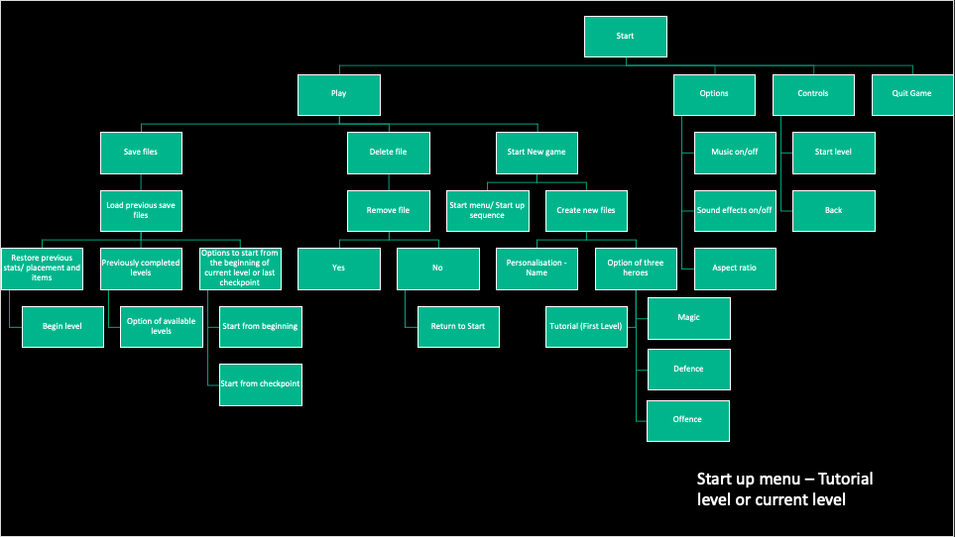It shows a mixture of feature that I’d like to include within each section as well as additional windows that will be connected to the current window.

**Entering a Level**

This next top down menu focuses on all the different options that the player has when playing or entering the level. It also focuses on the other events that could be happening to the player (e.g., being attacked by an enemy), as well what happens at the end.

Main different features are:

* HUD  
  Player
* Enemies
* NPCs
* Health checkpoints (enemy and player)
* Health checkpoint
* Ending

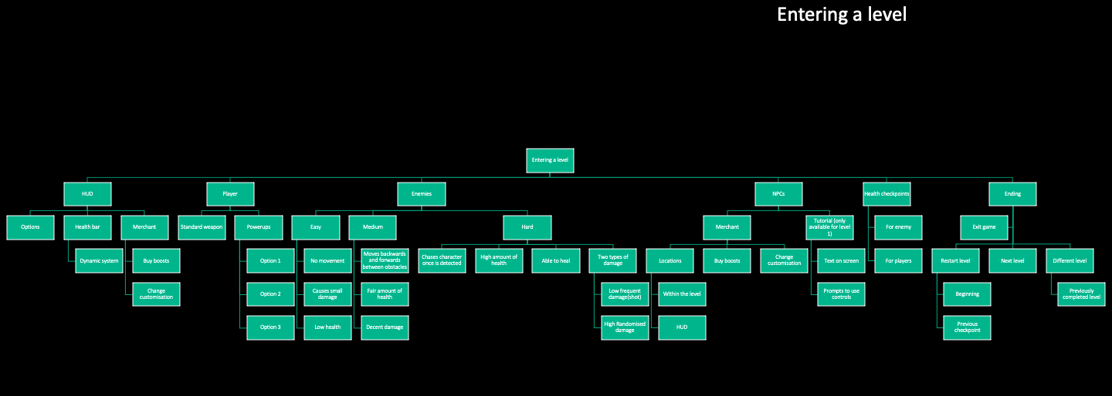

**Enemies**

Since the three varieties of enemies will be recycled throughout the levels, I wanted to make sure that they are all fairly different from each other, as well as interacting with the player in separate ways. This top down design focuses on the health for the enemy, the movement type, as well as the different types of attack that they may have.

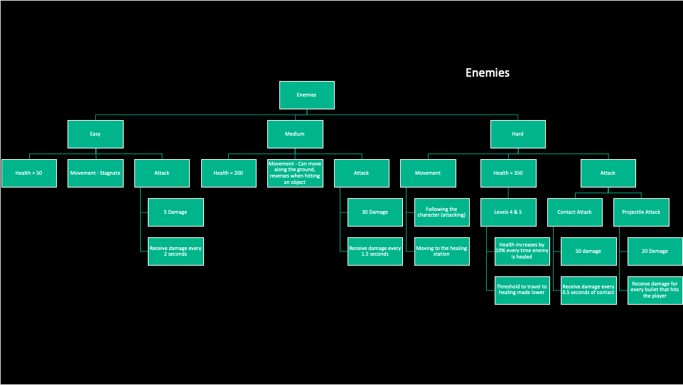

**Playable characters**

As there will be three choices of characters that the players can choose from, each needing a separate play style due to the particular stats. This top down design many focuses on the special moves (as well as a short description of what I want the move to do) that the player can choose from as well as the different stats (health, speed and attack). This would change the overall experience and could increase replay-ability, despite the layouts of the levels and enemies being the same. I have generally based each character on these three categories:

* Magic
* Defence
* Attack

This initial idea was meant to heavily change the different sprites and actions that I would, however I had an idea for a completely different theme, so the fantastical category is quite loosely based on what I currently planned for. Luckily, this was very early on, so it’s only really evident in some of the level concepts and character naming. So, the magic character doesn’t really have any magical features, however I struggle to describe them in any other way.

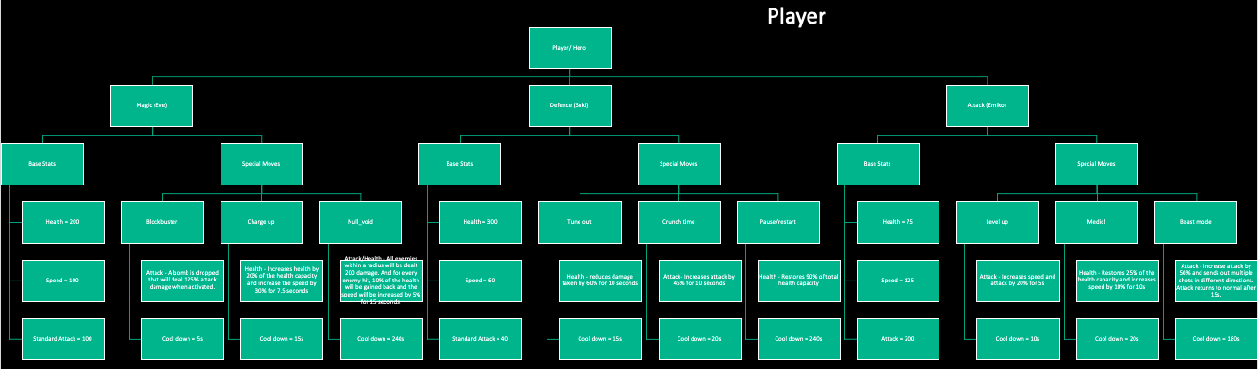

**Level 1-5**

Each level will be fairly similar to one another as the enemies will be recycled throughout all of them, however I would like to keep a separate theme and new feature for each one. Sometimes this will involve a section of the level that will be unique or that needs to be completed before the real level beginnings. I am unsure if I would like to add a separate tutorial section for these new features or instead just a prompt for the first couple of features.

Regardless of this, this is top-down design just goes through any key features that this level may have as well as the general theme. The enemy ratio (easy: medium: hard) is also mentioned.

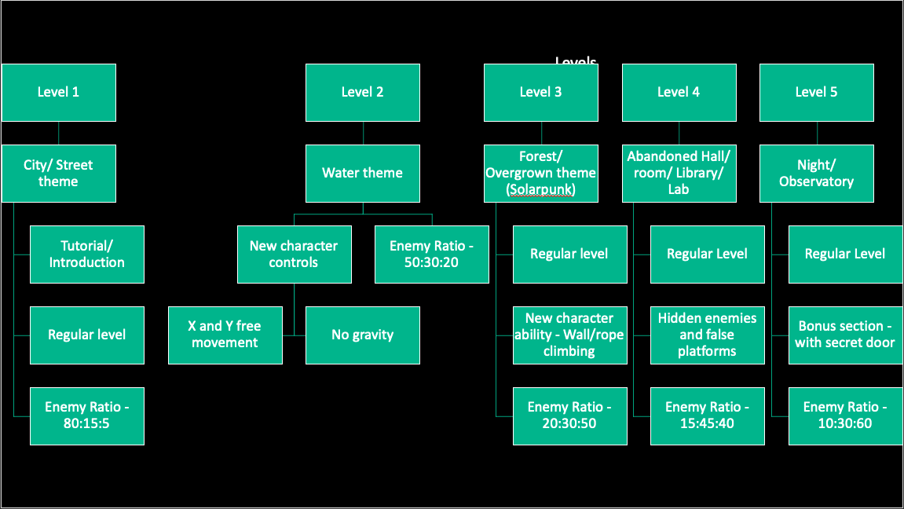

**Available upgrades (merchant upgrades)**

Due to two of the playable characters being fairly unbalanced, I wanted to have the option of trying to boost the stats, however any of these items cannot be used in combination if they are the same type, as this could lead to exploits later on and make the levels too easy or break the game. So only one item can affect the speed, health or attack, and if player try to, the other similar items would be disabled. The items can also just be generally disabled if the player no longer wants to use them.

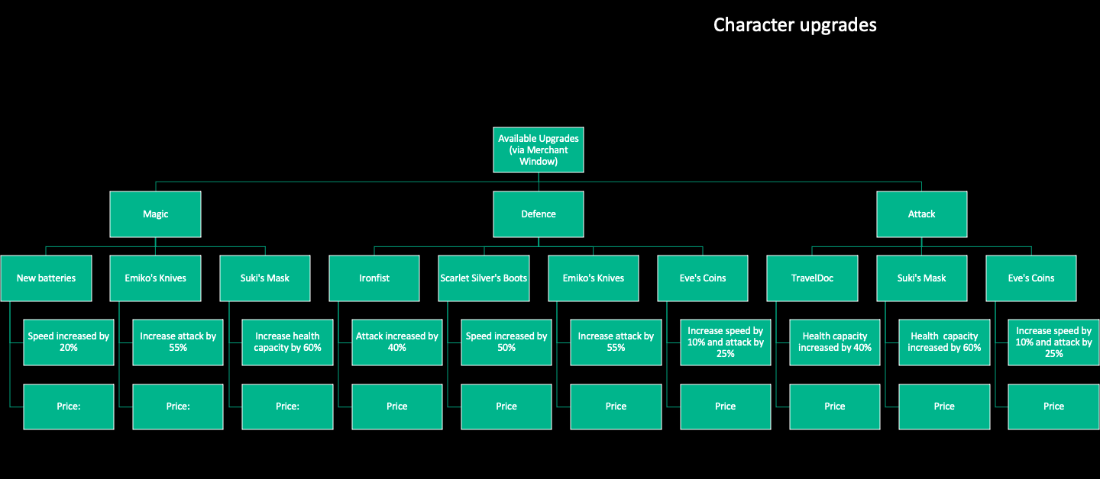The merchants window will be different based on the character that you choose to play as so this top down menu reflects that, as each character has different weaknesses. This only focuses on the character specific items that are available, however any enemy drops can also be bought on this menu and it will be the same for all three characters.

**General items/ enemy drop rates**

When an enemy dies, there will be a selection of items that can be dropped and collected. The in-game currency will also be dropped (the amount depending on a probability) which can then be used to buy items in the merchant window. Unlike the character upgrades, these items will be controlled using the numbered keys and can be stockpiled, and will normally be some kind of projectile, attack or temporary speed/attack boost. The prices for these will be much cheaper than the character upgrades, however players will only have a finite number of times to use it, whereas the character upgrades work until they are disabled.

These items will be available through the enemy drops as well as they can be bought in the merchants shop.

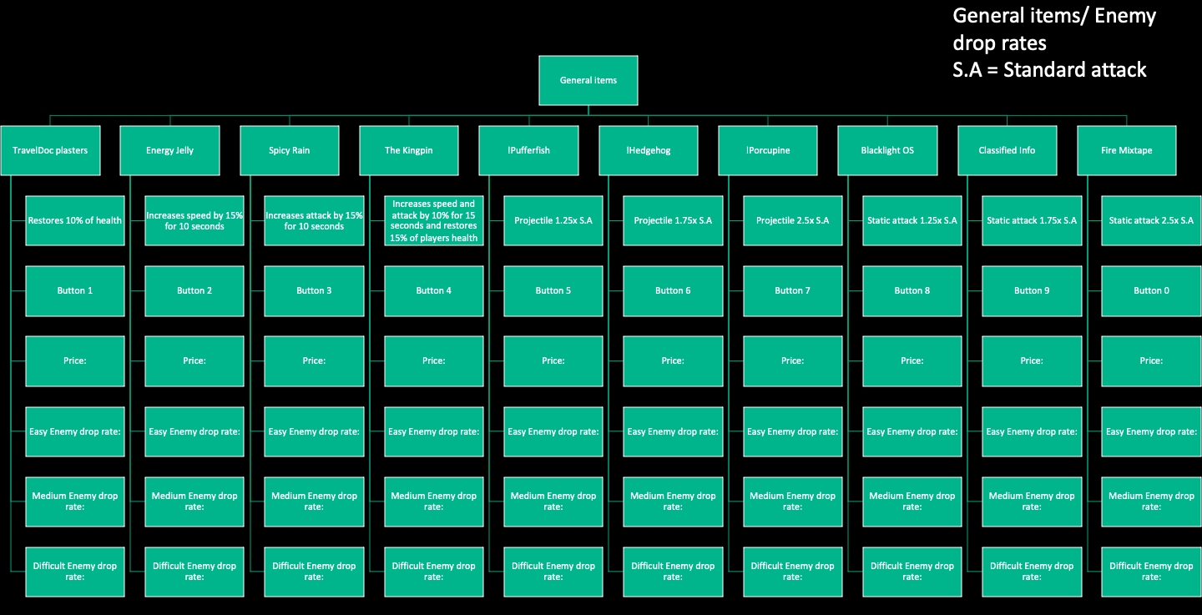This top down design focuses on the items available to be dropped by every enemy, the drop rates of these items and a short description of what they will do.

# 2.2 Detailed breakdown of each part of the system

**Overview**

When players are introduced to the world and follow the adventure of either Eve, Suki or Emiko working to find out more about the disappearances within their community and introduction of these replacements called the “**Watchers**”. They also cannot shake the feeling of being constantly watched and work to destroy anything that gets in the way of finding answers. They will progress through each level, travelling through new terrains, trying to find new people to tell them more information and learning more along the way.

Within the levels, players have the option of interacting with NPCs that tell them more about the situation and how they are affected. This aspect will be more so about creating a more fleshed out world, rather than surrounding any external tasks, however small rewards will be given to help them on their journey.

Players will need to get through every level attempting to avoid death and exploring their surroundings, potentially gaining upgrades to help them through future levels, as the difficulty increases. New skills will need to be learned for every level, and will be needed to be used in order to reach the end. Player do not need to collect anything, they just need to reach the checkpoint, it is their option if they would like to fight or interact with anything, allowing for different play styles.

The game will not be changed in any way based on their initial decisions, allowing for the game to be replay able, and different methods to be used for every play through. This can also make it easier for beginners to progress as they can generally anticipate any obstacles that may arise, especially if they chose a more vulnerable character.

**Title Screen**

When opening the game, the players would be given four options of that they could do. There are later windows that will be opened for some of them, while some of them just circle back to the main window or exit the game. These four options are:

* Play – Players will then be given two options to either:
  + Open a save file
    - They are also given the option to delete a previous save file that can then be used to start a new game (player are only able to have up to three save files.
    - If a save file has to no game data, then the start-up sequence for a new game is started.
  + Start a new game – self explanatory
* Options – This allows players to set their game preferences, however there will always be a default for each one of these settings. Players are able to change:
  + Music
    - On/Off - Toggle
    - Volume – If the music is on then a slider can be used
  + Sound effects
    - On/Off - Toggle
    - Volume – If the toggle is on then a slider can be used
  + Graphics quality
    - Low
    - Medium
    - High
  + Full Screen
    - On/Off – (Toggle)the standard aspect ratio will be 1920 x 1080
* Controls – There will be no interactable features on this window instead a photo will be here to indicate the different controls (however a tutorial section will be added to the game, so this will act as a reminder in case players forget). Players must have a keyboard and mouse to play, there will be no other controls available, unless I have extra time towards the end.
* Quit game – Players can exit the game

Here are some diagrams for how I would like for the menu to set out and any specific design or aesthetic features will be added later. I will create a vote for the most popular layout.

Layout diagrams:

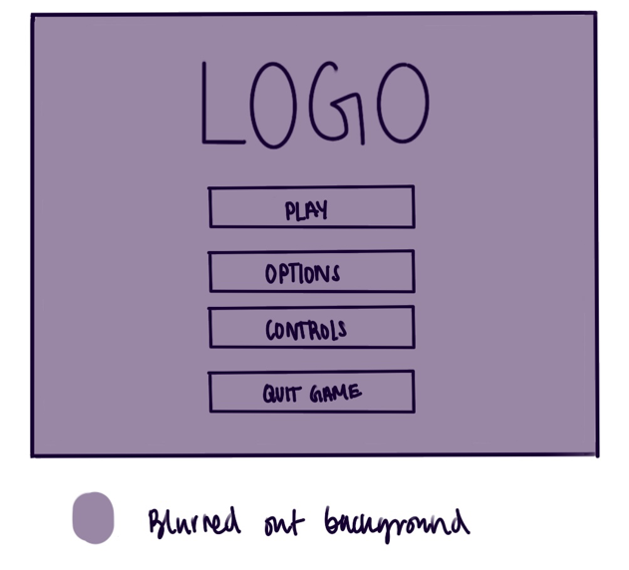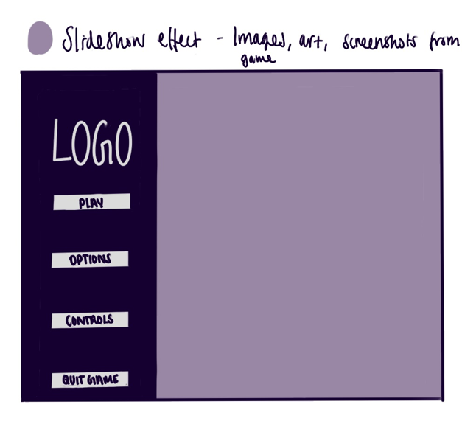Title screen option 1 Title screen option 2

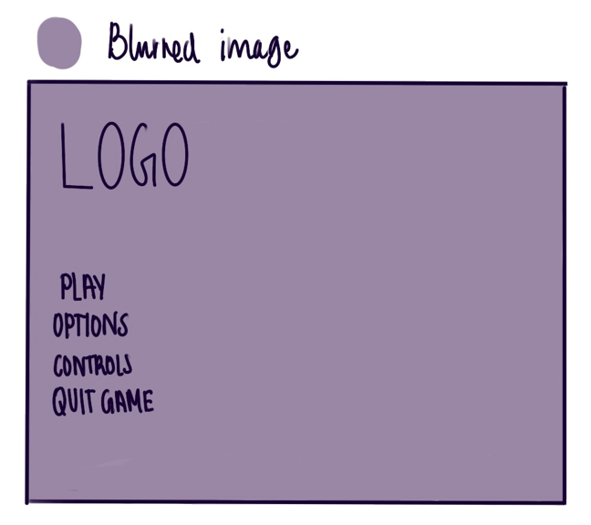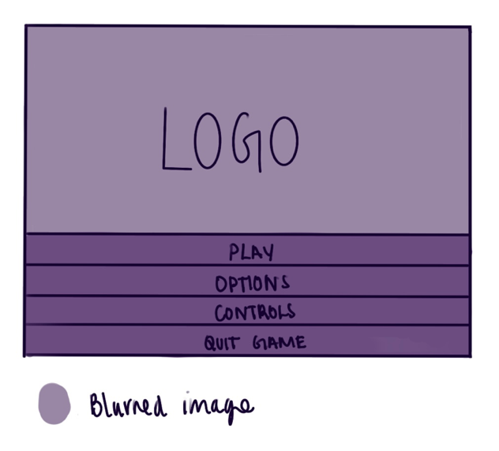Title screen option 3 Title screen option 4

And here are the final designs for the windows:

Title Screen



Controls

**Levels**

**Level 1**

For the first level, I wanted to try and introduce the players into the game and have a fairly easy level that they can explore and get used to the game mechanics. There will be a small section beforehand that is unlike the actual level and walks the players through each feature that they can use (walking, running, shooting etc), and once this section is finished, the real level will be loaded and the players can continue. Unless players are extremely reckless, they should be able to get through this level very easily. Everything will be refreshed once the players enter the new level so they are not left to a disadvantage when beginning.

The level will have a city theme and players will have the option of running along the rooves, streets and vehicles that are all around the level. I plan to add an outline or indicator to the players so they can distinguish a platform from an object in the background.

There will be a small underground section will be added and can be explored. There will be fewer enemies within this section (other than the ones that follow you down.) and is mainly focused on exploration and interactions with the NPCs. This can also be used as a cooldown area if players are feeling too overwhelmed by all the enemies.

The overall layout of the level will be designed like this:

There will a progression throughout the whole game that generally leads to the singular point where players complete the level. Later levels will have more options for dead-ends and needing to search around for the ending. Players will not take fall damage if they fall from a high point so there is a lot more freedom to walk around and explore.

The initial sketch/diagram for this level looks like this:

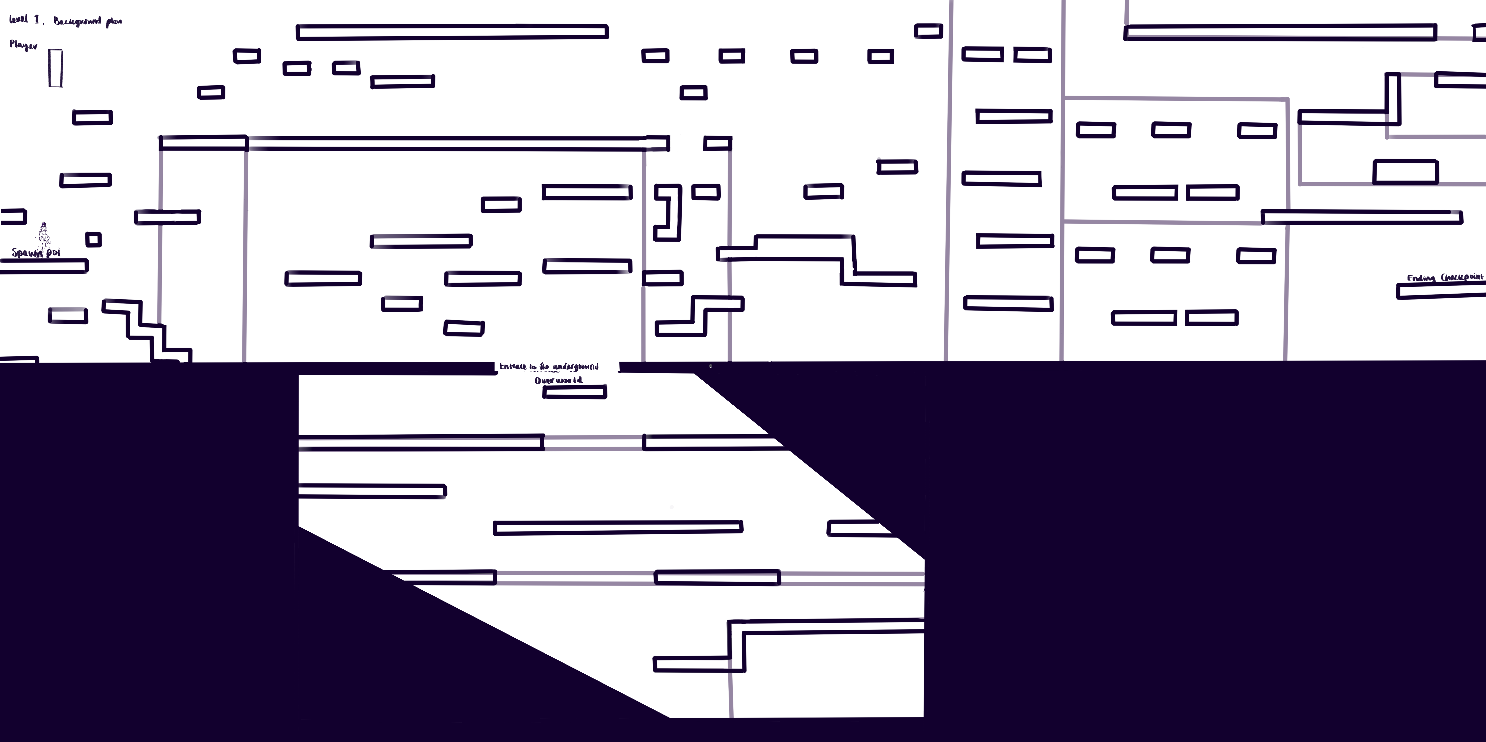The final product looks like this:

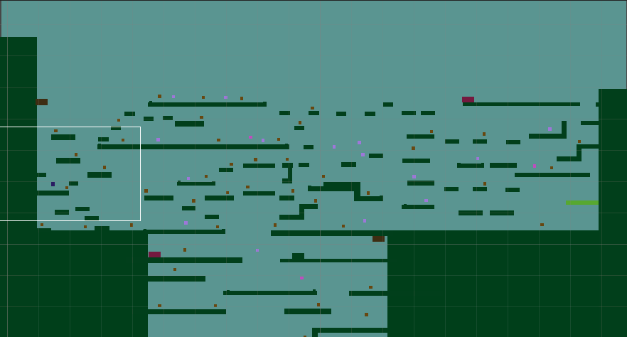I designed this level in procreate, using the layers feature to draw all the platforms, and then implementing them into the game by adding any appropriate script or colliders that allow for the other objects to interact with it correctly.

**Level 2**

For the second level, I want to go for a classic style of level and try to create a water level, however the game mechanics will only slightly differ to the regular level. Players will now be able move freely along the field on both the x and y axis, as there will be no gravity to bring them down. There will still obstacles in their way and some kinds of platforms, however these will no longer be needed to travel around the map. I plan to add this in by editing my code for the different characters so they move without using gravity, as well as the fire point would also need to be moved. Medium enemies will be able to move on a horizontal line along the x axis, whereas the players and the hard enemies can move in both x an y.

The theme of the level will be heavily based on areas such as the Great Barrier Reef and any large bodies of water that have extremely diverse amounts of wildlife and surroundings.

I also don’t plan to add any kind of timer that forces player towards ‘air checkpoints’ as the exploration and chill setting of the game would be removed and rush players to finish the level as soon as possible. Most water levels that I’ve seen or heard about are dreaded by players and just lead to stress and a race against the clock, and while I understand this can be enjoyed, I’m sure as how I can effectively implement this while maintaining this balance.

Enemies will now be places around the map in a more random arrangement and will not be focused to one area. They still should be visible to the player if they are close enough.

This level will be generally static and be on one plane that continues to go further, and there will be no sections that are above water (some kind of barrier would be added so players are unable to reach the surface.

**Level 3**

Level 3 will return back the regular character controller and continue as normal with an increase of the more difficult enemies. A new game mechanic will be added where players are able to climb up ropes and walls as a new form of movement. Some platforms will only be accessible through this method, however there will still be a path that is accessible through standard means, however it will be more difficult as you are unable to avoid any enemies and will take a longer time to complete. A combination of both would be best, and introduce more areas for exploration.

The general theme of this level is forest/ jungle and I plan to use inspiration from large forests and jungles such as the Amazon or Daintree forest. However, since the overarching theme is Cyberpunk, I wanted to add some kind of technology element, but not have it feel out of the place. When doing some research, I found this style called Solarpunk that is an almost opposite to Cyberpunk, where Solarpunk is an optimistic look to the future where the world has not been consumed by issues such as climate change or pollution, but society is still able to progress any created new technology. Cyberpunk is the idea of ‘high tech, lowlife’, so this level will create some kind of juxtaposition.

I will most likely implement the climbable sections through a switch case or if statement, where if the player is touching the object to be climbed then they will travel on the y axis, however this would need to tested to see what decision is.

Enemies will again be scattered around the level in a fairly random arrangement, with more of the easier enemies being on the higher levels.

With is level, I want the players to progress in this kind of hill shape, where they will start on a medium to high level, moving upwards until about ¾ of the way through the level, and then they would need to travel back downwards to the ending checkpoint. Players will not need to reach the peak of the level, however more rewards will be placed there for those who explore.

**Level 4**

When planning level 4, I was unsure of what feature I wanted to add to make it feel unique and not just feel like an iteration of a previous level, just with a different visual, but while thinking of the general theme I thought about horror and mystery games. Jump-scares and hidden rooms or sections where the main feature that I could think of and felt to be the best feature to add. The jump-scares would not be as extreme as some of the ones that you typically see, enemies will be able to come out of random walls and sections, so players need to beware of blindly entering any areas. I also gave some thought to adding some false walls or platforms that can trick the players into taking a different route. There will always be another way to get through, but just to catch the players off guard occasionally.

I would most likely implement the moving enemies by adding an extra trigger collider that is able to detect the players if they are within a certain radius. Enemies will then start their movement sequence and continue while the player is nearby. I potentially could do this for the medium and hard enemies but I see what works best during testing. Hidden rooms will also need some kind of trigger collider so then players can only see within certain sections, however this will be an extra feature if I have time to implement this.

The general theme of this level is meant to be an abandoned hall or laboratory, with experiments and hidden rooms all over the place. The NPCs in this level will be replaced by objects instead of people, as there would be no one there to interact with the player. I will most likely take inspiration from old science movies that make reference to some kind of hidden experience or mad scientist. I can also use reference to one of the playable characters to show some relation or just to act as decoration.

Enemies will be hidden in many corners of the level, so players will need to be careful of where they decide to go.

As mentioned there will be some hidden rooms, so the general level will just be fairly linear, but player can go into the hidden sections and this can act as some variety within the level. On the surface, the level will be fairly basic but through exploration, there will be more to uncover.

**Level 5**

For this level I plan to add in most of the special features from all the previous levels and combine them to the final level, almost to see what all the players have learned from all the time spent playing. The only feature that I will most likely not use is the swimming feature from level 2, it just seems a little unnecessary and possible could be a little out of place. However, wall/rope climbing and hidden platforms as well as hidden enemies will be all over this map. Players will need to be extra careful when navigating this level as there will be a lot more opportunities for them to be hurt, especially if they choose to play as a character will a low health stat and choose not to get any of the upgrades.

I would also like to add a secret room/ layer that players can explore and reach the boss level. This section can be completely avoided, but if player want the full experience and want the real ending, then they must defeat the boss. I plan to add this in a way that players have an option of two places where the checkpoint could be, with one location leading to the boss section and another that leads to the end of the level, however instead of the player immediately completing the level once reaching the level, they will be asked if they would like to continue exploring, allowing them to potentially find the true ending and final section.

The general theme of this level, will most likely be a continuation of the previous abandoned laboratory but instead this side is mainly an observatory focusing on space, whereas before its mainly focused living creatures within this world.

This level will mostly be made up of the harder enemies, and I think adding clusters of them together could add for a more difficult experience. These groups would be fairly far apart but would be made up of around 2-3 enemies. The same types of enemies would be put together.

Since this level will be similar to the previous level, the general space would be fairly linear, breaking off into hidden rooms around the map. Again, player will be rewarded with more information and action the more they chose to explore.

**Boss Level**

As mentioned before, this will lead on from Level 5, and will act as a singular room, instead of complete level. There will still be some platforming elements as this is the method to avoid be killed. The platforms will be more sparse and strangely shaped, where all the skill previously learnt must be used.

The boss will have a large hitbox, and the objective is to reduce it’s health until it dies. Several attacks will be sent out on a cycle, some being melee or projectile attacks. The boss can be hit at all times, however colliding with the boss will instantly kill the player. Players will be unable to leave the room once the boss has been started, and can only progress once the boss has been defeated. After being defeated, the ending scene will be run and the player will be congratulated on their success. Any achievements will be shown and the player will be thanked for playing.

Any enemies that follow the player through will be instantly dealt 1500 damage, removing them from the game. No other enemies will be present in this room. And once the player has started this section, they cannot go back unless they restart the level.

As for a theme, it will just be a continuation of Level 5, however with motifs of the main boss around the room.

**HUD**

As to not distract the player away from the main action of the game and lead to a claustrophobic experience, which can lead to disorientation and an overall bad experience. The only features of the screen will be:

* Health bar - this will be a small bar on the bottom left of the screen
* Special moves availability - each player has three of these, and will be placed in the bottom left with the health bar
* Extra items menu – there will be around 10 slots for these, however all icons will be made very simple and small, placed around the bottom of the screen.
* Merchant menu – this can be accessed through a small icon in top left corner, which will be small and simple.
* Pause menu – this will be similar to the merchant window

All these icons will be bright or at least have a slight background so they can be distinguished easier from the background. I may need to experiment with this for the best outcome.

Here is an initial sketch/ diagram of the HUD:

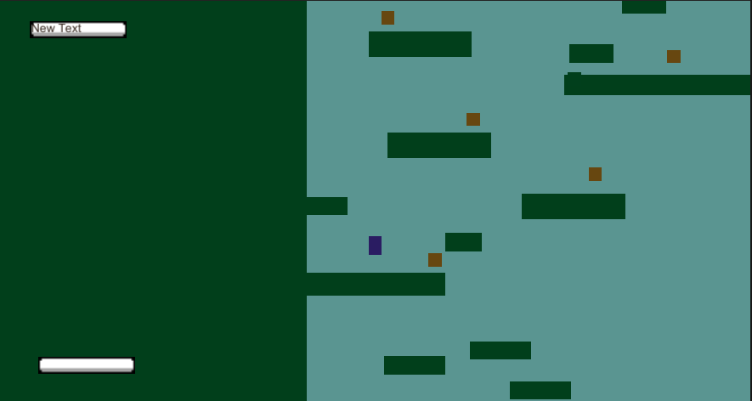**Playable Characters**

When starting a new game, player will have the option of three different characters. I like the idea of not explicitly telling the player which option relates to what player, so I’ve come up with two different ideas of how to do this:

* Option of three different objects – this will provide a more randomised experience and surprise for the player (however this would not the be the case for repeat players, as the same item will always reference the same character every time.) The stats and skills of the particular character will need to be learned and gotten used to.
* Option of easy, medium or hard – when planning out every character, I attempted to make them all balanced around different things, as well as some having more disadvantages than others. These choices have no effect on the enemies themselves, but the character chosen might be easier to play as. There will items implemented that allow for the player to upgrade their characters later on, which can lessen these disadvantages, but each would definitely provide a different play style. I am slightly reluctant to put this system in place as I am unsure of what the difficulty could truly be until proper testing has been done by myself and any play testers. Based on a few features, this is how I would categorise them:
  + Easy (Defence/ Suki) – Suki would probably by fit the best for beginners as it has the most health, and based off experience, health is one of the most difficult things to balance when playing. As well as this, they are fairly slow, allowing for platforming to be made easier and giving more time for decision making. The only major drawback would be that players would have a low amount of attack. This can be corrected through items, however any items must be bought and higher value items will be more expensive. Suki would also have most of her special moves dedicated to self-healing and small increases in speed or attack.
  + Medium (Magic/ Eve) – Eve is definitely the most well rounded of any of the three options. She has a decent amount of health (that should be easy enough to navigate with), is fairly fast and attacks enemies with quite a bit of damage. Players would still be more vulnerable to attacks than if they played with Suki, however I believe they should be good enough with the increased speed and attack.
  + Hard (Attack/ Emiko) – I believe that Emiko is the most difficult character to play as. Not only does she have a low health, her increased speed can lead to more mistakes when platforming, making the experience more difficult. More experienced player could find this style more enjoyable.

Each character will have a ratio of stats regardless of either option made beforehand. Character ratios are measured through attack : health: speed and should each add up to 400. While the health and attack are a one-to-one of their actual base stats, the speed ratio is just a percentage of the total value, (with 100% =3.4f, however this can be changed if testing proves this to be a poor choice). These base stats can also be modified if the character is too unbalanced and too difficult to use to the point where they’re unusable.

* + - Easy – 40:300:60
    - Medium – 100:200:100
    - Hard – 200:75:125

The three characters that players can choose from are:

**Eve (Magic)**

As mentioned before, Eve is the most well rounded of the three options, with most balanced stats. When initially planning this character, I was going to use a lot of magic moves that I had seen in other games, that I was going to try and replicate. However, since I ended up changing the overall style, these feature no longer fit and I instead went for most actions that were mainly projectile based.

I was also struggling how to fit a magic style character in a scenario that is based in a more realistic setting. But after deciding to use a Cyberpunk as the overall theme, I though making Eve a Cyborg or android would quite fitting and reduce the chance of her being out of place. The projectile based moves also fit quite well with the character as well.

Here is the design I ended up coming up with:

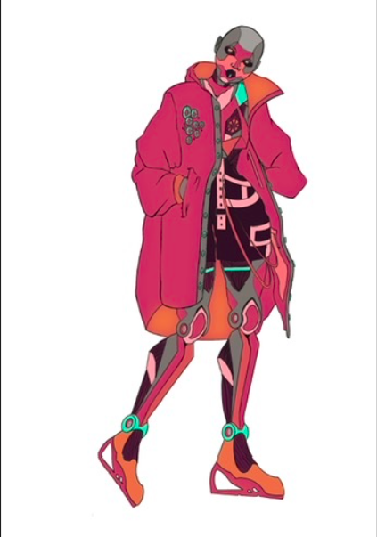

The three moves that players can use when playing as Eve:

* Blockbuster
  + Description – An object is left is the path of the player, which when collides with an enemy, it will deal 1.25x attack damage.
  + Cooldown – 5 seconds
* Charge up
  + Description – Heals players by 25% of their health capacity and increases the player’s speed by 30% for 7.5 seconds.
  + Cooldown – 15 seconds
* Null_void
  + Description – All enemies within a radius will be dealt 750 damage, and for every enemy hit, 10% of health will be replaced (this cannot go over the max health value.)
  + Cooldown – 240 seconds

Cooldowns can be edited later on if they are too difficult to use or can be easily exploited.

**Suki (Defence)**

Suki is probably my most unbalanced of the three options, with the health out weighing the speed and attack heavily. I wanted this character to be quite robust and able to withstand a bunch of attacks, similar to how I have seen tank characters in different games. Most of these characters are slow and have a low attack to prevent them from being easy to use, so I tried to do the same thing. This could be easier for beginners to use, especially since most of the special move are also based around self-healing.

I initially wanted this character to have some melee attacks, however when creating the enemies, I was unsure how to balance them out with the contact damage that enemies cause. I might revisit this idea at a later date if I think that the gameplay feels too static and needs mor variety.

This was the character that really brought the cyberpunk theme and made me rethink my choice of design. This design was not even meant to be for this character, however after some revisions, I think the overall look fits with the functions of this character, and a better design overall. In the first design, I think the only thing tying the design to the cyberpunk theme as the style of clothing, so with the second attempt I tried to add other types of technology, which ended up helping a lot.

Here is the final design that I ended up with:

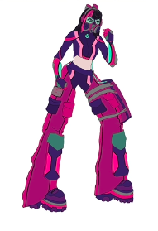

The three moves that players can use when playing as Suki:

* Tune out
  + Description – Health damage is reduced by 60% for 10 seconds
  + Cooldown – 15 seconds
* Crunch time
  + Description – Increased attack by 25% and increased speed by 45% for 10 seconds
  + Cooldown – 25 seconds
* Pause/Restart
  + Description – Health is restored by 90% of the total health capacity
  + Cooldown – 240 seconds

**Emiko (Attack)**

With the attack character, I wanted something that was fast and strong, so players who want to be a bit more reckless and fight with most of the enemies, this would be the best option for them. I deliberately made the health low to reflect this idea, as well as increasing the speed in such a way that could also affect platforming and combat. So those players who are more experienced with their skills can use a character that fits them better.

I was also planning to add melee actions for this character too, however Emiko takes damage way too easier, which can lead to an almost immediate game over, especially since only one special move is dedicated towards healing.

Emiko was designed last, so I had become more comfortable with the style I was trying to use for this game. I used lots of inspiration from virtual fashion and sportwear, mixed with references from other cyberpunk media as well as using spy gadget films. The overall execution was a pretty good representation what I want initially.

Here is the final design that I ended up with:

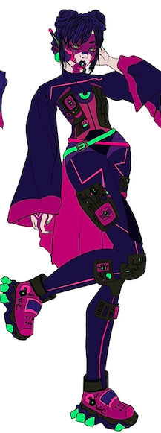

The three moves that players can use when playing as Emiko:

* Level up
  + Description – Increased speed and attack by 20% for 5 seconds
  + Cooldown – 10 seconds
* Medic!
  + Description – Health is restored by 25% of the capacity and the speed is increased for 5 seconds
  + Cooldown – 20 seconds
* Beast Mode
  + Description – Attack is increased by 50% and a series of fast projectiles are sent out in different directions are sent out. Attack is returned to normal after 10 seconds.
  + Cooldown – 180 seconds

**Enemies**

Throughout the five level, three types of enemies will be recycled and visually changed to fit their surroundings. To increase difficulty between the levels, different ratios of these character will be added, with all of these ratios have been stated beforehand.

I wanted each type of enemy to not only dealt differing amounts of damage depending on their difficulty, but I also want them to have a differing movement style, just to avoid them all acting to similarly.

**Easy**

This is the most basic enemy, and hardly an enemy at all, more so an inconvenience. They will be stagnant and not move or attack, instead only deal damage if ran into. This can allow characters to use them as another platforming element or easily kill them for some low level rewards.

These will be the simplest enemy to implement as they require no movement script and just a basic attack script.

Here are the different sprites for the easy enemies:

Level 1:



**Medium**

The medium enemy is similar to the easy enemy as any contact will result in damage. However, these enemies will be able to move around the map between any obstacles. They will be able to switch directions if they hit any object, otherwise they will continue in a straight line. Players count as an obstacle so players will need to be able to adapt as their standard weapons can only be used in one direction.

If think that the medium could provide a small amount of difficulty to level and keep players on their toes, but not too in their face and distracting from the rest of the challenges.

These enemies would provide a small reward to players and have a greater potential for better items (greater damage or healing).

Since the damage is the same as the easy enemy, I could probably reuse the same script and just change the amount of damage dealt. I would have to create movement script, but I could probably reuse sections of the player character movement script. If this does not work then I would need to do some more research.

Here are the different sprites for the medium enemies:

Level 1:



**Hard**

This is will be the main threat of all the levels and what player must avoid or fight within the levels. Not only will these enemies deal a higher amount of damage if player come contact, but these enemies will be actively hunting the player down, if they are detected within close enough range. Hard enemies will also be able to heal themselves once they have a low enough health.

These will most likely be the hardest enemies to implement since I would need to create a completely separate movement script that changes target based on some other factors, but a healing system needs to put in place for the enemies. No other enemies would be able to heal themselves, so this just makes these enemies even more difficult. I was also thinking to add a projectile attack alongside the contact damage that these enemies can do, however the damage of this attack would be fairly low compared to the contact attack.

The contact damage script could be reused from the other enemies, just with the damage increased, and the projectile attack can just be copied from the player’s standard attack, but instead of the projectile going off when a button is pressed, it will be on an automatic loop that shoots every period of time (e.g., every 0.5 seconds), however I would need to test this out to the find the best time that provide a challenge but allows players to get away if caught in the crossfire. I would probably need to add a trigger collider to detect the player.

Hard enemies will also need to change their speed based on the playable character chosen, as the speeds are so different. Trying to put it below the slowest hero would make the game too easy for the fastest character, so changing the speed would make the challenge fairly equal. The speed of the enemy would be around 85% of the player’s speed when starting the game.

Here is a diagram of the different components of the hard enemy:

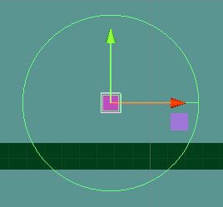

Here are the different sprites for the hard enemies:

Level 1:



**Healing stations**

Healing stations will be available to both the players and the hard enemies, however both healing stations will work slightly differently. Here is the difference:

* Player – In order to be healed, player will need to stand within the scope of the healing station and will be healed within 2.5 second increments (this can be changed) where 25 health is gained every increment, as there would be no singular place to interact with the healing station. This allows players to decide how much they would like to be healed, and if they would like to continue despite not being fully healed. These healing station will most likely use a trigger instead of a collider and then have a visual signal that indicts the range of the healing station (such as an aura).
* Enemy – This will be a lot more basic as if I used the same method as the player, the enemy will never reach beyond a certain threshold and would have more chances to be a bit broken and work incorrectly. Instead, there will be a physical location that the enemies go to, and collide with the object. Once hitting this object, they will be restored to full health.

There will most likely be clues all over the map all over the map to indicate the placement of any health stations, as well as the health stations themselves being fairly obvious. Players will also have alternative methods to healing themselves, either through their special moves or items that they have.

**Merchant window (items)**

Players will have the option to buy items that can lessen their weakness and help them complete any later levels. There will also be the option to buy smaller items that provide a small boost, a kind of projectile or item.

With the character upgrades, these will work continuously on the player until it is disabled and they cannot be used together if they effect the same feature (e.g., two items that effect the attack cannot be used together, however an item that effect speed and another effects health can be active together). These character upgrades can only be bought once, and they will be fairly high in price.

Whereas the smaller items, these can be bought multiple items and have no limits, so long that you can actually pay for them, (an in-game currency will be added), but player will only have a finite number of times they can use them. Once they have run out, they will need to be bought again or received by defeating an enemy, but these items will fairly inexpensive, and easy to buy, but if players want the character upgrades instead, they will need to save their money, so they will unable to constantly buy the smaller items.

Character upgrades will different based on the playable character that you choose since they all have different weaknesses, and certain items might greatly unbalance the character. Some items are the same, but there will be at least one that is unique to a single character.

All character upgrades effect the base stats of the player and not the current stats the player has, this is to avoid any overpowered character, or any issues that could be cause. Players will gain small boosts after completing each level for each of their stats.

Here are the items available for each character:

Eve

* New batteries
  + Increases speed by 20%
  + Price: 4500
* Emiko’s knives
  + Increases attack by 55%
  + Price: 8000
* Suki’s mask
  + Increases health capacity by 60%
  + Price: 6000

Suki

* Iron Fist
  + Increases speed by 40%
  + Price: 2000
* Scarlet Silver’s Boots
  + Increases speed by 75%
  + Price: 7500
* Emiko’s knives
  + Increases attack by 55%
  + Price: 8000
* Eve’s coins
  + Increases speed by 25% and increases attack by 25%
  + Price: 5000

Emiko

* TravelDoc
  + Increases health capacity by 40%
  + Price: 3000
* Suki’s Mask
  + Health is increased by 60%
  + Price: 6000
* Eve’s Coins
  + Increases speed by 25% and increases attack by 25%
  + Price: 5000
* CheeseBoi
  + Increases health by 10%
  + Price: 500

The percentages that each item effects specific character can be changed if the reward is too vastly different for each character.

Each item can be bought/ activated by a button, and will have the script on it that adds the action onto the players, and disables any upgrades that are in the same category. A selection would need to be added beforehand that checks to see if the player has enough money to buy the item, and then a boolean statement could be used to show that the item is bought, so then they can use the item for future turns.

As for the smaller items, I plan to use the numbered keys on the keyboard in order to activate them, allowing for 10 items to be made. Each one will fall into one of three categories; stat boost, projectile or static attack. As mentioned before, they will be cheaper than the character upgrades, but as I wanted to add different levels for each item, the prices will be slightly higher for any better items, so then the lesser items do not become obsolete. Any stat boosts will be the most expensive, next being the projectile attack and then the cheapest being the static attacks. I plan to apply the same logic when deciding the drop rates for each item. Any stats boost can only be dropped by medium or difficult enemies, with the percentage chance being quite low for the medium enemies and quite a bit higher for difficult ones. Projectile and static attack can be dropped by any of the enemies, but the percentages will be varied depending on the strength of the attack, with projectiles being rarer than static attacks.

All these items will be available for each character, and the same key mapping will be used for each one, so then players do not have to relearn the controls.

I will most likely program this by creating a selection so that, when the player presses the button and they still have at least one of these items left, the action is carried out and 1 of the items is removed from the counting variable. However, if the player has run out, nothing will happen. I plan to add some numbered sections onto each icon, so then players know how much of each item they have left. When wanting to purchase any item, another selection will be done to make sure they have enough money to purchase the item. If so, then the counting variable will be incremented, but if not, they will not be able to purchase the item.

Here are the different items that will be available:

* TravelDoc plasters:
  + Restores current health level by 15% of its capacity
  + Button: 1
  + Price: 500
* Energy Jelly:
  + Increases speed by 15% for 10 seconds
  + Button: 2
  + Price: 500
* Spicy rain:
  + Increases attack by 15% for 10 seconds
  + Button: 3
  + Price: 500
* The Kingpin
  + Increases speed and attack by 10% for 15 seconds, and restores 15% of player’s health
  + Button: 4
  + Price: 650
* !Pufferfish
  + Sends out a projectile that is 1.25 times the damage of their standard attack
  + Button: 5
  + Price: 300
* !Hedgehog
  + Sends out a projectile that is 1.75 times the damage of their standard attack
  + Button: 6
  + Price: 450
* !Porcupine
  + Sends out a projectile that is 2.5 times the damage of their standard attack
  + Button: 7
  + Price: 600
* Blacklight OS
  + Drops a static attack that is 1.25 times the damage of their standard attack
  + Button: 8
  + Price: 200
* Classified info
  + Drops a static attack that is 1.75 times the damage of their standard attack
  + Button: 9
  + Price: 300
* Fire Mixtape
  + Drops a static attack that is 2.5 times the damage of their standard attack
  + Button: 0
  + Price: 400

And here is what each item will looks like in the merchant windows and the icon that will be on the scene, as well as any sprites for objects that will be in game:

TravelDoc plasters



Energy Jelly



Spicy Rain



The Kingpin



!Pufferfish



!Hedgehog



!Porcupine



Blacklight OS



Classified info



Fire Mixtape



**Tutorial level**

This portion of the game will be pretty basic and will inherit many different features from the first level of the game, but will have some dialogue messages pop up whenever a new event happens. Simplified obstacles will be in this section so players can test out the different albitites shown. Hopefully enough of the game will be fairly intuitive so players do not need to constantly refer back to this section. There will be the controls window on the main menu and in the in-game options window, so players have a refresher of any controls.

There will also be a portion of the level that is dedicated to the different enemies that players could encounter. However, I want to avoid players being damaged before even starting the actual level, so these enemies will most likely be behind some kind of wall and interact the player minimally (such as the difficult enemy attempting to follow the character but being unable to due to the wall).

Colliders will most likely need to be used to achieve this, as when the player is within range of a new event, this will then trigger the event and dialogue to start. This way, player can continue without pressure of reading all instructions, in case players want to go into it blind or have already played the game (the dialogue and actions will be the same for each character apart from anything related to their special moves).

Once this level completed, player can start level and interact with everything properly, and all stats will be restored back n full. As well as any upgrades will be set to zero.

Any future levels will not have a dedicated tutorial sections to teach the new game mechanicals, instead players will need to interact will NPCs and receive the information that way, as well as there being small clues being hidden throughout the level and around the spawn point.

# 

# 2.3 Usability features

In order for players to have a decent experience and feel comfortable with the controls and environment. In order to achieve this, I need to include these different ideas related to creating an intuitive human/computer interface.

I added the tutorial in the beginning of the game as to make the learnability of this game to be very thorough and the chance for errors to be lessened. This avoids players going in blind and being unsure of what they can do and how to reach the checkpoint. I also used inspiration from other game as to how they set out the controls. I plan to keep the button mapping consistent and not allow for players to customised their controls. Players will also have many other avenues to help players if they are unsure what to do next, such as:

* **Comments around the map** – this will be in the form of poster and background elements that players cannot interact will.
* **Controls menu** – Here players have a visual of the all the button mapping for the different actions. This could either be a static image or an image of keyboard that players can interact with that allows you to see what each key does. This will be available:
  + Start-up menu
  + In game options menu
* **A tutorial level** – players can interact with a simplified version of the game that allows them to get used to the controls, platforming elements and enemies.
* **Hints from NPCs** – if players choose to interact with the player, they will either be told something about the story or a useful hint to help with the gameplay. These NPCs can also be used as navigator to try and steer the player in the right direction, or give them something to look out for. Reminders can also be added to these NPCs.

Not only will these actions be helpful to the players when learning how to play the game, but these features could increase the memorability of the game. Players that have a decent break between play sessions will still be able to gain familiarity with the controls quickly. Main parts of the game will have icons that relate back to different objects, and plan to make them fairly clear and consistent so then players can easier understand what they can do. There will also be many opportunities to look into what the different moves and objects do through either the merchant or controls menus. This will purely be for the key moves and items, but at least player have point of reference if they struggle to remember something.

To have the player relate to the experience and feel more immersed in the game, I want to add some personalisation to the game. This can be done by asking the player a few questions at the beginning that later impact the story. These answers will then be stored in a few variables, which will then be used in dialogue. There can be a base story that player can opted to use, which will be used in the place of any invalid or inappropriate answers (such as invalid symbols or offensive language). A warning will be given before this section that gives that option to player use the base story/ names or that any inappropriate answers will be replaced. Players will also be able to enter a name into the game so whenever the other characters interact with the players, it feels as though they are talking directly to the players. There also be an option here to use the base name as well.

In order to keep the players engaged game throughout its entirety although a lot of the content of the game will be recycled, I plan to add a new feature to each level that introduces a new game mechanic. I have specified beforehand which game mechanics will be continued throughout future levels. The difficulty of the game will also increase as the ratio of the more difficult enemies will be increases, as well as possibly the volume of enemies. This allows player to get used to the game mechanics and platforming, but still challenging them and maintaining the want to continue. The freedom to choose the style that you want to play is something that I hope adds to the engagement of the players, as their experience is slightly tailored to what they enjoy, as well as allow the game to cater to a larger group of people.

# 2.4 Key variables and data structures and classes

**Key Variables**

Variables are an important portion of my programs and making sure that each object is assigned the appropriate constants and variable for their classes is crucial. These variables will allow for the players, objects and environment to interact properly, and produce feedback through methods that create a visual or auditory response (such as an animation, window or sound effect).

Most of these variables will be changed or made specific to the character it refers to, as well as multiple other variables being made to avoid any of the constants being changed.

**Players**

The playable characters will need may different variables and constants that will be used across the game for interacting will everything. Most variables will be encapsulated through method however, will be made available to different classes as objects will need to interact with each other, both directly (real time events taking place) and indirectly (specific actions will be take place dependant on the playable character chosen.)

Different variables will be needed for most new characters or public variables/ constants to set these values. Switch case statement will also be used to dictate what specific variable are equal to (e.g., each playable character is assigned either 1,2 or 3, and the health bar class retrieved for the enemy damage will change.)

Here is a short description of the purpose of the variables:

* **Health (int) –** Keeps track of the players current or max health and create a visual queue through the health bar or death sequence. This will also be used to calculate any healing that needs to be done, or health boosts that can happen through items, upgrades or special moves. This will be incremented after every level completed.
* **Attack (int) –** This accounts for the amount of damage a player can do to an enemy. This will not only account for the standard attack, but any static or projectile attacks, as well as any attack boosts special moves that happen through items or upgrades. This will be incremented after every level completed.
* **Speed (int) –** This is the speed the character can move at. This will also be needed for any speed boosts through items, upgrades or special moves. This will be incremented after every level completed.
* **Jump height (int) –** This constant will be used so jumps can move on the y-axis. With levels 1,3,4 and 5, gravity and a double jump limit will be added to make the experience closer to life. Whereas level 2, will have no jump limit and no gravity, since player will be underwater, so they can move freely for both x and y. A collider will be added to prevent any characters from being able to escape the level.
* **Money (int) –** This variable contains the amount of in game currency players have. This can be increased by collecting enemy drops or completing levels (players will receive an amount after completing every level). It can decrease when spending money at the Merchant window.
* **General items amount (int) –** This variable keeps track of the number of items that the player has. It can be increased through enemy drops or purchasing items from the merchant window. There will be a separate variable for each item.
* **Character upgrades (bool) –** As there is only one of these available, and represents if the item is equipped or not. This can also be used to disable any similar item. There will a separate variable dedicated for the purchase of this item.
* **Cooldown (bool) –** To prevent items from being constantly used, this will allow for a cooldown period to take place. Only when this variable is false can the action be carried out. This will be needed for any special moves or used to create a delay for the standard weapon.
* **Specific key variables** 
  + **Eve**
    - **Enemy damage count –** When Null-void is used, this variable is used to count the number of enemies hit. After the move is completed, the number of enemies hit will be counted on this variable, which will then be multiplied with 10% of the health capacity.

**Enemy**

* **Health (int) ­–** The amount of current or max health that an enemy can have. A public variable will be use to set the max health constant.
* **Damage (int) -** The amount of current or dampened attack that an enemy can do. A public variable will be use to set the max health constant.
* **Speed –** How quickly the enemies can move.
  + Easy enemies will not need this variable.
  + Difficult enemies will move 85% of the players current speed.
* **Specific key variables**
  + **Difficult enemy**
    - **Jump height (int) –** Since difficult enemies will be the only ones that can jump around the platforms, they will need a constant that they will jump by when reaching the end of a platform.
    - **Seeker (pathfinding) (game Object) –** When using pathfinding to pick a target, a game object will need to be set so then an endpoint can be found. This will either be the player or an enemy healing station.

**Data structures**

**Saving process**

* **Scores –** This will be in the form of timings. A timing will be set at the beginning of every level. And to make sure that players have some kind of achievement when finishing a level, or a comparison if they want to replay a level, then this will be used to find this. The number of enemies damaged will also be recorded as well as any items received.
* **Items –** This will prevent the chance of any items being lost in-between levels, and needing to be repurchased, the number of any items or upgrades that a player has will be saved. This can also be used when a player reloads the game.
* **Stats –** The current base stats of the character will be saved so then when the game is reloaded, the stat do not return to value at the beginning of the game.
* **Money –** This value will need to be saved for a similar reason as the items. It will avoid lost progress, and prevent the chance of the money returning to zero at the start of any new level or gaming session.
* **Personal details**
  + **Names –** So that the player is consistently named the same throughout the whole game, the name entered/ chosen at the beginning will be saved.
  + **Answers to question for dialogue –** Similar reasoning as the names data structure.

**Classes**

**Players**

All three characters will share method or need to carry out the same function, and if possible share the objects that they interact will. The outcome will change based on a selection made within the player classes. This same idea will be applied for any objects that need specific variable/ methods. This polymorphism will reduce the number of classes that I need to create, saving space and the amount of time spent coding.

The buttons used for these moves will be the same for all three playable characters, however the actions carried out will be determined based on the character

**Polymorphism**

Here is a description of each of the player classes:

**Movement**

* + **Running –** This will be the standard movement script for Levels 1, 3, 4 and 5.
  + **Swimming –** This will be the movement script for Level 2, this will involve no gravity and will make use of the S key. Players can move around the x and y.
  + **Climbing –** This will be an additional movement script added to players in Level 3, 4 and 5. They will be able travel upwards if in contact with a rope or wall.
* **Health**
  + **Health Bar –** The players current health will be checked and represent on the UI slider object, that represents the current health of the player.
  + **Healing –** When a player within the vicinity of a healing station, they will receive 25 health every 2.5 seconds.
* **Attack**
  + **Standard attack –** A projectile will be sent off any time the E key is pressed. The projectile would hit enemies with the amount of damage equal to their attack stat. There would be a slight delay to prevent enemies from being too easily defeated.
* **Special moves**
  + **Eve**
    - **Blockbuster –** A static attack is left in the place of the player. If it collides with an enemy, then the enemy will be dealt 1.25x Eve’s attack stat. A cooldown of 5 seconds must be completed.
    - **Charge up –** Restores 20% of the players health and the speed stat would be increased by 30% for 7.5 seconds. A cooldown of 15 seconds must be completed.
    - **Null_void –** Player’s attack stat would be increased to 200% of the base value, and then any enemies within a certain radius will be dealt an attack. For every enemy within the radius, 10% of the health would be restored. Eve’s attack will return to normal after 5 seconds. A cooldown of 240 seconds must be completed.
  + **Suki**
    - **Tune out –** Damage taken from enemies is reduced by 60% for 10 seconds. A cooldown of 15 seconds must be completed.
    - **Crunch time –** Increases attack by 25% and increase speed by 45% for 10 seconds. A cooldown of 20 seconds must be completed.
    - **Pause/Restart –** Restores health by 90% of the total health capacity. A cooldown of 240 seconds must be completed.
  + **Emiko**
    - **Level up –** Increases player’s speed and attack by 20% for 5 seconds. A cooldown of 10 seconds must be completed. A cooldown of 5 seconds must be completed.
    - **Medic! –** 25% of the player’s health is restored, and the speed stat is increased by 10% for 10 seconds. A cooldown of 20 seconds must be completed.
    - **BEASTMODE –** Increases the attack by 50% and several projectile shots will be shot out in several directions. After 7.5 seconds, the attack stat will return to normal. A cooldown of 180 seconds must be completed.
* **Camera –** The camera will follow the player around and create a dead zone where the camera does not move (this is to prevent a motion sickness view).
* **Player –** An identifier used by other objects to find the player object.

**Character upgrades and general items**

For the character upgrades, each player will have a unique class that contains the method for each action. The items available will be determined on the character that you are playing as. I will not put all of these into one script, as this could affect efficiency as the computer would need to read through the whole class, when it will need only one section. Instead, I could reduce the total amount of code that each character needs.

As for the general items, this script will be shared between all the characters, as this would been consistent across each character, the same button would correspond to the same items for all three characters. Since the retrieved variables would need to be changed depending on the character chosen, a switch case statement would need to made to make the selection based on the current character.

Here is a diagram of how I plan to use polymorphism:

And here is a description of each of the classes:

* **Eve**
  + **New Batteries –** Increases the base speed stat by 20%
  + **Emiko’s Knives –** Increases the base attack stat by 55%
  + **Suki’s mask –** Increase the base health capacity by 60%
* **Suki**
  + **Iron fist –** Increases the base attack stat by 40%
  + **Scarlet Silver’s boots –** Increases the base speed stat by 75%
  + **Emiko’s knives –** Increases the base attack stat by 55%
  + **Eve’s coins –** Increases the base speed and attack by 25%
* **Emiko**
  + **TravelDoc –** Increases the base health capacity by 40%
  + **Suki’s Mask –** Increases the base health capacity by 60%
  + **Eve’s coins –** Increases the base speed and attack by 25%
  + **CheeseBoi –** Increases the base health capacity by 10%

**General items**

* **TravelDoc plasters –** Restores current health by 15% of the total capacity
* **Energy Jelly –** Increases current speed by 15% for 10 seconds
* **Spicy Rain –** Increases current attack by 15% for 10 seconds
* **The Kingpin –** Increases current speed and attack by 10% for 15 seconds and 15 of player’s health.
* **!Pufferfish –** Sends out a projectile that is 1.25 times the standard attack
* **!Hedgehog –** Sends out a projectile that is 1.75 times the standard attack
* **!Porcupine –** Sends out a projectile that is 2.5 times the standard attack
* **Blacklight OS –** Drops a static attack that is 1.25 times the standard attack
* **Classified Info –** Drops a static attack that is 1.75 times the standard attack
* **Fire Mixtape –** Drops a static attack that is 2.5 times the standard attack

**Healing stations**

There will be healing stations for both the players and the difficult enemy. They will be slightly different and placed in random places on the map, and the interactions between the heal station will be different.

Every healing station (either enemy’s or player’s) will be the same for each one in the game, so these classes will be added to every station. The stations will interact with the player, whereas the enemy will interact with the station. This is to prevent all enemies being healed at once rather than just the specific enemy.

* **Checkpoint healing station –** At the beginning of every level, player health will be restored to full capacity.
* **Healing**
  + **Enemy –** If a difficult enemy collides with the healing station, they will be returned to full health.
  + **Player –** If the player is within the collider around the healing station, then 25 heal points will be restored every 2.5 seconds. This will affect the players differently, so I might increase the radius of the collider is the player has a large heal capacity.

**Enemies**

Since the enemies will consist of one of three types; easy, medium or difficult. The classes for each of these enemies will be repeated across levels, as well as for each enemy within a level. The stat of each enemy might be changed throughout the level to make them more difficult. However, the difference would be small as the ratio of enemies would be changed and these changes could cause any upgrades or rewards to be negated, increasing the chance of player not completing the game.

There will be a few classes that each enemy shares (e.g., the contact damage class or health), however different movement classes will need to be made for each type of enemy as their movement styles have very little crossover, and there would be other classes that would need to be added or taken away.

Here is a diagram to represent the features of each enemy:

* **Damage**
  + **Difficult enemy projectile –** A small projectile would be shot forwards if the player is within range.
* **Health –** Keeps track of the enemies health, and stores the method for taking damage or dying. Enemy drop would also be decided here through a switch case statement(1 = easy, 2 = medium, 3 = difficult).
  + **Healing – Difficult enemy –** When the enemy collides with a healing station, their health is restored to full capacity.
* **Movement**
  + **Medium –** The enemy will move in one direction until they collide with another object, then the direction will be reversed. There will be no specific destination.
  + **Difficult**
    - **Detecting the player –** If the player is within range, set Boolean variable to true.
    - **Following the player –** If the player is in range and health is above the healing threshold, following the player.
    - **Find closest healing station –** If the enemy is within range of healing station one, the healing destination is station one, otherwise it’s station 2.
    - **Healing –** When the enemy collides with a healing station, it’s health is restored in full.
    - **Projectile damage –** A projectile will be shot out after a delay.
    - **Jumping onto platforms –** When the enemy is triggered, they will jump. This might not cause them to jump up a platform, but it gives them a chance.
    - **Climbing –** If an enemy collides with a wall or rope, they will be able to climb up the object.
  + **Both**
    - **Swimming –** Their movement classes will be changed to accommodate having no gravity.
* **Death**
  + **Death sequence –** If the enemies health is zero, a death sequence will be played out, and then the object is destroyed.
  + **Enemy drops –** A selection of items would be dropped when an enemy dies, and the selection would be dependent on the type of enemy (strong enemy means a greater reward). Some enemies will be unable to drop particular items.
* **Enemy identifier -** An identifier used by other objects to find the enemy object.

**Platforms**

All platforms will be built of the same parts, and some will have additional class identifiers, as they will have different purpose.

* **Ground -** An identifier used by other objects to find the ground/ platforms.
* **Wall (Only for specific platforms) –** An identifier used by medium enemies to reverse their direction.

**Start-up menu**

* **Main menu –** Contains all the methods that controls the function of any buttons within the main menu.
  + **Play –** Continues a previous game file, brings players to the start menu.
  + **Start -** Starts up a new game if there is an empty game file.
    - **Deciding character –** Sets the playable character and disables the two other characters and their cameras.
* **Options menu –** Controls any functions available on the options menu. Allows player to slightly tailor their experience.
* **Controls menu –** Players can see what controls are available and what the key mapping is.
* **Save menu –** Controls any functions that on the start menu.
  + **Save files –** Stores information from previous play sessions and allows for them to be loaded again.

# 2.5 Algorithms

Introduction

**Level Identifier**

This is just a simple algorithm that tell the other classes what level is currently being played. This will be a switch case statement. The level number will start at 0 and be incremented for every level completed.

Here is the pseudocode for the level identifier:

//this is for the current bases states being used by other classes

//this selection will be done at the very beginning of the game, and then incremented for every level completed

//declaring variable

OBJ gameObject level0

OBJ gameObject level1

OBJ gameObject level2

OBJ gameObject level3

OBJ gameObject level4

OBJ gameObject level5

VAR int level = 0 //the default level is the start

Void switchLevel()

switch (level):

case 0: //starts level 0

level0.SetActive()

level1.SetInactive()

level2.SetInactive()

level3.SetInactive()

level4.SetInactive()

level5.SetInactive()

break

case 1: //starts level 1

level0.SetInactive()

level1.SetActive()

level2.SetInactive()

level3.SetInactive()

level4.SetInactive()

level5.SetInactive()

break

case 2: //starts level 2

level0.SetInactive()

level1.SetInactive()

level2.SetActive()

level3.SetInactive()

level4.SetInactive()

level5.SetInactive()

break

case 3: //starts level 3

level0.SetInactive()

level1.SetInactive()

level2.SetInactive()

level3.SetActive()

level4.SetInactive()

level5.SetInactive()

break

case 4: //starts level 4

level0.SetInactive()

level1.SetInactive()

level2.SetInactive()

level3.SetInactive()

level4.SetActive()

level5.SetInactive()

break

case 5: //starts level 5

level0.SetInactive()

level1.SetInactive()

level2.SetInactive()

level3.SetInactive()

level4.SetInactive()

level5.SetActive()

break

Void nextLevelStart() //plays the next level, will most likely be assigned to a button

level ++

switchLevel()

**Shared player algorithms**

Each of the player will need to use these classes to navigate throughout the maps. As I am using unity to develop these levels, colliders and triggers will need to be used to recognise the other objects that the player interacts with, so then the correct reaction can occur.

Rigid bodies will also be used to make the objects react as if there is physics with the game. This will allow for specific objects to use gravity or have mass, as well as objects to act as solids and react to each other as such.

Each player will have colliders as in the diagram below:

Which will provide the best movement along the platforms, and collisions from projectiles.

* **Movement**

Each level will have a new game mechanic given for player to experiment with, and use through the game. These classes will affect the chosen character slightly differently due to their different speed stats. Other variables may need to be changed to accommodate this, however this will need to be tested. The same script will be used for all playable characters however specific stats will be made public and set that way. If this does not work then the code will need to be rethought out and a selection will need to be made beforehand. Here are the basic algorithms for these scripts:

The start and update methods will be used to loop these calculations that will move the player around the map. This also be used for other objects as the same type of loop is crucial for other objects. The start method can be used to initialise any external variable that need to be found before starting the method (otherwise the variables will be missing and cause an error.), this method will be called when the game is started/ restarted. These variables can be searched for again but a separate method would need to be called/made. The update method will call be called for every frame in the game (and the fixed update will be called a fixed number of times per second), this will need to be used sparingly as this can overload the computer with actions, and cause it to slow down, however this is the best method that I can understand how to use that allows me to use real time actions to affect the player.

This code can be subject to change if any issues arise, where extra sections might need to be added. Any new sections will be highlighted.

* + **Running (available for levels 1,3,4 and 5)**

For this section gravity will need to be used to control the player around the map, this will be possible using the Rigidbody feature that will treat an object as if it has mass and is solid. This will make the player move more naturally around the map, and avoid the player ‘floating’ around. This will also force them to use the platforming features.

Here is the pseudocode for the player running class (any comments will be highlighted in purple):

//this used for the controls w, a, s, d keys

//declaring variables

VAR float speed

VAR float maxSpeed

VAR float jumpHeight

VAR bool facingRight

VAR Rigidbody rd2

VAR bool isGrounded

VAR Collider mainCollider

VAR float moveDirection

VAR float moveDirectionVertical

Void Start() // retrieving current variables from the object

speed = Object.GetSpeedComponent

r2d = Object.GetRigidbodyComponent

facingRight = false

Void Update()

maxSpeed = speed

if (key.A is pressed && isGrounded):

moveDirection = -1*maxSpeed // moves the character to the left by the speed amount

if(key.D is pressed && isGrounded):

moveDirection = 1*maxSpeed //moves the character to the right by the speed amount

if(moveDirection !=0) // finding the facing direction

if(moveDirection < 0 && !facingRight)

facingRight = true

multiply character direction by 1 // character is now facing right

if(moveDirection < 0 && facingRight)

facingRight = false

multiply character direction by 1 // character is now facing left

if(key.W is pressed && isGrounded): //jumping

moveDirectionVertical = jumpHeight*r2d // allows the player to jump, and then return to ground with a gravity component

Void collision(collider_info) // using the main collider, other objects can be detected

if (collider_info == tag.ground): // if the object has a ground tag

isGrounded = true

else()

isGrounded = false

* + **Swimming (available for level 2)**

As this will be a water level, player will need to swim around the level and use a different method for platforming. Players will need to navigate freely on both the x and y axis. Gravity will also not be needed for this class, but the Rigidbody physics will still be needed, as the character still needs to be treated like a solid object, so the gravity will just be turned off.

Here is the pseudocode for the player swimming class (any comments are highlighted in purple):

// this will be used for the controls w, a, s, d keys

//declaring variables

VAR float speed

VAR float maxSpeed

VAR float upwardBoost

VAR float moveDirection

VAR float moveDirectionVertical

VAR bool facingRight

VAR Collider mainCollider

Void Start(): //retrieving current variables from the object

speed = Object.GetSpeedComponent

facingRight = false

Void Update():

maxSpeed = speed

if (key.A is pressed):

moveDirection = -1 * maxSpeed // moves the character to the left by the speed amount

if(key.D is pressed):

moveDirection = 1 * maxSpeed //moves the character to the right by the speed amount

if(moveDirection !=0) // finding the facing direction

if(moveDirection < 0 && !facingRight)

facingRight = true

multiply character direction by 1 // character is now facing right

if(moveDirection < 0 && facingRight)

facingRight = false

multiply character direction by 1 // character is now facing left

if(key.W is pressed):

moveDirectionVertical = 1 * upwardBoost // moves the characters upwards

if(key.S is pressed):

moveDirectionVertical = -1 * upwardBoost // moves the characters downwards

This code can be subject to change if any issues arise, where extra sections might need to be added. Any new sections will be highlighted.

* + **Climbing (available for level 3,4 and 5)**

This will be an additional script added onto the later version of players. Now when they interact with the rope around the map, they’ll be able to climb up to new sections. They’ll be unable to go through platforms, but there will be new levels for platforming, as well as making game mechanic slightly more complex.

Here is the pseudocode for the player climbing class (any comments will be highlighted in purple):

// Will be available is levels 3,4,5 when the player interacts with specific objects (the ropes)

//This is a separate script from the rest of the movement script, as the running script will be reinstated at this stage

//declaring variables

VAR float speed

VAR float maxSpeed

VAR float climbRateUp

VAR float climbRateDown

VAR bool ropeContact

VAR Collider mainCollider

VAR float moveDirectionVertical

Void Start() //retrieving current variables from the object

speed = Object.GetSpeedComponent

ropeContact = false

Void Update()

maxSpeed = speed //setting a constant

if(key.W is pressed && ropeContact):

moveDirectionVertical = 1 * climbRateUp //player climbs upwards

if(key.S is pressed && ropeContact):

moveDirectionVertical = -1 * climbRateDown //player climbs downwards

Void collision(collider_info)// using the main collider, other objects can be detected (i.e., ropes)

if(collider_info == tag.rope): //if the object has a rope tag

ropeContact = true

else:

ropeContact = false

* **Base stats**

Since there will three varieties of characters that the players can choose from, a script that holds the base attack, speed and health stat, would useful. Any other scripts require these constants can access them, and any boost or upgrades can still affect the playable character, but are still able to return to normal once the once the boost is over/disabled. This prevents the base stats from be permanently changed and effecting the game play for the rest and becoming broken. This script will also contain a method that will be enabled when completing a level, that will change the base stats used, so an increase is added. A Boolean variable will be added to each level to differentiate this. There will be a separate script for each character to prevent the constants being lost, as well as the level increase for each character being slightly different, depending on their initial weaknesses, so the pseudocode will just be a general idea.

Here is the pseudocode for the player base stats class (any comments will be highlighted in purple):

//these are the constants for the player

//declaring variables

VAR int baseHealthConstant

VAR float baseSpeedConstant

VAR int baseAttackConstant

VAR int level

Void Update()

level = GetLevelComponent //get this from the level identifier class

Void level_stats()

switch case(level):

case 0: //base stats for level 0

baseHealthConstant = 200

baseSpeedConstant = 3.4

baseAttackConstant = 100

case 1: //base stats for level 1

baseHealthConstant = 200

baseSpeedConstant = 3.4

baseAttackConstant = 100

case 2: //base stats for level 2

baseHealthConstant = 250

baseSpeedConstant = 3.4

baseAttackConstant = 125

case 3: //base stats for level 3

baseHealthConstant = 300

baseSpeedConstant = 3.6

baseAttackConstant = 150

case 4: //base stats for level 4

baseHealthConstant = 350

baseSpeedConstant = 3.6

baseAttackConstant = 175

case 5: //base stats for level 5

baseHealthConstant = 450

baseSpeedConstant = 3.6

baseAttackConstant = 250

* + **Base stats changed**

In order for there be increases in the base stats and the constants not be lost, an addition needs to be added to prevent the constants being permanently changed. This will be the class that all the other classes interact with, to get the base stats, as they will be increased and returned to normal here, rather than in many different locations.

There will be methods that increase the speed and attack here, and will be able to return them back to normal once it is over. Other classes will just need to have the appropriate variables and call the methods where appropriate.

Here is the pseudocode for the current base stats:

//these are the stats that the other classes will interact with

//declaring variables

VAR int baseHealth

VAR float baseSpeed

VAR int baseAttack

VAR float baseSpeedItem

VAR int baseAttackItem

VAR int level

VAR float increase

Void start()

baseHealth = GetHealthComponent

baseSpeed = GetSpeedComponent

baseAttack = GetAttackComponent

Void Update() //preventing the character upgrades being disabled by the general items

baseSpeedItem = baseSpeed

baseAttackItem = baseAttack

Void increaseAttack(increase) //increases the base attack

baseAttack = baseAttack * increase

Void normalAttack() //returns the attack back to the constant

baseAttack = GetAttackComponent

Void increaseSpeed(increase) //increases the base speed

baseSpeed = baseSpeed * increase

Void normalSpeed() //returns the speed back to the constant

baseSpeed = GetSpeedComponent

Void increaseHealth(increase) //increases the base health

baseHealth = baseHealth * increase

Void normalHealth() //returns the health back to the constant

baseHealth = GetHealthComponent

//normal stats for the items

Void normalAttackItem() //returns the attack back to the constant

baseAttack = baseAttackItem

Void normalSpeedItem() //returns the speed back to the constant

baseSpeed = baseSpeedItem

* **Health**
  + **Health bar**

In order for player to monitor their health and keep track throughout the game, a visual que needs to be added to the screen. I want to do this in the form of a health bar, which will change based on the current health. This will most likely need to be done by using the UI elements on unity, since it should not be interactable and should stay on a static place on the screen. Using a slider would be the best bet, and the health stat used would just be decided once the layer is chosen. The slider will then increase or decrease depending on the current health.

Here is the pseudocode for the player health bar (any comments will be highlighted in purple):

//used to set up the UI element for the health bar

//declaring variables

VAR Slider slider

VAR Image fill

Void SetMaxHealth(health)

slider.MaxValue = health; //setting the maximum value for the slider

slider.value = health; //start the slider at the maximum

Void SetHealth(int Health)

slider.value = health //setting the value to the current

fill.color = gradient.Evaluate(slider.normalizedValue) //makes the health bar go up in integers

* + **Health**

Now, for the slider to work, it needs to interact with a class that does the calculations and changes the current health value. This is where the health value comes in. This class fetch the health stat being used and feed the information back to the slider so it can be represented, visually.

This can also be used to stop the health from going below zero, as if the current health is less than 0, it will be set back to 0.

Here is the pseudocode for the player health class (any comments will be highlighted in purple):

//there will only be one script that makes a selection based on the character picked

//declaring variables

VAR int maxHealth

VAR int currentHealthset

VAR int currentHealth

VAR health_bar health_bar

Void Start()

maxHealth = Object.GetHealthComponent //fetching the health constant

currentHealthset = maxHealth //setting the current health to the constant

health_bar.SetMaxHealth(maxHealth) //setting out the slider

Void update()

maxHealth = Object.GetHealthComponent //fetching the health constant

if currentHealth <= 0:

currentHealthset = 0

if currentHealth >= maxHealth:

currentHealthset = maxHealth

Void TakeDamage(int damage)

currentHealthset -= damage //player takes damage

health_bar.SetHealth(currentHealthset) //health bar displays the damage

Void healingHealth(int healing)

currentHealthset += healing //player heals

health_bar.SetHealth(currentHealthset) //health bar displays the healing

* **Attack**
  + **Standard attack**

This algorithm should be fairly simple as a new object will just be created and projected outwards when the shooting button is hit. Once the bullet hits a target (the ground, an enemy, a wall, etc) the bullet will be destroyed and the item will take damage. The Bullet will then go into the enemy health script and make the enemy take damage. If the object is a wall or the ground, then the bullet will just delete itself.

In order to do this, prefabs(a stored game Object, that can be a reusable asset) will need to be used and instantiated wherever appropriate. This concept can be used in other areas, such as death sequences or enemy drops.

The bullets will then be shoot out of a specific point on the enemy (the fire point), and shot out on the x-axis. Gravity will not be used, so the bullet should continue in a straight line, with no change on the y-axis. Velocity that the bullet travels at can be adjusted for each character, as a separate class, object and stat will be used, however the general idea of the standard weapon should be the same.

Here is the pseudocode for the standard weapon:

//separate standard weapons will be made for each playable character

//declaring variables

OBJ transform fire Point

OBJ gameObject bulletPrefab

Void update()//the players press E, a bullet is created

if(key.E is pressed):

shoot()

Void shoot(): //calls the bullet prefab

instantiate(bulletPrefab, firePoint.position) //the bullet is spawned at the fire point

* + **Bullet**

For the actual bullets, the start method need start the projecting as soon as its spawned, and since it does not stop until hitting another object and destroys itself, there doesn’t need to be any condition to stop it.

When the bullet hits an enemy, the bullet will go into that specific enemies health script and set off the take damage script (which will be shown later on in the enemy health classes) using the attack stat found in the players base stats.

Here is the pseudocode for the bullets:

//here is the script for the bullet

//declaring variables

VAR float speed = 20f:

VAR Rigidbody r2d

VAR int damage

Void Start()

r2d.velocity = speed //shoots the bullet off by a certain speed

Void collision(hit_info)

damage = GetPlayerAttackStatComponent //get the players current base attack stat

OBJ enemy_health enemy = hit_info.GetEnemyHealthComponent() //the new enemy object that will be used is the one found in the collision

if((hit_info.enemy)||(hit_info.ground)): //if the object hit is an object or the ground

Destroy(gameObject) //destroy the bullet

if(enemy != null): //if the enemy is not destroyed

enemy.TakeDamage(damage) //call the TakeDamage method in the enemies health and use the damage stat retrieved

* **Money**
  + **Money screen**

In order for the players to know how much money that they have, there need to be a visual que on the screen. UI element will need to be used here as well so this component is not interactable and is constituently on the screen.

Here is the pseudocode for the UI element for the money:

**ADD PSEUDOCODE**

* + **Money amount**

This class will be used to directly control the amount of money the players have. They can lose money by paying for items or gain money by receiving rewards from completing the levels or collecting enemy drops. The merchant window will need to interact directly with this class as this will be used to determine whether or not the players can have sufficient funds for more items. The current amount of money will also need to be stored for future save files. A selection will need to be made when players start a new game, level or reload a previous game, so a selection will need to be made when the game starts to find the starting amount.

So, this class will have two methods; gainingMoney and spendingMoney. Both are fairly self-explanatory, but external objects will call these methods where it is appropriate and adjust the stat accordingly.

All players will use the same class, as the prices and function for this item will be the same.

Here is the pseudocode for the money amount class:

//this will be available for all playable characters

//declaring variables

VAR int currentAmount

VAR int gainedMoney

VAR int cost

VAR int levelNum

Void Start()

levelNum = GetLevelNumComponent // tells the script what level it is. 0 = a new game , 1-5 = levels 1-5

switch case(levelNum): //makes a switch case statement based on the level

case 0:

currentAmount = 100 //all players start out with 100 credits

break

case 1:

currentAmount = savedAmount //looks into the save file and finds the most recent saved amount

break

case 2:

currentAmount = savedAmount

break

case 3:

currentAmount = savedAmount

break

case 4:

currentAmount = savedAmount

break

case 5:

currentAmount = savedAmount

break

Void Update()

if(currentAmount<=0) //preventing the amount of money to go below 0

currentAmount = 0

Void gainingMoney(gainedMoney) //money is paid to the player

currentAmount += gainedMoney

Void spendingMoney(cost) //money has been spent

currentAmount -= cost

* **Camera**

Since the game will have a larger level that players will able to explore, the screen need to follow them. Unity has the feature of using cinemachine, which can create a dynamic camera that does this. A dead zone can also be created, which is an area where the camera does not move, preventing players from feeling motion sick due to the constant motion.

* **Character Identifier**

When the game starts, a selection of which character need to be made. This will be done in the form of a selection of buttons. Once this button has been pressed, the character chosen will be locked in and a number will be set. The other character objects will be disabled and the number will be used be other objects to retrieve the appropriate constants and values. This number is will also need to be used to switch the selection of character upgrades available.

Here is the pseudocode for the character identifier:

//this selection will be done at the very beginning of the game

//declaring variable

OBJ gameObject eve

OBJ gameObject suki

OBJ gameObject emiko

VAR int character = 1 //the default character is eve

Void switchCharacter()

switch (character):

case 1: //Makes eve's object active, and makes suki's and emiko's objects inactive

eve.SetActive()

suki.SetInactive()

emiko.SetInactive()

break

case 2: //Makes suki's object active, and makes eve's and emiko's objects inactive

eve.SetInactive()

suki.SetActive()

emiko.SetInactive()

break

case 3: //Makes emiko's object active, and makes eve's and suki's objects inactive

eve.SetInactive()

suki.SetInactive()

emiko.SetActive()

break

Void setCharacterEve() //this will be assigned to a button

character = 1

Void setCharacterSuki() //this will be assigned to a button

character = 2

Void setCharacterEmiko() //this will be assigned to a button

character = 3

**Character specific algorithms**

**Special moves**

* + **Eve**
    - **Blockbuster**

This move is fairly similar to the standard weapon, the only difference being that this will be a static attack. A separate prefab will be made and saved and then instantiated when the r key is pressed. The amount of damage will be set based on eve current attack stat. The blockbuster will be 1.25 times the strength of the standard attack.

A cooldown period of 5 seconds will need to be completed before this move can be used again so a Boolean statement will be used to determine whether or the not the move can used.

Here is the pseudocode for blockbuster’s activation:

//this will be similar to the bullet

//declaring variables

OBJ transform firePoint

OBJ gameObject blockbusterPrefab

VAR bool cooldownBool

Void update() //the players press R, blockbuster is created

if((key.R is pressed) && (!cooldownBool)):

shoot()

coolDown()

Void shoot() //calls the blockbuster prefab

instantiate(blockbusterPrefab, firePoint.position) // the blockbuster is spawned at the firepoint

Void coolDown() //starts the cooldown, blockbuster is unable to be used

cooldown = true

delay 5 seconds

enableBlockbuster()

Void enableBlockbuster() //enables blockbuster

cooldownBool = false

Here is the pseudocode for the blockbuster prefab:

//here is the script for the blockbuster prefab

//declaring variables

VAR int damage

Void collision(hit_info)

damage = (GetPlayerAttackStatComponent) * 1.25 //gets the player’s current base attack stat and make it 1.25x stronger

OBJ enemy_health enemy = hit_info.GetEnemyHealthComponent() //the new enemy object that will be used is the one found in the collision

if((hit_info.enemy)||(hit_info.ground)): //if the object hit is an object or the ground

Destroy(gameObject) //destroy the blockbuster

if(enemy != null): //if the enemy is not destroyed

enemy.TakeDamage(damage) //call the TakeDamage method in the enemies health and use the damage stat retrieved.

* + - **Charge up**

Since charge up is a boost to Eve’s speed and health, it acts as a multiplier for the speed and an addition for the speed stat. for the increase in speed, there will need to be an additional section added to the character controller that fetches the speed component again from Eve’s base stats when it’s been increased and again once it returns to normal after 7.5 seconds, as using the update method to repeatedly check could affect the computer’s performance and cause lag or error to occur. This way the speed stat only needs to be changed once an action has occurred. As for the health, the current total capacity just needs to retrieved and multiplied by 0.3, which give 30% of the health. Once achieved, this can be added onto the current health. Charge can only be enabled if the cooldown Boolean is false, and as soon as the f key is pressed, the cooldown will be set to true, but will only start once the speed has return back to its normal value.

This similar kind of concept will be used throughout the game, as many of the boost and upgrades are a kind of multiplier.

Here is the pseudocode for charge up:

//this will be repeated elsewhere for similar situations

//declaring variables

CLA class currentBaseStats

CLA class getSpeedStat

CLA class getHealth

VAR int getHealthStat

VAR bool cooldownBool

Void Update()

if((key.F is pressed) && (!cooldownBool)):

cooldownBool = true

getSpeedStat = GetComponent<currentBaseStats>() //finds the class where the increaseSpeed method is

getSpeedstat.increaseSpeed(1.30) //increases the speed by 30%

getHealthStat = GetComponent<currentBaseStats>().baseHealth

getHealthStat *= 0.2 //the health boost is calculated

getHealth = GetComponent<Health>() //finds the health class

getHealth.healingHealth(getHealthStat) //the player is healed by 20% of their capacity

Delay 7.5 seconds

getSpeedStat.normalSpeed() //the speed return to normal after 7.5 seconds

coolDown()

Void coolDown() //starts the cooldown, charge up is unable to be used

Delay 7.5 seconds

enableChargeUp()

Void enableChargeUp() //enables charge up

cooldownBool = false

Here is the additional section the needs to be added to the character controller:

//findSpeed will be added into the update method

Void findSpeed()

speed = GetSpeedComponent

* + - **Null_void**

Null_void is slightly different to all the other moves that are available, since it takes into account the number of enemies within certain radius. In order to achieve this, Eve will need an extra collider surrounding her, which then be able to keep track of any collisions that occur and if one of these objects is tagged as an enemy. A count will be made will the number of enemies with range, and then this will be multiplied by 10% of Eve’s health capacity. This calculated health will then be restored.

Eve’s attack stat will also be increased by 200% for 5 seconds then return to normal.

Here is the pseudocode for the enemy detector:

//this will use the extra collider

//declaring variables

OBJ collider enemyDetector

VAR int enemyCount

Void start()

enemyCount = 0

Void collisionEnter(collider_info) //if an enemy enters the collider

if(collider_info == tag.enemy):

enemyCount ++

Void collisionExit(collider_info) //if an enemy exits the collider

if(collider_info == tag.enemy):

enemyCount--

Void collisionEnter(hit_info)

damage = GetPlayerAttackStatComponent //get the players current base attack stat

BJ enemy_health enemy = hit_info.GetEnemyHealthComponent() //the new enemy object that will be used is the one found in the collision

if(enemy != null): //if the enemy is not destroyed

enemy.TakeDamage(damage) //call the TakeDamage method in the enemies health and use the damage stat retrieved.

Here is the pseudocode for the Null_void attack:

//using Null_void

//declaring variables

CLA class currentBaseStats

CLA class getAttackStat

CLA class getHealth

CLA class enemyDetector

OBJ prefab nullVoidPrefab

VAR int enemyCount

VAR int getHealthStat

VAR bool cooldownBool

Void Update()

if((key.T is pressed) && (!cooldownBool):

cooldownBool = true

enemyCount = GetEnemyCountComponent //finds the enemy count from the separate object

getAttackStat = GetComponent<currentBaseStats>() //finds the class where increaseAttack method is

getAttackStat.increaseAttack(2.0) //increase the speed by 200%

attack() //sends out attack for the enemies

getHealthStat = GetHealthComponent

getHealthStat *= (enemyCount * 0.1) //the health boost is calculated using the enemy count

getHealth.healingHealth(getHealthStat)

Delay 5 seconds

getAttackStat.normalAttack() //the attack stat is returned to normal

coolDown()

Void attack()

enemyDetector = GetComponent<enemyDetector>()

instantiate(nullVoidPrefab, firepoint.position)

Void coolDown() //starts the cooldown, Null_void is unable to be used

Delay 240 seconds

enableNullVoid()

Void enableNullVoid() //enables Null_void

cooldownBool = false

Here is the pseudocode for the Null_void prefab:

//Null_void prefab, will be spawned in to hit the enemies

//declaring variables

OBJ collider enemyDetector

Void collisionEnter(hit_info)

damage = GetPlayerAttackStatComponent //get the players current base attack stat

BJ enemy_health enemy = hit_info.GetEnemyHealthComponent() //the new enemy object that will be used is the one found in the collision

if(enemy != null): //if the enemy is not destroyed

enemy.TakeDamage(damage) //call the TakeDamage method in the enemies health and use the damage stat retrieved

Delay 1 second

destroyNull_void()

Void destroyNull_void()

Destroy(gameObject) //destroy the Null_void prefab

* + **Suki**
    - **Tune out**

Although this is a class that used by Suki’s object, it more so affects the enemies, as the damage they were previously able to do has been reduced by 60%. So, this have to work in two class, a class on Suki’s object that calls tune out when the R button is pressed, and another that affects the enemy damage when called, which most likely be done through a couple methods (one for decreasing the damage and another that returns the damage value to normal). After 10 seconds, the enemy’s damage will return to normal, and the cooldown method will be called.

This action makes me realise that all enemies might need put into a parent class and the contact damage class is affected that way. This prevent the script from looking for multiple different objects that might need to be manually assigned and potentially cause errors due to missing objects.

Here is the pseudocode for calling tune out:

//for calling tune out, on suki’s object

//declaring variables

OBJ gameObject enemy

VAR float sheildingFactor

VAR bool cooldownBool

Void Start()

enemy = GetEnemyObjectComponent //finds the enemy parent object

shieldingFactor = 0.6

cooldownBool = false

Void Update()

if((key.R is pressed) && (!cooldownBool)):

cooldownBool = true

startTuneOut()

CoolDown()

Void startTuneOut()

enemy.reduceDamage(sheildingFactor) //finds the enemy damage class and reduces damage

Delay 10 seconds

enemy.normalDamage() //finds the enemy damage class and returns damage to normal

Void coolDown() //starts cooldown, tune out is unable to be used

Delay 15 seconds

enableTuneOut()

Void enableTuneOut() //enables tune out

cooldownBool = false

Here is the additional section to enemy damage (contact and projectile):

//additional section for the enemy damage class (constant and projectile)

//declaring additional variables

VAR int enemyDamageConstant

VAR float sheildingFactorEnemy

Void start()

enemyDamageConstant = damage //store the base enemy damage as a constant

Void reduceDamage(sheildingFactorEnemy) //reduces the enemy damage

damage = damage / sheildingFactorEnemy

Void normalDamage() //returns enemy damage to normal

damage = enemyDamageConstant

* + - **Crunch time**

This action is fairly straight forward, it is an attack and speed increase. This will be possible through the calling the booster scripts within the base stat class. The speed increase will be 45% and the attack by 25% for 10 seconds, after this a 25 second cooldown will take place.

This is fairly simple as this factor only affects one object and is pretty self-contained.

Here is the pseudocode for crunch time:

//calls tune out

//declaring variables

CLA class currentBaseStats

CLA class getSpeedAttackStat

VAR bool cooldownBool

void update()

if((key.F is pressed) && (!cooldownBool)):

cooldownBool = true

activateCrunchTime()

coolDown()

Void activateCrunchTime()

getSpeedAttackStat = GetComponent<currentBaseStats>()

getSpeedAttackStat.increaseAttack(1.25) //increase the attack by 25%

getSpeedAttackStat.increaseSpeed(1.45) //increase the speed by 45%

delay 10 seconds

getSpeedAttack.normalAttack() //returns the attack to normal

getSpeedAttack.normalSpeed() //returns the speed to normal

Void coolDown() //starts cooldown, crunch time is unable to be used

Delay 25 seconds

enableCrunchTime()

Void enableCrunchTime() //enables crunch time

cooldownBool = false

* + - **Pause/Restart**

This will be a similar process to the health increase in Eve’s charge up, the maximum health capacity will be retrieved and multiplied by 0.9 (or 90%). This will then be feed into the health class and the healing method will be called.

Here is the pseudocode for pause/Restart:

//calls pause/restart

//declaring variables

CLA class currentBaseStats

CLA class getHealth

VAR int getHealthStat

VAR bool cooldownBool

Void Update()

if((key.F is pressed) && (!cooldownBool)):

cooldownBool = true

getHealthStat = GetComponent<currentBaseStats>().baseHealth //retrieves the base health

getHealthStat *= 0.9 //find the amount of healing that will be restored

getHealth = GetComponent<Health>() //finds the health script

getHealth.healingHealth(getHealthStat) //the player is healed by 90% of their capacity

coolDown()

Void coolDown() //starts the cooldown, pause/restart is unable to be used

Delay 240 seconds

enablePauseRestart()

Void enablePauseRestart() //enables pause/restart

cooldownBool = false

* + **Emiko**
    - **Level up**

This move is nearly identical to crunch time, but the percentage increase is 20% for both speed and attack instead of 25% and 45%, and there are slightly different method and variable names. And since they are so similar, I do to really need to repeat the pseudocode.

* + - **!Medic**

This move is nearly identical to charge up, but the percentage increase for speed is 25% and the health is healed by 25% it’s capacity. There will also be different method and variable names, however this is not enough to repeat the pseudocode algorithms.

* + - **BEASTMODE**

Emiko’s attack stat will be increased by 50% and a series of projectiles will be sent out in various directions.

For these projectiles, I’ll just base them around the standard weapons, however there will be several firing points surrounding Emiko. Like the bullets, they will either deal damage or hit a wall and be destroyed.

The cooldown period will be 180 seconds after the attack returns back to normal.

Here is the pseudocode for BEASTMODE:

//using BEASTMODE

//declaring variables

CLA class currentBaseStats

CLA class getAttackStat

CLA class firePoint

OBJ prefab bulletPrefab

VAR bool cooldownBool

Void Update()

if((key.T is pressed) && (!cooldownBool):

cooldownBool = true

getAttackStat = GetComponent<currentBaseStats>()

getAttackStat.increaseAttack(1.5) //attack stat increased by 50%

shoot() // several projectiles sent off

Delay 1 second

getAttackStat.normalAttack() //attack stat returned to normal

cooldown()

Void shoot()

instantiate(bulletPrefab, firepoint.position) // spawns in the different projectiles

Void coolDown() //starts the cooldown,BEASTMODE is unable to be used

Delay 180 seconds

enableBeastMode()

Void enableBeastMode() //enables BEASTMODE

cooldownBool = false

**Character upgrades**

**Shared scripts**

These classes will be added into the constant base stats class, as these will affect the base stats until these upgrades are disabled. There will be two classes per item, one to carry out the action, and another to disable any other items that are the same type (e.g., an item with a health boost will disable any other items that has a health boost, with no regards for which is the better item.)

These items can be enabled on the merchant window through buttons once it is purchased (items can be bought with a different button, but this does not need a separate algorithms). Each character will have a separate merchant window that has their specific item available, and the current base stats class will be shared with all characters, so there will be some obsolete classes, but this will reduce the total number of classes.

* **Emiko’s knives**

This increases the base attack stat by 55%. The items that will be disabled; Iron fist, Eve’s coin.

* **Suki’s mask**

This increases the base health stat by 60%. The items that will be disabled; TravelDoc, CheeseBoi

* **Eve’s coins**

This increases the base speed and attack stat by 25%. The items that will be disabled; Emiko’s knives, Iron fist, Eve’s coins, New batteries, Scarlet silver’s boots, Eve’s coins.

**Separate scripts**

The same principles hold true for the character specific upgrades, however there will just be no access for certain items on the merchant window. This will prevent certain methods from ever being accessed, therefore preventing certain characters from using them.

* **Eve**
  + **New batteries**

This increases the base speed stat by 20%. The items that will be disabled; Eve’s coins, Scarlet Silver’s boots .

* **Suki** 
  + **Iron fist**

This increases the base attack stat by 40%. The items that will be disabled; Emiko’s knives, Eve’s coins.

* + **Scarlet silver’s boots**

This increases the base speed by 75%. The items that will be disabled; Eve’s coins.

* **Emiko**
  + **TravelDoc**

This increases the base health by 40%. The items that will be disabled; Suki’s mask, CheeseBoi.

* + **CheeseBoi**

This increases the base health by 10%. The items that will be disabled; Suki’s mask, TravelDoc.

Here is the character upgrades pseudocode (each character will have this script or it will be in the merchant window menu object):

//enables character upgrades, will be controlled by buttons on the merchant window

//declaring variables

CLA class currentBaseStats

CLA class getStat

VAR bool evesCoins = false //used to see if eve’s coins has been enabled

Void enableEvesCoins()

evesCoins = true

getStat = GetComponent<currentBaseStats>() //accessing the base stats

getStat.normalSpeed() //disabling scarlet silver's boot, new batteries

getStat.normalAttack() //disabling emiko's knives, iron fist

getStat.increaseSpeed(1.25) //25% speed boost

getStat.increaseAttack(1.25) //25% attack boost

Void enableSukisMask()

getStat = GetComponent<currentBaseStats>() //accessing the base stats

getStat.normalHealth() //disabling TravelDoc, CheeseBoi

getStat.increaseHealth(1.6) //60% health boost

Void enableEmikosKnives()

getStat = GetComponent<currentBaseStats>() //accessing the base stats

getStat.normalAttack() //disabling eve's coins, iron fist

if (evesCoins):

getStat.normalSpeed() //disabling eve's coins

evesCoins = false

getStat.increaseAttack(1.55) //55% attack increase

Void enableNewBatteries()

getStat = GetComponent<currentBaseStats>() //accessing the base stats

if (evesCoins):

getStat.normalAttack() //disabling eve's coins

evesCoins = false

getStat.normalSpeed() //disabling eve's coins, Scarlet silver's boots

getStat.increaseSpeed(1.2) //20% speed increase

Void enableIronFist()

getStat = GetComponent<currentBaseStats>() //accessing the base stats

getStat.normalAttack() //disabling emiko's knives, eve's coins

if (evesCoins):

getStat.normalSpeed() //disabling eve's coins

evesCoins = false

getStat.increaseAttack(1.4) //40% attack increase

Void enableScarletSilversBoots()

getStat = GetComponent<currentBaseStats>() //accessing the base stats

if (evesCoins):

getStat.normalAttack() //disabling eve's coins

evesCoins = false

getStat.normalSpeed() //disabling eve's coins

getStat.increaseSpeed(1.75) //75% speed increase

Void enableTravelDoc()

getStat = GetComponent<currentBaseStats>() //accessing the base stats

getStat.normalHealth() //disabling suki's mask, cheeseBoi

getStat.increaseHealth(1.4) //40% health increase

Void enableCheeseBoi()

getStat = GetComponent<currentBaseStats>() //accessing the base stats

getStat.normalHealth() //disabling suki's mask, traveldoc

getStat.increaseHealth(1.1) //10% health increase

Void disableEvesCoins()

getStat = GetComponent<currentBaseStats>() //accessing the base stats

getStat.normalAttack() //disabling eve's coins

getStat.normalSpeed()

Void disableSukisMask()

getStat = GetComponent<currentBaseStats>() //accessing the base stats

getStat.normalHealth() //disabling suki's mask

Void disableEmikosKnives()

getStat = GetComponent<currentBaseStats>() //accessing the base stats

getStat.normalAttack() //disabling emiko's knives

Void disableNewBatteries()

getStat = GetComponent<currentBaseStats>() //accessing the base stats

getStat.normalSpeed() //disabling new batteries

Void disableIronFist()

getStat = GetComponent<currentBaseStats>() //accessing the base stats

getStat.normalAttack() //disabling iron fist

Void disableScarletSilversBoots()

getStat = GetComponent<currentBaseStats>() //accessing the base stats

getStat.normalSpeed() //disabling scarlet silver's boots

Void disableTravelDoc()

getStat = GetComponent<currentBaseStats>() //accessing the base stats

getStat.normalHealth() //disabling traveldoc

Void disableCheeseBoi()

getStat = GetComponent<currentBaseStats>() //accessing the base stats

getStat.normalHealth() //disabling cheeseBoi

**General items**

These some of these items will work similarly to the items in the character upgrades (TravelDoc plasters, Energy jelly, Spicy Rain and The Kingpin) however there will be a time limit when they are disabled and can only be activated through a button if the player have enough of them.

Some items are similar to the bullets (!Pufferfish, !Hedgehog, !Porcupine), and will just have a multiplier on the damage that it retrieves from the current base stats class, depending on the item. The speed might also be increased on stronger attacks.

The final items (Blacklight OS, Classified Info, Fire Mixtape) will be similar to the blockbuster move that Eve has. There will be a multiplier added to the attack stat retrieves from the current base stats class.

Player will be able to keep track of this through icons that will be displayed at the bottom of the screen. This means that there will need to be a variable for each item that keeps track of the number them. When going on the merchant window or receiving an enemy drop, a method will be called that increases the variable by one if an item is bought or used.

These classes will be put on the parent class for the playable characters, as all character can use all items.

* **TravelDoc Plasters**

This item gives players a 15% heath boost. It is activated using button 1.

Here is the pseudocode for TravelDoc plasters:

//activates traveldoc plasters

//declaring variables

CLA class currentBaseStats

CLA class getHealth

VAR int getHealthStat

VAR int traveldocPlastersCount

Void start()

traveldocPlastersCount = saved value

Void update()

if((key.1 is pressed) && (traveldocPlastersCount >= 1)): //if there is at least one traveldoc plaster, it can be used

useTravelDocPlasters()

getHealthStat = GetComponent<currentBaseStats>().baseHealth

getHealthStat *= 0.15 //the health boost is calculated

getHealth = GetComponent<Health>()

getHealth.healingHealth(getHealthStat) //the player is healed by 15% of their health capacity

useTravelDocPlasters()

traveldocPlastersCount -- //removes one traveldoc Plaster

gainTravelDocPlasters()

traveldocPlastersCount ++ //a traveldoc Plaster has been bought or given

* **Energy Jelly**

This item gives players a 15% speed boost for 10 seconds. It is activated using button 2.

Here is the pseudocode for Energy Jelly:

//activates energy jelly

//declaring variables

CLA class currentBaseStats

CLA class getSpeedStat

VAR int energyJellyCount

Void Start()

energyJellyCount = saved value

Void update()

if((key.2 is pressed) && (energyJellyCount >= 1)): //if there is at least one energy jelly, it can be used

useEnergyJelly()

getSpeedStat = GetComponent<currentBaseStats>() //finds the class where the increaseSpeed method is

getSpeedStat. IncreaseSpeed(1.15) //increase speed by 15%

Delay 10 seconds

getSpeedStat.normalSpeedItem() //the speed returned to normal after 10 seconds

useEnergyJelly()

energyJellyCount -- //removes one energy jelly

gainEnergyJelly()

energyJellyCount ++ //an energy jelly has been bought or given

* **Spicy Rain**

This item gives players a 15% attack boost for 10 seconds. It is activated using button 3.

Here is the pseudocode for Spicy Rain:

//activates spicy rain

//declaring variables

CLA class currentBaseStats

CLA class getAttackStat

VAR int spicyRainCount

Void Start()

spicyRainCount = saved value

Void update()

if((key.3 is pressed) && (spicyRainCount >= 1)): //if there is at least one spicy rain, it can be used

useSpicyRain()

getAttackStat = GetComponent<currentBaseStats>() //finds the class where the increaseAttack method is

getSpeedStat.increaseAttack(1.15) //increase attack by 15%

Delay 10 seconds

getSpeedStat.normalAttackItem() //the speed returned to normal after 10 seconds

useSpicyRain()

spicyRainCount -- //removes one spicy rain

gainSpicyRain()

spicyRainCount ++ //a spicy rain has been bought or given

* **The Kingpin**

This item gives players a 10% attack and speed boost for 15 seconds , and restores 15% of their health. It is activated using button 4.

Here is the pseudocode for The Kingpin:

//activates the kingpin

//declaring variables

CLA class currentBaseStats

CLA class getStat

CLA class getHealth

VAR int getHealthStat

VAR int theKingpinCount

Void start()

theKingpinCount = saved value

Void update()

if((key.4 is pressed) && (theKingpinCount >= 1)): //if there is at least one kingpin, it can be used

useTheKingpin()

getStat = GetComponent<currentBaseStats>() //accessing the base stats class

getHealthStat = GetComponent<currentBaseStats>().baseHealth

getHealthStat *= 0.15 //the health boost is calculated

getHealth = GetComponent<Health>()

getHealth.healingHealth(getHealthStat) //the player is healed by 15% of their health

getStat.increaseAttack(1.1) //increases attack by 10%

getStat.increaseSpeed(1.1) //increase speed by 10%

Delay 15 seconds

getStat.normalAttackItem() //the attack returned to normal after 15 seconds

getStat.normalSpeedItem() //the speed returned to normal after 15 seconds

useTheKingpin()

theKingpinCount -- //removes one kingpin

gainTheKingpin()

theKingpinCount ++ //a kingpin has been bought or given

* **!Pufferfish**

A projectile is sent out that is 25% stronger than the standard weapon. It is activated using button 5.

Here is the pseudocode for !Pufferfish activation:

//activates notpufferfish

//declaring variables

OBJ transform fire Point

OBJ gameObject NotpufferfishPrefab

VAR int notPufferfishCount

Void update() //the players press 5, a notpufferfish is created

if((key.5 is pressed) && (notPufferfishCount >= 1)):

useNotPufferfish()

shoot()

Void shoot(): //calls the notpufferfish prefab

instantiate(NotpufferfishPrefab, firePoint.position) //the notpufferfish is spawned at the fire point

Void useNotPufferfish()

notPufferfishCount -- //removes one notpufferfish

Void gainNotPufferfish()

notPufferfishCount ++ //a notpufferfish has been bought or given

Here is the pseudocode for the !Pufferfish prefab:

//not pufferfish prefab

//declaring variables

VAR float speed = 20f:

VAR Rigidbody r2d

VAR int damage

Void Start()

r2d.velocity = speed //shoots the bullet off by a certain speed

Void collision(hit_info)

damage = GetPlayerAttackStatComponent //get the players current base attack stat

damage *= 1.25 //increases damage by 25%

OBJ enemy_health enemy = hit_info.GetEnemyHealthComponent() //the new enemy object that will be used is the one found in the collision

if((hit_info.enemy)||(hit_info.ground)): //if the object hit is an object or the ground

Destroy(gameObject) //destroy the bullet

if(enemy != null): //if the enemy is not destroyed

enemy.TakeDamage(damage) //call the TakeDamage method in the enemies health and use the damage stat retrieved and increased

* **!Hedgehog**

A projectile is sent out that is 75% stronger than the standard weapon. It is activated using button 6.

The pseudocode for !Porcupine is nearly identical to !pufferfish, except for a multiplier of 75%, a different button used for activation and different variable and method names.

* **!Porcupine**

A projectile is sent out that is 150% stronger than the standard weapon. It is activated using button 7.

The pseudocode for !hedgehog is nearly identical to !pufferfish, except for a multiplier of 150%, a different key used for activation, and different variable and method names.

* **Blacklight OS**

A static attack is dropped that is 25% stronger than the standard weapon. It is activated using button 8.

Here is the pseudocode for Blacklight OS activation:

//activates blacklight os

//declaring variables

OBJ transform fire Point

OBJ gameObject blackLightOSPrefab

VAR int blackLightOSCount

Void update() //the players press 8, a blacklight os is created

if((key.8 is pressed) && (blackLightOSCount >= 1)):

useBlacklightOS()

shoot()

Void shoot(): //calls the blacklight os prefab

instantiate(blackLightOSPrefab, firePoint.position) //the blacklight os is spawned at the fire point

Void useBlacklightOS()

blackLightOSCount -- //removes one blacklight os

Void gainBlacklightOS()

blackLightOSCount ++ //a blacklight os has been bought or given

Here is the pseudocode for the Blacklight OS prefab:

//blacklight os prefab

//declaring variables

VAR Rigidbody r2d

VAR int damage

Void collision(hit_info)

damage = GetPlayerAttackStatComponent //get the players current base attack stat

damage *= 1.25 //increases damage by 25%

OBJ enemy_health enemy = hit_info.GetEnemyHealthComponent() //the new enemy object that will be used is the one found in the collision

if((hit_info.enemy)||(hit_info.ground)): //if the object hit is an object or the ground

Destroy(gameObject) //destroy the bullet

if(enemy != null): //if the enemy is not destroyed

enemy.TakeDamage(damage) //call the TakeDamage method in the enemies health and use the damage stat retrieved and increased

* **Classified Info**

A static attack is dropped that is 75% stronger than the standard weapon. It is activated using button 9.

The pseudocode for Classified Info is nearly identical to Blacklight OS, except for a multiplier of 75%, a different key used for activation, and different variable and method names.

* **Fire Mixtape**

A static attack is dropped that is 150% stronger than the standard weapon. It is activated using button 0.

The pseudocode for Fire Mixtape is nearly identical to Blacklight OS, except for a multiplier of 150%, a different key used for activation, and different variable and method names.

**Healing**

* **Healing player**

There will be two healing stations within each level, that will incrementally health the player 25 health every 2.5 seconds. There will be a collider that can detect if the player is within the vicinity, however they will only be healed if the delay has been completed. This should be easy enough to do all it will be fairly similar to any of the healing items.

Here is the pseudocode for the player healing station:

//assigned to the players healing station

//declaring variables

CLA class currentBaseStats

CLA class getHealth

VAR int getHealthStat

VAR collider mainCollider

VAR bool playerPresent = false

VAR bool healingDelay = false

Void update()

if((playerPresent) && (!healingDelay)) //healing can only take place when the player is in range and the delay is off

healingDelay = true

getHealth = GetComponent<Health>()

getHealth.healingHealth(25) //the player is healed by 25 points

delayHealing()

Void delayHealing() //delays the healing for 2.5 seconds

Delay 2.5 seconds

healingDelay = false

Void collisionEnter(collider_info) //healing start when the player is in range

if(collider_info == tag.player)

playerPresent = true

Void collisionExit(collider_info) //healing stop when the player is out of range

if(collider_info == tag.player)

playerPresent = false

* **Enemy healing station identifier**

This is even simpler than the player healing station, as the enemies just need to collide with the station and their health is restored to full capacity. The difficult enemies will be the only ones that can use this feature and they should already have a movement script that takes them to the station.

Here is the pseudocode for the enemy healing station:

//assigned to the enemy healing station

//declaring variables

VAR collider mainCollider

Void collision(collider_info)

OBJ enemy_health enemy = hit_info.GetEnemyHealthComponent() //the new enemy object that will be used is the one found in the collision

enemy.enemyGetsHealing() //enemy is healed

**Enemies (shared scripts)**

* **Contact damage**

When the player interacts with any of the enemies, damage will be received. Therefore, I need to create a script on the enemies that will cause damage to the player will any collisions. The damage that each enemy causes can set to the individual type of enemy. This reduces the total amount of classes need since all enemies do this kind of damage. Polymorphism can be used to create a variation in reaction from the player, which can be done by making the damage variable public.

Here is the pseudocode for the enemy contact damage class:

* **Enemy health**

This class will be fairly simple as the enemy’s health will not displayed anywhere for the player to see. Instead, this class will be used to keep track of the total amount of health the enemy has, the damage method that will be used whenever the enemy is hit with an attack, and a healing class that can be called whenever the difficult enemies go the enemy haling station.

Here is the pseudocode for the enemy health script:

//this will be given to all the enemies

//declaring variables

CLA class enemyDrops

VAR int baseEnemyHealth

VAR int health

VAR int numItem

VAR int numMoney

Void Start()

health = baseHealth //set the enemy health

Void TakeDamage(damage)

health -= damage //enemy is damaged

if(health <= 0)

die()

Void die()

enemyDrops = GetEnemyDropsComponent()

enemyDrops.dropItems(numItem, numMoney) //the number of items to be chosen and the number of money drops to be chosen

Destroy(gameObject) //destroys the enemy

Void enemyGetsHealing()

health = baseHealth //heals the enemy

Void collider(collider_info)

if(collider_info == tag.enemyHealingStation)

enemyGetsHealing() //heals the enemy

* **Death**
  + **Death sequence**

This is a section within the health class, and will be activated when the enemy’s health reaches 0. After this, a bunch of items will be dropped and then the enemy object will be destroyed.

The pseudocode for the enemy death sequence is within the enemy health script.

* + **Enemy drops (there will be an individual script for each type of enemy)**

There is a separate section for the enemy drop.

**Enemy drops**

Whenever the enemy dies, they will drop items that players can pick up and use. These will be the same items that are in the general items list. These items can also be bought in the merchant window.

In order to pick these items at random, an array of numbers will be made with each number being assigned to an item. To increase the chance of getting an item, more of that number will be added to the array, then these item’s prefab will be instantiated and then can be collected by the player by running into them. When the players collide with the items, a method will be called. If the enemy drop is an item, the item’s count will be incremented by 1, therefore giving the players a chance to use said item, however if the enemy drop is money, then the gainingMoney() method will be called, and the amount will be added to the player’s total.

The options for items are: TravelDoc plasters, Energy Felly, Spicy Rain, The Kingpin, !Pufferfish, !Hedgehog, !Porcupine, Blacklight OS, Classified Info, Fire Mixtape.

And the options for money rewards are: Small stack of coins (250 credits), Medium stack of coins (500 credits) and Large stack of credits (1000 credits).

Each enemy type will have a different script, as there will be different items available for each one, and the percentage chance of each of these items will be different.

Each enemy will have a different number of drops. Easy enemies will drop 1 item and 1 stack of coins, medium enemies will drop 3 items and 2 stack of coins, and difficult enemies will drop 5 items and 3 money rewards

Here is enemy drop option for each enemy type and their percentage chances (and what number will be used to reference them):

Easy

* Items
  + (1)!Pufferfish (30%)
  + (2)!Hedgehog (20%)
  + (3)Blacklight OS (30%)
  + (4)Classified Info (20%)
* Money
  + (1)Small stack of coins (75%)
  + (2)Medium stack of coins (25%)

Medium

* Items
  + (1)TravelDoc Plasters (5%)
  + (2)Energy Jelly (5%)
  + (3)Spicy Rain (5%)
  + (4)!Pufferfish (20%)
  + (5)!Hedgehog (20%)
  + (6)!Porcupine (5%)
  + (7)Blacklight OS (20%)
  + (8)Classified Info (15%)
  + (9)Fire Mixtape (5%)
* Money
  + (1)Small stack of coins (40%)
  + (2)Medium stack of coins (40%)
  + (3)Large stack of coins (20%)

Difficult

* Items
  + (1)TravelDoc Plasters (20%)
  + (2)Energy Jelly (10%)
  + (3)Spicy Rain (10%)
  + (4)The Kingpin (20%)
  + (5)!Hedgehog (10%)
  + (6)Classified Info (10%)
  + (7)Fire Mixtape (10%)
* Money
  + (1)Medium stack of coins (60%)
  + (2)Large stack of coins (60%)

So, here is the pseudocode for the easy enemy’s drops:

//enemy drops for the easy enemy

//declaring variables

OBJ prefab notPufferfishPrefab

OBJ prefab notHedgehogPrefab

OBJ prefab blackLightOSPrefab

OBJ prefab classifiedInfoPrefab

OBJ prefab smallMoneyPrefab

OBJ prefab mediumMoneyPrefab

OBJ transform firePoint

ARR array itemArray

ARR array moneyArray

VAR int numItem

VAR int numMoney

Void dropItems()

pickItems()

pickMoney()

Void pickItems()

itemArray = [1,1,1,2,2,3,3,3,4,4] //Defines the percentage chance for the items

numItem = itemArray.Random() //picks an item at random

dropSpecificItem(numItem) //calls the prefab related to that the random number

Void pickMoney()

numMoney = [1,1,1,2] //defines the percentage chance for the money rewards

numMoney = moneyArray.Random() //picks a money reward at random

dropSpecificMoney(numMoney) //calls the prefab related to that the random number

Void dropSpecificItem(int chosenItem)

switch (chosenItem) //calls the prefab and spawns it into the game

case 1:

instantiate(notPufferfishPrefab, firePoint.position) //spawns notpufferfish

break

case 2:

instantiate(notHedgehogPrefab, firePoint.position) //spawns nothegdehog

break

case 3:

instantiate(blackLightOSPrefab, firePoint.position) //spawns blacklight os

break

case 4:

instantiate(classifiedInfoPrefab, firePoint.position) //spawns classified info

break

Void dropSpecificMoney(int chosenMoney)

switch(chosenMoney)

case 1:

instantiate(smallMoneyPrefab, firePoint.position) //spawns a small money reward

break

case 2:

instantiate(mediumMoneyPrefab, firePoint.position) //spawns a medium money reward

break

Here is the pseudocode for the medium enemy’s drops:

//enemy drops for the medium enemy

//declaring variables

OBJ prefab travelDocPlastersPrefab

OBJ prefab energyJellyPrefab

OBJ prefab spicyRainPrefab

OBJ prefab notPufferfishPrefab

OBJ prefab notHedgehogPrefab

OBJ prefab notPorcupinePrefab

OBJ prefab blackLightOSPrefab

OBJ prefab classifiedInfoPrefab

OBJ prefab fireMixtapePrefab

OBJ prefab smallMoneyPrefab

OBJ prefab mediumMoneyPrefab

OBJ prefab largeMoneyPrefab

OBJ transform firePoint

ARR array itemArray

ARR array moneyArray

VAR int numItem

VAR int numMoney

Void dropItems()

for (i = 1, i => 3, i++) //picks three items

pickItems()

for (i = 1, i => 2, i++) //picks two money rewards

pickMoney()

Void pickItems()

itemArray = [1,2,3,4,4,4,4,5,5,5,5,6,7,7,7,7,8,8,8,9] //Defines the percentage chance for the items

numItem = itemArray.Random() //picks an item at random

dropSpecificItem(numItem) //calls the prefab related to that the random number

Void pickMoney()

numMoney = [1,1,2,2,3] //defines the percentage chance for the money rewards

numMoney = moneyArray.Random() //picks a money reward at random

dropSpecificMoney(numMoney) //calls the prefab related to that the random number

Void dropSpecificItem(int chosenItem)

switch (chosenItem) //calls the prefab and spawns it into the game

case 1:

instantiate(travelDocPlastersPrefab, firePoint.position) //spawns traveldoc plasters

break

case 2:

instantiate(energyJellyPrefab, firePoint.position) //spawns energy jelly

break

case 3:

instantiate(spicyRainPrefab, firePoint.position) //spawns spicy rain

break

case 4:

instantiate(notPufferfishPrefab, firePoint.position) //spawns notpufferfish

break

case 5:

instantiate(notHedgehogPrefab, firePoint.position) //spawns not hedgehog

break

case 6:

instantiate(notPorcupinePrefab, firePoint.position) //spawns notporcupine

break

case 7:

instantiate(blackLightOSPrefab, firePoint.position) //spawns blacklight os

break

case 8:

instantiate(classifiedInfoPrefab, firePoint.position) //spawns classified info

break

case 9:

instantiate(fireMixtapePrefab, firePoint.position) //spawns fire mixtape

break

Void dropSpecificMoney(int chosenMoney)

switch(chosenMoney)

case 1:

instantiate(smallMoneyPrefab, firePoint.position) //spawns a small money reward

break

case 2:

instantiate(mediumMoneyPrefab, firePoint.position) //spawns a medium money reward

break

case 3:

instantiate(largeMoneyPrefab, firePoint.position) //spawns a large money reward

Here is the pseudocode for the hard enemy’s drops:

//enemy drops for the difficult enemy

//declaring variables

OBJ prefab travelDocPlastersPrefab

OBJ prefab energyJellyPrefab

OBJ prefab spicyRainPrefab

OBJ prefab theKingpinPrefab

OBJ prefab notHedgehogPrefab

OBJ prefab notPorcupinePrefab

OBJ prefab classifiedInfoPrefab

OBJ prefab fireMixtapePrefab

OBJ prefab mediumMoneyPrefab

OBJ prefab largeMoneyPrefab

OBJ transform firePoint

ARR array itemArray

ARR array moneyArray

VAR int numItem

VAR int numMoney

Void dropItems()

for (i = 1, i => 5, i++) //picks five items

pickItems()

for (i = 1, i => 3, i++) //picks three money rewards

pickMoney()

Void pickItems()

itemArray = [1,1,2,3,4,4,5,6,7,8] //Defines the percentage chance for the items

numItem = itemArray.Random() //picks an item at random

dropSpecificItem(numItem) //calls the prefab related to that the random number

Void pickMoney()

numMoney = [1,1,1,2,2] //defines the percentage chance for the money rewards

numMoney = moneyArray.Random() //picks a money reward at random

dropSpecificMoney(numMoney) //calls the prefab related to that the random number

Void dropSpecificItem(int chosenItem)

switch (chosenItem) //calls the prefab and spawns it into the game

case 1:

instantiate(travelDocPlastersPrefab, firePoint.position) //spawns traveldoc plasters

break

case 2:

instantiate(energyJellyPrefab, firePoint.position) //spawns energy jelly

break

case 3:

instantiate(spicyRainPrefab, firePoint.position) //spawns spicy rain

break

case 4:

instantiate(theKingpinPrefab, firePoint.position) //spawns the kingpin

break

case 5:

instantiate(notHedgehogPrefab, firePoint.position) //spawns not hedgehog

break

case 6:

instantiate(notPorcupinePrefab, firePoint.position) //spawns notporcupine

break

case 7:

instantiate(classifiedInfoPrefab, firePoint.position) //spawns classified info

break

case 8:

instantiate(fireMixtapePrefab, firePoint.position) //spawns fire mixtape

break

Void dropSpecificMoney(int chosenMoney)

switch(chosenMoney)

case 1:

instantiate(mediumMoneyPrefab, firePoint.position) //spawns a medium money reward

break

case 2:

instantiate(largeMoneyPrefab, firePoint.position) //spawns a large money reward

And here is the general pseudocode for the general item prefabs:

//for the general item prefabs

//declaring variables

OBJ class itemsClass //this is the specific class that this prefab is related to(i.e., Energy Jelly)

void collision(collision_info)

if(collision_info.player): //if item collides with the player

itemsClass.gainItem() //player has gains one more use of this item

And here is the general pseudocode for the money prefabs:

//for the general enemy money prefabs

//declaring variables

VAR int amountMoneyNum = setAmount //this will be a constant dependant on the amount of money needed for the item

Void Collision(collision_info)

OBJ moneyAmount money = GetPlayersMoneyAmountComponent

if((collision_info.player)): //if item collides with the player

money.gainingMoney(amountMoneyNum) //adds the amount of money to the player's total

Destroy(gameObject) //destroys the item

**Enemies (separate scripts)**

* **Medium**
  + **Movement script**
    - **Running**

This enemy will be moving between two walls and switch directions when the enemy hits a wall (or an object with a wall script). This will most likely work by using the Rigidbody velocity method, and then multiplying the enemies direction by a -1 to reverse the direction. Gravity will be need to keep the enemy grounded.

Here is the pseudocode for the medium enemy running:

//for the medium enemy running movement

//declaring variables

VAR int maxSpeed

VAR Rigidbody r2d

VAR int dirX

VAR bool collisionObject

VAR collider mainCollider

Void start()

r2d = GetRigidbodyComponent //fetching the Rigidbody component

maxSpeed = 2.8f

mainCollider = GetColliderComponent

Void update()

if((dirX > 0) && (collisionObject)): //moving right

r2d.velocity = dirX * maxSpeed

if((dirX < 0) && (collisionObject)): //moving left

r2d.velocity = dirX * maxSpeed

Void collider(collision_info)

if(collision == tag.wall)

dirX *= -1 //reverses the direction when the enemy collides with an object with the wall class

collisionObject = false

else:

collisionObject = true

* + - **Swimming**

The same idea will be used for this script however the gravity will be turned off and the y axis will be frozen to prevent other objects from moving the enemy off its course.

The class should be identical to the running class, but the gravity will be set to zero.

* **Difficult**
  + **Detecting the player**

An external object will be added to the enemy, and will check to see if the player is within range, if so a Boolean variable will be set to true. Once the player is out of range, the Boolean will be set to false. This will stop the enemy following the player around.

Here is the pseudocode for the player detector:

//this detects the player

//declaring variables

OBJ collider playerDetector

VAR bool playerWithinRange = false

Void collisionEnter(collider_info) //player is within range

if(collider_info == tag.player)

playerWithinRange = true

Void collisionEnter(collider_info) //player is outside range

if(collider == tag.player)

playerWithinRange = false

* + **Movement**

Running and swimming should be the same class, however the gravity component on the Rigidbody will be set to zero, allowing for a full range of motion.

* + - **Following the player**

The enemy will need to target the player based on their positions, and then move in the same direction. The enemy can also only start following the player once they are in range, so a selection should be added that checks for that to be true.

Here is the pseudocode for the enemy following the player:

//following the player

//declaring variables

OBJ gameObject player_target

VAR bool playerWithinRange

VAR float speed

Void start()

player_target = GetPlayerTargetComponent

Void update()

playerWithinRange = GetPlayerWithinRangeComponent //checks if the player is in range

if(playerWithinRange) // if player is in range

speed = 2f

x-axes = (enemy.position, player_target, speed*time) //move the enemy in the x direction of the player based on their position relative to each other

* + - **Finding the closest healing station**

There will a variable that detects if the enemy is within range of either one of the two healing station. If so, then the enemy will use this as a target when its health is below 200, after which the enemy will travel to the closest healing station and heal itself by colliding with the healing station. Once reaching it will chase the player again.

Here is the pseudocode for the enemy finding the closest healing station:

//find a healing station

//declaring variables

OBJ transform target_Player

OBJ transform target1

OBJ transform target2

OBJ gameObject enemy

VAR Rigidbody r2d

VAR float speed

VAR bool station1variable

VAR int enemyStatHealth

Void start()

r2d = GetRigidbodyComponent

station1variable = gameObject.healthStation1

target_Player = gameObject.player

Void update()

enemyStatHealth = gameObject.GetEnemyHealthComponent.health() //checks the enemy's health

if (enemyStatHealth <= 200): //the enemy find a health station

if(station1variable)

x.axis = (target1.position, enemy.position, speed * time) //enemy moves to find health station 1

if(!station1variable)

x.axis = (target2.position, enemy.position, speed * time) //enemy moves to find health station 2

if(enemyStatHealth >= 200)

follow_Player() //this method will be added to this class

* + **Projectile damage**

This will be done using the same class as the standard weapon that player’s use however, there will be a loop that shoots a bullet periodically.

There are many examples for this, so I think I will use those as reference and add the loop, and switch out the enemy damage for player damage.

* + **Climbing**

Since there will be vines that player can climb from level three onwards, I want the enemies to be able to do the same thing. So, when an enemy collides with an object that has a rope class, they will travel upwards on the y-axis. Since they are following the player, they will either run up the rope following them, or move upwards but continue following the player if the player decides not to climb. This potentially creates the option for these enemies to be shaken off. The enemies will also have an extra boost at the end to prevent them from leaving the rope too early and missing the platform.

Here is the pseudocode foe the enemy climbing class:

//difficult enemy can climb

//declaring variables

VAR collider mainCollider

VAR Rigidbody r2d

VAR float climbRate

Void start()

r2d = GetRigidBodyComponent

Void collisionStay(collider_info)

if(Collider_info == tag.rope) //if the enemy is in contact with a rope, they will climb

rd2.velocity = climbRate * time

//player get down through gravity

# 

# 2.6 Test data to be used during iterative development

In order to achieve my success criteria and make sure that my classes work, as series of tests will be done and checked to make sure the correct outcomes. This can be check by doing a series of mock play throughs, monitoring process and methods through comments in the consoles or making variables public that can be watched and recorded.

The unity IDE is prefect for this as they have the inspector which displays the classes on an object, allowing for them to be enabled and disabled through the click of button or display the public variables(numbers are displayed for integers and floats, check boxes are used for Boolean statements). Objects can also be assigned in this panel, rather than needing to be found by the computer manually, which can decrease processing time, making the game run smoother.

Unity also has the scene panel where you can see the colliders on objects and any of the additional mapping on the different objects, whereas the game panel shows you what the players would see in the final product.

Here are the different tests that will be done to achieve the final game, (different categories will be made to achieve this:

**One player (one player will be used initially to check basic features work)**

|  |  |  |  |
| --- | --- | --- | --- |
|  | **Feature being tested** | **Testing method** | **Expected outcome** |
| 1. | Player can be spawned into the level | When the basic level is started the player drops into view. | The player spawns into the level and sits on the ground. |
| 2. | Player moves right when the ‘D’ key is pressed | When the ‘D’ button is pressed, the player object should respond and move right. | When the ‘D’ is pressed, the player will move right on the screen. |
| 3. | Player moves left when the ‘A’ key is pressed | When the ‘A’ button is pressed, the player object should respond and move left. | When the ‘A’ is pressed, the player will move left on the screen. |
| 4. | Player jumps when the ‘W’ key is pressed | When the ‘W’ button is pressed, the player object should respond and jump, and then return to the ground. | When the ‘W’ is pressed, the player will be boosted upwards, and then return to the ground like a projectile. |
| 5. | Player can jump onto platforms | When the player jumps onto a platform, the player should treat it as ground. | After navigating to a platform with the keyboard, the player should be able to land on it and not fall through. |
| 6. | The camera follows the player around the level | When the player moves around the level, the camera should follow. | The camera moves when the character is controlled. |
| 7. | There is a dead zone with the camera where it does not move, ever if the character does | When the player is in the central part of the scene, the camera should not move, however when reaching the boundaries, the camera should follow the player. | When navigating the immediate area, the camera should not move. However, when reaching the boundaries, the camera should be dragged along. |
| 8. | The player has a health bar (both class and UI element) | First, the player should have a variable that can be used as the health. This variable should be represented using a UI element on the screen. | A variable with the current health should be displayed in the inspector.  For the UI element, a health bar should be displayed in the corner of the screen, that does not move its place despite the player moving around the level. |
| 9. | Player can take damage when hitting an object | When the player collides with an enemy, their health should be decreased. | If the player collides with an object, their health should decrease (both the variable and health bar.) |
| 10. | The player can use the standard weapon and attack using the ‘E’ key | When the ‘E’ button is pressed, a bullet should be spawned in and shot out.  If it hits another object, it will be destroyed, and if the object is an enemy, it will damage the enemy. | When the ‘E’ button is pressed, an object should be spawned in that is projected from the player.  Once hitting another object, it should be destroyed, and if it’s an enemy, the enemy health should decrease. |
| 11. | The player has a money UI element shown on screen. | When starting a level, a money tracker is displayed on the screen. | When starting a level, there is a UI element displaying the player’s total amount of money. |
| 12. | Players can spend money. | When the player buys an item on the merchant window, their total money decreases. | When player’s buy an item, their money decreases. |
| 13. | Players can gain money. | When the player collides with a money reward, their total money increases. | When players collide with a money reward, their money is increased. |

**Enemy**

|  |  |  |  |
| --- | --- | --- | --- |
|  | **Feature being tested** | **Testing method** | **Expected outcome** |
| 1. | The easy enemy should be spawned into the level. | When the tester level is started, the easy enemy should drop into view. | The easy enemy spawns into the level and sits on the ground. |
| 2. | The easy enemy should have a health script and can take damage. | The current health variable in the inspector window should display 500 when the level is started.  This variable should decrease when shot with a bullet. | The enemy’s health is set to 500, and when hit with a bullet, the health variable decreases. |
| 3. | The easy enemy causes damage to the player when colliding with the enemy. | When playing the level, the player will collide with the easy enemy. | When the player hits the enemy, the health bar goes down from taking damage. |
| 4. | The easy enemy object is destroyed when it’s health reaches 0. | Use the player to shoot bullets at the easy enemy until its health reaches 0. | The enemy’s object is destroyed when it’s health reaches 0. |
| 5. | If the easy enemy dies, one random item and one money reward will be dropped. | Then, use the player to kill the enemy, wait for the easy enemy to drop any items.  Initially, use comments in the console to check random numbers are picked.  Then remove the comments, wait for the prefabs to be spawned into the game. | When the enemy dies, one item and one money reward is dropped. |
| 6. | The medium enemy should be spawned into the level. | When the tester level is started, the medium enemy should drop into view. | The medium enemy spawns into the level and sits on the ground. |
| 7. | The medium enemy movement script works and the enemy reverses direction when hitting another object. | When the level is start, the enemy should be automatically moving.  Check to see if the direction is reversed when hitting objects with the wall class. | Then the level is started, the enemy automatically moves, and changes direction when colliding with an object. |
| 8. | The medium enemy has a health script and can take damage. | The current health variable in the inspector window should display 1000 when the level is started.  This variable should decrease when shot with a bullet. | The enemy’s health is set to 1000, and when hit with a bullet, the health variable decreases. |
| 9. | The medium enemy causes damage to the player when colliding with the enemy. | When playing the level, the player will collide with the medium enemy. | When the player hits the enemy, the health bar goes down from taking damage. |
| 10. | The medium enemy is destroyed when it’s health reaches 0. | Use the player to shoot bullets at the medium enemy until its health reaches 0. | The enemy’s object is destroyed when it’s health reaches 0. |
| 11. | If the medium enemy dies, three random items and two money rewards will be dropped. | Then, use the player to kill the enemy, wait for the medium enemy to drop any items.  Initially, use comments in the console to check random numbers are picked. Also make sure the appropriate number of items and money rewards are chosen.  Then remove the comments, wait for the prefabs to be spawned into the game. | When the enemy dies, three items and two money rewards is dropped. |
| 12. | The difficult enemy should be spawned into the level. | When the tester level is started, the difficult enemy should drop into view. | The difficult enemy spawns into the level and sits on the ground. |
| 13. | The difficult enemy causes damage to the player when colliding with the enemy. | When playing the level, the player will collide with the difficult enemy. | When the player hits the enemy, the health bar goes down from taking damage. |
| 14. | The difficult enemy follows the player. | When the level is started, the difficult enemy should look to find and follow the player. | When the level starts, the enemy follows the player. |
| 15. | The difficult enemy follows the player unless they within range. | When the level is started, the difficult enemy should only start following the player once in range. Once out of range, the enemy should stop following. This can be looked at more closely in the scene panel. | When within the player detector, the enemy should follow the player. |
| 16. | The difficult enemy has a health script and can take damage. | The current health variable in the inspector window should display 1500 when the level is started.  This variable should decrease when shot with a bullet. | The enemy’s health is set to 1500, and when hit with a bullet, the health variable decreases. |
| 17. | The difficult enemy can find a heal station. | The difficult enemy’s health will be set to below 200.Then will need to find a healing station. | When the enemy’s health is below 200, a healing station is found. |
| 18. | The difficult enemy can find the closest enemy station. | When the difficult enemy is within range, the correct Boolean variable is set to true. | When the enemy’s health is below 200, the nearest healing station is found. |
| 19. | The enemy is fully healed when hitting a healing station. | When the enemy collides with a healing station, the enemy health variables need to return to its maximum value. | When the enemy collides with a healing station, the enemy’s health is restored to the maximum value. |
| 20. | The difficult enemy can make a selection that if their health is above 200, it follows the player, but if its below 200 it finds the nearest health station and travel to find it. | Start the level with enemy with maximum health, then find the enemy and make it follow the player.  Then attack the enemy to get it below 200 health, and check it finds the nearest healing station.  Find the enemy again to see if the enemy can follow the player again. | When the enemy’s health is above 200, it follows the player.  When the enemy’s health is below 200, finds the closest healing station. |
| 21. | **EXTRA: If the player is below a certain amount of health, instead of finding the heal station, the difficult enemy will continue to attack the player.** | **Set the player to be below a certain amount of health, and find the enemy.**  **Attack the enemy and try to get its health below 200, make sure to stay within range.** | **If everything works correctly, instead of the enemy finding a healing station, the difficult enemy should continue to attack the player.** |
| 22. | The difficult enemy sends out a projectile every 2 seconds when the player is within range. | Get within range of the difficult enemy, and wait. | A projectile should be shot in the direct that the enemy is facing. |
| 23. | If the difficult enemy’s health reaches 0, the object will be destroyed. | Use the player to shoot bullets at the difficult enemy until its health reaches 0. | The enemy’s object is destroyed when it’s health reaches 0. |
| 24. | If the difficult enemy dies, five random items and three money rewards will be dropped. | Then, use the player to kill the enemy, wait for the difficult enemy to drop any items.  Initially, use comments in the console to check random numbers are picked. Also make sure the appropriate number of items and money rewards are chosen.  Then remove the comments, wait for the prefabs to be spawned into the game. | When the enemy dies, five items and threes money rewards is dropped. |

**Three playable characters**

|  |  |  |  |
| --- | --- | --- | --- |
|  | **Feature being tested** | **Testing method** | **Expected outcome** |
| 1. | Each playable character can be spawned into the level. | Each character will be spawned into the level individually. There should only be one at a time. | Each character is spawned into the level individually when the level is started. |
| 2. | Each character has the correct variables for speed, attack and health. | When spawned into the level, the inspector window will be checked to see if the correct variables have been set. | Each player will have their corresponding stats when spawned into a level. |
| 3. | The health bar works with all three characters. | When the level is started, the health bar should respond to each character’s different health stat.  When the player takes damage (collides with an easy enemy), the health bar will be checked to see if the correct values are represented. | The health bar represents each character health appropriately. |
| 4. | All enemies interact with the character correctly. (Can make collisions and attack the player or follow them around) | Collide each character with each type of enemy, and use the health bar to see if they respond appropriately. | Each enemy can attack the player appropriately, and their stats represent this. |
| 5. | Each character has a functioning standard weapon. | Shoot the standard weapon at an enemy to see if damage is still taken and the correct attack stat is used. Monitor the enemy health stats through the inspector window. | When ‘E’ is pressed, a bullet should be shot out. The bullet should do an amount of damage equal to the character attack stat. |
| 6. | A specific character can be chosen at the beginning of a game. | Start the level three times, and pick a different enemy each run through.  Makes sure the other characters cannot be chosen. | When a button is pressed, the character is chosen and then spawned into the level. |
| 7. | All Eve’s special moves work | Test each special move out and check that all the correct actions happen. | All Eve’s special moves work. |
| 8. | All Suki’s special moves work | Test each special move out and check that all the correct actions happen. | All Suki’s special moves work. |
| 9. | All Emiko’s special moves work | Test each special move out and check that all the correct actions happen. | All Emiko’s special moves work. |
| 10. | All characters have a merchant window with their items | Open the merchant window in the level and check the appropriate character upgrades are available. | The merchant window represents the items that correspond to the correct merchant window. |
| 11. | All character upgrades work with their respected characters | Test out each character upgrade with each corresponding character, use the inspector window to check the stats reflect the upgrades.  Double check that other items have been disabled. | All the character upgrades work appropriately. |
| 12. | All general items work will all players. | Test out each general item in the level. Check the appropriate actions have been taken. | All the general items work appropriately. |
| 13. | All players can buy items from the merchant window. | Open the merchant window, and attempt to buy every item. Repeat this with each character. | Items can be bought from the merchant window. |

**Special moves**

|  |  |  |  |
| --- | --- | --- | --- |
|  | Feature being tested | Testing method | Expected outcome |
| 1. | Eve – Blockbuster | When Eve’s character is selected in the level, and the ‘R’ button will be pressed, the blockbuster class will be run. | A static attack will be dropped that deals 25% more damage than the standard attack when colliding with an enemy. After which the object will be destroyed.  5 seconds will need to be waited before using this move again. |
| 2. | Eve – Charge up | When Eve’s character is selected in the level, and the ‘F’ button is pressed, the charge up class with be run. | Eve’s health will be restored with 20% of its capacity. Her speed will also be increased by 30% for 7.5 seconds.  15 seconds will need to be waited before using this move again. |
| 3. | Eve – Null_void | When Eve’s character is selected in the level, and the ‘T’ button is pressed, the Null_void class will be run. | The number of enemies within Eve’s enemy detector will be counted and for every enemy counted, 10% of Eve’s health will be restored. Eve’s attack will be increased to 200% and each enemy within this detector will be hit with an attack.  240 seconds will need to be waited before using this move again. |
| 4. | Suki – Tune out | When Suki’s character is selected in the level, and the ‘R’ button is pressed, the Tune out class will be run. | The enemy’s damage will be reduced by 60% for 5 seconds.  10 seconds will need to be waited before using this move again. |
| 5. | Suki – Crunch time | When Suki’s character is selected in the level, and the ‘F’ button is pressed, the Crunch time class will be run. | Suki’s attack will be increased by 25% and the speed will also be increased by 45% for 5 seconds.  20 seconds will need to be waited before using this move again. |
| 6. | Suki – Pause/Restart | When Suki’s character is selected in the level, and the ‘T’ button is pressed, the Pause/Restart class will be run. | Suki’s health will be restored with 90% of its capacity.  240 seconds will need to be waited before using this move again. |
| 7. | Emiko – Level up | When Emiko’s character is selected in the level, and the ‘R’ button is pressed, the Level up class will be run. | Emiko’s speed and attack will be increased by 20% for 5 seconds.  10 seconds will need to be waited before using this move again. |
| 8. | Emiko – Medic! | When Emiko’s character is selected in the level, and the ‘F’ button is pressed, the Medic! class will be run. | Emiko’s health will be restored with 25% of its capacity. And the speed will be increased by 25% for 5 seconds.  20 seconds will need to be waited before using this move again. |
| 9. | Emiko - BEASTMODE | When Emiko’s character is selected in the level, and the ‘T’ button is pressed, the BEASTMODE class will be run. | Emiko’s attack will be increased by 50% for 1 second. A series of projectiles will be sent out in multiple directions,  180 seconds will need to be waited before using this move again. |

**Character upgrades**

|  |  |  |  |
| --- | --- | --- | --- |
|  | Feature being tested | Testing method | Expected outcome |
| 1. | All character upgrades items can be enabled on the merchant window. | Methods will be assigned to buttons that will run when they are pressed. These methods will write a comment in the console to show it’s been enabled. | When the enable button has been pressed, a comment that says ‘(Specific item) enabled’ in the console. |
| 2. | All character upgrades can be disabled on the merchant window. | Methods will be assigned to buttons that will run when they are pressed. These methods will write a comment in the console to show it’s been disabled. | When the disable button has been pressed, a comment that says ‘(Specific item) disabled’ in the console. |
| 3. | All character upgrades can be bought on the merchant window (the buy button is replaced by an enable/disable button). | Methods will be assigned to buttons that will run when they are pressed. These methods will write a comment in the console to show it’s been bought. | When the buy button has been pressed, a comment that says ‘(Specific item) has been bought’ in the console. |
| 4. | Suki/Emiko – Eve’s coins | Once the upgrade has been enabled, the base speed and attack stat will be checked in the inspector window to see if it’s been increased by 25%. | The base speed and attack stat is increased by 25%. |
| 5. | Eve/Emiko – Suki’s mask | Once the upgrade has been enabled, the base health stat will be checked in the inspector window to see if it’s been increased by 60%. | The base health stat is increased by 60%. |
| 6. | Eve/ Suki – Emiko’s knives | Once the upgrade has been enabled, the base attack stat will be checked in the inspector window to see if it’s been increased by 55%. | The base attack stat is increased by 55%. |
| 7. | New Batteries | Once the upgrade has been enabled, the base speed stat will be checked in the inspector window to see if it’s been increased by 20%. | The base speed stat is increased by 20%. |
| 8. | Iron fist | Once the upgrade has been enabled, the base attack stat will be checked in the inspector window to see if it’s been increased by 40%. | The base attack stat is increased by 40%. |
| 9. | Scarlet sliver’s boots | Once the upgrade has been enabled, the base speed stat will be checked in the inspector window to see if it’s been increased by 75%. | The base speed stat is increased by 75%. |
| 10. | TravelDoc | Once the upgrade has been enabled, the base health stat will be checked in the inspector window to see if it’s been increased by 40%. | The base health stat is increased by 40%. |
| 11. | CheeseBoi | Once the upgrade has been enabled, the base health stat will be checked in the inspector window to see if it’s been increased by 10%. | The base health stat is increased by 10%.+ |

**General items**

|  |  |  |  |
| --- | --- | --- | --- |
|  | Feature being tested | Testing method | Expected outcome |
| 1. | All general items can be enabled using the corresponding button. | When the item’s corresponding button is pressed, the method will write a comment in the console to show it’s been enabled. | When the corresponding button has been pressed, a comment that says ‘(Specific item) enabled’ in the console. |
| 2. | All general. Items can be enabled using the corresponding button, but only when there is at least one of these items. | When the item’s corresponding button is pressed and there is at least one of these items (1 item will be added in testing), the item’s method will be run. The method will write a comment in the console to show it’s been enabled. | When the corresponding button has been pressed and there is at least one item, a comment that says ‘(Specific item) enabled’ in the console. Otherwise, there will be nothing in the console. |
| 3. | TravelDoc Plasters | When ‘1’ is pressed and there is at least one item (1 item will be added for testing), TravelDoc plaster’s class will be run.  The player will be damaged and the health bar will be checked to see if the health has been restored. | When ‘1’ is pressed, the player will be healed by 15% of their capacity. |
| 4. | Energy Jelly | When ‘2’ is pressed and there is at least one item (1 item will be added for testing), Energy Jelly’s class will be run.  The base speed stat will be checked in the inspector window to see if it’s been increased by 15%. The speed will return to normal after 10 seconds. | When ‘2’ is pressed, the player will receive a 15% speed boost for 10 seconds. |
| 5. | Spicy Rain | When ‘3’ is pressed and there is at least one item (1 item will be added for testing), Spicy Rain’s class will be run.  The base attack stat will be checked in the inspector window to see if it’s been increased by 15%. The speed will return to normal after 10 seconds. | When ‘3’ is pressed, the player will receive a 15% attack boost for 10 seconds. |
| 6. | The Kingpin | When ‘4’ is pressed and there is at least one item (1 item will be added for testing), the Kingpin’s class will be run.  The player will be damaged and the health bar will be checked to see if the health has been restored. The attack and speed stat will be checked in the inspector window to see if it’s been increased by 10%. The speed will return to normal after 15 seconds. | When ‘4’ is pressed, the player will receive a 10% attack and speed boost for 15 seconds. |
| 7. | !Pufferfish | When ‘5’ is pressed and there is at least one item (1 item will be added for testing), the !Pufferfish’s class will be run.  The scene will be checked if a projectile is shot, and the enemies health will be checked in the inspector to see if the appropriate attack damage has been done. | When ‘5’ is pressed, a projectile will be shot out. If it hits an enemy, it will receive an attack 25% stronger than the standard weapon. |
| 8. | !Hedgehog | When ‘6’ is pressed and there is at least one item (1 item will be added for testing), the !Hedgehog’s class will be run.  The scene will be checked if a projectile is shot, and the enemies health will be checked in the inspector to see if the appropriate attack damage has been done. | When ‘6’ is pressed, a projectile will be shot out. If it hits an enemy, it will receive an attack 75% stronger than the standard weapon. |
| 9. | !Porcupine | When ‘7’ is pressed and there is at least one item (1 item will be added for testing), the !Porcupine’s class will be run.  The scene will be checked if a projectile is shot, and the enemies health will be checked in the inspector to see if the appropriate attack damage has been done. | When ‘7’ is pressed, a projectile will be shot out. If it hits an enemy, it will receive an attack 150% stronger than the standard weapon. |
| 10. | Blacklight OS | When ‘8’ is pressed and there is at least one item (1 item will be added for testing), the Blacklight OS’s class will be run.  The scene will be checked if a static attack has been dropped, and the enemies health will be checked in the inspector to see if the appropriate attack damage has been done. | When ‘8’ is pressed, a static attack will be dropped. If it hits an enemy, it will receive an attack 25% stronger than the standard weapon. |
| 11. | Classified Info | When ‘9’ is pressed and there is at least one item (1 item will be added for testing), the Classified Info’s class will be run.  The scene will be checked if a static attack has been dropped, and the enemies health will be checked in the inspector to see if the appropriate attack damage has been done. | When ‘8’ is pressed, a static attack will be dropped. If it hits an enemy, it will receive an attack 75% stronger than the standard weapon. |
| 12. | Fire Mixtape | When ‘0’ is pressed and there is at least one item (1 item will be added for testing), the Fire Mixtape’s class will be run.  The scene will be checked if a static attack has been dropped, and the enemies health will be checked in the inspector to see if the appropriate attack damage has been done. | When ‘0’ is pressed, a static attack will be dropped. If it hits an enemy, it will receive an attack 150% stronger than the standard weapon. |

**UI elements for items**

|  |  |  |  |
| --- | --- | --- | --- |
|  | **Feature being tested** | **Testing method** | **Expected outcome** |
| 1. | Icons representing the special moves (and if they can be used, when the cooldown is over) | The special moves will be used, and then the UI element on the game window will be recorded if they show when a move can be used. | The icons grey out when the item is in cooldown, and then return to saturation when the cooldown is over. |
| 2. | Icons represent number of the general items available | Different numbers of items will be assigned and the icon will be checked if they match the variables in the inspector window.  Items will be used and bought to see if the value changes. | The icons on the screen will change depending on the number of item available. |

**Merchant window**

|  |  |  |  |
| --- | --- | --- | --- |
|  | **Feature being tested** | **Testing method** | **Expected outcome** |
| 1. | An icon in the corner of the screen opens the window with the merchant shop. | During a level, the merchant window icon will be clicked.  Initially, a comment in the console will be used to see if this works, then the real menu will be implemented. | The icon will open the merchant window. |
| 2. | All the character upgrades are on the screen (specific to the character). | Each character will be tested in a level, and the merchant window will be opened and checked if the correct items are there. | The character upgrades in the merchant window will correspond the character. |
| 3. | All the general items are on another screen | The merchant window will be opened and the general items will be checked. | The general items will be on the merchant window. |
| 4. | Two buttons that display either the general items, or the character upgrades | Initially, a comment in the console will be used to see if this button works.  Afterwards, the buttons will be checked if they change the view of the merchant window. | When either button is pressed, the respective window is opened. |
| 5. | The buy button under each item | A comment in the console will be used to see if this button works.  Then the money script will be used. | When the item is bought, the money will be changed on the UI element. |
| 6. | The buy button turning into the use/remove button for character items, but remaining for the general items | The buy buttons will be pressed for the character upgrades and general items. | When the buy button is press on the character upgrades, the button is replaced with use/remove buttons. For the general items, the button will stay the same. |
| 7. | The close button | During a level, the merchant window icon will be clicked.  Initially, a comment in the console will be used to see if this works, then merchant will be closed. | The merchant window will be closed. |

**Levels**

|  |  |  |  |
| --- | --- | --- | --- |
|  | **Feature being tested** | **Testing method** | **Expected outcome** |
| 1. | Level 1 | Run through test level 1. | Characters can navigate through the level with no issues, all special moves work and items. All the enemies are working. |
| 2. | Level 2 | Run through test level 2. | Characters can navigate using the swimming class through the level with no issues, all special moves work and items. All the enemies are working. |
| 3. | Level 3 | Run through test level 3. | Characters can navigate through the level with no issues, along with the climbing class all special moves work and items. All the enemies are working. |
| 4. | Level 4 | Run through test level 4. | Characters can navigate through the level with no issues, all special moves work and items. All the enemies are working. |
| 5. | Level 5 | Run through test level 5. | Characters can navigate through the level with no issues, all special moves work and items. All the enemies are working. |

**Save menu**

|  |  |  |  |
| --- | --- | --- | --- |
|  | **Feature being tested** | **Testing method** | **Expected outcome** |
| 1. | Variables saved from level 1 loaded into level 2 | The save file will be checked for its contents. | Level 2 will open with all the correct information. |
| 2. | Save current level | The save file will be checked for its contents. | All the correct variables will be saved to separate area. |
| 3. | Save current amounts of items, money, character upgrades, competed levels, character used, player name | The save file will be checked for its contents. | All these variables can be used for the next level or a reloaded file. |
| 4. | Save file being reload | The game will be reopened use the save file. | A game can reopening using a save file. |
| 5. | Three save files | The game will be reopened using the three different save files. | Three separate games can open or player. |
| 6. | Deleting a save file | Attempt to find a deleted save file. | The game fille has been removed or deleted. |

**Level transitions**

|  |  |  |  |
| --- | --- | --- | --- |
|  | **Feature being tested** | **Testing method** | **Expected outcome** |
| 1. | Tutorial level ending checkpoint leading onto level 1 | Go to the tutorial ending checkpoint and loading the next level. | After finishing the tutorial level, level 1 will be started. |
| 2. | Level 1 ending checkpoint leading onto level 2 | Go to the level 1 ending checkpoint and loading the next level. | After finishing level 1, level 2 will be started. |
| 3. | Level 2 ending checkpoint leading onto level 3 | Go to the level 2 ending checkpoint and loading the next level. | After finishing level 1, level 2 will be started. |
| 4. | Level 3 ending checkpoint leading onto level 4 | Go to the level 3 ending checkpoint and loading the next level. | After finishing level 1, level 2 will be started. |
| 5. | Level 4 ending checkpoint leading onto level 5 | Go to the level 4 ending checkpoint and loading the next level. | After finishing level 1, level 2 will be started. |
| 6. | Level 5 ending checkpoint leading onto the final message. | Go to the level 4 ending checkpoint and loading the ending message. | After finishing level 5, the ending message will be started. |

**Starting sequence (Tutorial sequence)**

|  |  |  |  |
| --- | --- | --- | --- |
|  | **Feature being tested** | **Testing method** | **Expected outcome** |
| 1. | Opening menu | Navigate the opening menu, checking all the different windows and checking if you can navigate to the initial opening menu. | The opening menu has all the correct feature and can be easily navigated. |
| 2. | Play menu | Navigate the play menu, looking into all the starting options. | Using the play menu, player can open a previous save file or start a new game. |
| 3. | Options menu | Open the options menu and check all the features are working. | All features in the options menu work. |
| 4. | Control menu | Open the controls menu and close it by returning to the opening menu. | The control menu can be opened and closed |
| 5. | Quit menu | Click the button, calling a method that makes a comment in the console.  Then checking if the game can be closed. | The game is closed. |
| 6. | Opening a new game | Start a new game. | A new game is start if there are only up to three games. |
| 7. | Opening a previous save file | Open a save file. | Continue the level using a save file. |

**Animation**

|  |  |  |  |
| --- | --- | --- | --- |
|  | **Feature being tested** | **Testing method** | **Expected outcome** |
| 1. | Playable characters able to switch animation when running, jumping, climbing or standing still | The player will be moved around a level that has all these features and checked to see if the animation changes based on the control. | The player animation changes depending on the controls used. |
| 2. | Playable characters able to switch shooting, using their special items, or using general items | The player will be moved around a level that has all these features and checked to see if the animation changes based on the control. | The player animation changes depending on the controls used. |
| 2. | Easy enemies being animated, (both idle and death sequence) | Easy enemies will be monitored in the game window, to check the idle animation.  The enemy will then be killed off to see if the dead sequence works. | The easy enemies are animated within the levels and have an animated death sequence. |
| 3. | Medium enemies being animated (both idle and death sequence) | Medium enemies will be monitored in the game window, to check the movement animation.  The enemy will then be killed off to see if the dead sequence works. | The medium enemies are animated within the levels and have an animated death sequence. |
| 4. | Difficult enemy being animated (running, healing, death sequence) | Easy enemies will be monitored in the game window, to check the idle, running, searching healing and death animation.  The enemy will then be killed off to see if the dead sequence works. | The medium enemies are animated within the levels and have an animated death sequence. |
| 5. | Standard weapons being animated (bullet and explosion) | The standard weapon will be shot and monitored using the game window. | All the standard weapons have an animation, and then explode when colliding with another object. |
| 6. | Any projectiles being animated (being shot or explosion) | The projectiles will be shot and monitored using the game window. | All projectiles have an animation, and then explode when colliding with another object. |
| 7. | Any static attacks being animated (being dropped or explosion) | The static attacks will be dropped and monitored using the game window. | All static attacks have an animation, and then explode when colliding with another object. |
| 8. | Any enemy drops being animated | Each type of enemy will be killed and checked if the items are animated correctly. | All the enemy drop prefabs are animated. |
| 9. | Background being animated | Each level will be started and checked through the game window. | The background in every level is animated. |

**Cut scenes**

|  |  |  |  |
| --- | --- | --- | --- |
|  | **Feature being tested** | **Testing method** | **Expected outcome** |
| 1. | Text feature features being shown in the tutorial | Set off the triggers set off in the tutorial level and check the correct information is being said. | The player is told a new piece of information, and navigated through the game. |
| 2. | Text shown in level 1 | Talk to the NPCs in level 1. | The NPCs tell the player about level 1, directions to the ending checkpoint or helpful tips. |
| 3. | Text shown in level 2 | Talk to the NPCs in level 2. | The NPCs tell the player about level 2, directions to the ending checkpoint or helpful tips. |
| 4. | Text shown in level 3 | Talk to the NPCs in level 3. | The NPCs tell the player about level 3, directions to the ending checkpoint or helpful tips. |
| 5. | Text shown in level 4 | Talk to the NPCs in level 4. | The NPCs tell the player about level 4, directions to the ending checkpoint or helpful tips. |
| 6. | Text shown in level 5 | Talk to the NPCs in level 5. | The NPCs tell the player about level 5, directions to the ending checkpoint or helpful tips. |
| 7. | Final message to the player | Run the class for this final section. | A final thank you message is displayed to the players. And then the opening menu is displayed. |

**Tutorial level**

|  |  |  |  |
| --- | --- | --- | --- |
|  | **Feature being tested** | **Testing method** | **Expected outcome** |
| 1. | Players can choose their character. | Choose all three characters. Check the inspector window that the correct number referencing the character has been selected. | One of the three character is chosen, and spawned into the tutorial level. |
| 2. | Players can enter their name or not. | Attempt using a name for one run through and check the variable stored through the inspector.  Do another run through and opt out of choosing a name. | The name will be stored in a variable, wither being chosen by the character or the default name. |
| 3. | Players are able to test out the different platforming features (running, jumping, climbing). | Use the character controller and navigate the small platforming section. | Players can run, jump, climb around the practise section. |
| 4. | Players can test out their special moves | Let each player use their abilities the previous section. Damage those will a healing ability. | A small situation will be built for each special move, and then can be tested out. |
| 5. | Players can test out the general item (just one of the projectiles and static attacks, all others will just be explained). | Test out these items in the tutorial level. | Players can test out the new items on fake enemies (they act the same but do not cause contact damage.) |
| 6. | Players will be introduced to the enemies. | Players can explore the different types of enemies and learn what they can do. | An example of each enemy will be is the level and explained, however the player will be unable to directly interact with them. |
| 7. | Reaching the final check point and starting the first level. | Collide with the ending checkpoint. | The tutorial is finished and the first level is started. |

**Final testing**

|  |  |  |  |
| --- | --- | --- | --- |
|  | **Feature being tested** | **Testing method** | **Expected outcome** |
| 1. | The game can be played at least once. | Play the game once all the way through. | The game will have little to no issues. |
| 2. | No areas where the player can get stuck in a level | Test around the boarders to make sure that there are no points where the player can get stuck. | The player can navigate the whole range of the level. |

# 2.7 Further data to be used in post development

**Meeting the success criteria**

The game will be periodically tested in the unity IDE and the statement above will be used to check that the desired outcome has been achieved.

Here is the success criteria I would like to achieve by the time the game is completed:

* **C**haracter controller (running, swimming, climbing)
* Options to choose between heroes (Eve, Suki, Emiko)
* Dynamic heath system (health bar)
* Interactions with the environment and enemies (collisions and responses)
* Interactions between supporting characters and objects
* Healing system (healing stations)
* Customisation to the heroes through add-ons (character upgrades and items)
* Ability to cause damage
* Standard weapon/attack available to the player (accessible at all times)
* Three special moves per variety of hero
* Enemies are able to attack the player
* Defensive move that decreases the amount of damage taken
* Varying levels of damage, dependant on attack
* Disadvantage to special moves (risk vs reward)
* Multiple levels of height and various options to reach final destination
* Three varieties of enemy
* Variety of rewards available (greater value item = more difficult enemy)
* Different number of each enemy depending on the level
* Enemies are able to retreat
* Window with upgrades/customisable playable character
  + Accessible outside of the level
  + Available within level
    - Physical checkpoint
    - UI button/dedicated key on keyboard
* Cutscenes
* Tutorial level
* Narrator does not interact with surroundings/characters/player
* Health bar checkpoints
* Starting and ending checkpoints
* Auto-saving
* Save files
* Respawning within the game
  + Checkpoint
  + From the beginning of the level
* Personalisation to the heroes
  + Name
* Game feedback and statistics

**Beta testing**

I would like for my game to be played by some other parties and gain feedback from some outside perspectives. This could be used to tell me what needs to be fixed, any broken sections of the game, as well as have a general opinion of the game. Additional ideas could be had as well, which can be used for future projects.

This feedback will be in the form of a google form, as I can collect the statistics easier.

Here are the questions from the google document:

* What device did you play adventure on?
* Which character did you play as?
* Did you enjoy the game?
* Did you complete the game?
* How would you rate your experience?
* Do you like platforming games?
* Do you play games often?
* Were the controls easy to use?
* Was the objective easy to understand?
* Are the levels challenging?
* Were the levels engaging?
* Would you like to play again?
* What is your favourite feature?
* What improvements should be made?
* Are there any errors that you’ve found when playing?
* Are there any additional comments you'd like to make about Adventure? (Positive or negative)

After collecting this data, I will try and draw some conclusions and describe what a future version would be like, or features that I’d like to add for the next time I attempt a game.)

**Section Three: Development & Testing**

**Max marks 25**

# 3.1 Iterative Development of the coded solution

## 3.1.1 Prototyping

Before building the actual levels and fundamentals of the game, I would like to break down the development into smaller parts and use a smaller practise level to test out features. This can make everything more manageable and make keeping track of variables and objects easier. Later on, this should be transferable to the actual level, as many objects will just be repeated (such as the enemies).

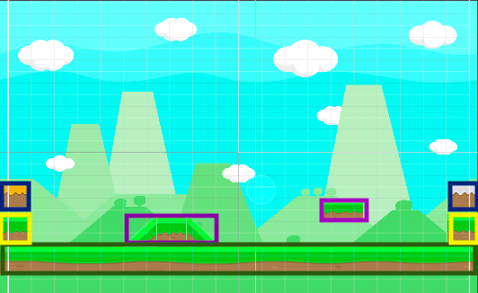There is still enough space to explore and a couple platforms, this prototype will be used to tests the playable character (both the initial tester and the final three main characters), the enemies ( easy, medium and difficult), the character upgrades (general and character specific), the general items, the merchant window and different platforming elements (climbing, jumping and swimming.). Some additional objects will be added later on.

Here is what the basic tester level will be made up of:

Highlighted sections:

* Green = ground
* Purple = platforms
* Yellow = walls
* Dark blue = enemy healing stations

This should be basic enough that all features can be tested correctly, but there is nothing unnecessary here.

The graphic elements will be very basic and coordinated so they just act as place holders. Once development is over, these place holders will be replaced with the actual sprites that will make the game much more polished. More time is needed for these sprites as I need to design and make them, so they will be added last. All the animations and switching will still be added, but instead each object will just be colour coded to show if they are for example, running instead of standing still. This will make the late sprites even easier to implement as little to no development will need to be done at that stage.

## 3.1.2 Development and testing

Any sections added in red and start with ‘SEE ___’ reference a video that should be attached with this file.

**Starting with Unity**

Starting out with unity, it was definitely a difficult learning process as I have never built a game before or used the C# language. While C# is similar to JAVA which I had some experience using, I heavily relied on research from different experienced unity users/ creators as well as using concepts from python and other programming languages and then finding how to translate this into C#.

I began to feel more confident using unity and C#, and the more I developed this game, I was able to written more programs from scratch, and editing other user’s code to fit my particular needs and objectives. Largely, I used trial and error to achieve my want outcomes but I feel I had a better understanding of that I was doing. In future, I would explore more of the features and projects that unity has to offer, and attempt different projects.

**Building a level**

As I am just creating a level for testing, the different components will be fairly simple and only made up of a background, floor, grounded platforms, a raised platform, walls (preventing me, future players and enemies from falling out of the level) and two enemy healing stations. More objects will be added in future development, but to properly test some initial features correctly, these will be the only components of this level, as some objects like the enemy healing station can be replaced with player healing station, but only once everything has been completed.

I need to make sure that unity has been set to 2D mode, so then I can only see the project on the x and y axis and not the z (this is used for 3D games as these objects have depth, whereas 2D scenes are all flat). This prevents me from accidently adding objects that are unable to interact.

I had some issues setting this level up as when I was trying to add objects into the scene panel, the background was on top of all the other objects and everything else could not be seen or selected unless using the hierarchy window.

Here is what was is in the scene:

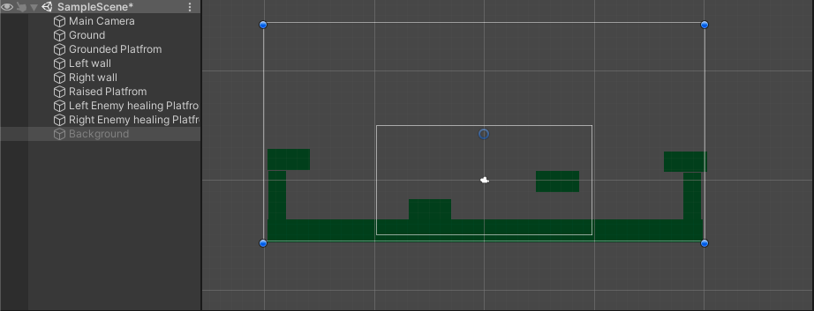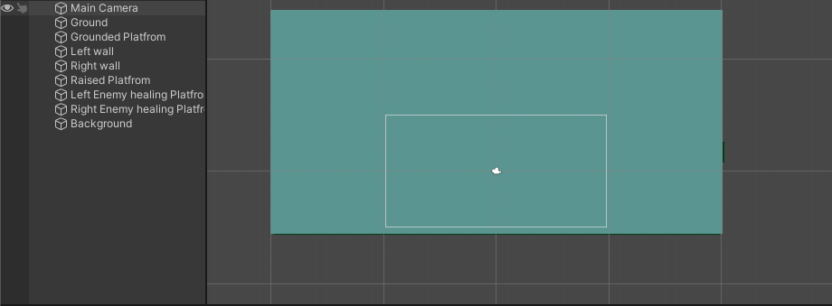

On the left is the scene with the background enabled and the right is with the background disabled.

After doing some research, I found that the objects needed to be on different sorting layer, so that the background is loaded into the game/scene behind all the other objects, otherwise they are all placed on top of each other. So, I put the background into the background sorting layer, and then the rest of the other objects into the platform sorting layer. Which then created this:

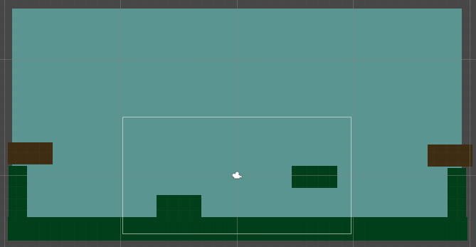I changed the colour of the enemy healing stations to make them clearer during later testing.

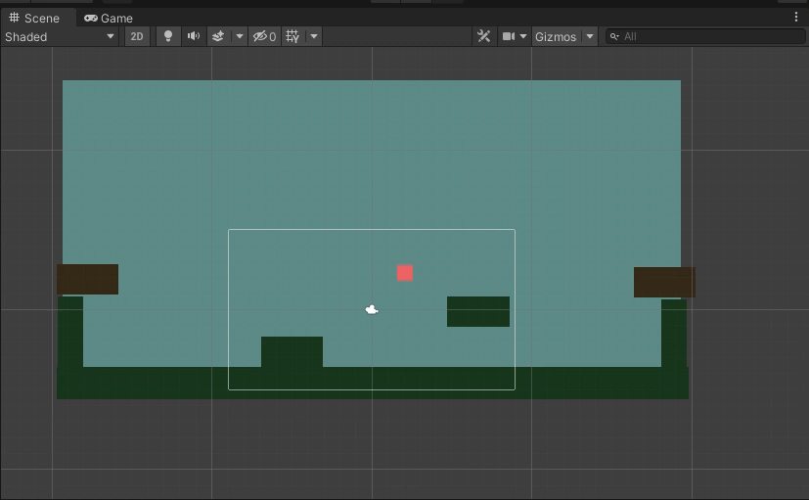Since the tester level has been built, I can now add the player into the level.

**Adding the player**

I added a new object into the scene, putting it into the default sorting layer. When hitting play and starting the scene, my player just stayed floating in the air and did not fall to the platform.

After research, the Rigidbody needs to be added to the player, as this can adds real time physics onto an object, such as gravity (which is needed in this case). There are other features that can be change or used but they are irrelevant for the current situations.

**SEE player falling through the floor**

Now the player can fall when the scene is played, but the player just falls through the ground and out of the level. Adding Rigidbody components onto the other objects just makes them fall as well. Further research said that colliders need to be added onto added on any objects that need to interact with each other, otherwise the computer cannot distinguish between the different objects and the free space. The colliders come up as a After adding colliders onto all the objects in the scene (apart from the background), the player now drops onto the platform when the game is started.

**SEE Player falling onto platform**

I changed the Rigidbody on the player to be continuous instead of discrete with created a smoother fall.

**Character controller**

After making a list of actions that I want the character controller to have (running left and right and being able to jump using the w, a, d keys), to write some pseudocode as to how I was going to be able to achieve this. I was fairly lost as to how to code my pseudocode into C# or in a way that unity understand and respond to. So, I did some research into other’s character controllers, focusing on experienced unity users. What I was trying to achieve was fairly simple and I found a Youtube channel called ‘Brackeys’, who had made a video walking you through the process of creating a character controller as well as explaining the different features that are used to achieve this. This channel was an extremely useful tool that introduced the features of unity as well as using C#.

Here are some of the features that I learned about:

* Start() method – this is a method that is called when the game is started or an object has been enabled. This is typically used to assign any external components or objects, or it can be used to call any other methods. Not every class will need it, but it can be very useful.
* Update() method – this is a method called every frame. This can be important for any feature that rely on real time reactions or variables/components. This was critical for detecting any button inputs from the players, but it can also be used for things such as automatic movement.
* Transform – this is the component responsible for keeping track of an object on the x, y (and z) axis, and can used to find the rotations, positions and scale of an object in a scene. This is important for movement in the game, as all objects have a transform.
* Camera – This is the object used to track what parts of the scene are shown in the game or to the players. This allow for other events to happen around the player or be programmed beforehand, and then the players can just explore the scene one section at a time.
* Collider – as mentioned before, this allow the computer to detect other object and interact as if they were solid 3D objects rather than a 2D image.
* Rigidbody – this introduces physics into the game, and has methods that use gravity, velocity or mass, which can b translated to your players.
* Fixed update – This is similar to the update() method but its only called a specific number of times per second.
* Using public assignable objects/ components – Objects can be assigned into a class through selecting them on the inspector window. This avoids the computer from needing to manually find objects, which reduces processing time and can reduce lag. This can only be done if the variable is made public, and if the object is not assigned, this will lead to a missing object error.

So, after using the video and my pseudocode and the video, I was able to make a character controller that uses A and D to move left and right, or use W to make the player jump. I was also able get the player to be followed around in the scene but this will be talked about in a later section.

Here is the code of the character controller:

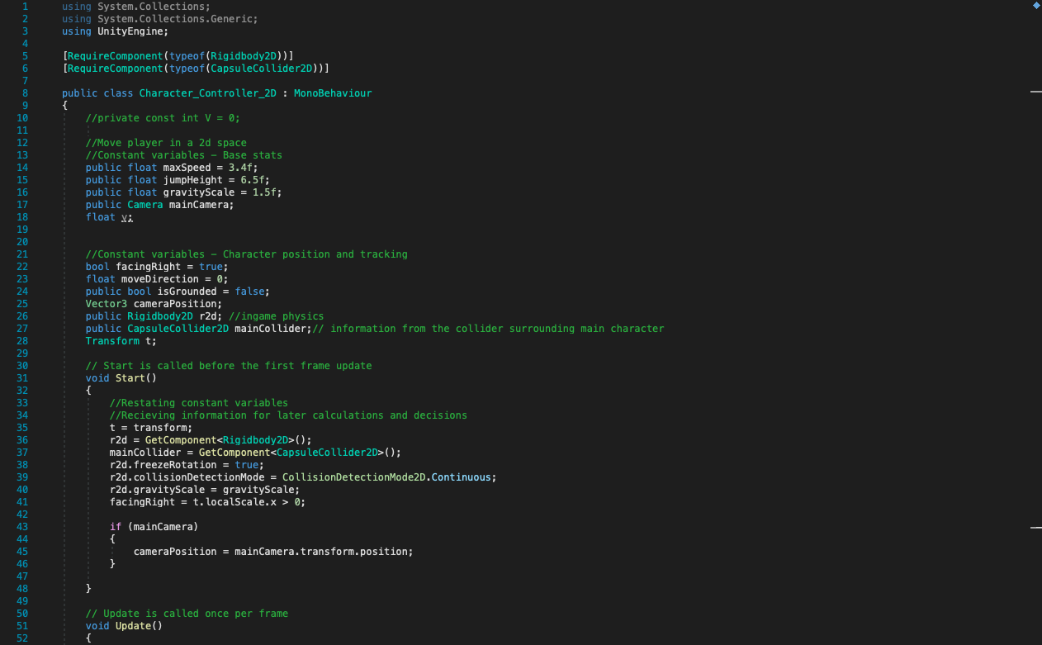

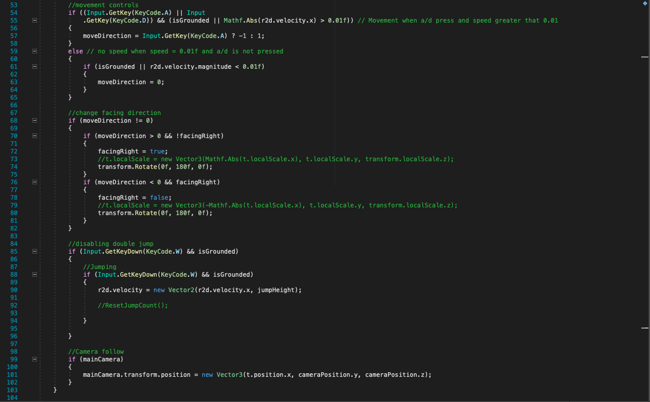

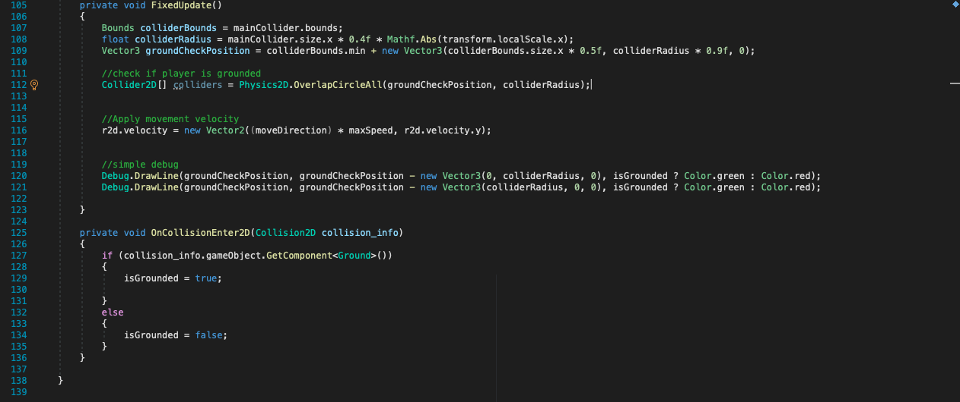

Here is a breakdown of the methods:

* Start – Assigning many of the variable, and setting up the camera to follow the players position.
* Update – Checking if the a, d or w buttons are pressed. If a is pressed the transform in the x direction is increased by the speed variable. If a is pressed the transform in the x direction is decreased by the speed variable. If w is pressed, the transform in the y direction is increased by the jump height variable, and the Rigidbody component brings the player back to the ground/ platforms. The camera’s transform is also updated to the player’s current position.
* Fixed update – Used by the collider to gain the correct information and dimensions.
* OnCollisionEnter2D – Detects any other objects that the player comes into contact with. If the object has a ground class, then the is grounded variable is set to true (meaning the player is touching the ground), otherwise isGrounded is false.

An issue I found is that the player is able to jump infinitely, which could remove some of the platforming elements. To rectify this, I added a new integer variable called jumpCount that will be incremented every time the player presses w. The player will then be only able to jump when the jumpCount is less than 2. The jumpCount can only be reset to 0 when the player is touching the ground. When the jumpCount is greater than 3 and the player is grounded, resetJumpCount is called, setting JumpCount to 0.

Here is the section of code that removes the infinite jump:

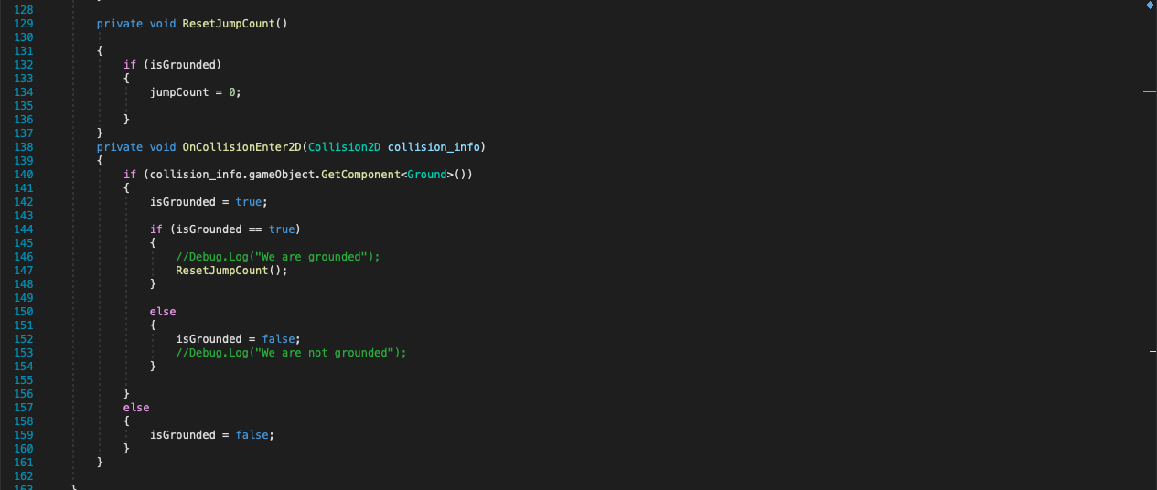

And here is the updated update() method:

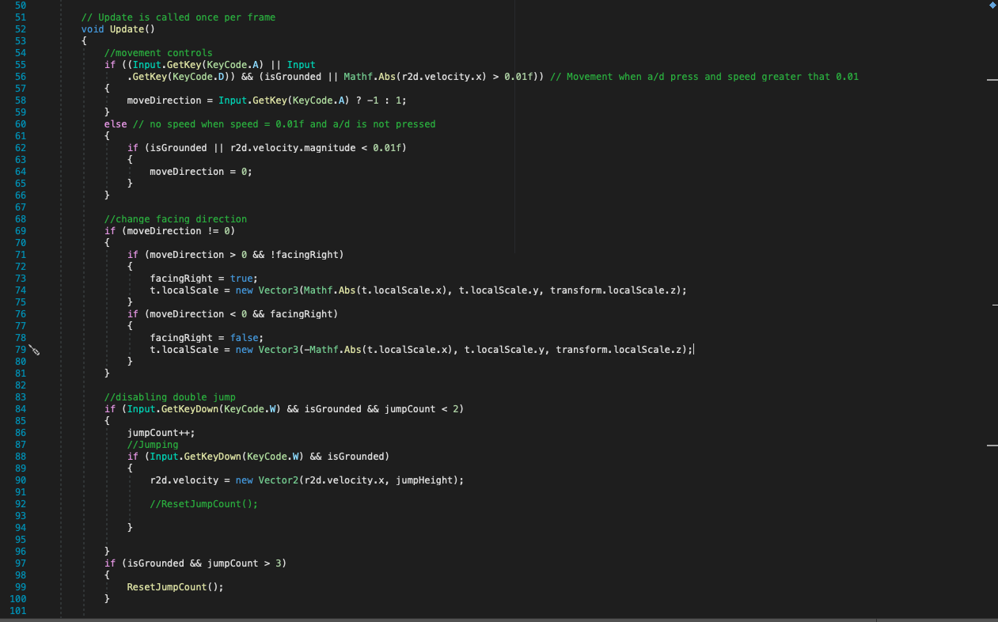

Here is the player being controlled around the level:

**SEE AFTER CINEMACHINE**

Looking back on the feature that need to be tested, I have achieved these objectives:

|  |  |  |  |
| --- | --- | --- | --- |
| **Feature being tested** | **Testing method** | **Expected outcome** | **Achieved** |
| Player can be spawned into the level | When the basic level is started the player drops into view. | The player spawns into the level and sits on the ground. | **SUCCESS** |
| Player moves right when the ‘D’ key is pressed | When the ‘D’ button is pressed, the player object should respond and move right. | When the ‘D’ is pressed, the player will move right on the screen. | **SUCCESS** |
| Player moves left when the ‘A’ key is pressed | When the ‘A’ button is pressed, the player object should respond and move left. | When the ‘A’ is pressed, the player will move left on the screen. | **SUCCESS** |
| Player jumps when the ‘W’ key is pressed | When the ‘A’ button is pressed, the player object should respond and jump, and then return to the ground. | When the ‘W’ is pressed, the player will be boosted upwards, and then return to the ground like a projectile. | **SUCCESS** |
| Player can jump onto platforms | When the player jumps onto a platform, the player should treat it as ground. | After navigating to a platform with the keyboard, the player should be able to land on it and not fall through. | **SUCCESS** |

**Camera**

While I was happy with the camera following the player around, the constant motion is something I can see becoming very annoying and cause motion sickness. I personally have problems with this when playing games and it forces me to only play them is to play in small sessions, and even then it can lead to a headache or sick feeling.

To avoid this, I want to reduce the amount that the camera is moving around the scene, but still follow the player if they move around the map. After research, I found the cinemachine is an additional feature that can be downloaded from unity. This can introduce a dead zone where the camera does not move, but when the player reaches the boundaries of the screen, the camera moves along with them.

A new virtual camera needs to be added to the camera which will then follow the player around, and a new sub object has been added onto the camera where the dead zone can be set. (I made the dead

Here is what I set the cinemachine variables to in the inspector window:

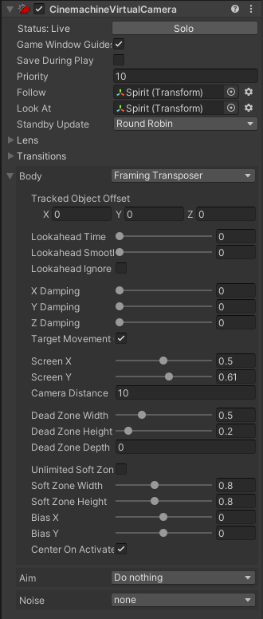I set the target to the player so the virtual camera knows what object is following, which can then be feed into the main camera.

I am also able to shift the camera to be a little above the player, rather than focusing on the centre. This just makes the platform take up less of the screen and focus more on the contents of the level.

I set the dead zone to being 0.5 wide and 0.2 high (players will move horizontally more so than vertically, so the camera movement will still be lessened).

Here is what the camera looked like before using cinemachine:

**SEE BEFORE CINEMACHINE**

Here is the camera after using cinemachine:

**SEE AFTER CINEMACHINE**

Looking back on the feature that need to be tested, I have achieved these objectives:

|  |  |  |  |
| --- | --- | --- | --- |
| **Feature being tested** | **Testing method** | **Expected outcome** | **Achieved** |
| The camera follows the player around the level | When the player moves around the level, the camera should follow. | The camera moves when the character is controlled. | **SUCCESS** |
| There is a dead zone with the camera where it does not move, ever if the character does | When the player is in the central part of the scene, the camera should not move, however when reaching the boundaries, the camera should follow the player. | When navigating the immediate area, the camera should not move. However, when reaching the boundaries, the camera should be dragged along. | **SUCCESS** |

**Player’s health**

While I could have the health variable as something in the background that players just have to be cautions of or they instantly die whenever they interact with an enemy, I feel that this would be a fun experience, it also limits the range of items that I can make. So, I wanted to have some kind of health system, that players can use to take chances or last longer in the levels. I had two choices, either a static health system like hearts where one collision with an enemy, not matter the difficulty, will remove a heart. This seemed like a decent idea, but I preferred the idea of a dynamic health system, where different enemies can deal different amounts of damage.

Now that I had decided the kind of health system I wanted to use, I needed a way to represent it. Players need to be able to keep track of their health, and in simple way that is able instantly tell them the information with just a glance, it also needs to stay on the screen at all times. Using a health bar seemed to be the best option, so I did some research on how I could achieve this.

Using a combination of UI slider and health script I will be able to have a health bar in the corner of the screen. This is not directly useable as the player, but it should be able to respond to event that happen. UI elements will be used for other elements, so this provided a decent introduction.

To implement the health bar, I created an UI image that will be the border and then I put this in an empty object which will contain all the different element. I then added a second object that will be used as a fill image which can then be scaled to show the amount of health left. The fill needed to be anchored in several places to prevent it being distorted and scaled strangely. A slider component has then added to the empty object, where the fill object was assigned, so as the slide number increases, the image scales appropriately.

Here is the code used to assign the fill image to react to the slider number:

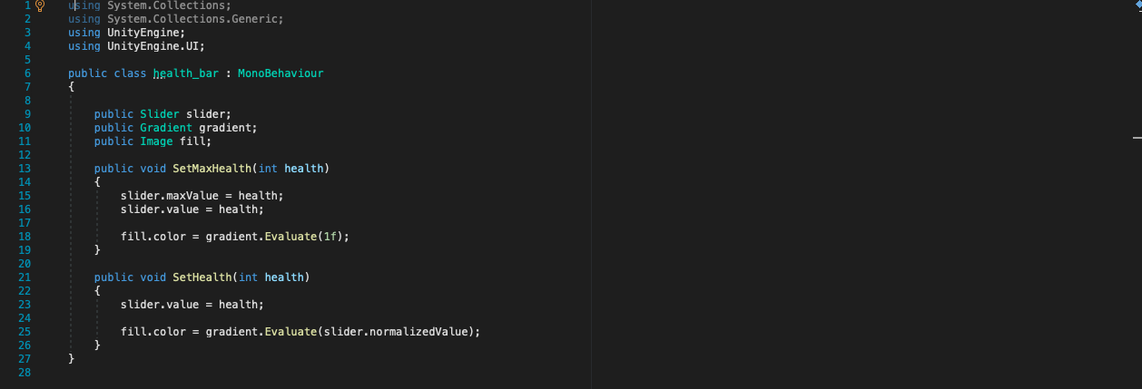

The health bar class is then added to the empty object, and the fill can be assigned in the public image variable. The gradient was a cool touch that was added so then the colour of the fill will change with a gradient depending on the number on the slider. The fill colour needs to be normalised for this reason as the slider value is set of a scale of 0 to 1.

Here is a demonstration:

**SEE SLIDER EXAMPLE**

The idea is the maximum and minimum values can then be manually set and used to react to the real time events. This can be done with an additional class which I will now use to set the player health. For now, the max health value is just set to 20 but in the future, this value will be fetched from an external script.

When the game is started, the max health value is fetched and put into the slider. The slider will then be updated anytime damage has been taken or healing has been done. A take damage method has been added, which is able to decrease the current health variable. Specific condition will be set later on, but for testing it is just activated using the space bar.

Here is the code for the player’s health:

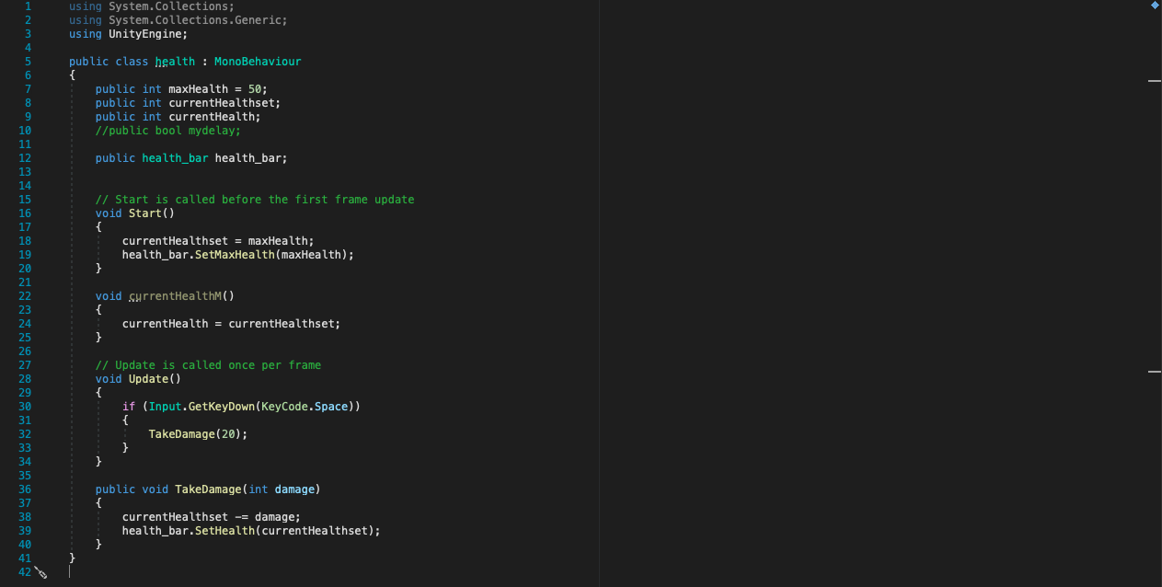

Here is the health bar working:

**SEE WORKING HEALTH BAR**

Looking back on the feature that need to be tested, I have achieved these objectives:

|  |  |  |  |
| --- | --- | --- | --- |
| **Feature being tested** | **Testing method** | **Expected outcome** | **Achieved** |
| The player has a health bar (both class and UI element) | First, the player should have a variable that can be used as the health. This variable should be represented using a UI element on the screen. | A variable with the current health should be displayed in the inspector.  For the UI element, a health bar should be displayed in the corner of the screen, that does not move its place despite the player moving around the level. | **SUCCESS** |

**Medium enemy**

Now that I have a moveable player and health system, I thought I should add one of the biggest key features of the game, the enemies. I wanted to challenge myself and add the medium enemy, since the easy enemy only does damage and does not move.

**Spawning the medium enemy**

This was fairly simple as it would be the same process as the player. I created an 2D square object, coloured it to distinguish it from the other objects, added a capsule collider, Rigidbody component and then run the scene to make sure it does not fall through the floor.

**SEE MEDIUM ENEMY SPAWNED**

Now that I have the object in the scene I want to try add the movement. The enemy should not receive any input from the player and just automatically start moving when the game is started. With this in mind, I tried to copy the character controller but instead of responding to input, the character just starts moving. When it then hits a wall it reverses direction.

When trying this it did not go very well and lead to some weird movement. There was also a lot of unused code that would probably be pretty intense for the computer to process, especially when many of these objects are all over the map.

Instead, I simplified the code down so there’s the main movement transforms in the update method, where a selection is made based on integer. If the variable dirX is greater than 0, the enemy moves to the right. But if it is less than 0, the enemy moves to the right. Whenever, the enemy hits an object and it has the wall class, it multiplies the dirX variable by -1, which switched the dirX variable from positive and negative or vice versa, changing the direction of the enemy.

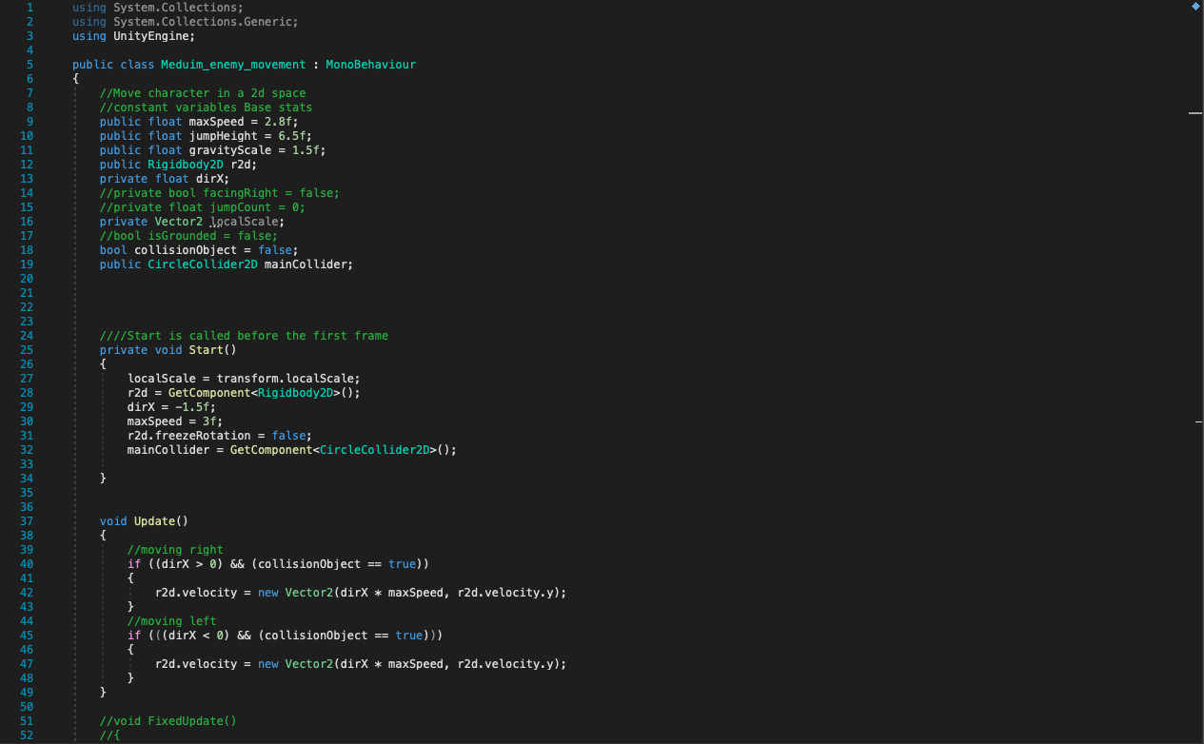

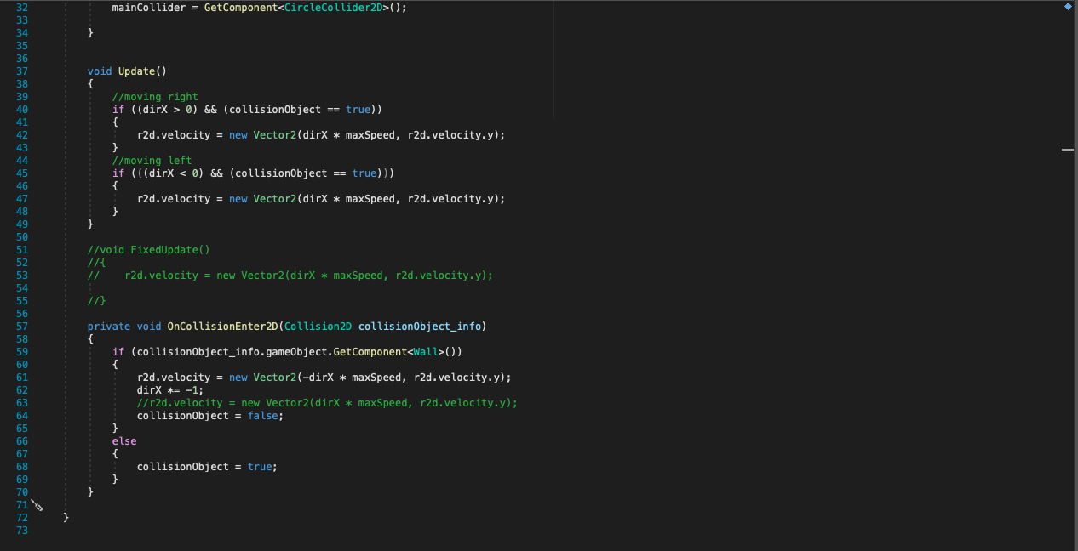

The enemy is able to change directions whenever hitting an object with the wall class. It did cause the player to stop moving when it initially collided, but this was fixed by increasing the enemies mass.

**SEE MEDIUM ENEMY MOVEMENT**

There was a slight issue where the enemy would get stuck and stop moving, but this was fixed by the enemy receiving a boost every time the enemy hits a wall.

I am not completely sure why the enemy is rotating as it moves, it still functions as normal, so I decided to keep it in. This means the sprite for it can be rounded and minimally animated.

**Contact damage**

Now that I have an enemy and moveable player, I can try and switch out the space bar for some damage to take place when the enemy collides with the player. It will need to interact with the health bar and decrease the current set health, then update the slider to represent this. A method within the health script will be called and this will send the changed results back to the slide bar.

At first I tried to do this all in the enemy contact class, but this created an issue of multiple current health values being made, leading to the player having separate health bars for any of the enemies they encountered. This was definitely an issue and was fixed by adding the TakeDamage method within the player health class. This helped keep things more centralised, so I will be using this concept for future situations.

The player can be found using the GetComponent.Find(“”), as the player class assigned to any player objects. The health class on the player object can then be found and the TakeDamage method can be called.

Here is the code used for the enemy contact damage class:

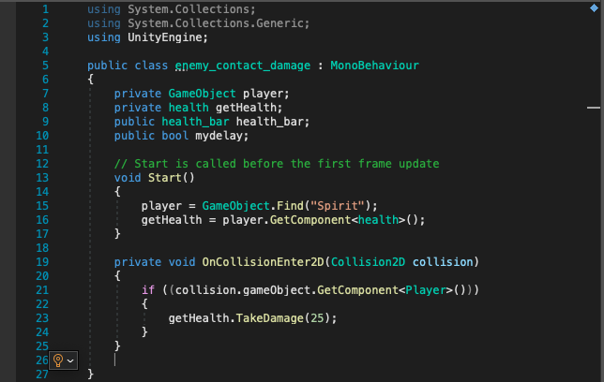

And here is the TakeDamage method in the player’s health script:

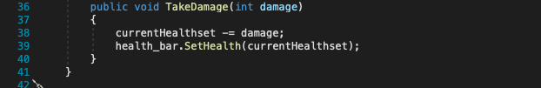

The TakeDamage method takes the damage integer that was called with the method and then subtracts it from the current health value. The current health value is then sent to the slider, so then it comes up on the health bar.

**SEE CONTACT DAMAGE – INSTANT DEATH**

However, this was causing the issue that the health would instantly go down to 0, which I believe is due to the update function calling the TakeDamage method too quickly for the player to respond. A way I manage to fix this was by adding a Boolean variable that need to be false for the enemy to cause damage. The variable will be set to true whenever the player first takes damage, but then waits 1 second and then sets the Boolean variable to false. This causes a delay that stops the health going instantly down. After research, I found that the delay can be done through using Invoke(), which allows you to set an amount of time to wait then a method is called.

Here is the improved code on the health class:

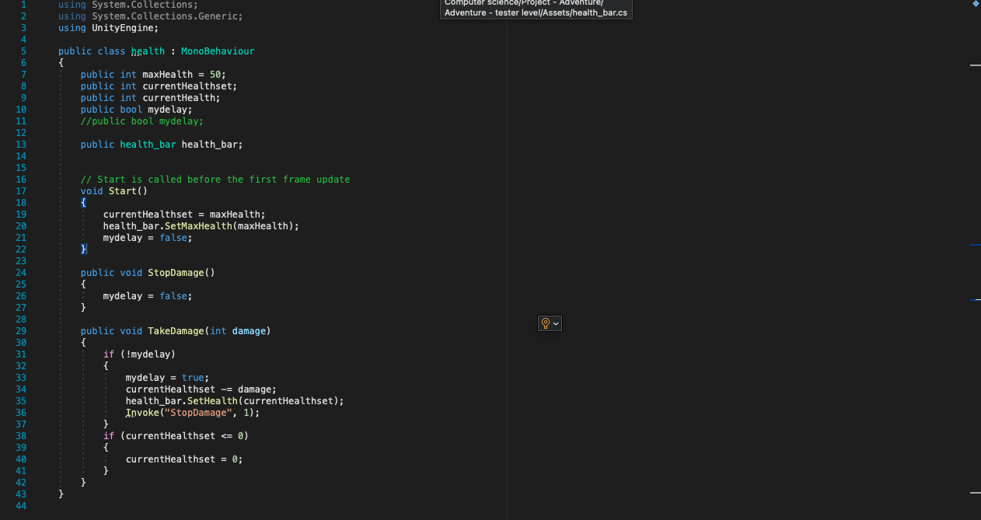

**SEE Contact damage – first collision**

There was still another issue with the contact damage where the player was only being damaged when first colliding with the enemy so I did some more research and found there are some different kinds of On Collision methods. Here are the differences:

* OnCollisionEnter – method is run called when two items first collide with each other.
* OnCollisionStay – the method is called while two objects are still connected.
* OnCollisonExit – the method is called when two objects separate

So, by adding an OnCollisionStay method, the health goes down while the two objects are still connected.

Here is the added section:

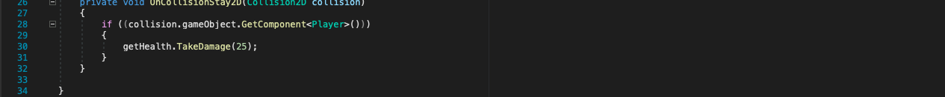

**SEE Contact damage incremental**

With that, the medium enemy is finished and time to move onto the easy enemy.

**Easy enemy**

I moved the medium enemy over for now, as I implement the easy enemy. I created the easy enemy object the same way as the medium enemy, assigning a box collider, Rigidbody, contact enemy class and enemy identifier.

I made a small edit to the contact damage class where the damage set in the called method is a variable rather than just 25. This allows me to set different values for the different enemies but they can still use the same class. I just double check that the contact damage works for both enemies.

**SEE EASY ENEMY IMPLEMENTED**

**Enemy health**

In order for the enemies to be attacked, they need a health class. They will all share the same class but will have a public max variable that can be set in the inspector window. Easy enemies will be set with 500 health, medium enemies will have 1000 health and difficult enemies will have 1500 health. For now, all of them will have 50 health but after the three main characters are added, this will be changed.

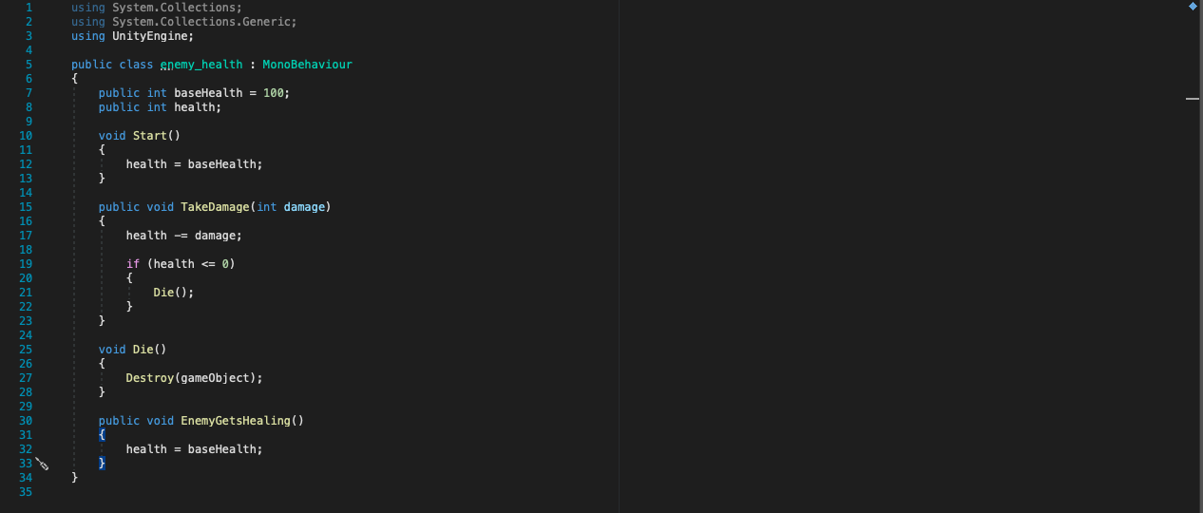

The start class sets the health, and the TakeDamage method works the same way as the one on the player. The die method just destroys the enemy when they die, but the enemy drops class will be called here later on.

**Implementing the standard weapon**

Before adding the difficult enemy, I wanted to try and add the standard weapon for the game. Again, this was a new concept that I wasn’t sure how to implement, so I turned to the Brackey’s channel as well as Stack Overflow. The idea of prefab was shown to be the best solution for the bullets as it allows for an object to be spawned into the game from a specific point. Not only would this be useful for the standard weapon but also for any moves or items that require a projectile or static attack, or even the enemy drops later on.

In order to add the standard weapon, I need to make a ‘firepoint’ on the object, where the prefab will come from. This is just an area with a transform component, and where the activation code for the standard weapon will be stored.

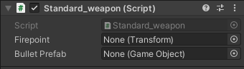

The firepoint will just be assigned the object itself, and the bullet prefab is where the object prefab that is shoot will be assigned.

The prefab can then be made by creating a 2D square object, and adding a Rigidbody (with the gravity turned off), a circle collider with the trigger enabled (as we just want to detect an object, not interact with it). An additional class needs to be written to make the bullet move automatically when spawned in. This class also goes into the enemy health class on the enemy object the bullet collides with and calls the TakeDamage method, which decreases the enemies health. As stated before, the player attack stat will be used when calling the TakeDamage method but for now it is just going to be 10.

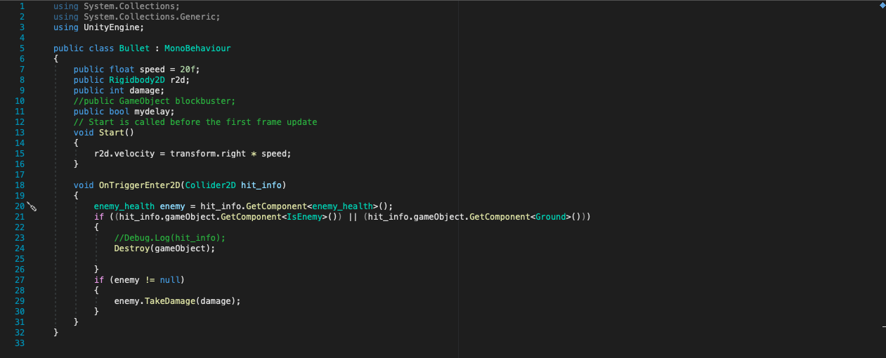

After saving this object to the assets folder and assigned to the standard weapon, I can test out the shooting.

This does not work the first time, as any prefab need to be deleted from the hierarchy window, otherwise a missing game object error appears.



**SEE STANDARD WEAPON-NON REVERSING**

As seen in the test, the bullets are only able to shoot out of the right side of the player object. The transform should rotate with the player, however it is only able to stay on one side of the object. This not a problem with the firepoint but instead an issue with the player object, or rather the character controller. When reversing the player’s direction, I just multiplied the transform to be negative, instead the object needs to be rotated 180 degrees. Visually this looks the same, but it will correct the problem.

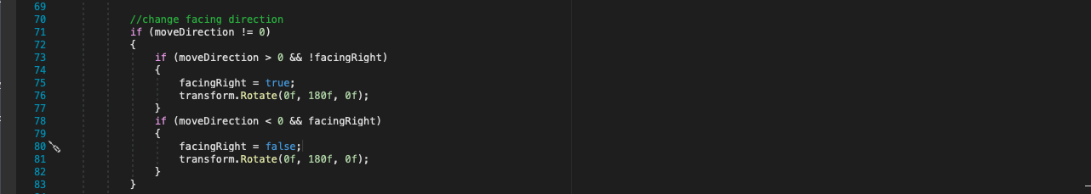

**SEE STANDARD WEAPON FIXED**

**Difficult enemy**

Now that the player has a standard weapon and the other variety of enemies are functional, I wanted to implement the difficult enemy. I want this to be the main threat of the game, as the other varieties of enemies are more so moving objects that can do damage. The difficult enemy is meant to add pressure and test the players. There will be the options to disregard them, as they only attack when triggered and when they find the healing station they will not come after you again, unless you come within range.

This game is still mainly a platformer but I though this could add some fun challenge.

I created a duplicate of the easy enemy, and changed the colour (to help distinguish the different enemies). This created a good base for the next stage of adding the movement scripts. I also disabled the other enemies temporarily, so I can focus on this mainly.

The first idea that came to mind when implementing them was to use pathfinding to reach the player. This a calculation done by an object, and by using a graph of all the obstacles, the object can find its target in the shortest distance. Initially, this is exactly what I wanted and did some research as to how to implement this and found out about the A* project created for Unity. This is meant to add pathfinding to any object and anything can be a target.

A separate object needs to be added that maps out all the obstacles in the level. This can be done through adding the premade pathfinder, and setting it to work in a 2D space. All the obstacles that need to be detected will have to be added onto the platforms layer.

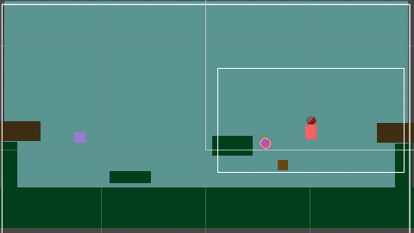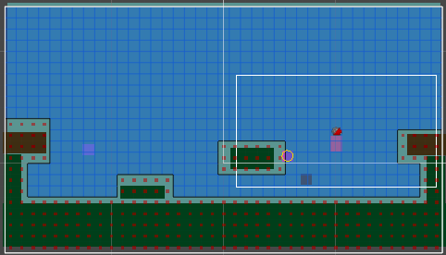

All the highlighted area is spaces where the enemy can move, whereas the areas with the red grid are the obstacles (that have been set in the layer).

A seeker class as well as an AI destinations class needs to be added to the enemy in order for them to be able find an object to track and navigate around the obstacles.

Initially, I thought I could just use the premade script comes along with the pathfinder as this would probably work best, and while it did work, it wasn’t exactly what I want. The enemy would fly around and follow the player, whereas I wanted a grounded character and since there is no Rigidbody component that I can change, there not much of a chance of me being able achieve this.

**SEE Premade enemy pathfinding testing**

Instead, I found a tutorial which demonstrates how to make your own pathfinding class using the information collected from the object with the graphs. The seeker class will still be needed but I can attempt to customise the class to fit what I would like better.

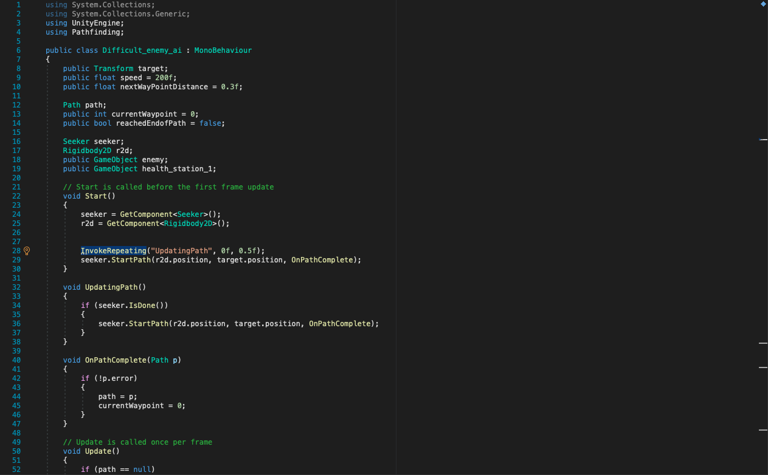

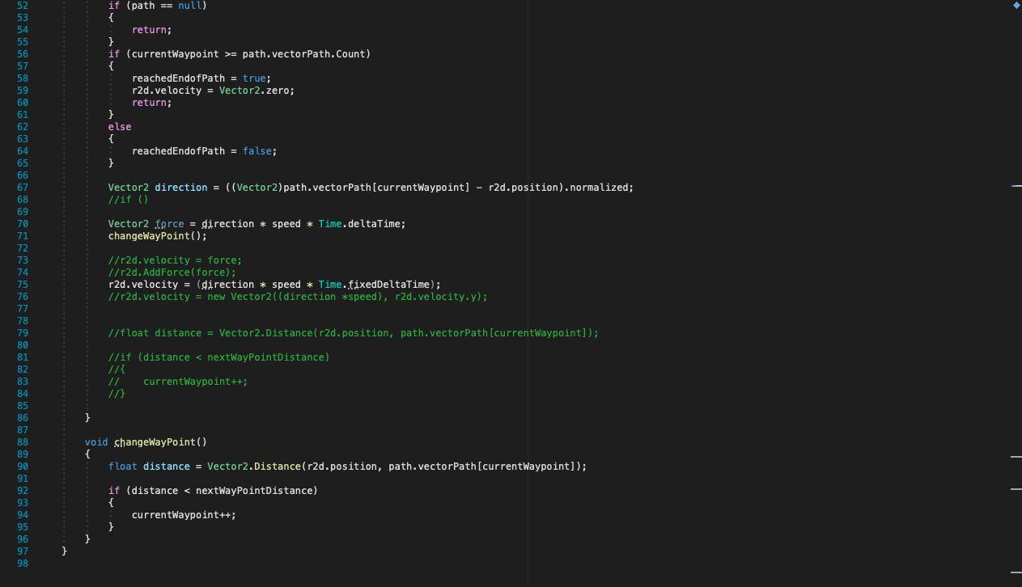

Here is a quick break down of the code:

* Declaring variables
* Start – assigning the external components to their objects/ classes. Also adding invoke repeating which calls a function every period of time. (in this case updating path is called every 0.5 seconds). And the seeker has been started and found the position of the targeted object (the player).
* Updating path – This updates the ending point of the path that is being calculated. Without this method, the enemy would only go to the spawn point of the player. It also sets a new path if the enemy reaches the end of their current path.
* OnPathComplete – stops an error occurring when the object has no final destination after reaching the end of the path.
* Update – If the path is not available return this to the console. If the currentWayPoint and the player’s point have some distance, move the player in the direction of the player.
* ChangeWaypoint – If the distance between the enemy and the end of the path are greater than the next point, increment the way point so then the player can move on to the next point.

**SEE CUSTOM DIFFICULT ENEMY PATHFINDING**

After writing this, I tested it out and it worked fairly similar to the premade class, so I deleted the other component off the object and tried to make the object grounded. However, I could not get this to work. The enemy would still follow the player but it would still be flying, however now the movement was jerky and irregular, and just looked really bad. And if I did manage to get the enemy to be grounded, it would just not move.

After doing some research, many people seem to be having the same issue and does not seem possible with the A* project. While this was disheartening, I thought of other ways I could reuse the code, since it was functional but just floated around. I had put a couple weeks into to trying to get this to work and it felt to be a waste otherwise.

I thought to instead use this pathfinding class when the enemy is trying to find a health station. The enemy is then always able to find them quickly and the code does not just get discarded.

After choosing to not use pathfinding to make the enemy follow the player, I did some more research to find how I could get the enemy to follow in general. I found that you use the process of changing the enemies position based on where the enemy’s position based on the player’s coordinated, which is a similar way as to how I was trying to make the enemy grounded.

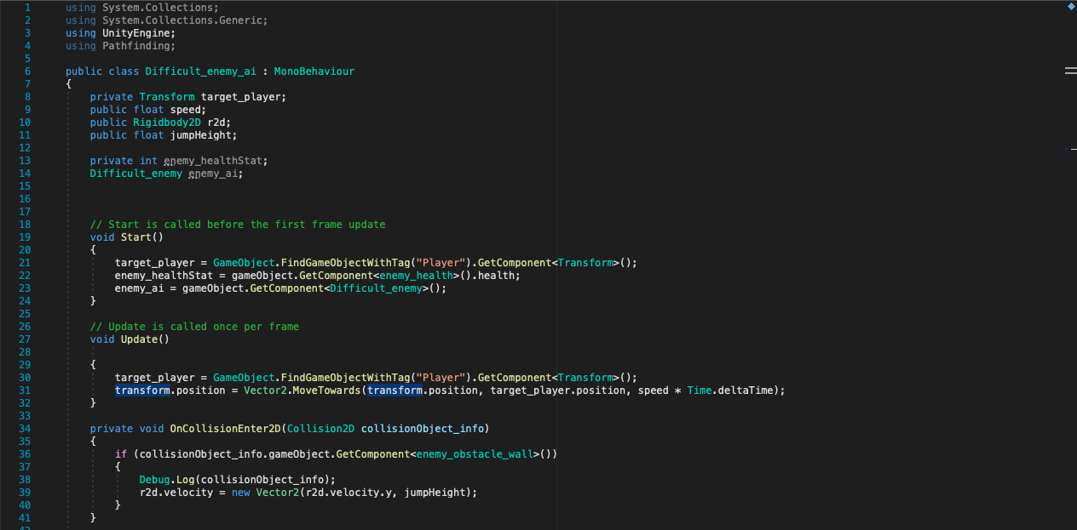

Here is a breakdown of the code:

* Start – The external components have been found and assigned. FindGameObjectWithTag is a new method that I got to use and it finds the player object that I have assigned the tag to, this allows the enemy to know what object to use as it’s target.
* Update – the enemy’s object is moved in the direction of the player with a magnitude of the speed variable (3).
* OnCollisionEnter – If the enemy interacts will an object that has the enemy_obstacle_wall class, then it will be boosted upwards with a rate of the jumpHeight. It can come back down again due to the gravity acting on it.

**SEE ENEMY FOLLOWING TEST**

Next, I altered the code that I used initially for the enemy path finding. I switched the target for one of the healing stations and removed the repeating UpdatingPath method in the start. Since the position of the health stations never change, there is no need to update the objects current position, and waste some of the processing time. I also changed the target from the player to the healing station.

**SEE ENEMY FINDING A HEALING STATION**

Once I completed that I wanted the enemy to make a decision on what health station I should choose based on which one is closer. While I could do to calculations and find which one is short, instead I added a collider on one of the enemy healing stations. If the enemy is within that collider then a Boolean variable will be set to true and the target is that healing station. If not, then the other healing station is the target. This will make the enemy move to the nearest health station.

This did not work at first since the collider was forcing all objects outside the collider once the game was started. This was because the enemy healing stations collider was acting like a solid object, and instead I should have used a trigger. Triggers just detect what is instead their range, not creating as a solid wall. This trigger would also need to be added onto a child object so the enemy can still run into it, and be healed.

Here is the code added onto the child object:

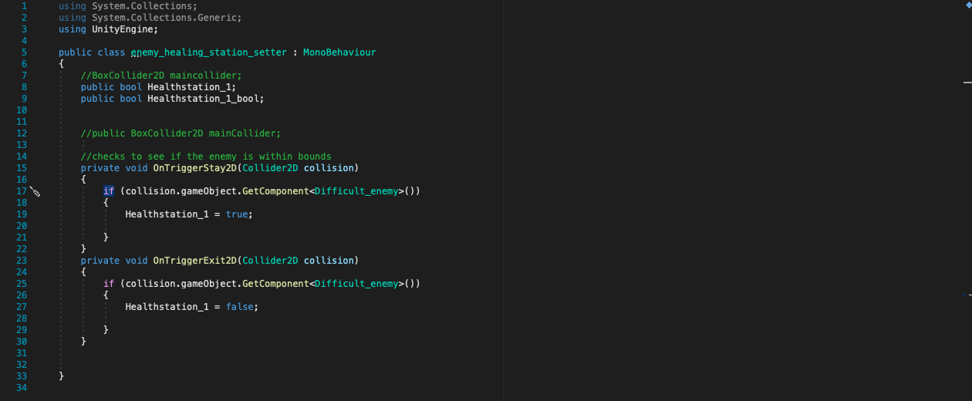

Here is a backdown of the code:

* OntriggerStay2D -If the enemy is inside the range of the health station, the healthstation_1 Boolean is set to true.
* OntriggerExit2D -If the enemy is outside the range of the health station, the healthstation_1 Boolean is set to false.

This will be changed later so then the healing station calls a method from within the difficult enemy movement class that sets the Boolean variable to true. Originally, I thought to just have the enemy constantly check if they are within range, but this could lead to the computer becoming overwhelmed.

Now that everything works separately, I wanted to put all the different components together; the enemy follow, finding a healing station and healing station selection. In order to properly test this, I will use the ‘R’ button to set the enemies health to 49, but this will be removed later on.

At first, I tried to get everything to work using methods calling each other but this just ended in a stack overflow error. Realising a much simpler solution, the enemy made a selection in the update method. If the enemy’s health is above 50, then the information is the update method for the enemy follow is called. But if the enemy’s health is below 50, the code in the update method in the finding healing stations method is called. Any addition methods and variables were added to the class so then everything works.

When adding everything together, I added an extra section to the enemy health station setter class. Now, when a difficult enemy is detected within the health station enemy detector, a method is called from within that specific enemy’s movement script where the target is set to the left health station. When the enemy exits the detector (trigger), the target is then set to the right enemy health station. Since I am only planning to use two enemy health stations, I do not really need to have both health stations detect for the enemy, instead just the one. If the enemy is out of range for one health station, it must be in range for the other station.

When testing this out the first time, if the enemy was following the player then they would both be shot around the level, but the enemy would move to the health station fine. And then when the enemy was following the player around, when the enemy went to find the health station, it would just stop moving.

After messing around with the code, and testing it periodically, I was still confused as the classes worked when they were by themselves, as I tested them again and they still worked. Anytime I tested them together, it did not work. This was especially weird since the correct methods where being called, as I checked them using comments the console whenever they were used.

After referring back to my original movement classes, I realised that the speed was extremely different. The player follow class used 3f, whereas the healing station finding used 200f. That explained the weird movement and allowed me to figure out a solution. The speed would need to be reset at the beginning of each sequence.

After this the enemy is able to follow the player when it’s health is above 50, and find the closest health station if its health is below 50.

**SEE ENEMY FOLLOWING PLAYER THEN FINDING HEALTH STATION 1  
SEE ENEMY FOLLOWING PLAYER THEN FINDING HEALTH STATION 2**

A class needed to be added to the healing stations that calls the enemy’s health class and calling a method that heals them back to full capacity if the enemy collides with the station.

This did work once, as the enemy would start following the player after being healed, but then if the enemy needed to heal again, then it would just hover around the healing station. I tested it again and found the healing station’s collider being knocked off its object. This was due to the mass of the enemy, so I fixed it by increasing the objects mass to 1000 on a Rigidbody component.

Now the enemy is able to follow the player around and find the closest health station.

The final part I wanted to add to the difficult enemy is to make it only start following the player when it is within range. I used a similar solution as to how I got the healing station to be set in the movement class, but instead of the methods setting a target, a Boolean (playerRange) will be enabled. The enemy can then only start following the player when they are within range. Once the player has been detected, the difficult enemy will chase them, so the player will need to either kill it or damage it enough that it goes to a health station.

**SEE ENEMY FOLLOWING PLAYER WITHIN RANGE**

**SEE ENEMY FOLLOWING IN RANGE THEN HEALTH STATION 1**

**SEE ENEMY FOLLOWING IN RANGE THEN HEALTH STATION 2**

Here is the extra code added to the enemy health class:



When this method is called, the enemy’s health is set to the maximum value.

Here is the code for the enemy healing station class:

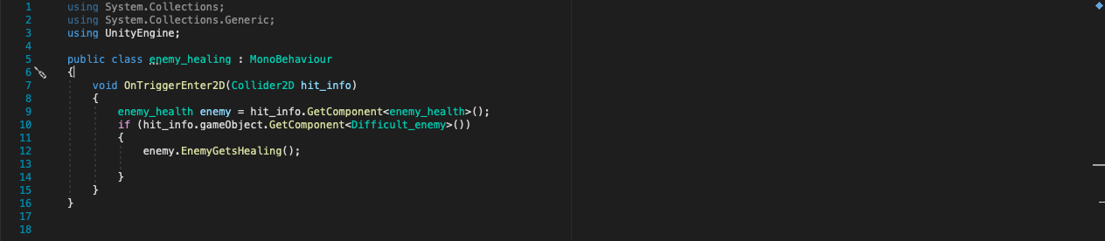

When an object with the difficult enemy class on the object, the station will call a method within that specific difficult enemy health class, and set the enemy’s health to max value.

Here is the code for the enemy detector class:

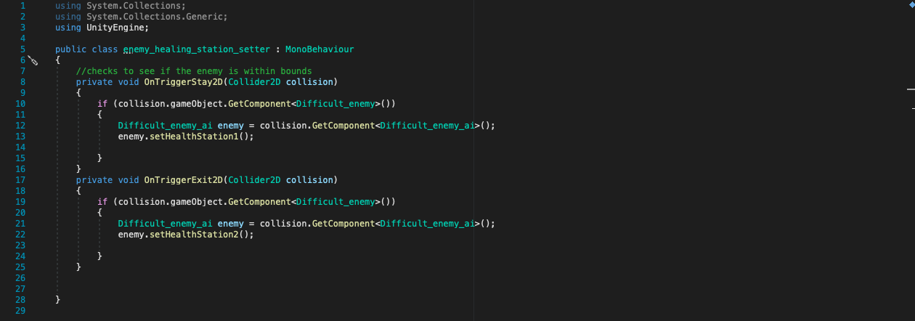

If a difficult enemy is detected with the range of the trigger on the left enemy health station object, a method is called that is in the movement class on that specific enemy. The method will then set the target for the pathfinding to be the left enemy healing station. Once the enemy exits the trigger range, another method is within that class that sets the target to be for the right enemy healing station.

Here is the code for the player detector class:

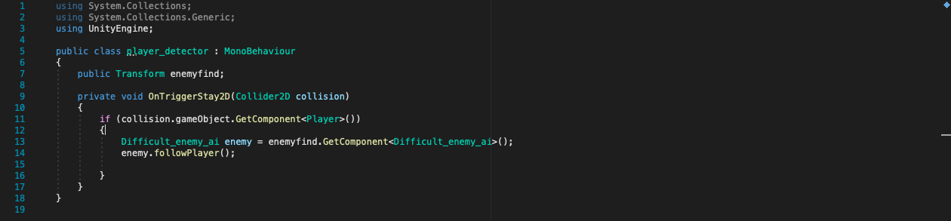

This does a similar thing to the enemy detector, but instead of the class and method being called on the object that is detected, instead it happens on the parent object. The followPlayer method sets a Boolean to true when the player comes within range of a target. There is no condition for when the player exits the trigger as the enemy will now continue to follow the player until it is killed or needs to find a healing station. The parent object needs to be set manually in the inspector otherwise this class cannot find the correct object, as when there are multiple of the same enemy, searching with a tag, class or name will not work.

Here is the code for the difficult enemy movement class:

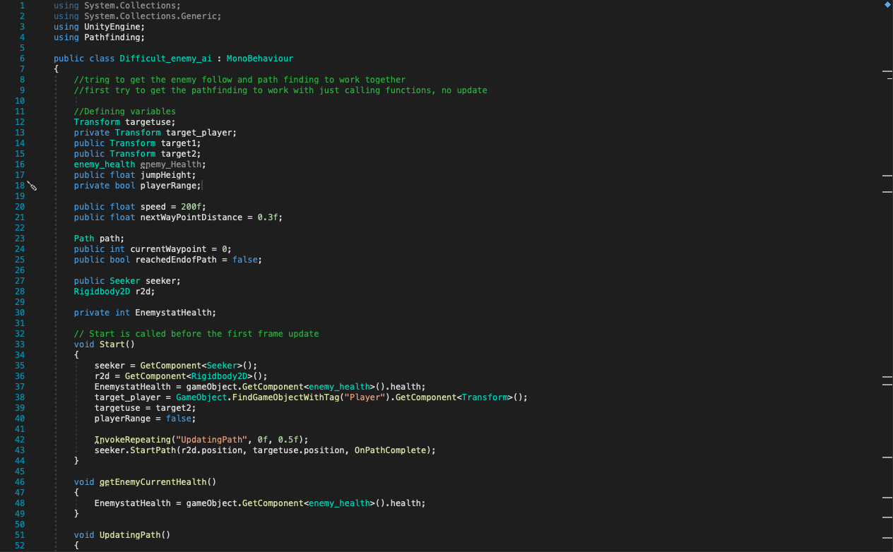

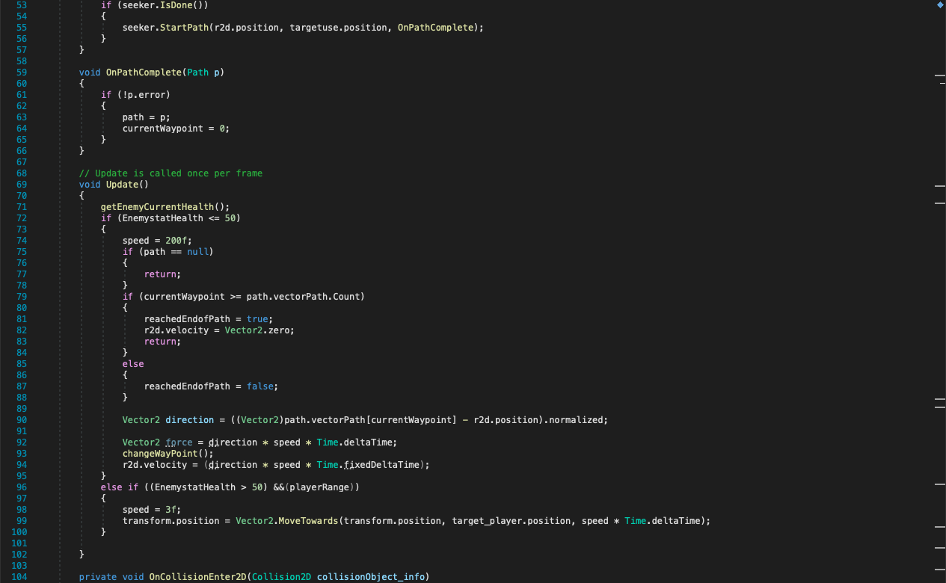

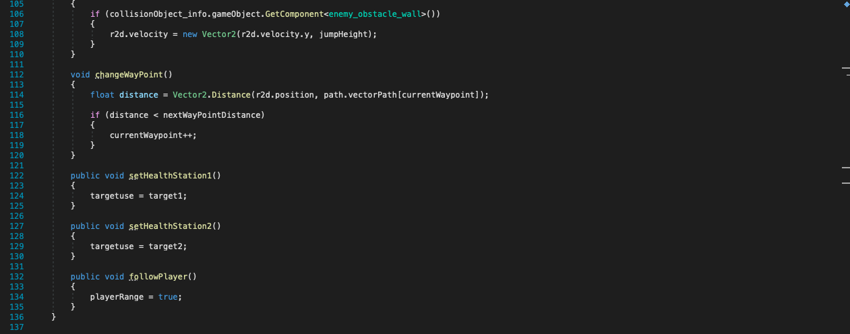

Here is a breakdown of the enemy movement class:

* Start – The external components have been found and assigned. Several variables have been set to their default setting (e.g., targetuse = target2, so the right hand enemy health station is the default target for the enemy pathfinding). The updating path method is also called repeatedly so when the enemy is finding a health station, it will be able to find the next point (I tried to change this so it only happens when the enemy is pathfinding, but then it just stopped moving). The target for the pathfinding is set to the default of the right hand enemy health station.
* getEnemyCurrentHealth – when called, this method goes into the object specific health script and retrieves the enemy’s current health.
* UpdatingPath – The next point for the pathfinding movement is found along the current shortest path.
* OnPathComplete – when the player has reached the next point, it sets its current position so then the next point can be calculated in relation.
* Update – GetEnemyCurrentHealth is called. Depending on the enemy’s current health, if the health is above 50 and the player has been within range at least once, then the enemy will make a movement to follow the player. If the enemy’s health is below 50, the pathfinding sequence is started and the enemy moves to find the health station. This is repeated for every frame.
* OnCollisionEnter2D – If the enemy collides with an object with the class ‘enemy obstacle wall’ then it will receive a jump boost.
* changeWayPoint – This calculates the next point relative to the enemy’s current position.
* setHealthStation1 – Makes the target for the pathfinding to be the left enemy healing station.
* setHealthStation2 - Makes the target for the pathfinding to be the right enemy healing station.
* followPlayer – sets the playerRange variable true, so then the enemy can start following the player around.

All tester classes and code have been removed so that the classes only hold the essential features. Some testing feature might be added again, but currently they are no longer needed.

**Difficult enemy projectile damage**

This will be similar to the player’s standard attack but instead of the bullet being activated using a button, an invoke repeating will be set so the enemy shoots out a bullet every 2 seconds. I will make a duplicate of the bullet prefab, and assign this to the enemy.

Here is the code of the activation of the bullet prefab:

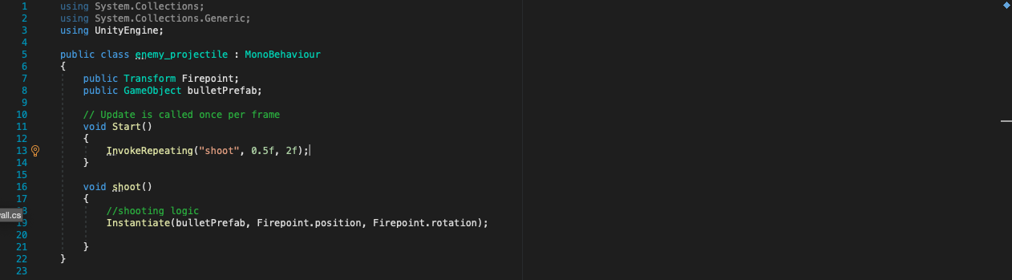

Here is the code of the enemy bullet prefab:

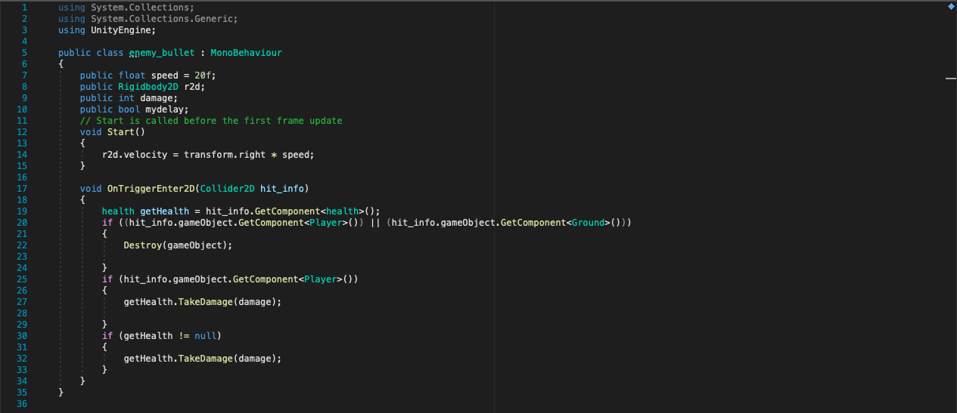

**SEE ENEMY PROJECTILE**

**Health station for the players**

This is going to be pretty simple since it will combine the parts of the contact damage class and the enemy/player detectors. If the player is within range of the detector it will call a function inside the player health station, if the delay is off (or set to false), then the healing method in the player class will be called and 25 health point will be restored. Once the player exits the range of the detector, then another method will be called to the player health station and the variable will be set to false, preventing the player from being healed.

Here is the class of the player health station:

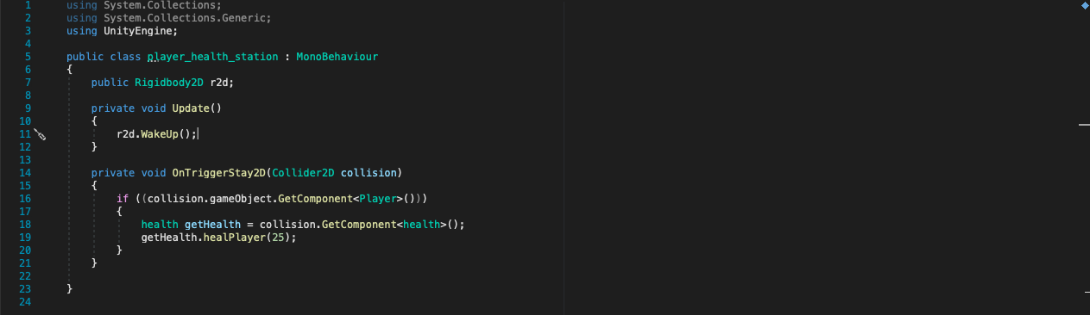

(r2d.Wakeup() needed to be added as colliders do not work unless at least one of the objects are moving.)

And here is the extra method added to the player health class:

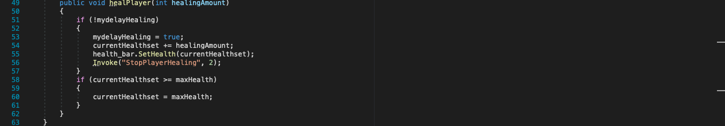

**SEE PLAYER HEALING STATION**

**Money system**

Since there will be a paying system later on in the game, I wanted to have a UI element that represents the current amount of money the player has. This will most likely be similar as to how the health system works, but instead of the current amount of money being represented by a slider, the number will just be shown one screen and updated.

I added a section of code for testing, so when the ‘Q’ button is pressed, then the money amount will decrease by 10, and if the ‘T’ button is pressed then money amount will increase by 10 but this process will be removed for later processes, as the players could spend their money by buying items or gain money through enemy drops.

Here is the code for setting up the text UI:

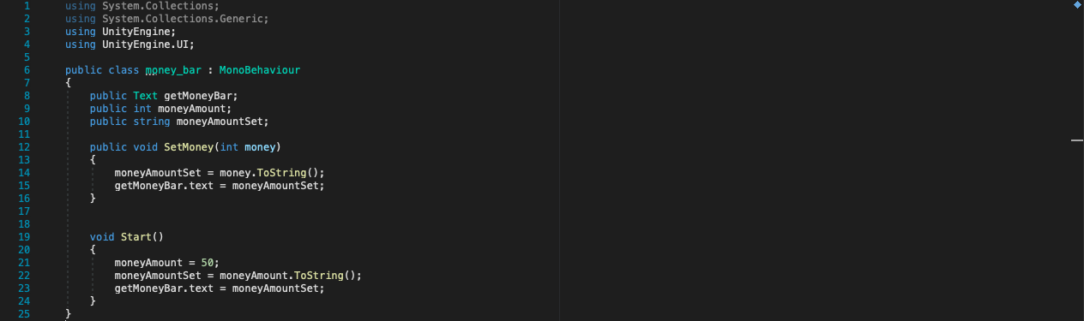

Here is the code for the money class:

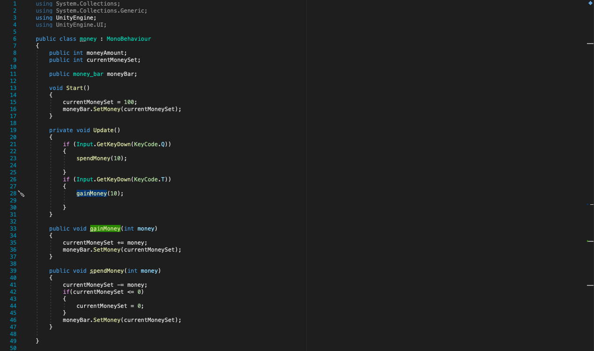

**SEE TESTING MONEY VISUAL COMPONENT**

**Implementing three main characters**

Now that all the essential features have been added (player, enemies, level, standard weapon, money system, health system for both the enemies and players) I want to implement the three main character. Spirit was just acting as a placeholder for these characters, as it made it easier to test everything out, so now that all these sections have been completed, I can add the three main characters.

In order to pick one of the players, a window will come up and then the level will be started. Once the button has been pressed the window will disappear and not return, the only way to choose a different character is to restart the game.

In order to make this work, I need to make two parent objects, one holding the menu to set the players and the other holding the level. This gave me the opportunity to tidy up some of my objects and put them together with a parent object.

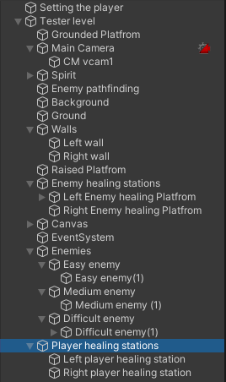Now that I have the two parent objects, I can disable and enable them using buttons or other features. Since I want the players to be chosen first, the setting player object will be enabled when the game is started. Once the player has been chosen, the setting player menu will be disabled and then the level will be started up. A similar kind of concept will be applied later on or when the later levels are set up, but for now I just need for this to work.

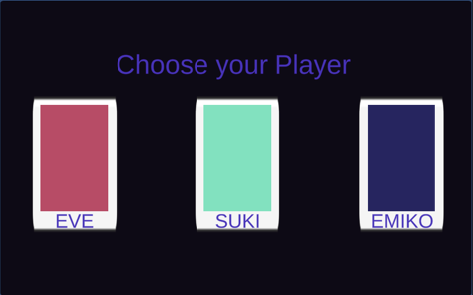At first I build a basic window that allows you to select which character you are going to play as. The button’s only function is to set out a comment to the console. Although you are able to press multiple buttons during one playthrough, this will be changed so this window is closed and the level is begun.

**SEE PLAYER SELECTOR BUTTON TEST**

Now that the buttons work, I’m going to back to the tester level create the three player objects, all under one parent object called ‘playable characters’. I will then have to go into each object that with interacts with the health, speed or attack and add a switch case statement. This will set the particular information that the object needs to interact with. Since two of the objects need to be disabled, an if statement cannot be used to do this. When I tried initially, unity keep sending ‘missing object/ component errors’, even if the object was just disabled. And since the whole section of code need to be read before processing, nothing worked. However, with a switch case, a number is chosen and instantly goes to the correct condition, with no regard if there are any other components missing.

I managed to connect the buttons to an external object which keeps track of the chosen character. This object is outside the levels and menus, so it cannot be disabled or changed. When each button is pressed it saves either 1, 2 or 3, which each have a corresponding character (1 = Eve, 2 = Suki, 3 = Emiko).

**SEE PLAYER SWITCH CASE NUMBER SET**

Now that there is a constant that tells the rest of the game what character has been chosen I can try connect the character selector menu to the tester level. This can be done as unity has the ability to enable and disable an object, using buttons by using the onClick section the inspector window and using the SetActive method. So now when the button is pressed; the character number is set, the player selector menu is closed and the level is started.

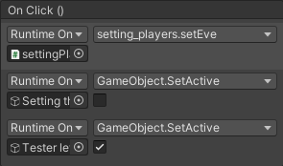 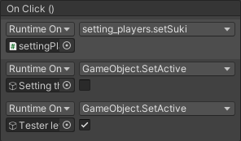 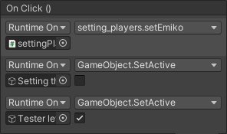

**SEE PLAYER SELECTOR TO LEVEL**

Now that I have a system to get into the game and select the player, I need to make the three main characters. At first I just tried to duplicate the spirit object and get is to work that way, but this caused a lot of errors, since everything had been set to work for Spirit.

One main issue is that the camera is no longer following the players, as it would either not move or stutter around the screen. Although all three of the objects are there I can understand this happening as the computer does not know which object to focus on, but this still happens even if there is only one player. I found that it’s because the virtual camera can only have one target that it can follow, so I would need to make three different virtual camera that ae enabled or disabled depending on character. All of these would be under the main camera object, so everything should switch seamlessly. I also add some commands to the buttons so there is only one player object when the level is started.

**SEE PLAYER SELECT TEST – NOT CONNECTED TO CLASSES**

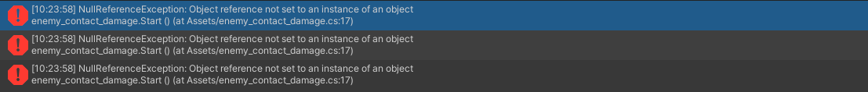

Now that I have got the layer selector to work, I have another issue that needs fixing. There are a bunch of missing objects for the classes now that I have gotten rid of Spirit. A lot of the previous class were hard coded for that object and some of the classes on it. Now I’ll have to go back through all my classes and either set the empty to the ‘playable characters’ object or add a selection into the variable declaration section. Some classes will have a method that specifically makes the selection of what information will be retrieved, but this will only be for classes that need to repeatedly find a variable on the character’s object, as this will reduce the amount of code needed.

These classes will make a decision using a switch case statement and the number stored in the player_selector object, and then retrieve the correct information. A switch statement used here also as an if statement would cause an empty object error to occur.

Before doing this I needed to make the classes for each player that has their current states for each level(both the constants and the current stats). I make the classes for this using the pseudocode that I wrote previously.

Here is the constant stat class for Eve:

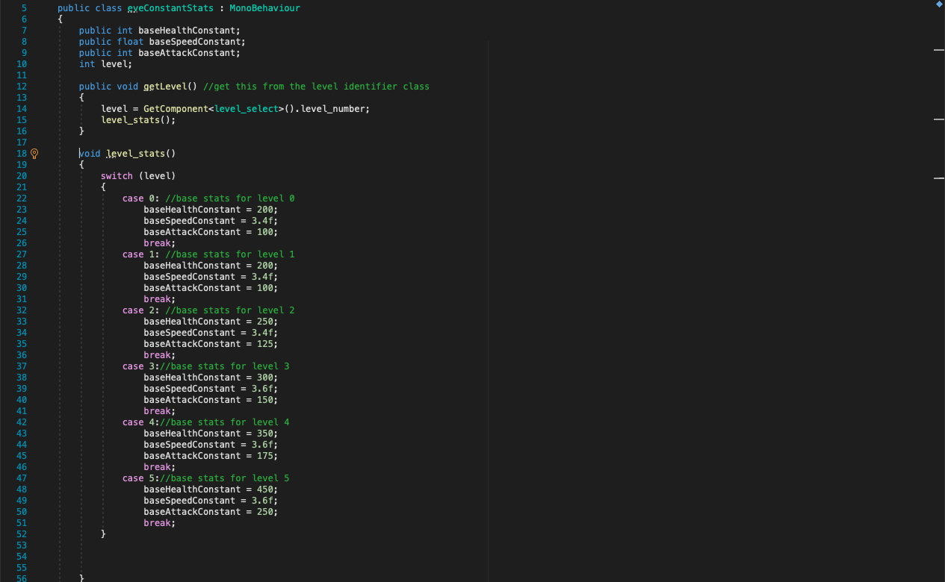

Here is a breakdown of the code:

* getLevel – the current level is found by going into the player_selector object and retrieving the number that is stored in the level_select class. This number is incremented every time the next level is started, so when this happens, this method will be called as well. The level_stats method is then called, which sets the variables in this class to the new value.
* Level_stats – this has a switch case statement that uses the current level value from the player_selector, and changes the player’s base stats. This is meant to give player a boost every time they complete a level.

And here is the current stat class for Eve:

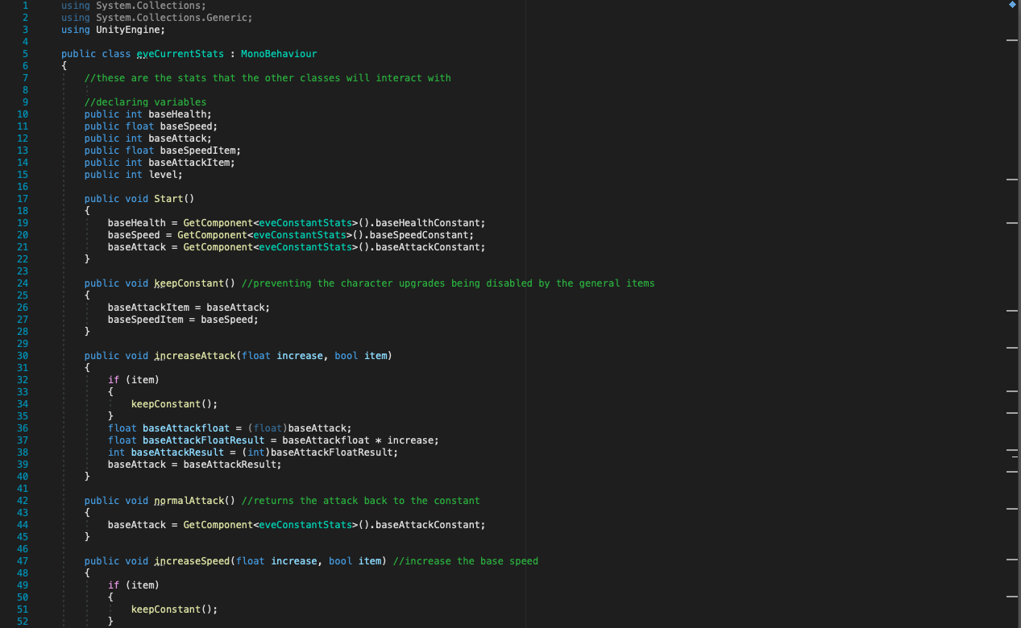

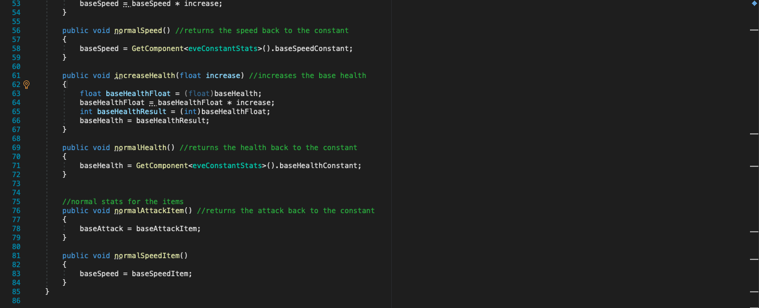

Here is a breakdown of the code:

* Start – All the stats variables are called from the constant class.
* keepConstant – As the increase method will be used for temporary boost or items, it prevents the original base stat from being lost, as a backup of the stat has been stored, so instead of the normal_ method being called, the normal_item method is called instead. Originally this was the update method but it negated any of the use it has, as the variable would change with the increase. Now this method is called whenever any of the stats is increased.
* increaseAttack – this takes the increase rate that would be called with this method and increases the base attack by that much. And if this method is being called by an item (a Boolean statement will be called with this method), then the current base stats for the attack and speed will be stored in a backup variable.)
* normalAttack – this goes back to the constant stat class of the character and returns the attack back to its constant.
* increaseSpeed - this takes the increase rate that would be called with this method and increases the base speed by that much. And if this method is being called by an item (a Boolean statement will be called with this method), then the current base stats for the attack and speed will be stored in a backup variable.)
* normalSpeed - this goes back to the constant stat class of the character and returns the speed back to its constant.
* increaseHealth - this takes the increase rate that would be called with this method and increases the base health by that much.
* normalHealth - this goes back to the constant stat class of the character and returns the speed back to its constant.
* normalAttackItem – Since if I used the normalAttack when an item is finished, it would remove the effect any character upgrade would have, instead of restoring the attack by going into the constant stats class, the base speed variable is just changed back to the saved value that should have been before.
* normalSpeedItem – Has the same purpose as the normalAttackItem method, but instead is for the speed stat.

Although I did make one for each character, the format is nearly identical, other than the fact for the constant base stats class has different values for each situation, due to the main character all having different base stats, and the current stats class calls different classes depending on the character.

Here are all the classes that needed to be updated and what was added:

* Character_controller_2D

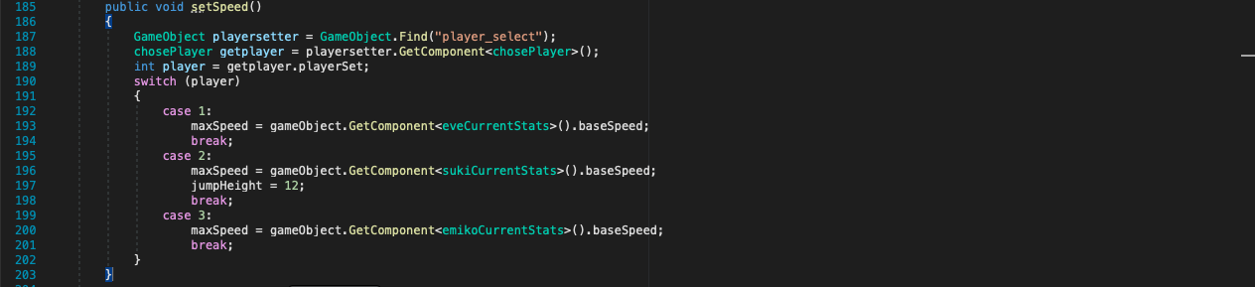

* + Whenever this class is called, the set player is the maxSpeed is retrieved from the current stats class of the particular character.
* Health

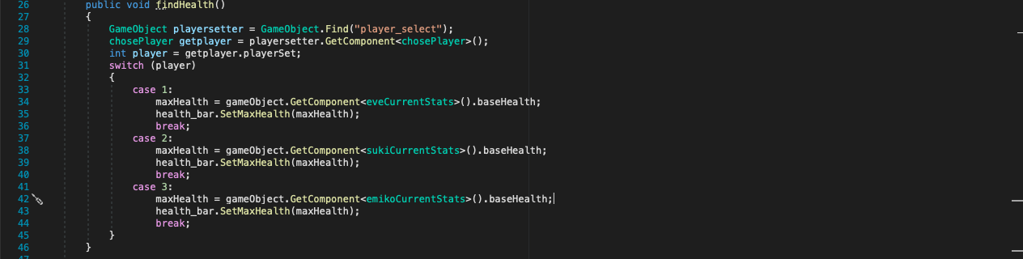

* + Whenever this class is called, the set player is the maxHealth is retrieved from the current stats class of the particular character. The maximum capacity is increased and value is then represented on the health bar, but the current health is not changed. This might make it look like player have less health, but the capacity has increased.
* Bullet

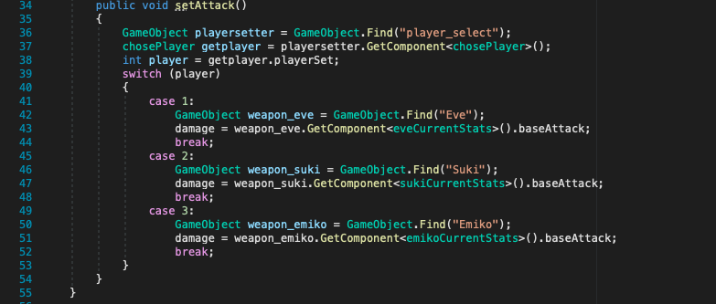

* + Whenever this class is called, the set player is the attack is retrieved from the current stats class of the particular character.
* Enemy_contact_damage
  + 
  + This needed to be changed from Spirit to the player’s parent class, an empty object error would occur.

Addition sections need to be added to the current base stat class, so then the variables for the speed, attack and health are updated any time that any of these variables are changed. This prevents needing to use the update method to constantly update them, which should reduce performance issues as then these variables are not being constantly checked by the classes that need them.

Here are the updated sections of the current base stats class:

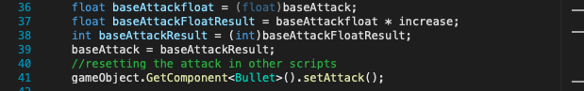

This section needed to be added to the attack and health’s increase and normal method, since a float cannot be multiplied by an integer, so in order to use the multiplies later on for the boost, so I needed to set this up. So, the health/attack variable is saved and then used to create a float value. This is multiplied by the increase and then turned back into an integer. Finally, the base attack/health is saved to the main variable.







These were added to the corresponding variable that they effect, so that when the health, attack or speed is changed, then game can reflect these changes without these classes needing to constantly check if they work.

After testing everything out, the health, attack and speed change depending on the player initially chosen and there are no errors that come up saying that there is a missing object. I check the speed and health by looking in the inspector window for each character object and changing the different character for every playthrough test. I checked the attack by disabling the medium and difficult enemy and checking the health of the easy enemy, then when I start each playthrough I shoot one bullet at the easy enemy and check that the health decreases by the correct amount.

**SEE MULTIPLE PLAYER SPEED AND HEALTH TEST**

**SEE MULTIPLE PLAYER ATTACK TEST**

**Creating the special moves**

Now that the three characters have been set up and the current health scripts work, I can start implementing the character individual moves. Since the over object are disabled, I can just make the individual classes for each move and then even if the same buttons are used for them, there should be no missing object error.

**Eve**

* **Blockbuster**
  + This was a fairly easy move to do since I had already created the standard weapon. This is identical to that but instead of the bullet will not be shot out and the damage will be retrieved and multiplied by 1.25 to give the 25% attack boost. The blockbuster activator will also have a cooldown method attached so then blockbuster can only be used every five seconds.
  + A UI element will be connected to this move’s cooldown later on but for now a comment is just written to the console.
  + To test this, I disabled the easy and difficult enemies, and then checked the medium enemy’s health if the blockbuster does the correct amount of damage.
  + Here is the code for blockbuster prefab:

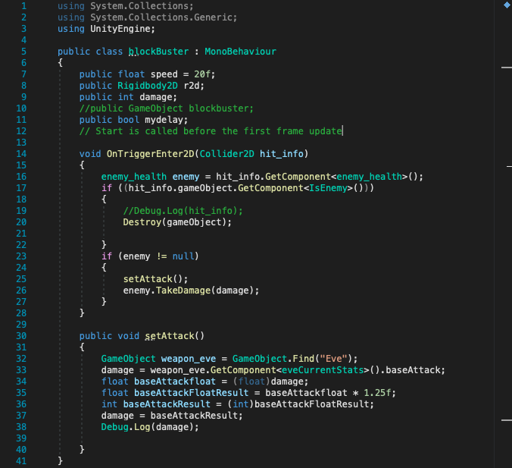

* + Here is the code for the blockbuster activator:

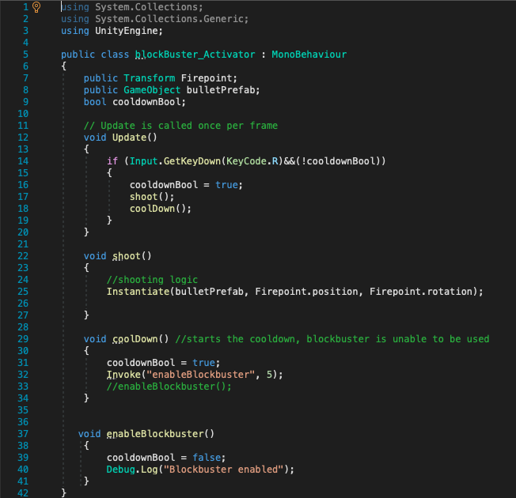

* + **SEE BLOCKBUSTER TEST**
* **Charge up**
  + Starting this move, I am able to start using the increase and normal methods that I created in the current stats class. The heal restore will be easier as it only requires the current health and then it calls the health class and uses the healPlayer method along with the health restore. The speed boost is a little bit more difficult as I need to call the increaseSpeed method, wait 7.5 seconds, and then call the normalSpeedItem method and start the cooldown.
  + To test this, I used the easy enemy and take some damage, I hen started charge up and kept an eye on the character controller (speed stat specifically) to make sure that the speed increases, the health bar should go up noticeably as well. I will add a comment that show the health restore that is put into the health bar. (60 health points should be restored.)
  + Here is the code for the charge up class:

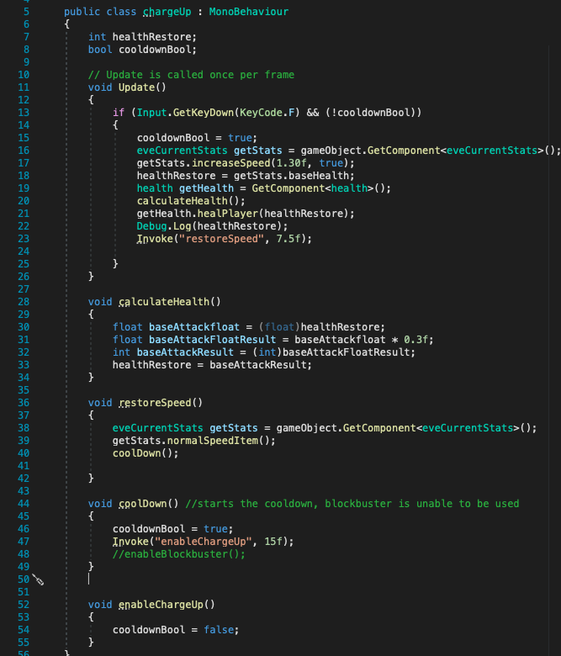

* **SEE CHARGE UP TEST**
* **Null_void**
  + Since I have created the enemy/ player detectors for the other classes, I can apply the same concept here. Whenever an enemy enters the range of the attack, a counter will be incremented, and once an enemy leaves the range, the counter will be decreased. The circle will have a radius of 5, but this can be adjusted.
  + There will be an addition if statement within the OnTriggerStay2D statement, so then the enemy’s take damage if they are within range and the activation Boolean has been set to true. Once this happens, the enemies should be dealt a 200% attack
  + When attempting to increase the attack and return it to normal, I have found a constant empty object error occurring.
  + 
  + And as shown, when using console comments to find the issue, the prefabs that have the bullet class do not come up. I have found that the process I’m trying to achieve can only work using static objects. So, I have removed the lines of code that would call the setAttack method and instead the attack value is retrieved every time the prefab is instantiated. This is something I was trying to avoid, however there seems to be no other alternative, so future attacks that do not use the bullet class will ned to do the same thing.
  + The player detector did not work as the enemy was just incrementing the enemy continuously, so instead I separated the function between a OnTriggerEnter2D method, which increases the enemy count, and an OnTriggerStay2D that calls the attack to the particular enemy objects within range.
  + After I sorting this out, I focused on getting the attack proportion to work. Unlike blockbuster or any of the standard weapons, a prefab is not instantiated when the button is pressed, instead the trigger uses the enemy objects within its range and the calls the TakeDamage method in their health class.
    - I tried to get this to work by getting the enemy detector to go into the activator and use a Boolean variable to decide whether or not to attack the enemies. This did not work as the enemy detector could not receive the variable in time, therefore not attacking the player. I managed to fix this by switching the situation so the Null_void activator calls a method within the player detector that sets a Boolean to true, to which the enemies within the detector are attacked.
  + After getting the attack to work, I focused on the health part of this move. In the activator class, I retrieved the enemy count that is in the Null_void detector, then referencing the player healing station class and the increase speed method in the current stat class, I found a way to multiply the base health by 0.1 and then multiply that product by the number of enemies within the detector. This is then set to the health class on the player, and the increase is represented on the health bar.
  + I tested this by spawning in two easy enemies, then using them to take some damage. Then I call the Null_void class and check the enemies to see if they have lost the right amount of damage (200 damage). I also check through the current stat class that Eve’s attack switches between the increased rate and the reduced amount. I also double check that the health bar increases. I add some addition comments for the console so that I can make sure that everything has the correct values.
  + Here is the code for the Null_void activator:

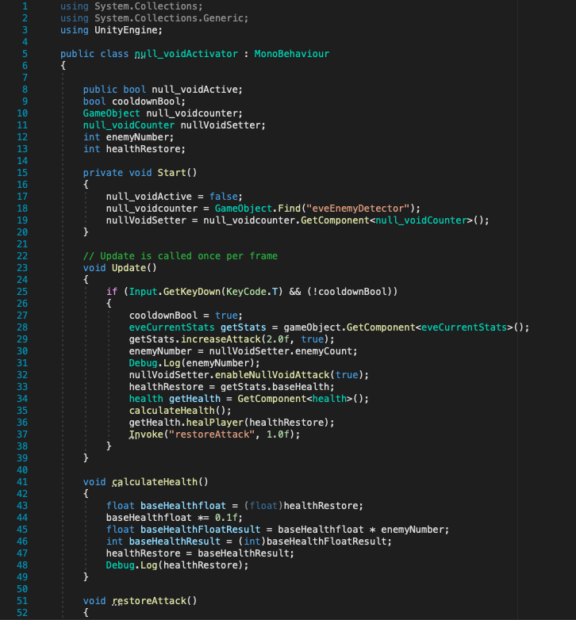

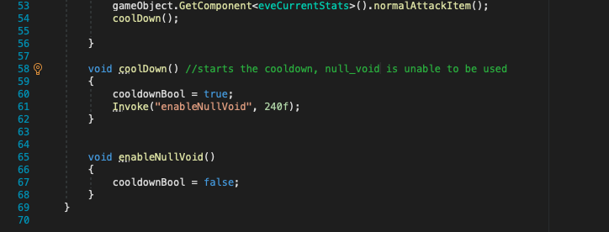

* + Here is the code for the Null_void detector:

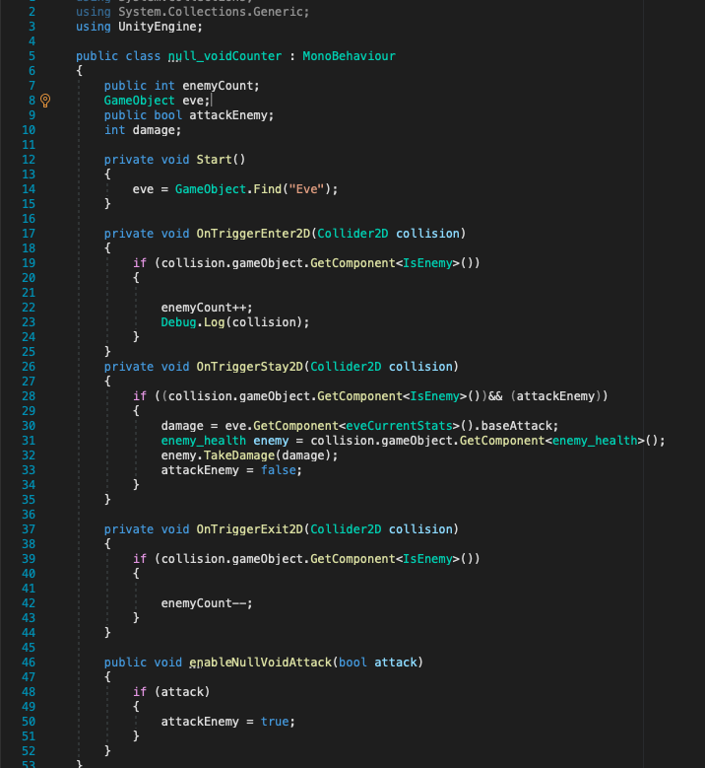

* + **SEE NULL_VOID TEST**

**Suki**

Now that I have done a health restore, attack and speed boost, future moves should be a lot easier to complete.

* **Tune out**
  + This call is fairly easy to complete, even if it’s a different type of move than I have made before, it will be similar to the increase stats method in the current base stats of the main characters.
  + In order to get this to work, I’ll have to make some addition the contact enemy class and the difficult enemy projectile class. The base attack for these enemies will need to be saved(which can just be to a variable since the enemy damage remains the same throughout the game), then the damage stat will be multiplied by 0.6 to reduce the damage to 60%. After 5 seconds the damage will be returned to normal. This will need to be done through classes so Suki’s object can call the correct information.
  + Since the same issue for the bullets not being able to be assessed from other class due to them remaining constant, the enemy projectile just needs to constantly check the enemy_contact class for an updated damage variable.
  + I was also having the issue that the enemies are unable to have their stats decreases due to the enemy objects not being able to be found, resulting in a missing object error. So, I have changed the attack so now, any enemy’s that player comes into contact with, the damage is decreased. With this I can use a collision method with goes into the objects health class and decreases the damage, then after 10 seconds, the enemy’s damage is restored back to its original value.
  + I tested this using an easy enemy, enabling tune out and then checking Suki’s health class to see the amount see was decreasing.
  + Here is the additional section added to the enemy_contact class:

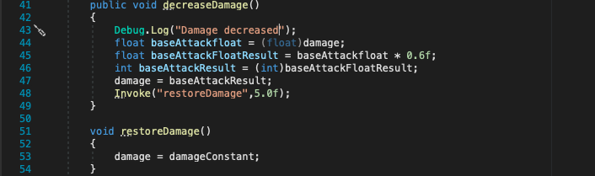

* + Here is the Tune out class:

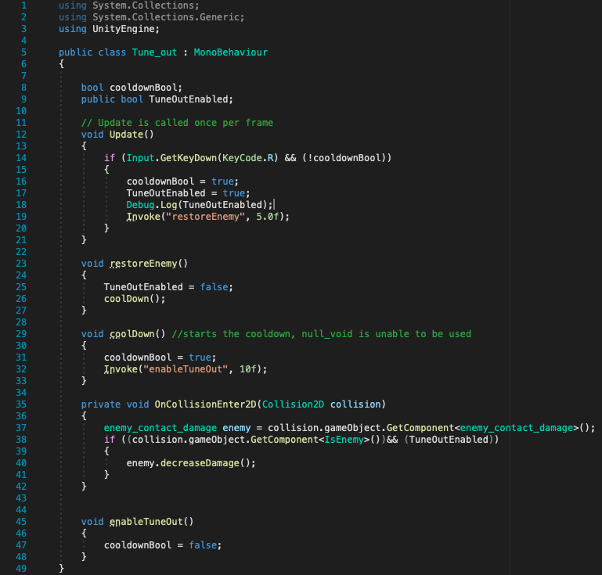

* + **SEE TUNE OUT TEST**
* **Crunch time**
  + This class will be nearly exactly the same as the charge up and part of the Null_void class.
  + Here is the crunch time class:

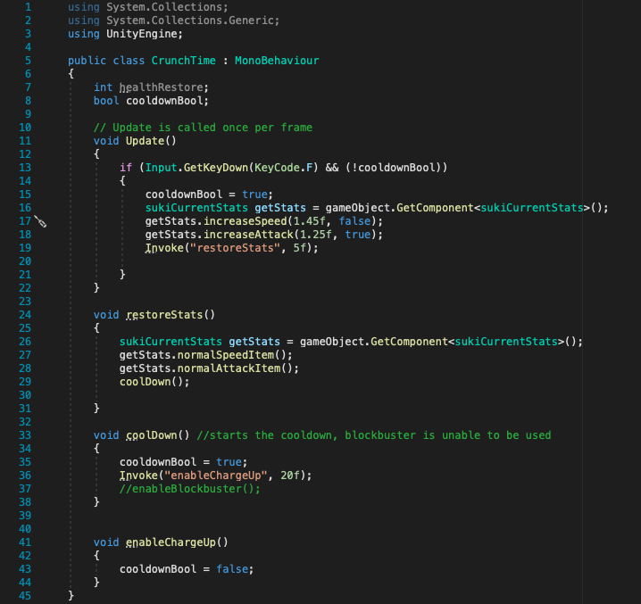

* + **SEE CRUNCH TIME TEST**
* **Pause/Restart**
  + Copied section from the charge up class
  + Everything went to plan, fairly simple concept
  + Reset the standard weapon to the space bar.
  + Used a pre-set button to set health to 10, and then enabled Pause/Restart. An extra comment was added to make sure the correct amount of health is restored to the player.
  + Here is the code for the Pause/Restart class:

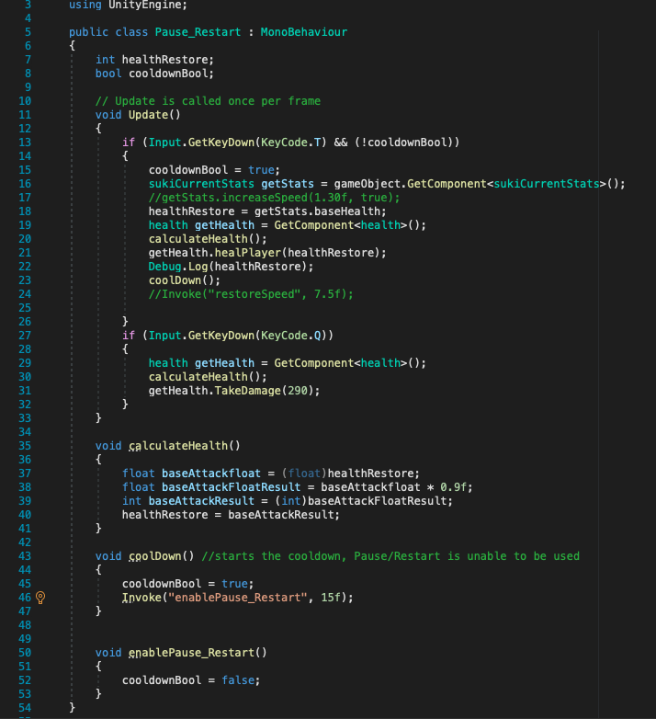

* + **SEE PAUSE/RESTART TEST**

**Emiko**

* **Level up**
  + This class is very similar to charge up but instead affecting the Emiko object rather than the Eve one. I made reference back to the charge up and wrote it so it could work similarly changing the appropriate features, This is definitely made easier by the object working the same way and the fact I tried to keep everything fairly consistent. I have not added many comments throughout my code but I have planned everything fairly well, so I keep making references back to that which prevents me from having conflicts with the code. Most issues that I run into are due to my misunderstanding of using unity, or a lack of familiarity with the system. There are some incidences where I have problems with concepts from other languages not really being transferable but this can normally be fixed with research.
  + In order to make this fit Emiko, I just changed some variable names and wait times.
  + Same issue as Crunch Time, Speed not being saved, fixed by adding an extra variable.
  + Tested by checking the current base stats in the inspector window.
  + Here is the code for Level Up:

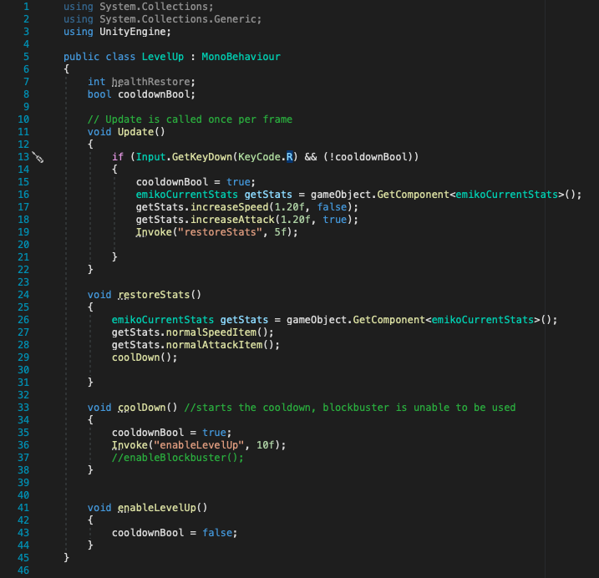

* + **SEE LEVEL UP TEST**
* **Medic!**
  + I copied the health restore from the charge up class, everything works correctly, some variables needed to be changed around and some of the cooldown wait times needed to be change to fit this move.
  + Tested it by pre-setting a button to remove 70 health from the player, and watching the current stats in the inspector window. The health retore was also printed to the console (18.75 points should have been restored and 18 has add, which makes sense as the amount needed to be put into an integer format).
  + Here is the code for Medic!:

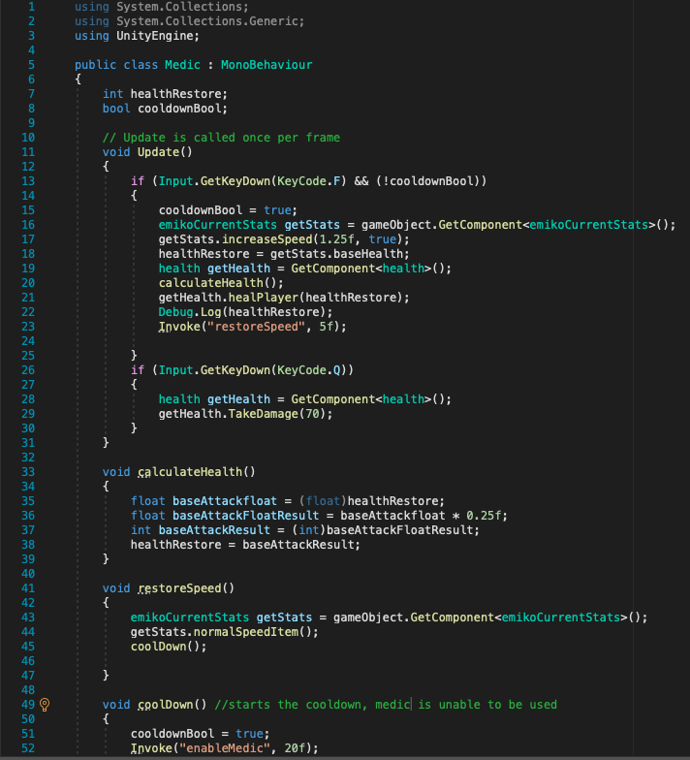

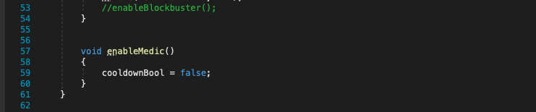

* + **SEE !MEDIC TEST**
* **BEASTMODE**
  + Although I though this to be quite difficult, I managed to make a variation of the standard weapon, but instead there being only one firepoint, there will be multiple on the object. An attack increase will be added as well so that each bullet deal 50% more damage, but this will be disabled after 1 second.
  + Initially I tried to add the bullets by creating a series of transforms and then adding a BEASTMODE class to each one, but this did not work as only one bullet would be spawned in. Instead, I added the BEASTMODE class to a parent object and then manually set each transform. This work but all the bullets were going in the same direction. To fix this I added a start method, which rotated half the transforms to face the other direction. The bullets themselves worked when colliding with an enemy, since it is the same bullet prefab as before and the rest of the script is an edited version of the standard weapon.
  + Now I added the attack increase, but I will just reference the level up class to do this, it just needs to be before the bullet are called so they have the increased damage. The attack will be returned to normal 1 second after the bullets have been called.
  + I tested this by calling the BEASTMODE class and then checking the current stats class in the inspector window to make sure that the attack increases and returns to normal correctly. I then check the easy enemies in the scene if they received the correct amount of damage.
  + Here is the code for the BEASTMODE activator:

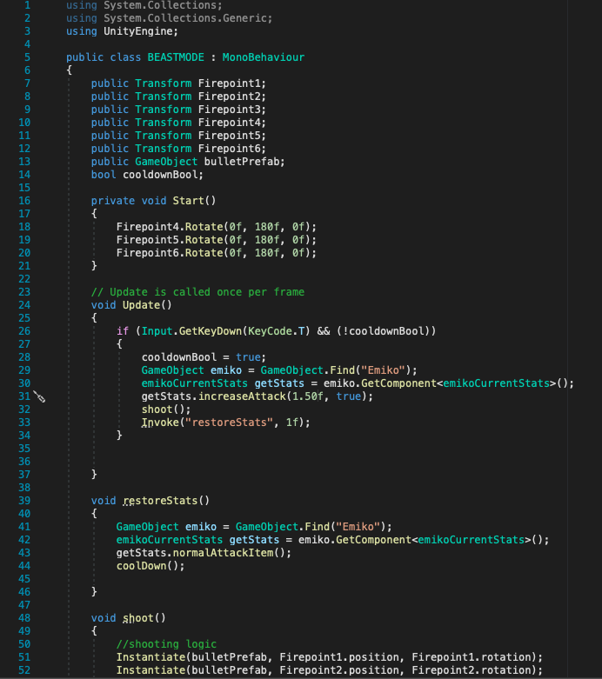

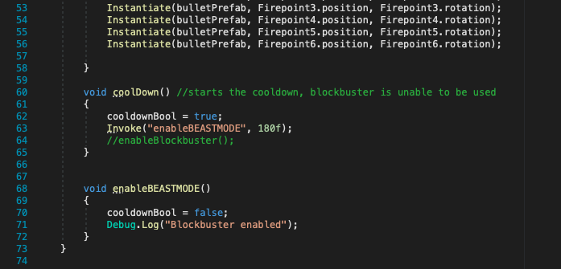

* + **SEE BEASTMODE TEST**

**Character Upgrades**

Introduction

Initially when I thought of character upgrades, I was going to make some classes that could be enables after a button was pressed, but I could not figure out how to get it to work, especially how the players were going to be able to buy anything from it. But after I became more familiar with the UI elements, I found the best way to make the character upgrades. Since buttons can be assigned with a function from a class when they are clicked. This then gave me the idea of changing the way the stats are held. Since all the upgrades affect the stats, there will two classes that interact with each other that creates the stats for the player, which were the constant base stats and the current base stats.

The current base stats class is the class with all the other class interact with in order to control the player, whereas the constant base stats can only be accessed by the current base stats class, and even then the variables cannot be changed, other than the level changing.

The character upgrades will the then accesses the current base stats, and call a function that increases the stat is affecting. If this item is used, then I will then add a multiplier onto the stat. If the upgrade is removed then a method to the current base stat class that goes back to the constant base stat class and resets the stat. For this to work on the merchant window, the button will then be connected to the character upgrade.

Main class accesses the character upgrades, and enables or disables them, another class is used to see if the player can buy the item, if so the buy button is removed and the enable and disable buttons are there instead.

Creating the merchant window that can be enabled or disabled using a button on the screen.

Each player character needed to have their own their own menu, so the character specific items are not available for all of them, and so the correct current stats class is accessed. So, I needed to write a class for buying the upgrades and another for using the character upgrades, then repeat this for each character.

Here is the class for buying the character upgrades:

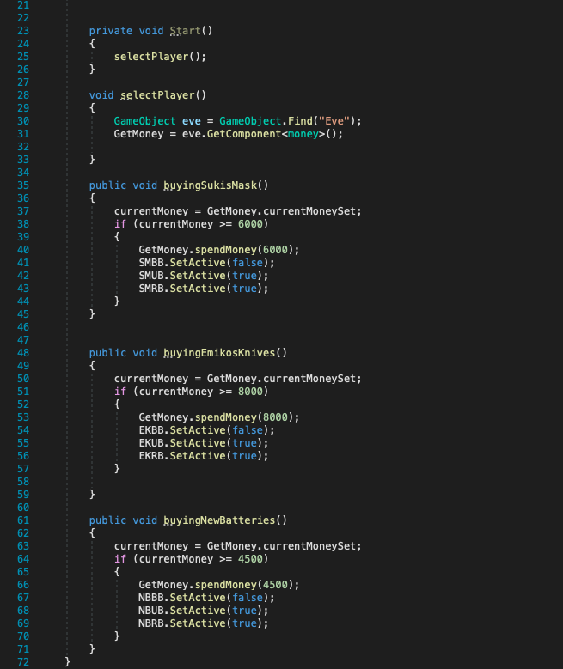

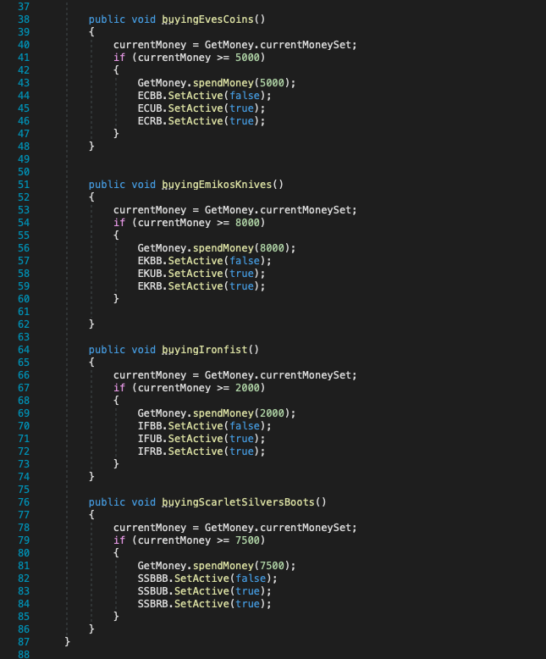

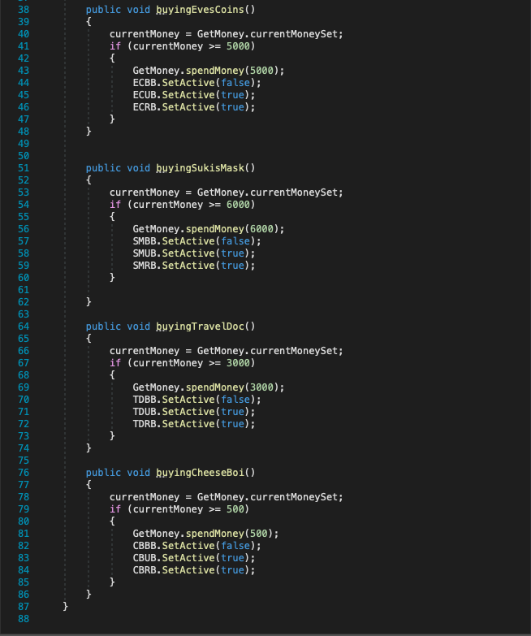

Here is the class for the buying the general items:

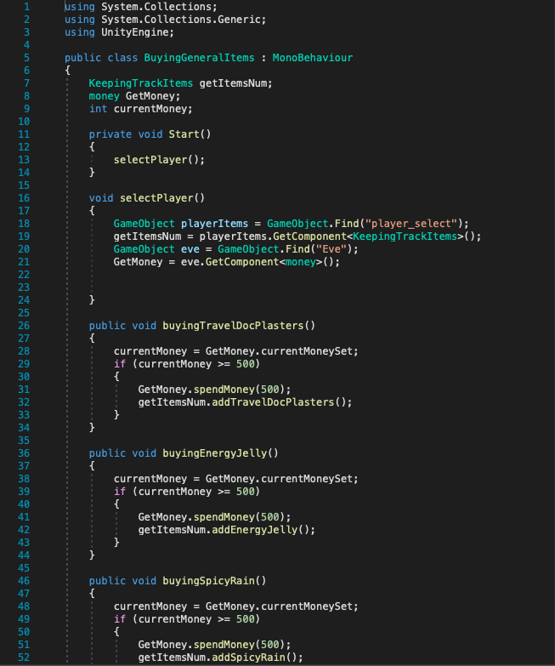

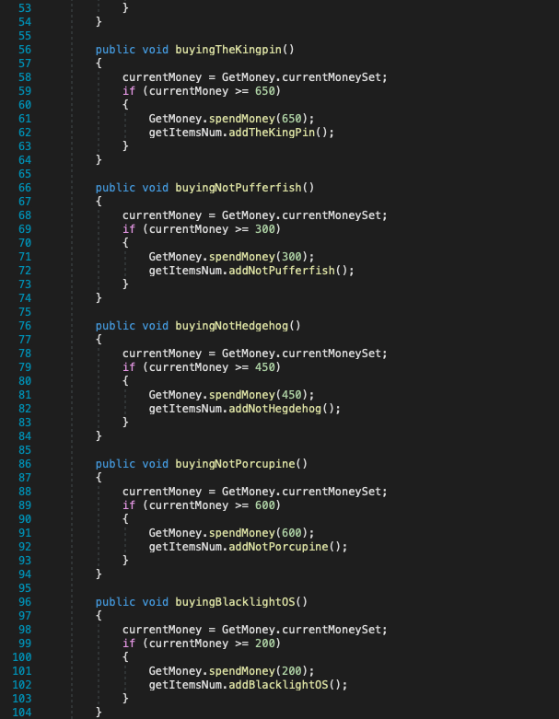

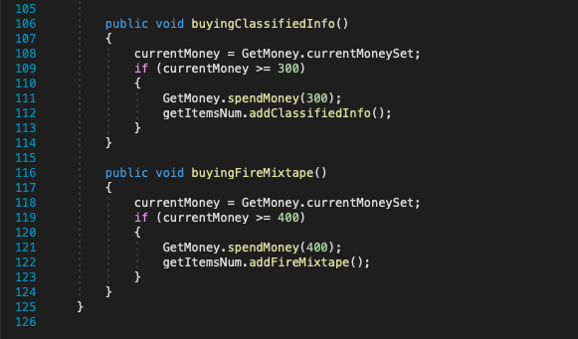

Here is the class for using the character upgrades:

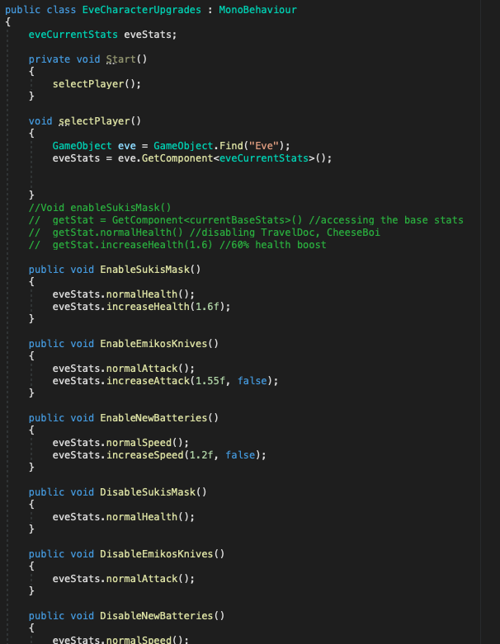

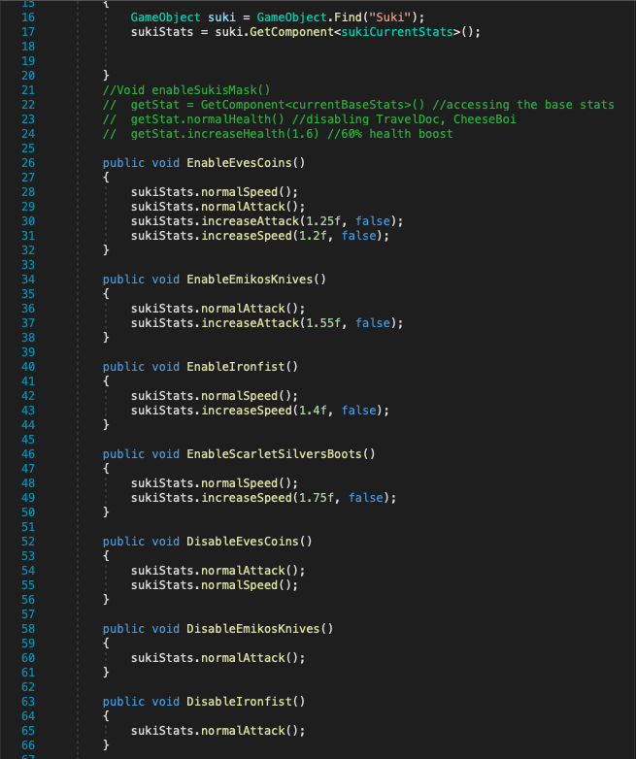

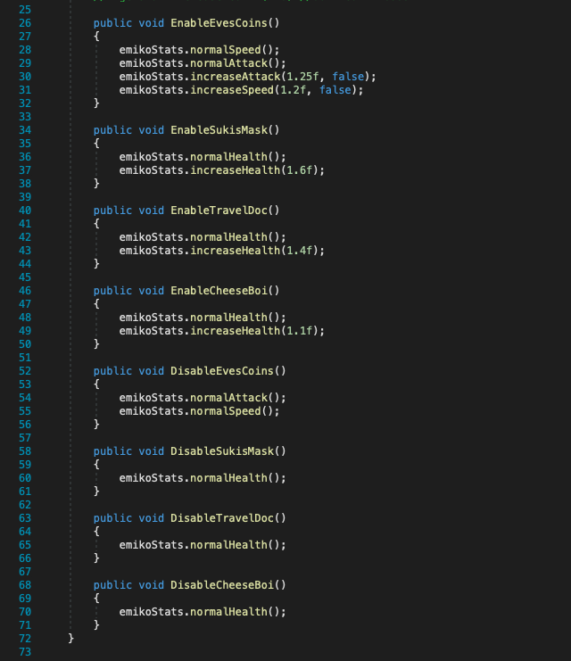

**Building the merchant window**

Now that I have completed the character upgrades, I can move onto the merchant window. Although the general items can be accessed through this window, it is less about the function of them and instead increasing the amount the player has. I could keep track of this by creating a class within the players select object. Since this object is outside of the level, the number of items will be useable for all levels. Since I was mainly checking the function of the character upgrades, the general items actual functions have not been added yet.

To make the actual window come up, a button in the corner of the screen can be clicked and the window will be opened, this menu can then be closed by clicking the exit button. Since there are three separate menus, there are three separate buttons that open them. The buttons are disabled when the game is started and then is only enabled when the character is selected.

Each merchant window will then have two windows that display either the character upgrades or general items. There are buttons that correspond to each window, which when pressed enables that window and disables the other.

Here is the general items window:

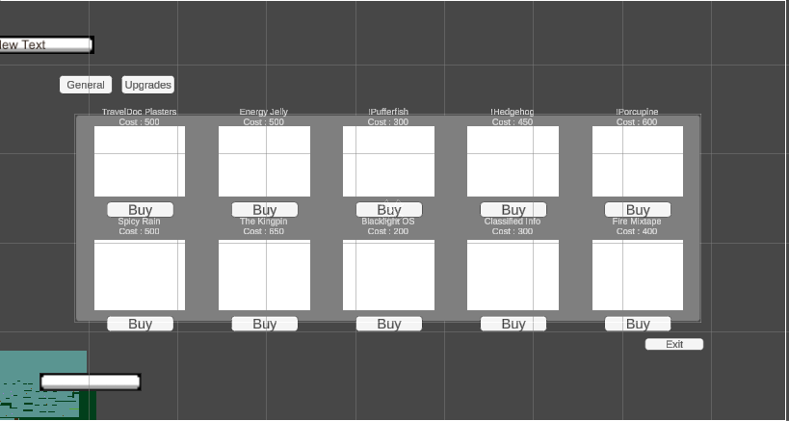

Here is the eve character upgrades window:

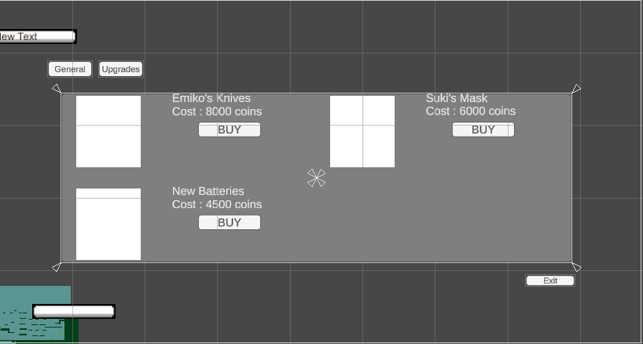

Here is the suki character upgrades window:

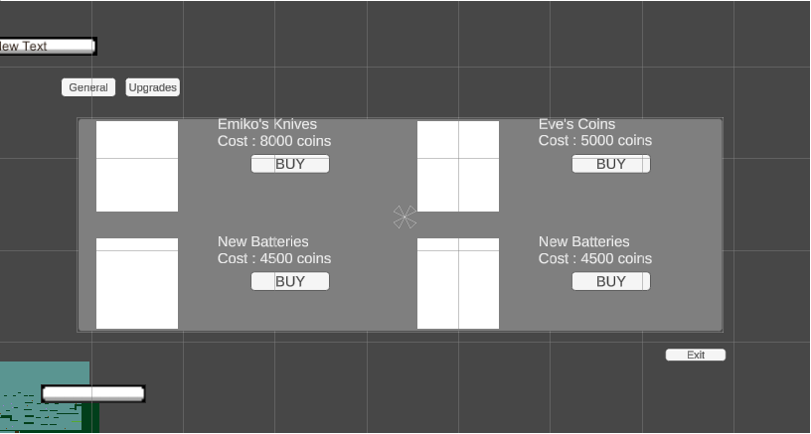

Here is the emiko character upgrades window:

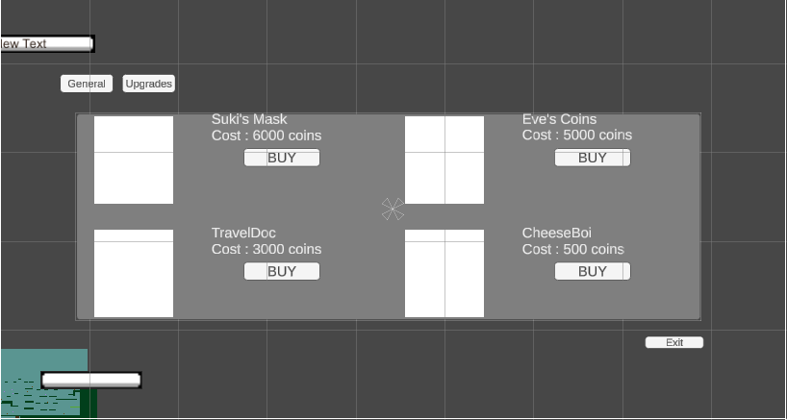

The character upgrades function has been explained beforehand. The buying upgrades methods was added to the buy button’s OnClick feature.

Since the general items can be bought so long the player has enough money, I created a class that checks how much how much money the player has, and if they have enough, a method in the player_select object’s class called keepingTrackItems is used and increases the amount of that item increases by 1.

Here is the keepingTrackItems class:

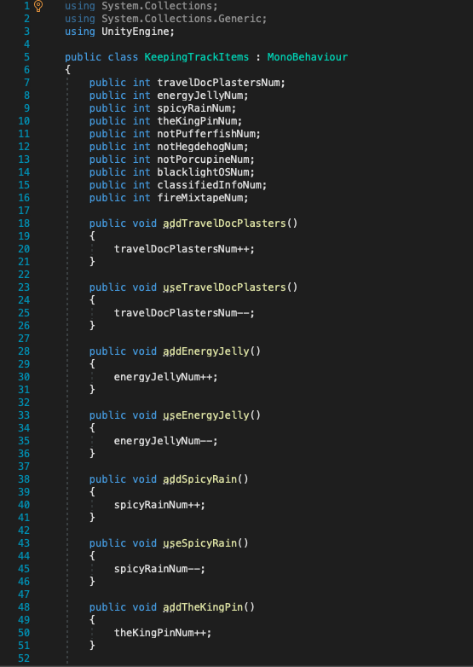

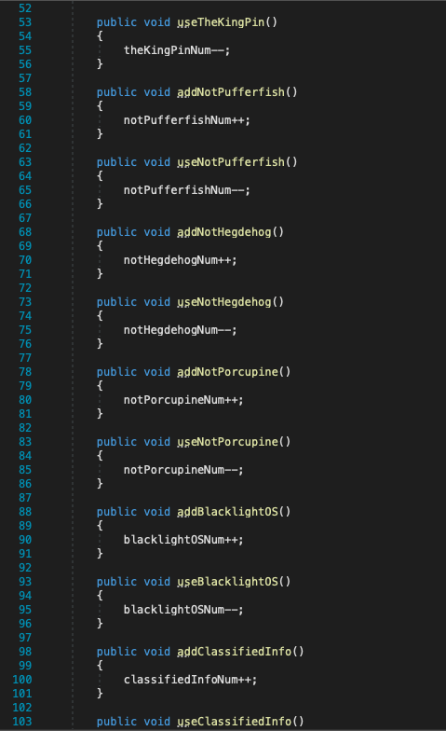

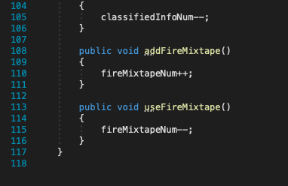

**SEE EVE CHARACTER UPGRADES**

**SEE SUKI CHARACTER UPGRADES**

**SEE EMIKO CHARACTER UPGRADES**

**SEE EVE BUYING GENERAL ITEMS**

**SEE SUKI BUYING GENERAL ITEMS**

**SEE EMIKO BUYING GENERAL ITEMS**

**General Items**

Now that I had the merchant window where you could purchase the general items and a place within the game where I could keep track of the number of them, I could start implementing them to the game.

Originally, I planned for individual classes to be made for each item and then this would be added to the parent object of the players, but this was before I realised that there would be missing object errors that would occur when this is used. So instead, I created a general items class that is specific to each character so the correct classes/ variables are accessed, that also had all the items actions contained within them. The function and contents of these class will be the same, but I needed to make this distinction otherwise this could cause issues. I could have added a switch case statement like I did for other classes, but I thought the constant checking with player could so down the progress.

The actual writing of the class was made significantly easier since I have made a similar move using the special moves that the player has, so the coding process during the process, I was referencing my pseudocode as well as using previously made class to achieve their function. The only difference being that instead of the move checking if it can be enabled if the cooldown Boolean was set to false, this move instead checks the keepingTrackItems class if there is at least one of these items left, if so then the action can be used. Otherwise, nothing is being done. And while the item has been used, it removes decreases the corresponding variable in the keepingTrackItems class by calling the useItemName method.

Here is a quick break down of each action:

* TravelDoc Plasters – a 15% health restore is calculated after the player’s health capacity has been retrieved. Then the healingPlayer method in the player’s health class is called, using the calculated value. I made references from the character special moves.
* Energy Jelly – the increaseSpeed method in the character current stats class is called, with a 15% multiplier used. After 10 seconds, the normalSpeedItem is called, returning the speed back to its original value.
* Spicy Rain – Similar process to Energy Jelly, but instead for the attack stat.
* The Kingpin – the same code for the TravelDoc Plasters is added, as well as energy Jelly and Spicy Rain with a 15% restore to the players health, and a 10% boost to the attack and speed for 10 seconds.
* !Pufferfish – A prefab is instantiated that has been publicly defined in the inspector window. The prefab gameObject is identical to the bullet [prefab, but instead the attack is retrieved for the player’s class and then multiplied by 1.25 (25% increased attack). The code in the actual general items class is just the activator.
* !Hedgehog – The same as !Pufferfish, but instead the attack value is multiplied by 1.75 (75% increased attack).
* !Porcupine - T he same as !Pufferfish, but instead the attack value is multiplied by 2.5 (150% increased attack).
* Blacklight OS - A prefab is instantiated that has been publicly defined in the inspector window. The prefab gameObject is identical to the blockbuster (so the attack does not move) prefab, but instead the attack is retrieved for the player’s class and then multiplied by 1.25 (25% increased attack). The code in the actual general items class is just the activator.
* Classified info - T he same as Blacklight OS, but instead the attack value is multiplied by 1.75 (75% increased attack).
* Fire Mixtape - T he same as Blacklight OS, but instead the attack value is multiplied by 2.50 (150% increased attack).

Initially, I tested these actions out by removing the if statement that checks whether or not the player had at least one of these items, so I could just see if the actual action worked. After confirming that the item’s action worked correctly, I added the if statement back and checked that the item can still be used only when there is at least 1 item, I could then buy the items in the merchant window and test out each action, which was a success.

Here is the code for the general items:

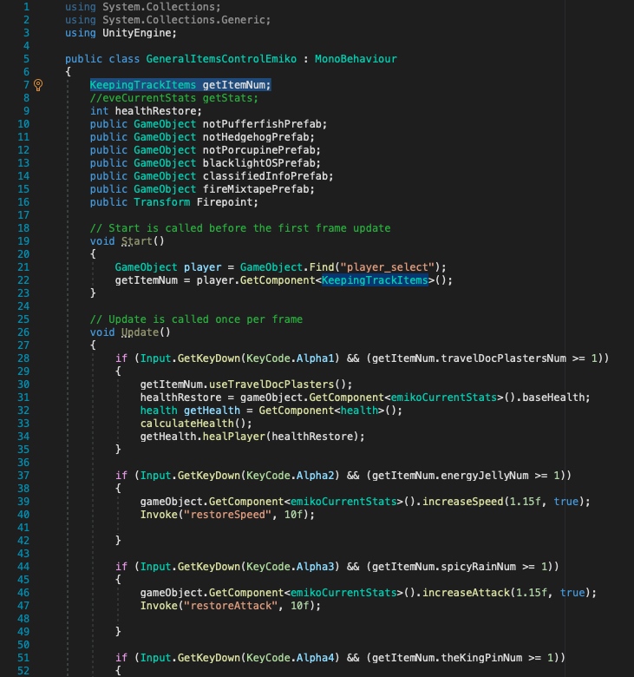

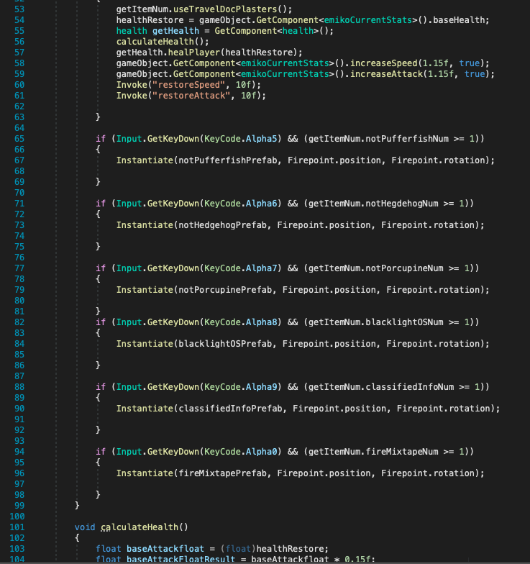

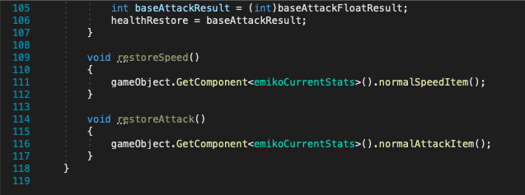

**SEE GENERAL ITEMS TEST**

**Enemy drops**

Now that I had created functioning general items I could implement the enemy drops that enemy would leave when it dies. In order to do this, I need to create a prefab that when the player collides with it, it calls the gainItemName method in the keepingTrackItems method and increments the integer for that item by 1. Once this was completed, I could start creating the class that the enemies would call when they die.

Here is the code for one of the items:

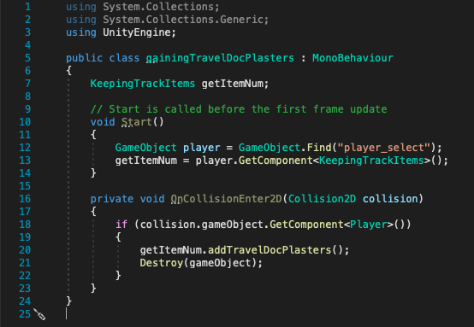

After this I made prefabs for all the general items, so they can be picked up by the player.

Then I need to create the class that would instantiate the prefab into the level. To do this I thought I could create a method that could be called by the enemy when it dies and then it randomly generates a specific number for an array. This number is then put into a switch case statement that can then instantiate a prefab that has been manually assigned in the inspector window.

I needed to create separate classes for each type of enemy and then assign this class to the parent object that the different enemies are under. This would mean the object would need to be manually searched for but it would work all the same. All the enemy would need to give is a transform point or firepoint that the prefab can be sent out from.

The class would then generate a random number from an array and send that result to another method that instantiates the corresponding prefab. Since each enemy has different item available, the switch case statement will vary in length, and the number of objects that need to be assigned in the inspector window. A for loop would be added to the randomly generated number so then multiple items can be randomly chosen. When I had initially planned for this class to be available to all the enemies, when the enemy called to this class, it would also say how many items were needed. This however would not work so I now, that I had to create separate classes, I just hardcoded the number of items that need to be selected.

The array that I used in this class has the probably of each item skewed, as I could not increase the likelihood of getting a specific class as the random method gives each number an equal change. So, the more that number is in the array, the greater the chance of receiving the item.

When I tested this out and just wanted to see if this would work, I set it so the enemy would drop the items as soon as the level was started, and once that worked, I added a section to the enemy health class so when the enemy dies, it drops the items. I needed to add an additional variable to the enemy’s so it could differentiate what type it was so then it could call the correct drop script. (1 – Easy, 2- Medium, 3- Difficult)

Here is the additional section added to the enemy health class:

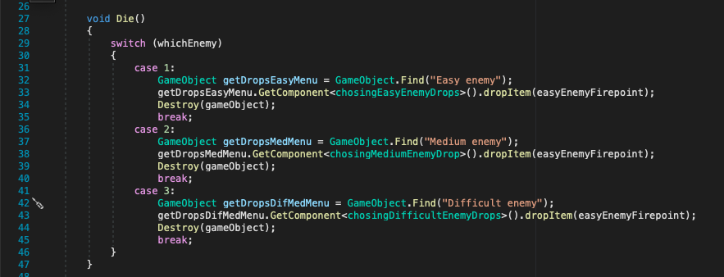

Here is the code for the Easy Enemy drops class:

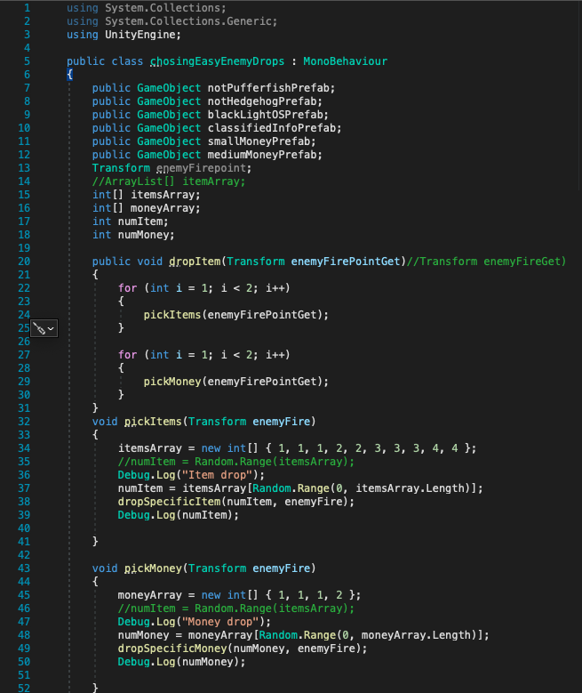

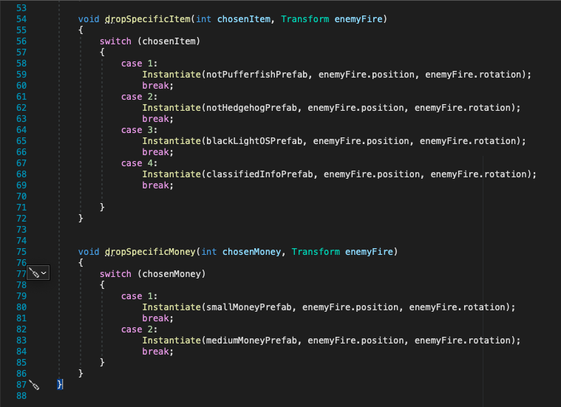

Here is the code for the Medium Enemy drops class:

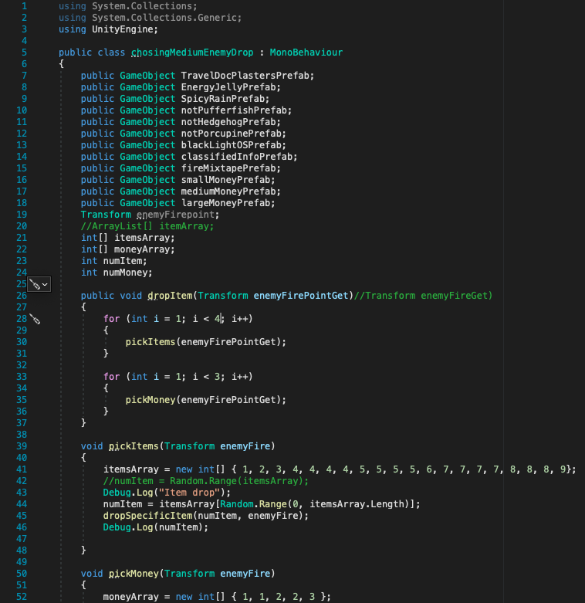

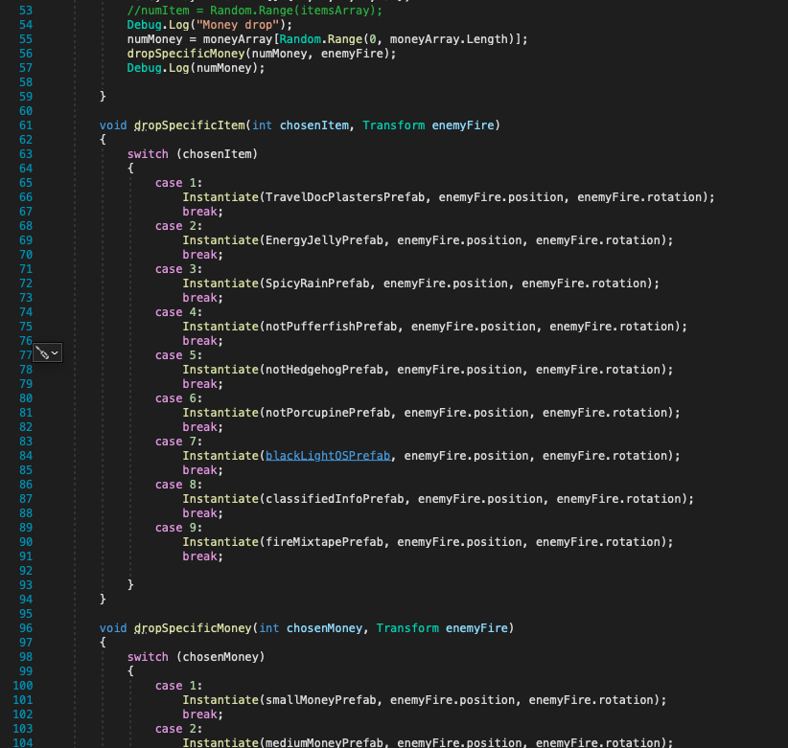

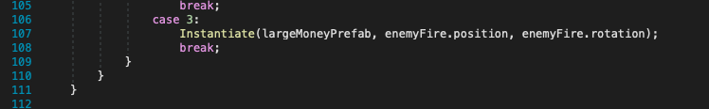

Here is the code for the Difficult Enemy drops class:

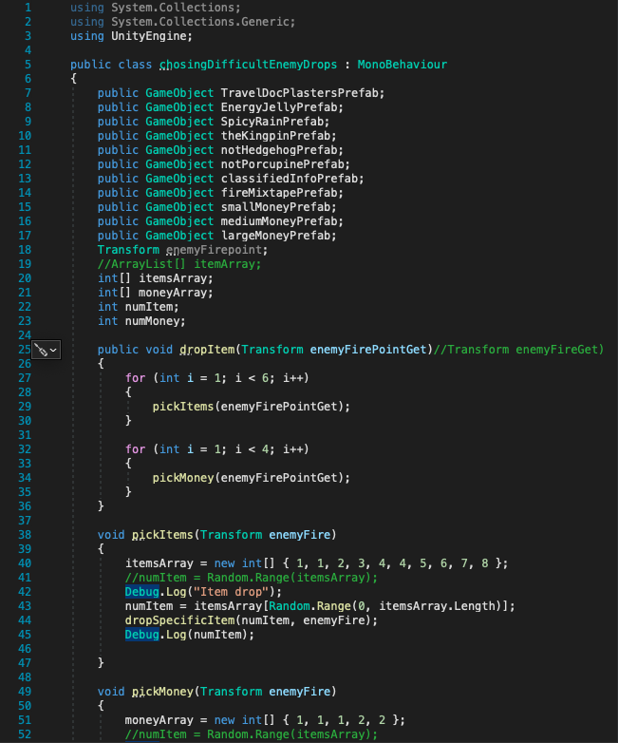

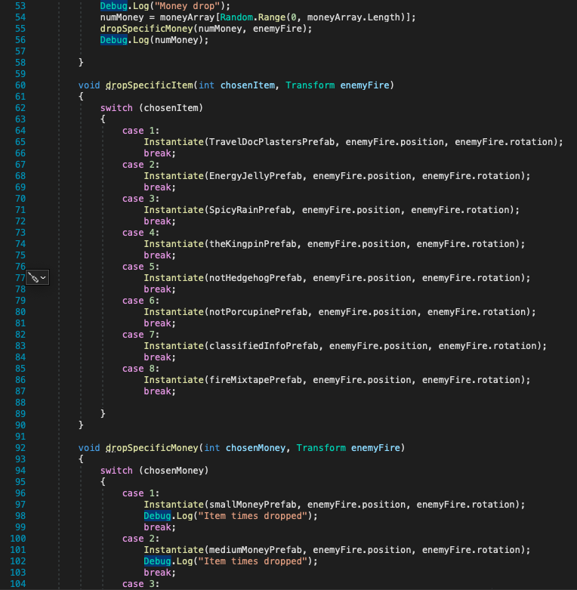

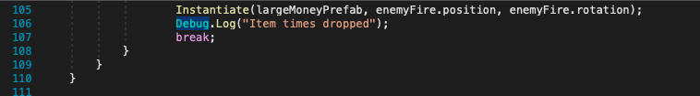

**SEE ENEMY DROPS TEST**

**Re-evaluating game features due to time constrains**

Although I thought about this before starting to build the merchant window for items, time was beginning to run out and I found that I would not have enough time to completely implement all the feature I wanted. The enemies themselves took a lot longer than anticipated and everything seemed to be taking an extra three days to complete. I had planned for this as I know that I was fairly ambitious during planning especially since I had little to no knowledge about developing a game, let alone in a language that I had only recently learnt how to use.

If I continued the way that I was going, there would be not final product to present, so soe choices needed to be made. In order to combat this, I looked back to my features to be tested plan and decided what to remove and this is the list of what needed to be changed, how I was going to work around it and why I thought so.

* Multiple levels – Since the game just needed at least one level to use all the main features, I decide to just focus on making the one level and making sure everything worked. The character would still be capable of moving onto the next level, but trying to transfer everything over would take too long to figure out which would then lead to broke features.
* Other types of character/enemy movement – This more so to do with the fact that there are no longer any further levels, so the player just needs need to be able to run around normally. I might have been able to add this if so some the movements were not so drastically different to everything else.
* Animation – Since this is not integral to the main features of the game mechanics, I decided to just work with the placeholders and show that everything has a place. This would not create the best looking project but I needed to focus on the actual building of the game, so this seemed fairly unimportant.
* Icons for the items and special moves – The computer was struggling with all the UI elements that I had in the game, and the icons were just not appearing even after replicating some of the actions I had made prior with other UI elements. Since I believed other feature to be more important I decided to scrape this idea.
* Save menu – This was a another fairly big chunk of the game that I decided to leave out, and after doing some more research, I found that this could take me another month or so properly implement, so that was a big reason as to why I scraped this idea. This also a feature that could not be left unfinished as I could cause many issues later down the line. Also, since the game has been reduced to one level, there did not seem much reason to save anything as just restarting the game would give you the same result.
* Options menu – This was more so something I would have l liked to add, rather than a key feature, so deciding to remove it for time seemed to be the best option.
* Cutscenes/ story – Like the animation, this was not integral to the key mechanics of the game and was more so to provide a more immersive experience. Planning a cohesive story would have taken up even more time, as well as probably seem a bit out of place if not completed. Removing the story does not affect the game play, so it was a pretty easy thing to do.
* Interactive tutorial level – This was somewhat linked to the story for the game, but also creating three different tutorial sequence would have taken a fairly long time. Not only would I need to create the specific situations that could get the specific moves to work, but trying to add the UI elements to top of that seemed extremely time consuming, which was time I did not have.

I was initially upset I would not be able to create exactly what my plan displayed, but I knew this was best in the long run if I want something at all playable.

**Dealh window and Ending window**

These menus where pretty easy to implement as it just required me to set them up and assign the replay button to open the starting window again and the exit button to shut the game down.

The death window is brought up whenever the player reaches 0 health, and the level object is closed. The ending/ winning window is then enabled whenever the player collides with the ending checkpoint. The level object is also closed at this point.

Here is the code for the ending checkpoint:

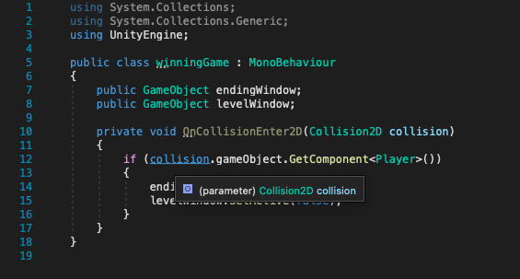

Here is the layout of the death window:



**SEE DEATH WINDOW TEST**

Here is the layout of the ending window:



**SEE WINNING GAME TEST**

**Opening sequence**

This was another section of the code that needed fairly little coding and mainly focused on the UI elements within the game and the onClick feature of the buttons which can enable and disable different objects. Any objects that cannot be used together(e.g., the character object or their virtual cameras) need to be disabled before the game is started. Once the play button is pressed, the character select menu can be brought up.

I created a series of windows that connect to one another and use the buttons to function. The opening menu is shown initially and have links to the control menu or the quit button. If the quit button is pressed the application will be closed, and the controls button brings you to a separate window that shown you the controls (there is an empty image there currently as a place holder) and then there is also a back button that can return you to the opening menu. Once the play button is pressed it brings up the character select and disables the opening menu object.

Here is the opening menu:



Here is the controls menu:



Here is the OnClick on the opening menu:

Play button

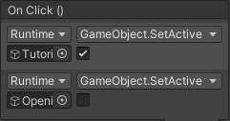

Controls button

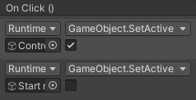

Exit button

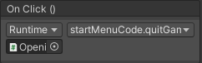

Back button

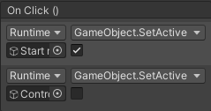

**SEE OPENING WINDOW TEST**

**Tutorial sequence**

Since I had to deviate from my original idea, I still needed a way to introduces the players to the game and understand some of the features. So, when the play button is pressed, instead of the interactable tutorial that I had planned, I would instead create a series of menus that tells the player about the different feature and enemies that they can use. There is a button that move onto the next window, which will enable the next window and disable the current menu open. When the final window is open, the player selector window is opened.

The on click feature is still heavily used in this section but really only have two functions, enable the next window and close the current one.

Here is one of the onClick functions for the next buttons:

And each menu is made up of a series of images, text and a button, which related to a portion of the game.

Here are the menus for the tutorial section:

Movement

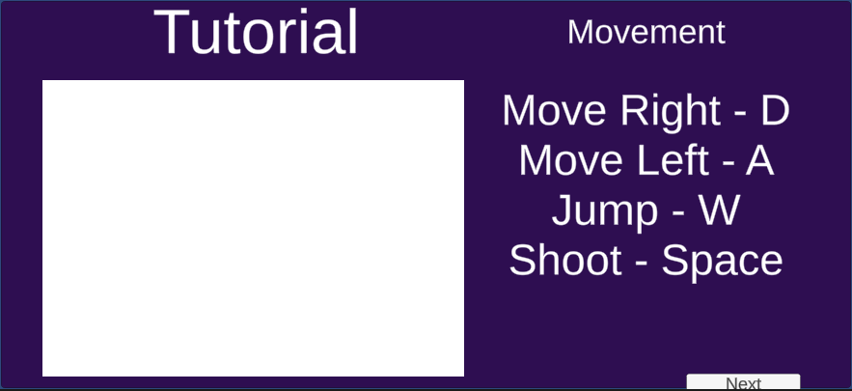

Special moves eve

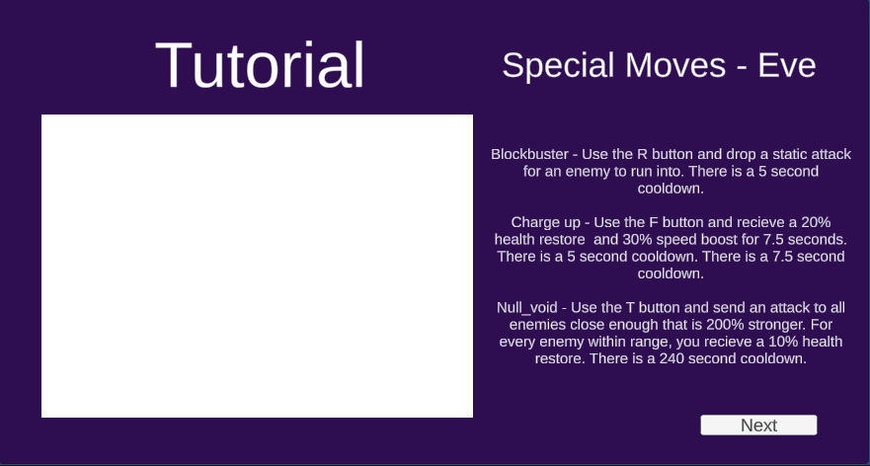

Special moves suki

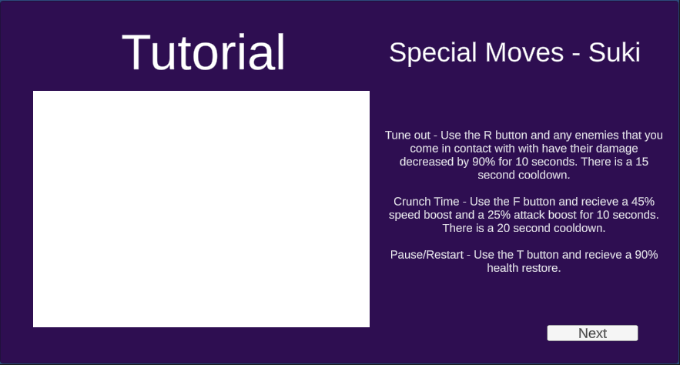

Special moves emiko

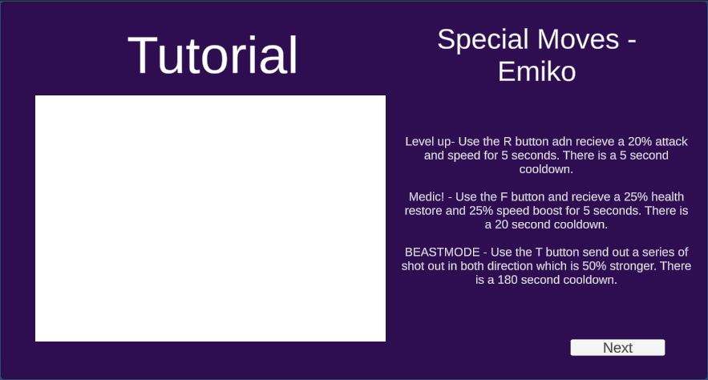

Character upgrades

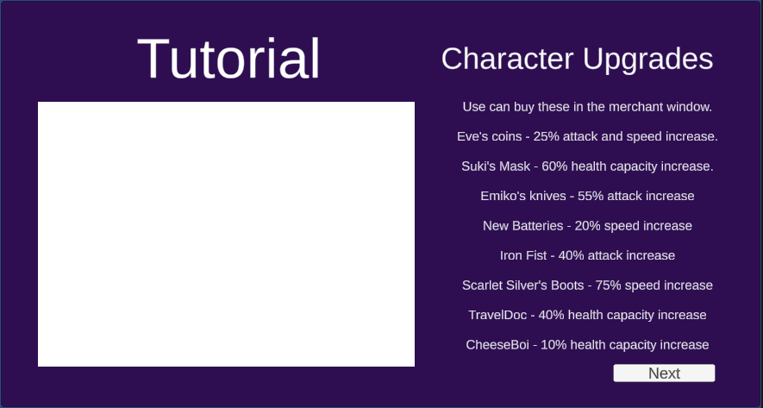

General Items

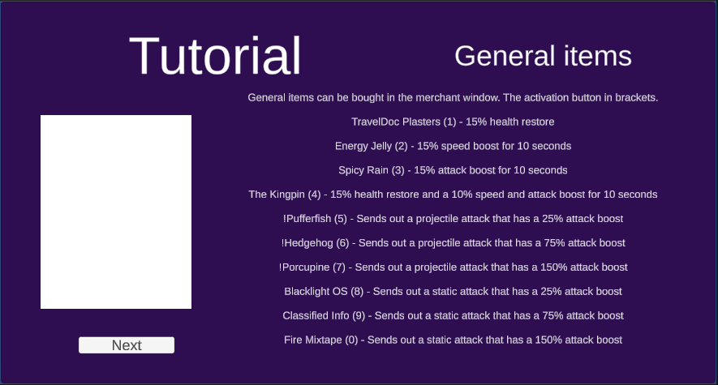

Easy enemy

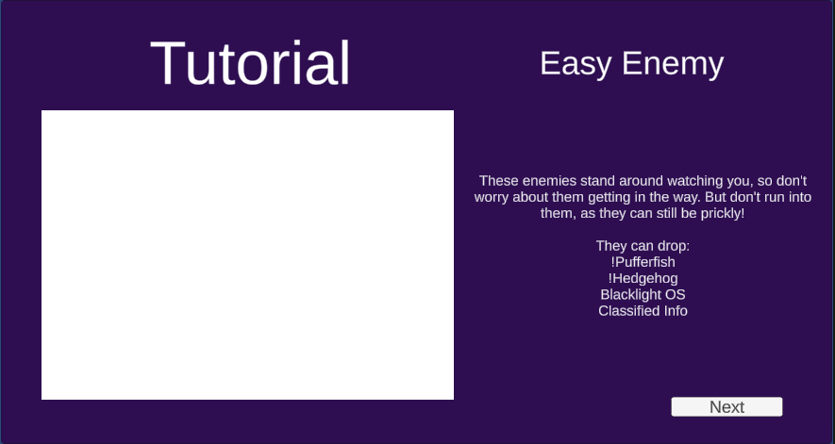

Medium enemy

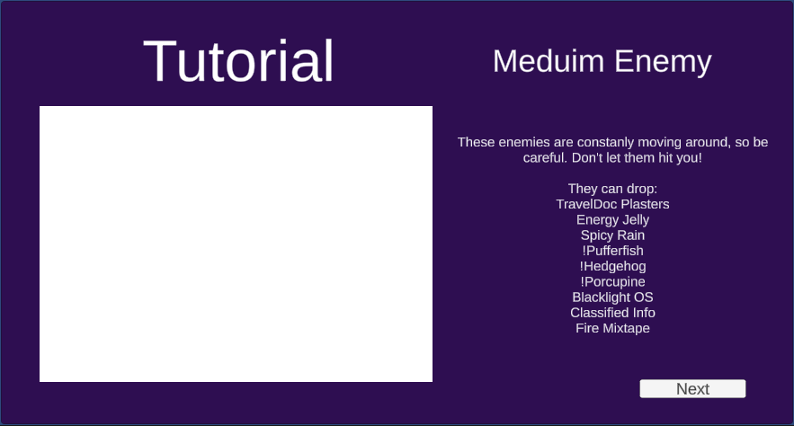

Difficult enemy

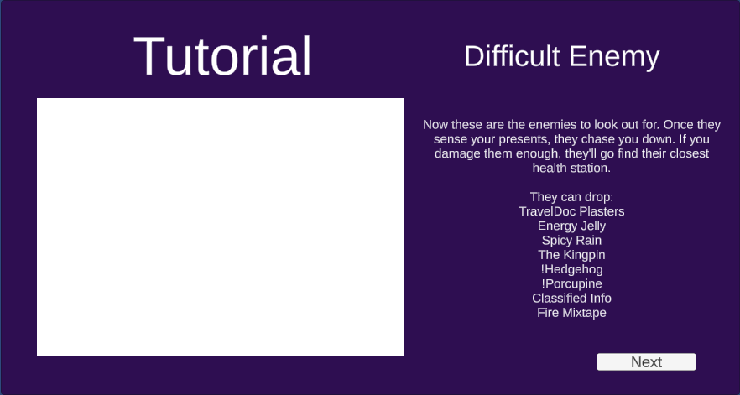

Player health section

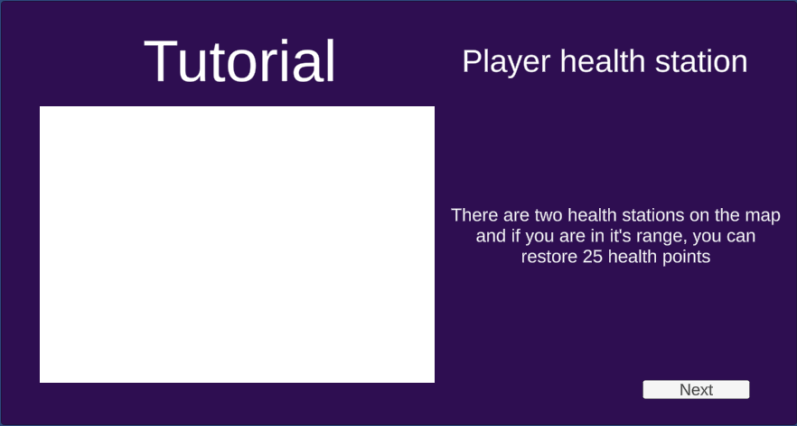

How to win

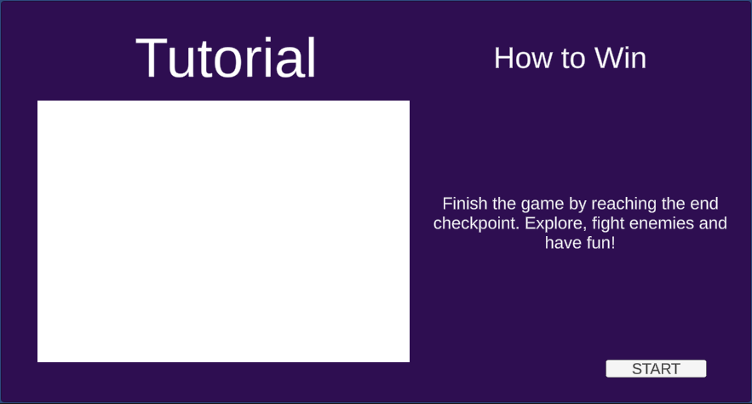

**SEE TUTORIAL WINDOWS TEST**

**Final game**

Now that I have all the components finished, I needed to just turn everything into the main level. This was easy enough as I had made the game so then I can just duplicate and place all the objects I need to within the game for the level. Using a diagram of level 1, I placed all my objects and now have a finished game. I disabled all the appropriate object and left the opening window, so now Adventure can be played.

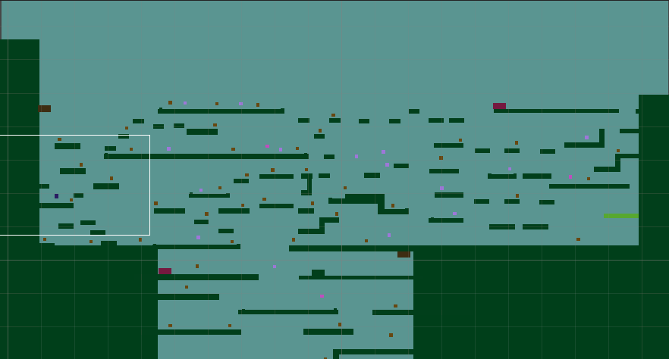

**Section Four: Evaluation**

**Max marks 20**

# 4.1 Testing to inform evaluation

## 4.1.1 Post development testing

Once I had finished developing the game, I did a run through and checked that it could be completed, however I wanted to see what other people’s perspective was on my game, especially some of those who did know anything about the game. I had tested this game consistently throughout development and become very familiar with everything, which probably skewed my interpretation of the game since I knew everything about it from development. By opening this up to a few beta testers, this gave the opportunity for people to truly navigate the game and have fun with it. Afterwards I gained some feedback through a survey sheet and here is some of the key data that I though could be important.

This would allow for any bugs that I have missed or features that are less intuitive to be spotted from someone who does not know anything about the game. I tried to explain as little as possible to my beta testers so I could get more genuine results.

## 4.1.2 Usability testing

As mentioned before, I got players to fill out a survey after they completed the game, so here are the results and some of my thoughts based on the feedback:

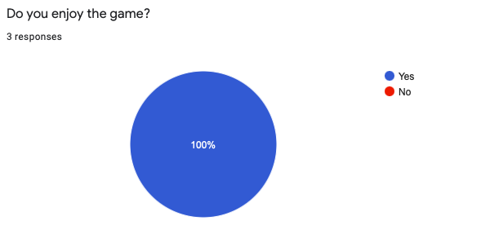

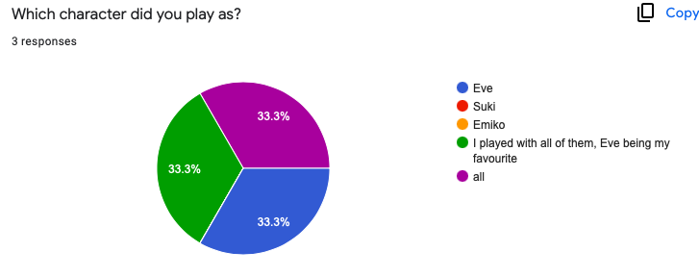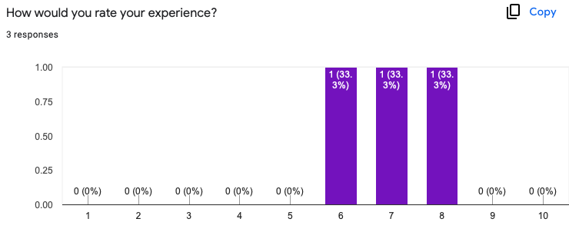

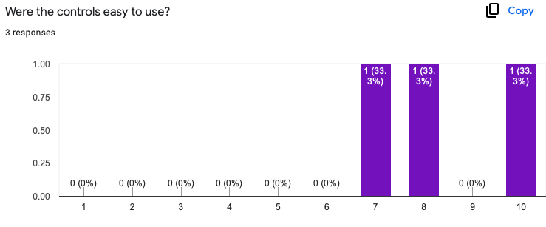

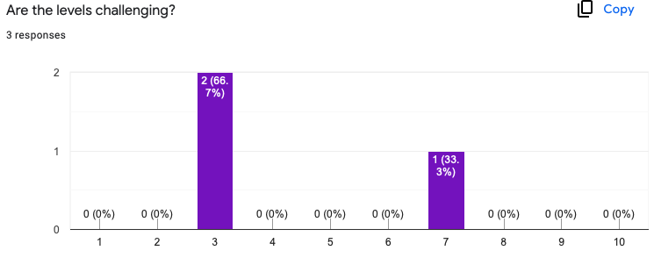

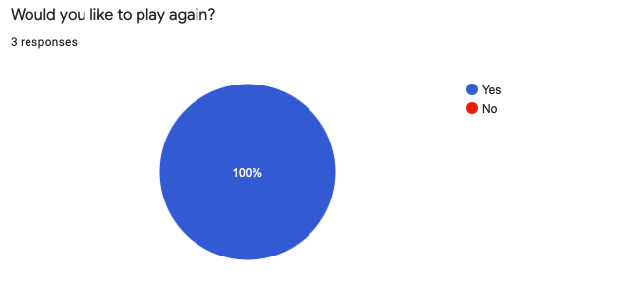

**What is your favourite feature?**

* I liked how you're able to destroy the enemies which they then drop an effect. I also like the aspect of the hard enemy chasing the player, it gives a sense of alertness and liveliness to the atmosphere.
* having so many upgrades available to buy in the merchants store.
* The different features for each character

**What improvement should be made?**

* The tutorial could be more accessible during the game? After reading about the different items and such, I couldn't exactly remember the item boosts and also the special moves each character had.
* just adding in images and sprites into the game to differentiate what each of the objects actually are whilst playing the game and adding more levels. I think you should make it more obvious as to where the player should go in order to reach the ending checkpoint as there are so many different routes the player can take around the map
* Increase the general speed of the players

I think that each of these points are very much valid and I think something I would like to add when revisiting the game. As for the tutorial portion, I think if I were able to create the tutorial I originally had in mind, this issue would have been fix as it would give players a chance to explore the different features. However, I did not realise that the tutorial level that I have in place felt like too much information, so I’m glad that I have this outside prospective.

As for the second point, to make it easier for players to understand where they need to finish the game, I could add a zoom out at the beginning of the game, starting at the ending checkpoint and coming back to the player which gives them some perspective of the level. I initially I wanted player to go in blind and explore around the map, but this could add some direction to this exploration making the objective easier to understand.

As for the final point, this Is most likely due to when I build the level, there was just so much more ground that you needed to cover than when I started. I thought I would not need to increase the speed since there were speed boosts and I was worried some characters would be too fast, however I will keep this in mind and try to increase the general speed of the players.

**Were there any errors that you spotted?**

* When moving around, I found that if I made contact with the slight raised green rectangles, it would freeze my character and I was unable to move despite pressing any buttons or waiting a bit. When I reached the end and tried to replay, I was frozen to where I had won the game.
* sometimes the players movement would lag and the player would continue moving even after I had let go of the key on the keyboard. And the player got stuck in the wall and would not move.
* Controls sometimes not working

These were most likely point that I missed during testing, and I will use this in a later section when I look back and see what I like to change in future versions of my game.

**Are there any additional comments you'd like to make about Adventure? (Positive or negative)**

* I liked the freedom of the game and exploring the map. It was cool seeing the different types of enemies and the ability to take damage. Being able to double jump and fall with gravity was interesting too. Keep up the good work!
* I enjoyed playing the game and would love to play the updated version.
* Nice names for the characters 😃

I am glad that my beta testers enjoyed the game and have pretty positive feedback about their experience. Like I said, I would really like to revisit this project and take into account this feedback and some of my own points, which could increase the general experience.

# 4.2 Evaluation of the Solution

## 4.2.1 Evaluating against the Success Criteria

Throughout development I made references to my 2.6 ( Test data to be used during iterative development) to act as a check list to my development process, which in turn allows me to follow my success criteria.

Although I did not manage to add everything, I was still able to achieve a decent end result that completes most of my success criteria. Here is my evaluation of each success point and how I believe I achieved it or not, and to what extent.

|  |  |  |  |
| --- | --- | --- | --- |
| **No.** | **Feature** | **Aim met?** | **Proof of this feature working or reason for aim not met.** |
| 1. | Player can be spawned into the level | YES | Video proof : Player falling onto platform |
| 2. | Player moves right when the ‘D’ key is pressed | YES | Video proof : After Cinemachine |
| 3. | Player moves left when the ‘A’ key is pressed | YES | Video proof : After Cinemachine |
| 4. | Player jumps when the ‘W’ key is pressed | YES | Video proof : After Cinemachine |
| 5. | Player can jump onto platforms | YES | Video proof : After Cinemachine |
| 6. | The camera follows the player around the level | YES | Video proof : After Cinemachine |
| 7. | There is a dead zone with the camera where it does not move, ever if the character does | YES | Video proof : After Cinemachine |
| 8. | The player has a health bar (both class and UI element) | YES | Video proof : Working Health bar |
| 9. | Player can take damage when hitting an object | YES | Video proof : Contact damage incremental |
| 10. | The player can use the standard weapon and attack using the ‘E’ key | YES | Video proof : Standard weapon fixed |
| 11. | Players can spend money. | YES | Video proof : Eve buying general items |
| 12. | Players can gain money. | YES | Video proof : Enemy drop items |
| 13. | The easy enemy should be spawned into the level. | YES | Video proof : Easy enemy implemented |
| 14. | The easy enemy should have a health script and can take damage. | YES | Video proof : Standard weapon fixed. |
| 15. | The easy enemy causes damage to the player when colliding with the enemy. | YES | Video proof : Enemy death drop test |
| 16. | The easy enemy object is destroyed when it’s health reaches 0. | YES | Video proof : Enemy death drop test |
| 17. | If the easy enemy dies, one random item and one money reward will be dropped. | YES |  |
| 18. | The medium enemy should be spawned into the level. | YES | Video proof : Medium enemy spawned |
| 19. | The medium enemy movement script works and the enemy reverses direction when hitting another object. | YES | Video proof : Medium enemy movement |
| 20. | The medium enemy has a health script and can take damage. | YES |  |
| 21. | The medium enemy causes damage to the player when colliding with the enemy. | YES | Video proof : Contact damage incremental |
| 22. | The medium enemy is destroyed when it’s health reaches 0. | YES |  |
| 23. | If the medium enemy dies, three random items and two money rewards will be dropped. | YES |  |
| 24. | The difficult enemy should be spawned into the level. | YES |  |
| 25. | The difficult enemy causes damage to the player when colliding with the enemy. | YES | Video proof : Enemy follow test |
| 26. | The difficult enemy follows the player. | YES | Video proof : Enemy follow test |
| 27. | The difficult enemy follows the player unless they within range. | YES | Video proof : Enemy following within range |
| 28. | The difficult enemy has a health script and can take damage. | YES | Video proof : Enemy following player then finding health station 1 |
| 29. | The difficult enemy can find a heal station. | YES | Video proof : Enemy following player then finding health station 1 |
| 30. | The difficult enemy can find the closest enemy station. | YES | Video proof : Enemy following player then finding health station 1, enemy following player then finding health station 2 |
| 31. | The enemy is fully healed when hitting a healing station. | YES | Video proof : Enemy following player then finding health station 1 |
| 32. | The difficult enemy can make a selection that if their health is above 200, it follows the player, but if its below 200 it finds the nearest health station and travel to find it. | YES | Video proof : Enemy following player then finding health station 1 |
| 33. | **EXTRA: If the player is below a certain amount of health, instead of finding the heal station, the difficult enemy will continue to attack the player.** | NO | Although I wanted add this into the difficult enemy, I felt that the number of features added to this enemy was good enough, so this was not a key feature, and could be disregarded in favour of working on something else. |
| 34. | The difficult enemy sends out a projectile every 2 seconds when the player is within range. | YES | Video proof : Enemy projectile |
| 35. | If the difficult enemy’s health reaches 0, the object will be destroyed. | YES |  |
| 36. | If the difficult enemy dies, five random items and three money rewards will be dropped. | YES |  |
| 37. | Each playable character can be spawned into the level. | YES | Video proof : Player select test – Not connected to classes |
| 38. | Each character has the correct variables for speed, attack and health. | YES | Video proof : Multiple player speed and health test, Multiple player attack test |
| 39. | The health bar works with all three characters. | YES | Video proof : Multiple player speed and health test |
| 40. | All enemies interact with the character correctly. (Can make collisions and attack the player or follow them around) | YES | Video proof : Multiple player speed and health test, Multiple player attack test |
| 41. | Each character has a functioning standard weapon. | YES | Video proof : Standard weapon fixed |
| 42. | A specific character can be chosen at the beginning of a game. | YES | Video proof : Player selector button test |
| 43. | All Eve’s special moves work | YES | Video proof : Blockbuster test, Charge up test, Null_void test |
| 44. | All Suki’s special moves work | YES | Video proof : Tune out test, Crunch time test, Pause/restart test |
| 45. | All Emiko’s special moves work | YES | Video proof : Level up test, !Medic test, BEASTMODE test |
| 46. | All characters have a merchant window with their items | YES | Video proof : Eve character upgrades, Suki character upgrades, Emiko character upgrades |
| 47. | All character upgrades work with their respected characters | YES | Video proof : Eve character upgrades test, Suki character upgrades test, Emiko character upgrades test |
| 48. | All general items work will all players. | YES | Video proof : Eve general items test, Suki general items test, Emiko general items test |
| 49. | All players can buy items from the merchant window. | YES | Video proof : Eve character upgrades test, Suki character upgrades test, Emiko character upgrades test, Eve general items test, Suki general items test, Emiko general items test |
| 50. | Eve – Blockbuster | YES | Video proof : Blockbuster test |
| 51. | Eve – Charge up | YES | Video proof : Charge up test |
| 52. | Eve – Null_void | YES | Video proof : Null_void test |
| 53. | Suki – Tune out | YES | Video proof : Tune out test |
| 54. | Suki – Crunch time | YES | Video proof : Crunch time test |
| 55. | Suki – Pause/Restart | YES | Video proof : Pause/Restart test |
| 56. | Emiko – Level up | YES | Video proof : Level up test |
| 57. | Emiko – Medic! | YES | Video proof : Medic! Test |
| 58. | Emiko - BEASTMODE | YES | Video proof : BEASTMODE test |
| 59. | All general items can be enabled using the corresponding button. | YES | Video proof : Eve general items test, Suki general items test, Emiko general items test |
| 60. | All general. Items can be enabled using the corresponding button, but only when there is at least one of these items. | YES | Video proof : Eve general items test, Suki general items test, Emiko general items test |
| 61. | TravelDoc Plasters | YES | Video proof : General items tests |
| 62. | Energy Jelly | YES | Video proof : General items tests |
| 63. | Spicy Rain | YES | Video proof : General items tests |
| 64. | The Kingpin | YES | Video proof : General items tests |
| 65. | !Pufferfish | YES | Video proof : General items tests |
| 66. | !Hedgehog | YES | Video proof : General items tests |
| 67. | !Porcupine | YES | Video proof : General items tests |
| 68. | Blacklight OS | YES | Video proof : General items tests |
| 69. | Classified Info | YES | Video proof : General items tests |
| 70. | Fire Mixtape | YES | Video proof : General items tests |
| 71. | Icons representing the special moves (and if they can be used, when the cooldown is over) | NO | As mentioned in the re-evaluating game features in component 3, I was having some issues with the UI elements coming up, and which could have taken an undetermined time to fix. I wanted to focus this time elsewhere, and focus on some more key features. |
| 72. | Icons represent number of the general items available | NO | The same situation as point 71. |
| 73. | An icon in the corner of the screen opens the window with the merchant shop. | YES | Video proof : Eve character upgrades test, Suki character upgrades test, Emiko character upgrades test |
| 74. | All the character upgrades are on the screen (specific to the character). | YES | Video proof : Character upgrades and general items buttons |
| 75. | All the general items are on another screen | YES | Video proof : Character upgrades and general items buttons |
| 76. | Two buttons that display either the general items, or the character upgrades | YES | Video proof : Character upgrades and general items buttons |
| 77. | The buy button under each item | YES | Video proof : General items test |
| 78. | The buy button turning into the use/remove button for character items, but remaining for the general items | YES | Video proof : Eve character upgrades test, Suki character upgrades test, Emiko character upgrades test |
| 79. | The close button | YES | Video proof : General items test |
| 80. | Level 1 | YES |  |
| 81. | Level 2 | NO | As mentioned in the re-evaluating game features in component 3, time was beginning to become an issue and I was worried I would not need have a final product that is broken and unplayable. So, instead I wanted to focus my remaining time on a decent experience. |
| 82. | Level 3 | NO | The same situation as point 81. |
| 83. | Level 4 | NO | The same situation as point 81. |
| 84. | Level 5 | NO | The same situation as point 81. |
| 85. | Variables saved from level 1 loaded into level 2 | NO | The same situation as point 81. |
| 86. | Save current level | NO | The same situation as point 81. |
| 87. | Save current amounts of  items, money, character upgrades, competed levels, character used, player name | NO | The same situation as point 81. |
| 88. | Save file being reload | NO | The same situation as point 81. |
| 89. | Three save files | NO | The same situation as point 81. |
| 90. | Deleting a save file | NO | The same situation as point 81. |
| 91. | Tutorial level ending checkpoint leading onto level 1 | YES (somewhat) | Video proof : Opening menu test |
| 92. | Level 1 ending checkpoint leading onto level 2 | NO | The same situation as point 81. |
| 93. | Level 2 ending checkpoint leading onto level 3 | NO | The same situation as point 81. |
| 94. | Level 3 ending checkpoint leading onto level 4 | NO | The same situation as point 81. |
| 95. | Level 4 ending checkpoint leading onto level 5 | NO | The same situation as point 81. |
| 96. | Level 5 ending checkpoint leading onto the final message. | NO | The same situation as point 81. |
| 97. | Opening menu | YES | Video proof : Opening menu test |
| 98. | Play menu | YES | Video proof : Opening menu test |
| 99. | Options menu | NO | The same situation as point 81. |
| 100. | Control menu | YES | Video proof : Opening menu test |
| 101. | Quit menu | YES | Video proof : Opening menu test |
| 102. | Opening a new game | NO | The same situation as point 81. |
| 103. | Opening a previous save file | NO | The same situation as point 81. |
| 104. | Playable characters able to switch animation when running, jumping, climbing or standing still | NO | Since I wanted to focus on the game mechanics and different actions that you can have in the game, I decided to remove any visual components and stick to the placeholders. To prevent things looking out of place, I decided to leave the placeholders and keep everything consistent. There are image objects in any areas where images can be added, so they can be added at a later date. |
| 105. | Playable characters able to switch shooting, using their special items, or using general items | NO | The same situation as point 104. |
| 106. | Easy enemies being animated, (both idle and death sequence) | NO | The same situation as point 104. |
| 107. | Medium enemies being animated (both idle and death sequence) | NO | The same situation as point 104. |
| 108. | Difficult enemy being animated (running, healing, death sequence) | NO | The same situation as point 104. |
| 109. | Standard weapons being animated (bullet and explosion) | NO | The same situation as point 104. |
| 110. | Any projectiles being animated (being shot or explosion) | NO | The same situation as point 104. |
| 111. | Any static attacks being animated (being dropped or explosion) | NO | The same situation as point 104. |
| 112. | Any enemy drops being animated | NO | The same situation as point 104. |
| 113. | Background being animated | NO | The same situation as point 104. |
| 114. | Text feature features being shown in the tutorial | NO | The same situation as point 81. |
| 115. | Text shown in level 1 | NO | The same situation as point 81. |
| 116. | Text shown in level 2 | NO | The same situation as point 81. |
| 117. | Text shown in level 3 | NO | The same situation as point 81. |
| 118. | Text shown in level 4 | NO | The same situation as point 81. |
| 119. | Text shown in level 5 | NO | The same situation as point 81. |
| 120. | Final message to the player | YES | Video proof : Winning game test |
| 121. | Players can choose their character. | YES | Video proof : Player selector button test |
| 122. | Players can enter their name or not. | NO | The same situation as point 81. |
| 123. | Players are able to test out the different platforming features (running, jumping, climbing). | NO | The same situation as point 81. |
| 124. | Players can test out their special moves | NO | The same situation as point 81. |
| 125. | Players can test out the general item (just one of the projectiles and static attacks, all others will just be explained). | NO | The same situation as point 81. |
| 126. | Players will be introduced to the enemies. | YES | Video proof : Tutorial window test |
| 127. | Reaching the final checkpoint and starting the first level. | NO |  |

And here are the success criteria I did complete:

* **C**haracter controller (running, swimming, climbing)
  + References - Points : 1-7
  + Player has a character controller that lets them navigate the map and explore. This was such key part to the experience that I am glad that I was fully functional in the end.
* Options to choose between heroes (Eve, Suki, Emiko)
  + References – Points: 37 - 42
  + This was a key feature that surrounded a lot of the gameplay. It allows for replay ability to be increased and more variety in actions. If I tried to condense everything down to a singular player, I think the button mapping would have been difficult to use and players would be overwhelmed with choice. This allows them to potentially have different experiences and a more personal type of play style.
* Dynamic heath system (health bar)
  + References – Points: 8, 9, 37
  + This opened up a lot of different experiences that the player could have. Enemies where able to affect the player differently, as well as each player being able to have individual health stats. If this were a more fixed system, I do not think I would have as much freedom as to what the player could do.
* Interactions with the environment and enemies (collisions and responses)
  + Without this, the game would not be playable in the first place. The player would not be able to move around the level, enemies would be obstacles and lack movement, and many other features would be unusable. Colliders and the information that they provided was the key way I managed to get any feature to work and were a corner stone to development.
* Healing system (healing stations)
  + References – Points : 8, 9, 29 – 32, 37
  + Both player and (some) enemies were able to heal themselves, which plays into the idea of having a dynamic health system. It provided a greater chance to players that they would be able to finish the level.
* Customisation to the heroes through add-ons (character upgrades and items)
  + References – Points: 73 - 78
  + This allowed to player to tailor the experience to what they want, and balance out the different characters. I deliberately made them unbalanced so players have an incentive to test out different player and replay the game, and also make the experience more challenging.
* Ability to cause damage
  + References - Points: 9,38, 50, 52, 56, 58, 65 - 70
  + Without the player being able to attack the enemies, this would just be a sandbox game with some enemies. Combat is normally a fun action added to a game and I was unsure of what I could add otherwise.
* Standard weapon/attack available to the player (accessible at all times)
  + References - Points: 9
  + This was a good addition to the game is it was more simplistic to use and player would always have the opportunity to attack the enemies. I believe this feature works well and the decision to change the control button from ‘E’ to the space bar was a good idea.
* Three special moves per variety of hero
  + References – Points: 50 - 58
  + Other than the enemies themselves, the different special move that each character has is one of the favourite parts of my game. It came out fairly similarly to how I initially planned them out to be, and they add a lot of extra gameplay elements.
* Enemies are able to attack the player
  + References – Points: 34 - 39
  + If think I was pretty successful with this feature since all enemies are able to make some kind of contact damage, and the difficult enemies have a projectile that they can shoot out. Without this, the enemies would just blend into the background, but with this they are able to be a threat to the players, all to a varying degree.
* Defensive move that decreases the amount of damage taken
  + References – Points: 53
  + Tune out is the only move that completes this and it works pretty well. Even if the process had to be slightly edited from how I imagined it to work initially, I was happy with the result.
* Varying levels of damage, dependant on attack
* Disadvantage to special moves (risk vs reward)
  + References – Points: 50 - 58
  + I think I was able to achieve this pretty well. Powerful moves were not able to be used without reason and players need to think about when they would need to use it most.
* Multiple levels of height and various options to reach final destination
  + I believe this to be a success since player able to explore the level freely. There are varying section, high ledges and deep pit, that you can navigate and continue to move around using the platforms.
* Three varieties of enemy
  + References – Points: 13 - 36
  + This personally is one of my favourite features with the game. Although the medium and easy enemy are much simpler, the difficult enemy is able to do so much and use different coding ideas to achieve that. They are all a big threat in the game, and provide some pressure to the players to keep going.
* Variety of rewards available (greater value item = more difficult enemy)
  + This is a success as player are able to receive a various amount of item and money drops from enemies depending on the difficulty. The more difficult enemies have the more expensive items.
* Enemies are able to retreat
  + References – Points: 28 - 32
  + This is success as the difficult enemies are able to make a decision when their health is low and find a healing station, forcing them to run away from the player.
* Window with upgrades/customisable playable character
  + Available within level
    - UI button/dedicated key on keyboard
      * References – Points: 73 - 79
      * The merchant window is able to be accessed through a button on the HUD of the players. This gives them a lot of option to use the different items and gain boost.
* Starting and ending checkpoints
  + - References – Points: 120
    - The players are only able to win once hitting the ending checkpoint.

And here are the success criteria I did not complete:

* Window with upgrades/customisable playable character
  + Accessible outside of the level
  + Available within level
    - Physical checkpoint
      * **Reason:** During development, I added the button to the level that controlled the merchant window and after I realised that this feature was fairly redundant and would just take up space on the level. Player would most likely use the button, as going back to checkpoint would be tedious, so this did not seem like a feature I want to add.
* Cutscenes
  + **Reason:** As mentioned in the re-evaluating the game due to time constrains in component 3.1.2, I was struggling with time and I did not want to have some half-finished features that could be buggy and instead focus on the key details. Cutscenes, although fun and could have proved game play, where not integral to the game and could be left out. This was something I kept in my mind when first developing Adventure, since I knew if I was running out of time, this would be a feature that can be left out with few consequences.
* Tutorial level
  + **Reason:** As mentioned in the re-evaluating the game due to time constrains in component 3.1.2, I did not feel I could provide the correct amount of time properly testing and developing the tutorial level. This could have had many issues arise from a various number reasons, and I did not want to take that chance. Instead, I focused on other game play features and made sure that those worked first. Since I still needed a way to inform the player about the different controls, items and enemies, so I made a revised version of the tutorial window where it was non-interactive other than the buttons. This was the best solution I could come up with, and although I know it has its faults, it still can get some of the point across.
* Narrator does not interact with surroundings/characters/player
  + **Reason:** The tutorial was changed and not added as an interactive level, so this feature was no longer needed.
* Health bar checkpoints
  + **Reason:** Since the save features/ save menu were removed, this would no longer be needed during gameplay.
* Auto-saving
* Save files
* Respawning within the game
  + Checkpoint
  + From the beginning of the level
* Personalisation to the heroes
  + Name
* Game feedback and statistics

## 4.2.2 Evaluating usability features

**Tutorial section**

Although I did not manage to complete the tutorial section as to how I wanted originally, I was still able to inform the player about the environment and the abilities that they are able to use.

Using the one of the beta tester’s feedback comments , I will think to revise how this information is presented and give players extra places that tell them about the abilities, items, enemies and other parts of the environment. Either through an extra basic level than walks them through everything, or maybe a hover feature that that when an element is highlighted (at least for the first level) some information about that component is described.

**Personalisation**

Now this was out of the features that were cut out due to time, and is definitely something I would like to implement to future versions. Since the whole story element was cut out, this did not seem out of place and did not cause many issues. And I know that the beta testers still enjoyed the selection of items, upgrades and character at their disposal. So, since they did not seem too fazed by this not being in the game, it is something I wish to revisit in a future version.

## 4.2.3 Maintenance issues and Limitations of Solution

In order to make sure that development was running smoothly, I made sure to break down my process and write notes to myself that would indicate any issues that needed fixing or so I knew where I left off from a previous development stage. This would be done in a physical notebook that was fairly well documented and organised, and allowed me to make notes in real time, making it much easier to understand my previous ideas and workings. I did not add many comments to my classes for that reason, as well as me heavily using my pseudocode as a base for any actions in the game. By planning everything to the same degree I had, I was able to make references to this plan and decide the next best possible actions. This made the process a lot smoother and allowed me to get more comfortable using Unity. Since there are a few bugs that have been reported, I can take this same approach and fix them.

Another thing that I tried to do was keeping everything consistent within my code. Although I tried to use inheritance wherever I could, there were some situations where this would not work and I had to deviate my plan. By keeping all my classes named similarly if they had a similar purpose (the same idea being used for methods), which made it easier to fix them/ access them. This documentation makes it easier to back track and find where problems arose from, allowing for me to properly deal with them.

I also tried to make many of my variables public, not for them to be used in other method or class, but instead to use the inspector window to monitor any issues that could have happened or make sure the expected outcome has been reached. Debug menu comments have also been added all around the code, which can also be used to make sure the expected outcome has happened. Since a lot of these feature are still in the code or just have been commented out, this can help me fix future bug and make sure everything is working correctly.

**Limitations**

One big issue I had with this project was timing. Although I did set deadlines and made checklist of what I needed to achieve, I severely underestimated how long everything took, leading me to the situation I am in. An example being, when I was implementing the difficult enemy I had planned for this to go on for 2 weeks, however after finding and fixing all the bugs, it took a little over a month to fix, which then happened to many other features, making me have to make decisions if I wanted a playable game or not. Although I am happy with the final product, there were many other features that I feel could have enhanced the game play experience, and an improvement to my time management as well as a better understand about when to take a new approach, is something that I need to work on if I want to be more efficient.

After receiving the feedback, I want to relook at the player experience and figure out a way improve the issues. More of an objective needs to be added to the game, making it easier for players to navigate the level. I think that by adding some story elements, I would be able to improve this aspect.

## 4.2.4 Potential Improvements and changes

**Adding missing features**

This is the biggest improvement that I would like to make to my game. Many of the improvements that the beta testers talked about, could be solved by adding the missing features. The problem with information could have been solved if player where able to play a tutorial level that walks them through the process of the features, easing them into the game mechanics and making the information more digestible. The game was also meant to have custom assets and the placeholder are meant to be removed. I believe by completing these things, the user experience would be increased and the game would be easier in general to play.

**Adding a different type of enemy**

Although I am extremely happy with how my enemies came out, I think that the jump between the medium and difficult enemy is a little bit too much. To fix this I could have a fourth enemy that is able to follow the player around but does not find a healing station. I think I would need to think further about this, but I think it would be another piece of game play that is quite fun.

**Adding an addition player stat**

Since the player stat are only based on the speed, attack or health of a character, I though another stat to be aware of could increase the difficulty of the game. Since the feedback seems to be that the difficulty needs to be increased, this could provide that challenge. Future additional levels would also be able to increase the difficulty as well.

**Allowing for other platforms to be available**

Although I did not realise this until exporting the game, I was only able to make it available to mac user. This was not my intension and really put a limit as to who could play. To rectify this, I could like to see if I could make a web based version that would improve the accessibility and gain a larger audience, as anyone with a computer would be able to pay. I would also like to look into different platforms and how I would need to map the controls to a controller.

I think these features would increase the interest in the game and increase the difficulty. I also wanted to listen to the feedback the beta testers proved, and add some of these features/ fix the bugs that have been found. These people represent possible players in the future, so it feels important to listen to them and make their suggestions a reality.

Now, I would have more time to dedicate to the game, I would like to revisit it and match the idea that I had in my head initially, and create a more polished version. This was a great learning experience and allowed me to be introduced to games design/ development and a skill I would like to continue to work on and develop. There are so many other possibilities of things to create and something I would like to continue doing.